VCSE Collaborative
Meeting Overview – 5 December 2022

The VCSE Collaborative’s vision is to enable the potential and impact of the Voluntary, Community and Social Enterprise (VCSE) Sector to be realised by being fully integrated into the planning, design and delivery of health and care across Humber and North Yorkshire.

The VCSE Collaborative meet on a monthly basis. Following each meeting we share an overview of the discussions with the wider VCSE sector to update you on the Collaborative’s activities. Approved Minutes are available on request.

Useful links:
Read our Memorandum of Understanding
Read our Terms of Reference
Visit the Humber and North Yorkshire Health and Care Partnership’s VCSE webpage

Grants framework finalised to provide guidance and transparency when distributing funds

The VCSE Collaborative is responsible for managing funds from the Humber and North Yorkshire (HNY) Health and Care Partnership (HCP) and distributing these funds to the wider VCSE Sector to deliver specific pieces of work. With support from Two Ridings Community Foundation who provided specialist advice using best practice and national guidance, the Collaborative has created a Grants Framework to ensure the process is accessible, transparent and that funds are managed effectively.

A key element of the framework is the importance of inclusivity and ensuring that all sized VCSE organisations are able and supported to access funding opportunities. The framework also emphasises the Collaborative’s performance management role and how this will be reported and shared with the wider VCSE sector to ensure processes are open and transparent.

New Place Leads join the VCSE Collaborative
The VCSE Collaborative has welcomed three new Place Leads; Jamie Lewis, the new Chief Executive of Hey Smile Foundation joins the VCSE Collaborative to represent East Riding's VCSE Sector, Lucy Stephenson, Chief Executive of Citizens Advice North Lincolnshire will be representing North Lincolnshire's VCSE Sector, and Jennifer Johnson, Sector Support North East Lincolnshire joins the Collaborative to represent North East Lincolnshire's VCSE Sector. Jamie, Lucy and Jennifer bring a wealth of knowledge, experience and insight with them and are a welcome addition to the VCSE Collaborative.

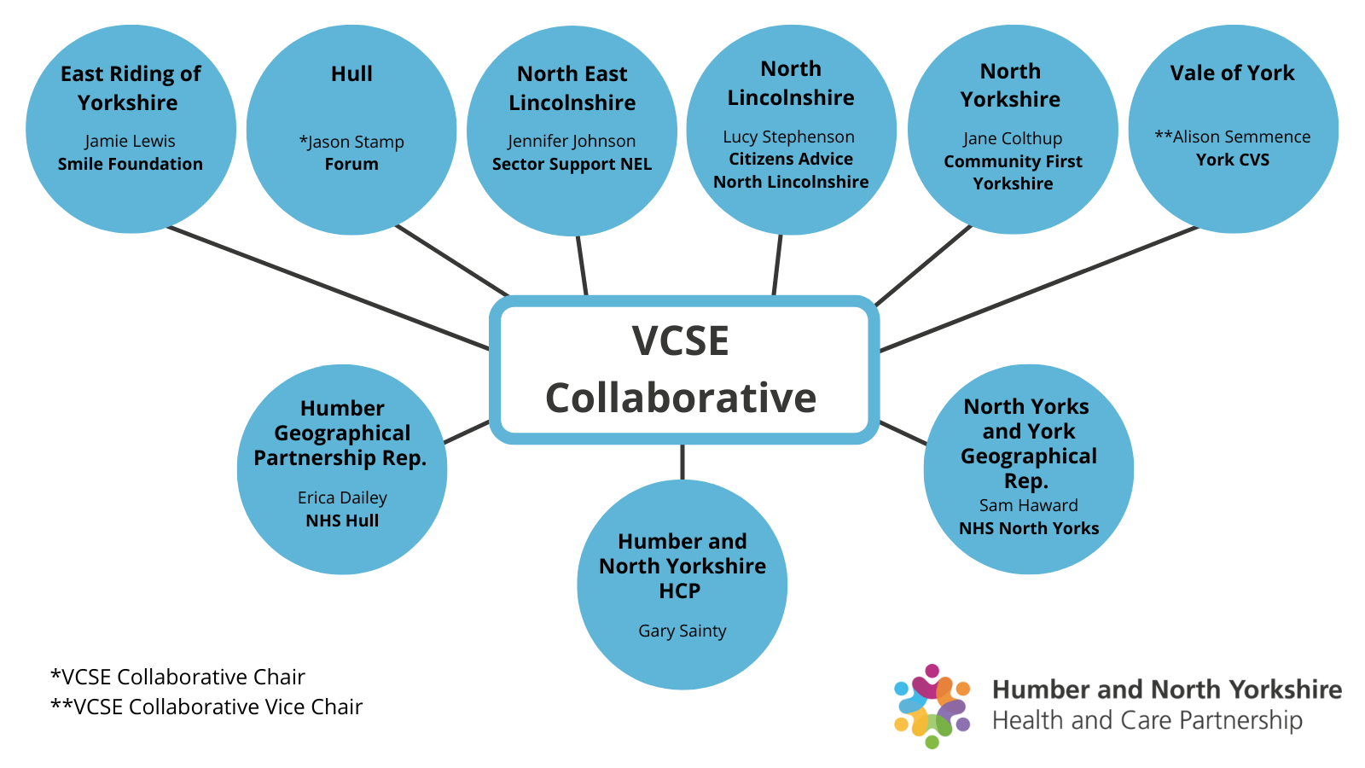

Establishing VCSE Assemblies at Place

To achieve the VCSE Collaborative’s vision to ‘enable the potential and impact of the VCSE Sector to be realised by being fully integrated into the planning, design and delivery of health and care across Humber and North Yorkshire’, each place was tasked with creating a mechanism to connect the wider VCSE Sector with Humber and North Yorkshire Health and Care Partnership.

Each place has now established a VCSE Assembly which is unique to the geographical location and the demographics of the VCSE Sector in that area. The Assemblies provide a structure to connect the VCSE Sector at Place with service development and delivery opportunities created by the Humber and North Yorkshire Health and Care Partnership.

We will share more about the development of each Assembly in future updates, but if you would like to know more about your local Assembly, please get in contact with Gary Sainty via: gary.sainty@nhs.net
Green Social Prescribing progress report

During the meeting we welcomed Anthony Hurd, Programme Manager (Green Social Prescribing) to provide an update on the Green Social Prescribing (GSP) Programme which is one of seven test and learn sites across England focusing on supporting mental ill health through outdoor activities.

To date, five funded projects involving 156 people have been completed. Of those people who were involved, 17 were referred from Social Prescribing services (11%); five from Mental Health services (3%) and 86% from other sources – predominately self-referral and other community groups. All projects saw a positive impact on participants’ wellbeing and some participants have now been recruited as volunteers.

There are still some challenges connecting community groups to Social Prescribing services but all projects reported that learning captured is being used to shape future activities – for example altering the timing of activities to increase participation.

For more information about the GSP Programme, please visit HEY Smile Foundation’s website.

Growing diversity in research participation

HNY HCP have recently been successful in securing some investment to increase inclusivity and diversity in research and understanding our people. The work will be led by the VCSE Collaborative and will initially look to engage VCSE organisations that operate and support people living along our coast.

Our approach will be to work with organisations to understand what they already know and understand about their communities. Then together we will explore how we can better meet their needs, gain a greater understanding, and hear from currently underrepresented voices. A briefing session is currently being planned for the New Year which will include more information about the project and the next steps. We’ll share more information as soon as it is available.

If your organisation is interested in being involved, please email Gary via: gary.sainty@nhs.net.

View the full update regarding the Research Network Development Programme here.

VCSE Collaborative Contact:
If you have any questions for the VCSE Collaborative, please get in contact with Gary Sainty, VCSE Programme Director via gary.sainty@nhs.net.

Useful definitions:
Integrated Care Systems (ICSs) - are partnerships that bring together providers and commissioners of NHS services across a geographical area with local authorities and other local partners to collectively plan health and care services to meet the needs of their population.
Integrated Care Board (ICB) - an organisation with responsibility for NHS functions and budgets for the ICS.
Integrated Care Partnership (ICP) - a statutory committee of the ICB bringing together all system partners to produce a health and care strategy.
Place-based / At place - Refers to the geographical locations across Humber and North Yorkshire.

