180 Days of Action on Workforce
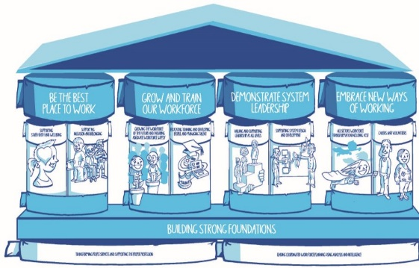
In December 2021, key partners from across our system came together to develop the Humber and North Yorkshire Health and Care Partnership People Strategy. Our People Strategy is a shared vision around how we support and develop our current workforce as well as focusing on designing and growing the future workforce. Our shared ‘One Workforce’ vision recognises that within our Partnership, our people are our biggest asset. This strategy built on the assessment across our system carried out in September 21 and incorporating the guidance on developing a people function.
Representatives from all parts of the system (including primary care, acute and mental health trusts, social care, ambulance services, community services and the diverse voluntary and community sector) have been working together to agree a set of key priorities for action to support the delivery of our People Strategy. These are:
- Supporting Inclusion and Wellbeing – developing a shared approach to staff health and wellbeing.
- One System, Learning Together – developing the current talent across the system, balanced on creative ways in which we can develop our future workforce.
- Ethical International Recruitment – developing a shared approach across all partners around a common approach to international recruitment opportunities, including our system partnership with the state of Kerala.
- Upskilling Leaders for Retention – developing a shared approach to how we retain talent across our system.
- Care at Home Redesign – led by social care we are developing a new approach to how we transform the current social care offer across the system.
- Volunteers at the Heart of the System – recognising the important role volunteers play as part of our wider workforce and developing meaningful and accessible volunteer roles as an introduction to workforce opportunities across our system.
- One System, Recruiting Together – developing a joined-up approach to recruitment which challenges the way we currently work.
- Telling the People Story – developing a shared approach to workforce data and workforce modelling to support the design of a new system that focuses on skills rather than roles.
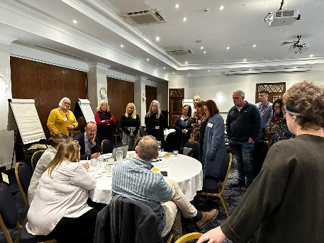
To support our strategy, we launched the 180 Days of Action on Workforce in September 2022 and invited all partners from across the system to become involved in this work. To date 185 people from different parts of our system have taken up our challenge to shape and deliver this work.
At a time when our system is working under unprecedented pressure, this has been a significant achievement.
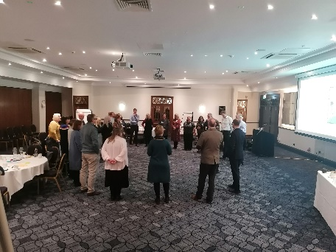
Our partners met in January 2023 to review our progress and share the outcomes that we have already achieved together. After 120 days, we are already showing how we are starting to think and work differently and how we are developing system solutions to system problems. Our partners have also reflected on the value of coming together to develop ideas and highlight current good practice around our priorities, recognising the value and importance of developing a shared understanding of what we currently do and what we could do together in the future. They recognise the value of managing change and our ambitions for workforce transformation together.
Our 180 Days of Action on Workforce comes to a close at the end of March 2023. This will provide us with strong foundations to agree the next phase of our work.
At this point in time, workforce remains one of our biggest challenges as both a system and our partner organisations. Wherever you are in the system the challenge remains the same. Building on our People Strategy and our 180 Days of Action on Workforce challenge, one system transforming together provides us with our biggest opportunity.
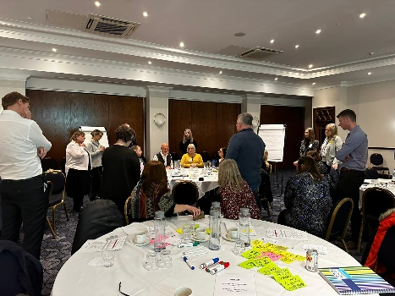
For more information about the Humber and North Yorkshire Health and Care Partnership People Strategy or the 180 Days of Action on Workforce please contact carly.mcintyre1@nhs.net

