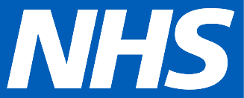
<Address, Postcode>
Dear [Title] [Surname],
The NHS Type 2 Diabetes Path to Remission Programme
We are writing to you because you have been identified as someone that could join the NHS Type 2 Diabetes Path to Remission Programme.
The programme helps people with Type 2 diabetes using a total diet replacement approach, with the aim of helping you lose over 10kg in weight, improving your blood glucose levels, reducing the need for diabetes-related medication and even putting your Type 2 diabetes into remission.

How it works
You will be offered low calorie, total diet replacement products - for example, soups and shakes totalling 800 to 900 calories per day - for up to 12 weeks. During this time, you will be expected to replace all normal meals with these products.
Alongside this, you will receive support and monitoring for 12 months, including help to re-introduce food after the initial 12-week period. You can choose how the programme is delivered to best suit your needs. This can either be one-to-one in-person support or one-to-one digital support.
This support will provide you with the help and advice you need throughout every phase of the programme. The whole programme, including the products, is funded by the NHS and completely free-of-charge to you. Your GP practice will be kept informed of your progress and if any medication changes might be needed.
In our area, the service is provided by Oviva.

Find out more
If you would like to find out more about taking part, please contact us at the practice so we can discuss whether the programme is suitable for you and get you started.
[Enter contact details]
Your sincerely,
[Name of healthcare professional to go here]
Service provided by
