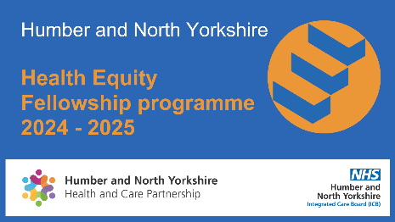
Humber and North Yorkshire Fellowship:
Volunteer Mentor Brief and
Expression of Interest

Mentors are a vital aspect of the Health Equity Fellowship - Humber and North Yorkshire Health and Care Partnership
The purpose of the role is to:
- Provide support and guidance for Health Equity Fellows during their time on the programme (April 2024 to March 2025)
- Assist fellows in refining, delivering, and evaluating their project, which they will undertake during their time on the fellowship.

As a HNY Health Equity Fellowship Mentor, you will support the programme by:
- Providing support to your assigned fellow/s focused on exploring issues related to developing and delivering their fellowship project*
- Providing support to your assigned fellow/s focussed on exploring issues related to the Health Equity Fellowship - Humber and North Yorkshire Health and Care Partnership
- Providing broader support and advice regarding public health
- Participating in the Fellowship Community of Practice
- Working with the Population Health team to promote and raise the profile of the HNY Health Equity Fellowship Programme and Fellows
- Providing updates to the project manager as required.

*Project support may include assisting your assigned fellow/s with:
- Identifying a research problem
- Evaluating its significance
- Designing interventions to address the problem/answer the question posed
- Interpreting data collected
- Making relevant connections across the partnership where necessary
- Preparing a written report and oral presentation of the results

HNY Health Equity Fellowship Mentors must commit to the following:
- To meet (virtually or face-to-face) with their assigned fellow/s on a monthly basis for the duration of the programme
- To supervise assigned fellow/s in the preparation of a research project report, including fellows’ project plan, interim project report, and final project report
- To provide feedback on their assigned fellow/s draft project report allowing time for them to make changes before submitting their final report
- To submit a testimonial of their assigned fellow/s’ achievements at the end of the programme
The time commitment is typically 1 hour per month (minimum) of contact time per fellow, plus time for reviewing the listed assignments (project plan, draft project report, final project report, & final presentation), and any extra time you would like to spend researching useful resources for your fellow/s.

How to volunteer as a mentor:
To register your interest as a mentor, please email hnyicb-ery.populationhealthandprevention@nhs.net by 15th March 2024 with the following information:

Name
Job title
Organisation
Contact details
The maximum number of fellows you can mentor
(e.g., 1, 2, …)
Short bio,
including any public health training
(100 words max. – this is so we can assign you to an appropriate fellow)

Mentors and fellows will be matched based on professional area of expertise and fellows’ chosen project topic.

