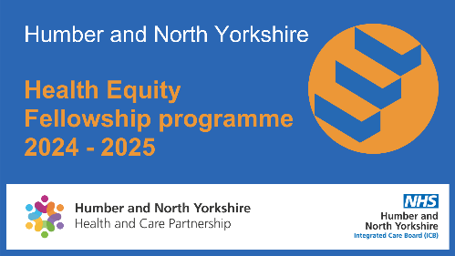
Humber and North Yorkshire Health Equity Fellow proposal
We are very pleased to announce the inaugural 2024 Humber and North Yorkshire Health Equity Fellowship Programme.
We are looking for 50 enthusiastic people who want to make a change and tackle inequalities in Humber and North Yorkshire.
This Programme aims to give Fellows the skills they need to improve population health and reduce health inequalities in their own organisation and across the Humber and North Yorkshire area.

The fellows will be expected to dedicate one day a week of their time to attend training and work on a project. The projects could be delivered in the applicant’s usual place of work or it could contribute to wider joined up or system approaches taking place across the area.

We would like to ensure that we have a variety of projects to achieve the best outcomes for our population, therefore we are project seeking ideas from partners, if you have a project that you would like to put forward please complete the table below and return to
hnyicb-ery.populationhealthandprevention@nhs.net.

Contact name and  email address |  |  | Organisation
Title of proposed project
Brief description and context of the proposed project (max 200 words)
Target population group
How will success be measured (max 100 words)

