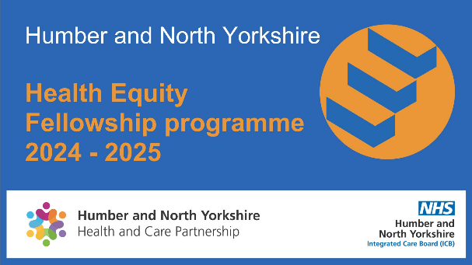

Health Equity Fellowship Statement of interest

To apply for Humber and North Yorkshire Health Equity Fellowship programmes, please complete and return this statement of interest to
hnyicb-ery.populationhealthandprevention@nhs.net

Who should apply?
The Health Equity Fellowship is open to colleagues from all sectors, including health, social care, local authority, voluntary and community services across Humber and North Yorkshire, irrespective of your current job role, grade, or profession.

You will need to:
- be passionate about tackling health inequalities
- want to become a champion and achieve change
- be committed to the delivery of a fellowship project
- agree to carry out formal learning as part of the fellowship
- confirm prior support from your current organisation that you will have protected time to take part fully in the fellowship.

The Health Equity Fellowship is designed to bring together the diverse organisations and professionals that influence health and wellbeing and attract applicants that are representative of the communities we serve. There are no specific educational requirements or preferred professions. We particularly welcome applications from professionals who do not currently hold a health inequalities position.

Selection criteria
We will select fellows based on demonstrated commitment to tackling health inequalities. A selection panel will score the expressions of interest against the following selection criteria, which you’ll need to demonstrate through this form.

- Strength of statement of interest, including personal motivation, commitment to reducing inequalities, application in the workplace and continued application of learning following the fellowship.
- Quality of proposed project.
- Confirmation of support from your line manager.

Demographics
Your personal information will only be used for the purpose of contacting you regarding your application. We will not share this information with any third parties
Name:
Contact email:
Job title:
Current employer:
Location:
Ethnicity:
Do you have any accessibility needs?
Statement of interest
- Please write a brief statement about yourself and your personal motivation for applying for the fellowship (no more than 250 words)
- Please provide an overview of the current challenges related to tackling health inequalities that you see in your current role and how you would seek to expand your learning and experience to address these through the fellowship (no more than 250 words)
- Please describe any existing experience and contributions to date in reducing health inequalities, either through work or through community or volunteer service, and how they will contribute to your fellowship experience (no more than 250 words)
- Please provide an overview of how you plan to continue to develop your knowledge and skills relating to health inequalities beyond completion of the fellowship (no more than 250 words)
Project proposal

Please describe one project you would like to complete during the fellowship term. The project should focus on a topic that is aligned with health inequalities and issues that you and/or your organisation focus on. The project is a key part of the overall learning and should include the following:
- description of project idea/chosen project
- the difference it will make to your organisation
- what you think success could look like
- how the learning from your project could be shared (no more than 400 words)
Programme expectation
The Health Equity Fellowship programme will run between 1 April 2024 and 31 March 2025.

You will be expected to:

- commit to one day a week to work on a fellowship project. This will include independent project work, monthly meetings with your mentor and submission of an interim and final project report in a format of your choice.
- participate in the Foundation Programme in Public Health – this will be 4 x 3 hour sessions over a period of approximately six months.
- Attend additional trainings and face-to-face events organised through the fellowship.

Please note, if you are working in a voluntary or community sector organisation, funding may be available to support backfill for Health Equity Fellows.
Line manager support
Line manager name:
Line manager role:
Line manager organisation:
I understand the time commitment expected of the named applicant to undertake the Health Equity Fellowship and I agree to support the applicant with the time required to as part of their role.

Signed:

Name:

Date:

