Healthier Together
Communications and marketing toolkit
August/September 2023

Content
- Introduction
- Internal bulletin and newsletter copy
- Website copy
- Social media content
- Printed materials

Introduction

Healthier Together is a website that provides consistent and high-quality advice from local health professionals on children and young people's health.
You'll find clear information on common childhood illnesses, including advice on what 'red-flag' signs to look out for, where to seek help if required and how long your child's symptoms are likely to last.
Healthier Together is a partnership project which continues to grow by putting children, young people and family’s needs at the heart of the website, into one easy to navigate place.
The information on the website is checked by clinicians and developed with experts.
This launch campaign will focus on:
- Launch – August/September
- Starting School/Back to School – September
- Choosing well - October
- Respiratory - Winter

Internal bulletin and newsletter copy

New website launched for parents to get the right help
Part of Let’s Get Better, Healthier Together is a new is a website that provides consistent and high-quality advice from local health professionals on children and young people's health.
You'll find clear information on common childhood illnesses, including advice on what 'red-flag' signs to look out for, where to seek help if required and how long your child's symptoms are likely to last.
Professionals can find lots of useful guidelines, local information, and much more. We have a special page for professionals on how to use the website.
Healthier Together is a partnership project which continues to grow by putting children, young people and family’s needs at the heart of the website, into one easy to navigate place.
The information on the website is checked by clinicians and developed with experts.

Website Copy
Healthier Together brings together consistent and high-quality advice from local health professionals for families into one easy to navigate place.
The information is written and approved by NHS clinicians including GPs, which means families/carers/young people will receive consistent self-care/management health advice from the website.
You'll find clear information on common childhood illnesses, including advice on what 'red-flag' signs to look out for, where to seek help if required and how long your child's symptoms are likely to last.
Together we’ll do the right thing for your child. Visit: www.hnyhealthiertogether.nhs.uk

Social media content
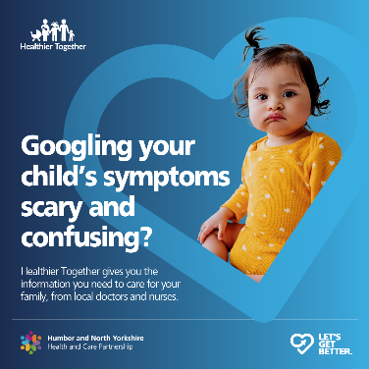 | Using the internet to search for your child's symptoms can often be scary – that’s why we have launched Healthier Together. A new NHS website aimed at providing you with the best guidance and support for your family.  Visit: www.hnyhealthiertogether.co.uk
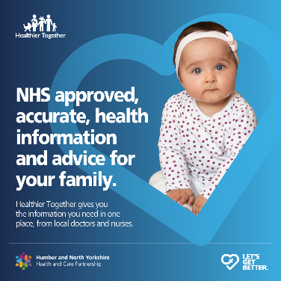 | If you are worried about your child or child in your care, it is important to seek NHS approved health information and advice.  Save wwww.hnyheaslthiertogether.co.uk in your favourites so its handy when you need it
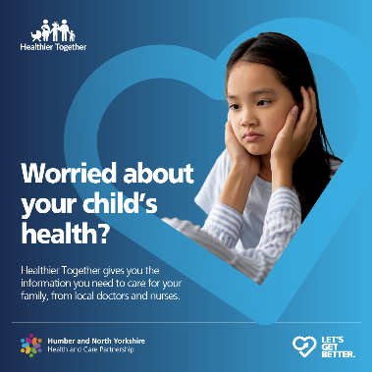 | Healthier Together provides parents, carers, pregnant women and birthing people, babies, children and young people in our local area with consistent and high-quality advice from local health professionals.  Together we’ll do the right thing for your child. Visit: ww.hnyhealthiertogether.nhs.uk
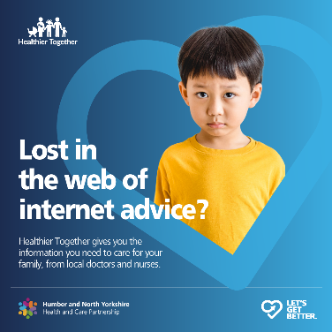 | For the right health service, or the reassurance you need, visit ‘Healthier Together’. The website provides parents, carers, pregnant women and birthing people, babies, children and young people in our local area with consistent and high-quality advice from local health professionals. NHS approved and accurate local information all in one place. Together we’ll do the right thing for your child. Visit: www.hnyhealthiertogether.nhs.uk

Printed media
A4 posters and A5 postcards are being shared with GP practices and community venues, a digital copy has been included in the toolkit for you to print and use whilst distribution is confirmed.

