Let’s take pride in our health – communications toolkit
June 2023

Content
- Introduction
- Background
- Pride events in Humber and North Yorkshire
- Bulletin/web copy
- Text messaging copy
- Social media content

Introduction
The Humber and North Yorkshire Health and Care Partnership is launching a system wide Pride campaign to run throughout the months of June, July and August and we would encourage all partners to share the messages included in this toolkit to show a unified front across health and care for LGBTQ+ people.
This campaign will focus on:
- Access to support – June
- Workforce and recruitment – July
- Intersectionality – August
We will share further information and content for July and August in due course.

Background
We know that LGBTQ+ members of our communities face significant health inequalities.
From data collected in 2022 (NHS Hull Pride in Our Health Survey), two main themes were present when asked why people don’t access services when they need them:
- People didn’t know what support was available near them
- People didn’t know where to find out what support is available near them
A further question asked what medical issues members of the LGBTQ+ were most worried about, to which the top answers were:
- Cancer
- Mental health
With this information, we have developed a website for all things LGBTQ+ health and wellbeing, available here: www.prideinourhealth.co.uk and have developed tailored social media messaging (below).
It's important to remember that our LGBTQ+ colleagues are also patients and service users. The inequalities LGBTQ+ people face in society are mirrored within the workplace and we'll be exploring this more in the second month of the #PrideInOurHealth campaign (July).

All resources and materials have been co-designed in partnership with LGBTQ+ colleagues across Humber and North Yorkshire but we would encourage you to work in partnership with your organisation's LGBTQ+ staff network throughout the campaign.

Pride events in Humber and North Yorkshire
If you would like to get involved in supporting your local pride, or your organisation is already doing something to support, please let us know: hnyicb.communications@nhs.net
- Bridlington Pride – Saturday 1 July 2023
- Grimsby and Cleethorpes - Saturday 22 July 2023
- Hull Pride - Saturday 29 July 2023
- Beverley Pride - Saturday 5 August 2023
- Goole - Saturday 12 August 2023
- Scunthorpe Pride - Sunday 27 August 2023
- Wolds (Pocklington) - Sunday 17 September 2023
- Scarborough Pride - Saturday 30 September 2023

Pride campaign 2023 key messaging
Overarching messaging
- Let’s take pride in our health
Access to support – June 2023
- Health and care services are for everyone
- We take pride in providing health and care services that welcome everyone
- Let’s talk about screening
  - Trans and non-binary people are eligible for NHS screening programmes
  - Cervical screening is for everyone with a cervix
  - If you still have breast tissue, you still need to be breast aware
  - Bowel cancer screening is available to everyone over 65
  - If you’re 65+ and assigned male at birth, you are eligible for AAA screening
July & August
TBC

Bulletin/web copy (200 words)
Let’s take pride in our health
New one-stop-shop launches for all things LGBTQ+ health and care
For the first time in Humber and North Yorkshire, knowing where to turn for health and wellbeing support as a member of the LGBTQ+ community will be at your fingertips. A new website has launched to make finding support in Humber and North Yorkshire easier for people who identify as LGBTQ+.
Launched this Pride month, you can quickly find useful information, services, and support to help you to live a healthy life on the site, as well as contact details for services near you.
Visit www.prideinourhealth.co.uk to find tailored information on mental health and emotional wellbeing, screening programmes, sexual health, drug and alcohol use, and eating disorders. You’ll also find information on how to register with a GP practice near you and how to change your name and gender on your medical record.
Follow Let’s Get Better on Facebook for more tailored LGBTQ+ health and wellbeing information throughout June 2023.

Text message copy
A new website has launched to make it easier for LGBTQ+ people to find health and care support in Humber and North Yorkshire. Visit www.prideinourhealth.co.uk to find out more.

Social media
Please see below some suggested social media content for use across your channels.
Week 1 – GP services
Topic | Imagery | Copy
Registering with a GP | 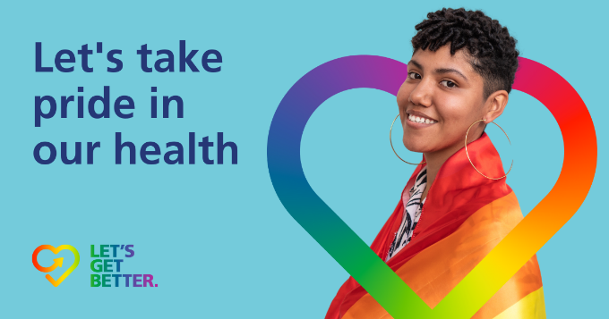 | Get the most out of your GP practice as a member of the LGBTQ+ community.  It’s important to register with a GP practice near you so you can receive the right care for you when you need it.  Find more LGBTQ+ health and wellbeing information here: www.prideinourhealth.co.uk  #PrideInOurHealth
Changing gender marker on medical record | 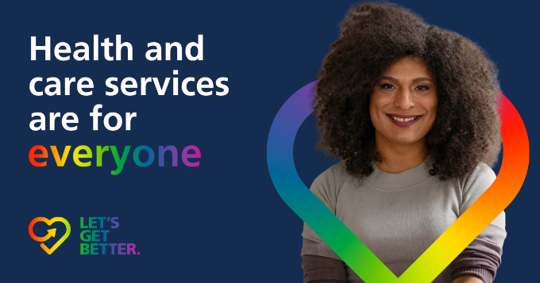 | It’s easy to change your gender marker on your medical record, just speak to the team at your GP practice.  The practice team will handle the rest, including transferring all your medical information to a new file under your new gender and name. All reference to your old name or gender will be redacted from the files.  Find more LGBTQ+ health and wellbeing information here: www.prideinourhealth.co.uk  #PrideInOurHealth
Why it’s important to tell your GP about your gender identity and sexuality | 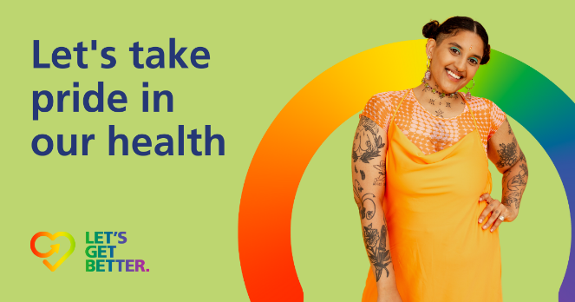 | Just as you would tell your doctor about your age, occupation or ethnicity, it’s a good idea to tell them if you identify as LGBTQ+. It makes it easier to discuss your life, relationships and health concerns and make sure you receive care that is tailored to the whole of you.  Find more LGBTQ+ health and wellbeing information here: www.prideinourhealth.co.uk #PrideInOurHealth
Week 2 – mental health
Topic | Imagery | Copy
Mental health | 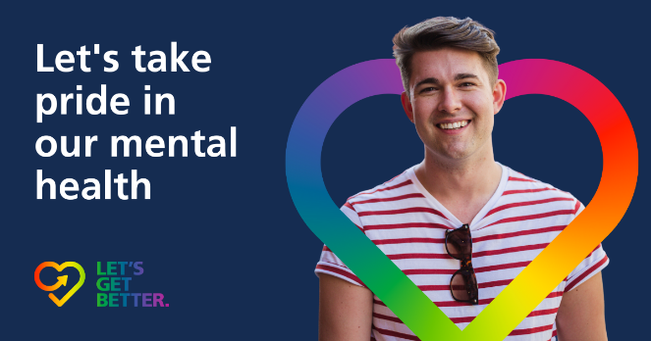 | We all struggle with our mental health from time to time. But being part of the LGBTQ+ community poses its own unique mental health challenges.  It might not be easy, but you deserve to get help the help and  Support you need. No-one should have to struggle alone.  Find out more: www.prideinourhealth.co.uk/mental-health  #PrideInOurHealth
Mental health |  | If you’re struggling, talking with a therapist may help. They could help with:  - exploring your sexual orientation  - coping with other people’s reactions to your sexuality  - feeling your body does not reflect your true gender (gender dysphoria)  - fear of violence  Find out more: www.prideinourhealth.co.uk/mental-health  #PrideInOurHealth
Week 3 – screening (19th cervical screening week)
Copy | Imagery | copy
Cervical screening (19th) |  | Cervical screening is for everyone with a cervix, regardless of our sexual orientation.  Trans men and non-binary people who still have a cervix should have cervical screening to help prevent cervical cancer too.  Find out more: www.prideinourhealth.co.uk/screening  #PrideInOurHealth
Breast screening | 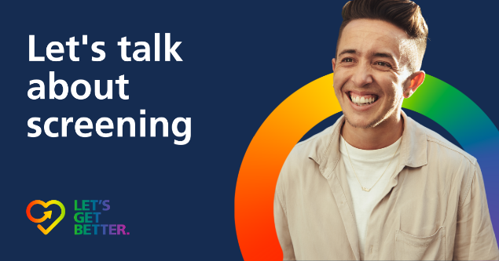 | Make sure you’re feeling and getting your screening!  If you still have breast tissue, you are eligible for breast screening. If you’re a trans man and have had chest reassignment surgery (top surgery), ask your surgeon about how much breast tissue you have remaining. They may advise that you still need breast screening.  Find out more: www.prideinourhealth.co.uk/screening  #PrideInOurHealth #CopAFeel
Generic screening | 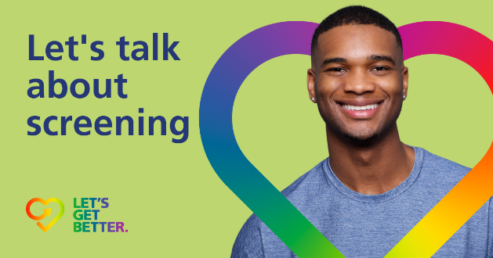 | NHS screening programmes aim to detect problems early when treatment may be more effective.  They do not discriminate against gender identity or sexuality. If you are eligible, it’s important to attend.  Find out more: www.prideinourhealth.co.uk/screening  #PrideInOurHealth

