Let’s get ready for the bank holiday

We want to encourage people to prepare for the bank holiday weekend and access NHS services responsibly.
Please see our suggested messages and assets which can be used across social media, websites and digital screens.

SOCIAL MEDIA
Asset | Suggested message | Link to include
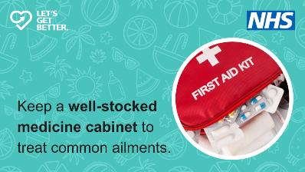  Medicine cabinet | Are you ready for the bank holiday weekend?  Add basic remedies to your shopping list so you can treat common illnesses and ailments at home.  More info ➡️ [Link] | letsgetbetter.co.uk/bank-holiday
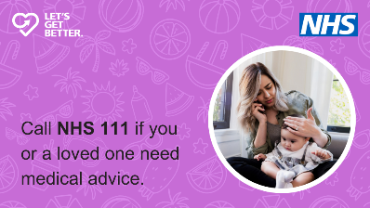  NHS 111 | For non-emergency medical advice, NHS 111 is available 24/7. ️  Trained medical professionals can provide guidance on the most appropriate medical care.  Find out more ➡️ [Link] | letsgetbetter.co.uk/bank-holiday
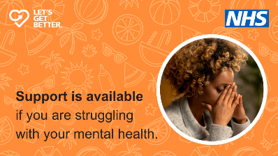  Mental health | Whatever you might be going through, support services are available.  If you need help for a mental health crisis or emergency, get expert advice and assessment.  More info ➡️ [Link] | letsgetbetter.co.uk/bank-holiday
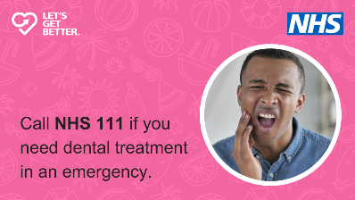  Dental emergency | Access an NHS dentist out-of-hours or in an emergency.  NHS 111 can provide advice and arrange an appointment if you need urgent treatment.  Find out more ➡️ [Link] | letsgetbetter.co.uk/bank-holiday
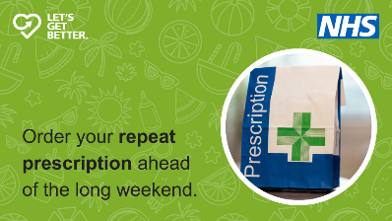  Repeat prescription | Are you ready for the bank holiday?  Pharmacy processing times may be slightly longer at this time of year. Don’t delay ordering or collecting repeat prescriptions.  Find out more ➡️ [LINK] | letsgetbetter.co.uk/bank-holiday
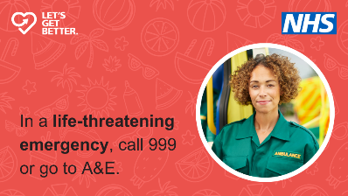  999 | In a life-threatening emergency, do not hesitate to call 999 or go to the nearest A&E.  If you're not sure what to do, NHS 111 can help.  More info ➡️ [LINK] | letsgetbetter.co.uk/bank-holiday
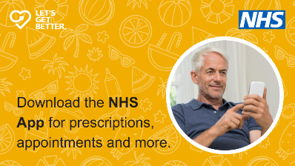  NHS App | Get ready for the bank holiday weekend.  Use the NHS App to book appointments, order repeat prescriptions, access 111 and more.  Download now ➡️ [LINK] | letsgetbetter.co.uk/bank-holiday
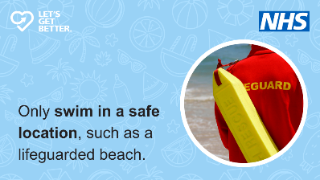  Swim safely | Heading to the beach? ️  Make sure you always swim in a safe location where lifeguards are present.  Stay coast clever ➡️ [LINK] | hmcoastguard.uk/coast-clever

WEBSITE COPY
Essential healthcare tips for the Bank Holiday weekend
Residents across the region are being urged to make informed choices and seek the right healthcare service this summer bank holiday.
The NHS often experiences increased demand during weekends and public holidays, but by choosing the right service, people can alleviate pressure on healthcare providers and avoid unnecessary trips to A&E.
Over the weekend, a range of healthcare services will be available to those in need. These include local pharmacies and NHS 111. Using these resources appropriately can ensure that everyone receives the care they need without overwhelming busy emergency departments.
Across the region, emergency departments remain extremely busy – people should only use A&E or call 999 in a serious or life-threatening emergency.
To help you and your loved ones stay safe and healthy this bank holiday weekend, visit the Let’s Get Better website or use the checklist below:

Summer safety
With the summer heat tempting many to take a dip, it's important to remember that despite the warm weather, the temperature of open water can still be dangerously low. Cold water shock remains a significant risk, particularly for those unaccustomed to swimming in open water.
If you plan to swim, choose a safe location – such as a lifeguarded beach – and follow these crucial safety tips:
- Check the weather forecast and tide times before heading out
- Always take coastal walks when the tide is going out, not coming in
- Carry a fully charged mobile phone with you at all times
If you experience a coastal emergency, call 999 and ask for the Coastguard.

Self-care
For minor illnesses and injuries like sore throats, grazes and hangovers, self-care at home is often the best approach.
Most minor conditions will start to improve within a few days. It's also important to ensure that you have ordered and collected any necessary prescriptions before the weekend begins. Keeping your medicine cabinet stocked with essentials like paracetamol and ibuprofen can also help manage minor ailments.

Local pharmacy
Pharmacies remain a vital resource for non-urgent health concerns. Pharmacists are highly trained professionals who can provide confidential advice and treatment for a range of common conditions.
Many pharmacies will remain open during the evenings and on bank holidays, but may have altered opening hours. Use the Find a Pharmacy service to get your local pharmacy’s opening times.

NHS 111
For medical concerns that are urgent but not life-threatening, the NHS 111 service is available 24/7, every day of the year. By dialling 111 or visiting 111.nhs.uk, you can speak with a trained adviser who will guide you to the most appropriate care.

Emergency care
For medical emergencies, A&E remains the appropriate place to seek care. Conditions such as difficulty breathing, chest pains, or serious accidents require immediate attention.
In such cases, call 999 for an ambulance or go directly to the nearest emergency department.

Dental emergencies
If you need dental treatment in an emergency, contact your dental practice if you are registered. If you are not registered with a dentist, contact NHS 111.
If you’re in pain while waiting to see a dentist, take painkillers such as paracetamol or ibuprofen. NHS 111 can also offer other self-care advice. Only go to A&E if you have:
- Heavy bleeding
- Injuries to your face, mouth, or teeth
- Severe swelling, or increasing swelling of your mouth, lips, throat, neck or eye

