Graphic | Suggested copy | Link to include
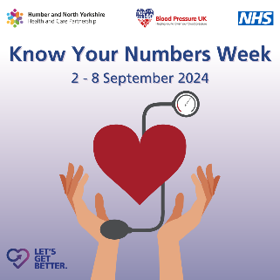 | We believe every adult should know their blood pressure numbers in the same way they know their height and weight.  Did you know high blood pressure usually has no symptoms and left untreated can cause health problems.  The good news is you can get a free, simple blood pressure check today. If your blood pressure is high, there are things you can do to treat it.  Find out more ➡️  #Knowyournumbers #BloodPressure #Hypertension | www.letsgetbetter.co.uk/bloodpressure
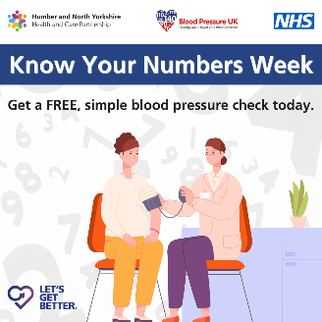 | We believe every adult should know their blood pressure numbers in the same way they know their height and weight.  Did you know high blood pressure can cause heart attack, stroke or kidney disease.  The good news is you can get a free, simple blood pressure check today. If your blood pressure is high, there are things you can do to treat it.  Find out more ➡️  #KnowYourNumbers #BloodPressure #Hypertension | www.letsgetbetter.co.uk/bloodpressure
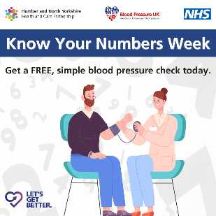 | We believe every adult should know their blood pressure numbers in the same way they know their height and weight.  Did you know detection and treatment of high blood pressure can help you live a healthier, longer life.  The good news is you can get a free, simple blood pressure check today. If your blood pressure is high, there are things you can do to treat it.  Find out more ➡️  #KnowYourNumbers #BloodPressure #Hypertension | www.letsgetbetter.co.uk/bloodpressure

