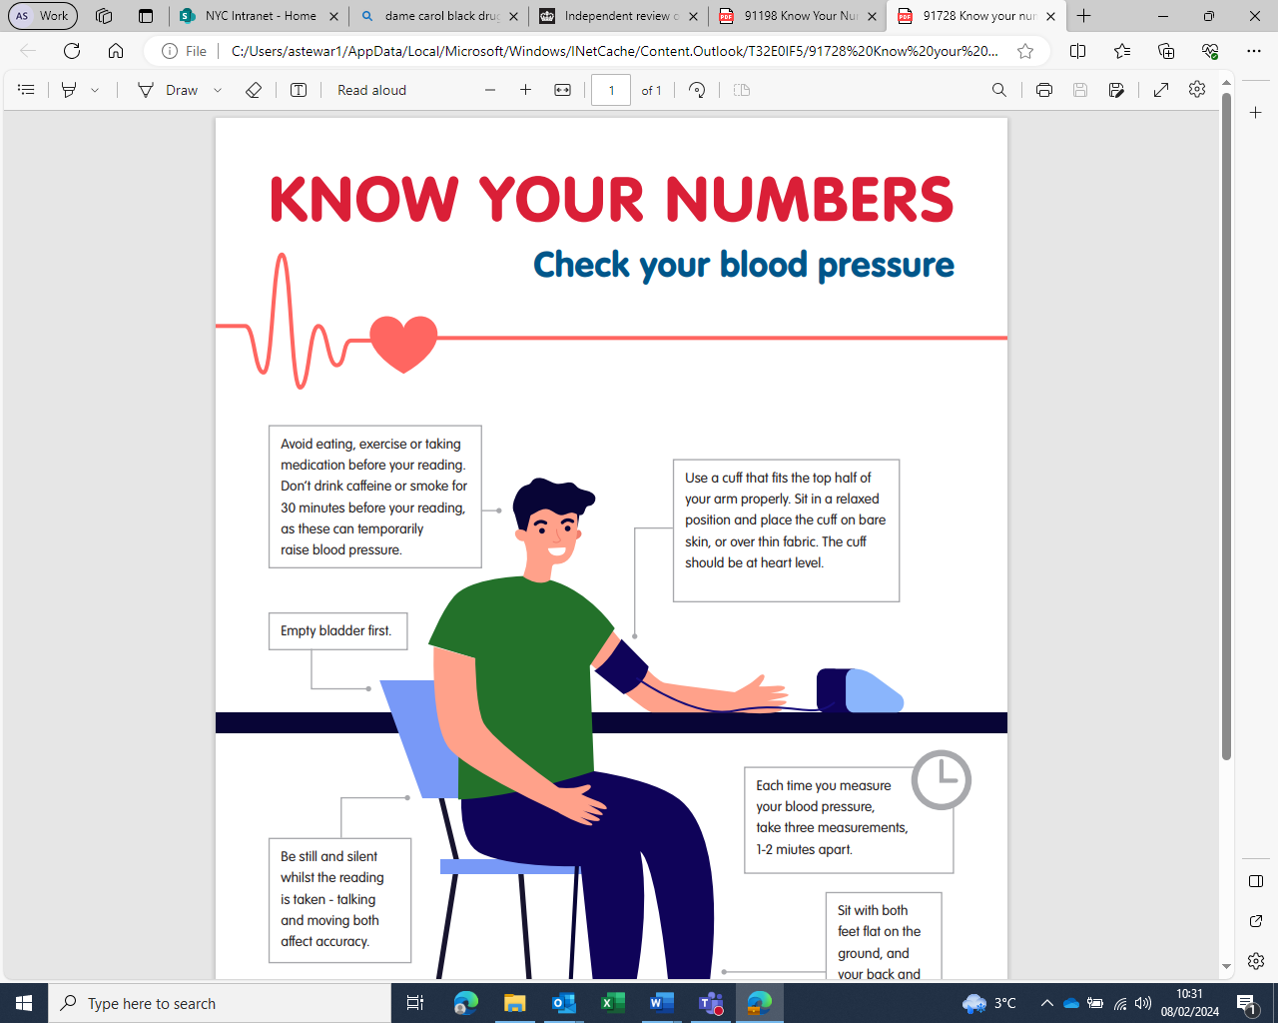

**Evaluation Form**

To help us evaluate and improve the pressure stations, we would appreciate it if you could provide us with some information (please mark the box to the right of your answer):

|  |  |  |  |  |  |  |  |  |  |  |  |  |  |  |  |  |  |  |  |
| --- | --- | --- | --- | --- | --- | --- | --- | --- | --- | --- | --- | --- | --- | --- | --- | --- | --- | --- | --- |
| **Which H&NY ICB Place do you live in? Write N/A if you live outside of our ICB.** | | | | | | | | | | | | | | | | | | | |
| **Pen with solid fill** | | | | | | | | | | | | | | | | | | | |
| **What is your gender?** | | | | | | | | | | | | | | | | | | | |
| **Male** | | |  | | | | **Female** | | |  | | | **Other** | | | |  | | |
| **What is your age?** | | | | | | | | | | | | | | | | | | | |
| **Under 30** |  | | | **30-39** | |  | | | **40-49** |  | **50-59** | | |  | | **Over 60** | |  | |
| **When was the last time you checked your blood pressure?** | | | | | | | | | | | | | | | | | | | |
| **Under 1 year ago** | | |  | | | | **Between 1 and 5 years ago** | | |  | | | **Over 5 years ago** | | | |  | | |
| **What was your blood pressure result?** | | | | | | | | | | | | | | | | | | | |
| **Below 90/60** | |  | | | **Between 90/60 and 139/80** | | |  | | **Between 140/90 and 179/119** | |  | | | **180/120 or higher** | | | |  |
| **How easy did you find it to use the pressure station?** | | | | | | | | | | | | | | | | | | | |
| **1 (hard)** |  | | | **2** | |  | | | **3** |  | **4** | | |  | | **5 (easy)** | |  | |
| **Please provide any other comments you may have about the pressure station:** | | | | | | | | | | | | | | | | | | | |
| **Pen with solid fill** | | | | | | | | | | | | | | | | | | | |

Thank you very much for your feedback, please put it in the evaluation box