Stoptober

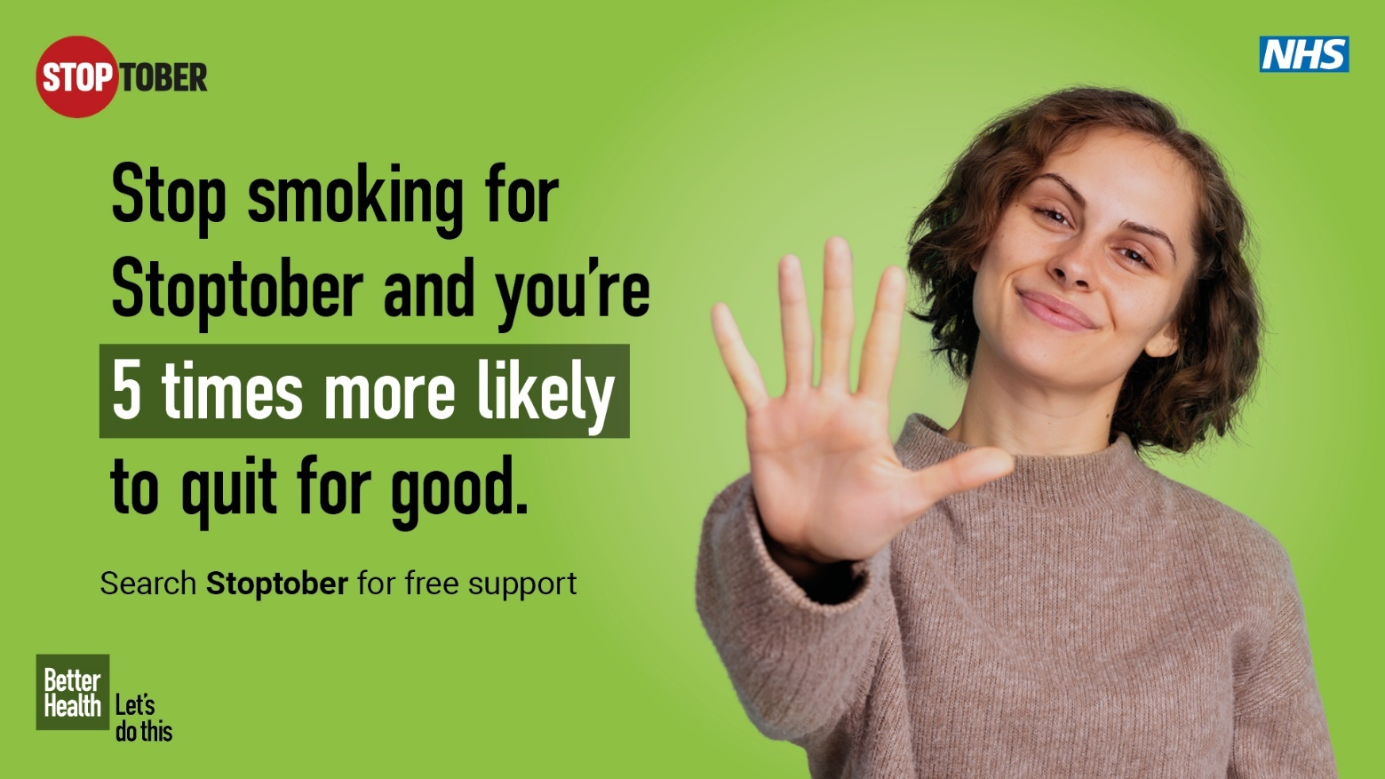

  - Targeted Toolkit for Healthcare Teams in Humber and North Yorkshire

Stoptober Toolkit for Healthcare Teams
Why is tobacco still a top priority?
While smoking rates have declined in recent years, over 5 million people in England still smoke and smoking remains the single biggest cause of preventable ill health and death. The total cost from smoking to the Humber and North Yorkshire ICB area is estimated by ASH as £1.41 billion each year, which includes a cost to the NHS in our region alone of approximately £58.5 million per year to treat smoking related diseases.

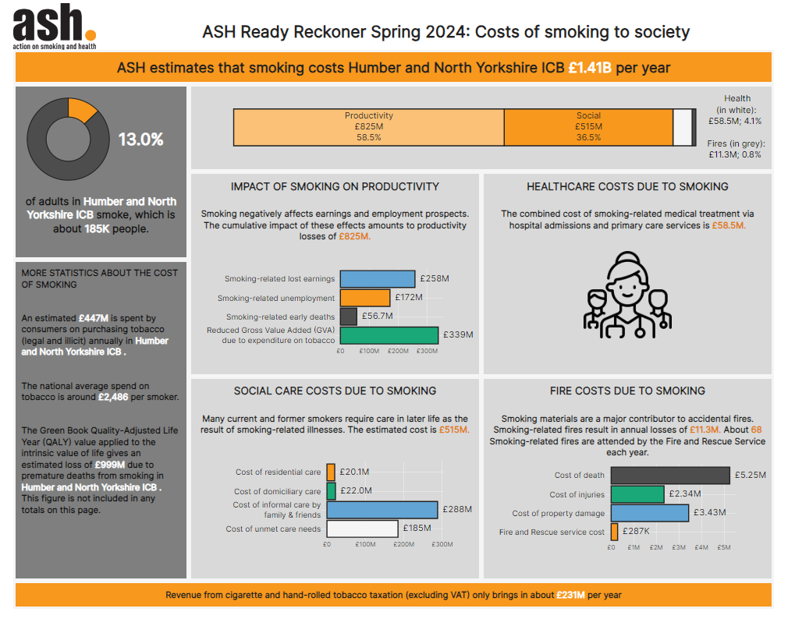
Training for Clinicians
- Making every contact count - refresher on Very Brief Advice – how to ask the question/available support MECC Link
- NCSCT eLearning modules – short sessions, around 30 minutes maximum and are helpful to refresh clinicians and healthcare providers with the most up to date information and advice. It only takes a minute and is free to set up an online account. Sessions include Very brief advice, A guide to vaping for healthcare professionals, stop smoking medications, very brief advice for smoking in pregnancy, very brief advice for second hand smoke, very brief advice for homelessness services.
Copy for clinicians/staff newsletters/email/intranet
It’s Stoptober
- Patients expect to be asked about smoking ( Chapter 11: Smoking and tobacco use - GOV.UK (www.gov.uk) – research shows that by not addressing smoking, patients can feel that it’s either not important or the clinician doesn’t believe they’re capable of stopping.
- Record smoking status on systems – this presents further opportunities to offer smoking cessation support through text messaging or email systems.
- Deliver Very Brief Advice – brush up on your knowledge here: NCSCT e-learning (it only takes a minute to register for a free account and begin the short 30 minute eLearning programme)
Your local stop smoking service is (delete all others which are not applicable)
- East Riding Quit Smoking | Smoking Cessation Help in East Riding (healthier-futures.co.uk)
- Hull Hull stop smoking service - SmokeFree Hull (changegrowlive.org)
- North East Lincolnshire livewell.nelincs.gov.uk
- North Lincolnshire Living a healthy life - North Lincolnshire Council (northlincs.gov.uk)
- York CYC Health Trainers – City of York Council
- North Yorkshire Stopping smoking | North Yorkshire Council
Sample text message to patients identified as tobacco dependant – please let us know if you’re planning to text out to patients, and we can link you in with the locally commissioned stop smoking service to coordinate the approach
- It’s nearly Stoptober – Join thousands of others and give quitting a go. Get expert help and advice here: (link to local stop smoking service)
- Ready to give quitting a go this Stoptober? Get free, expert help and here (link to local stop smoking service)
- This Stoptober, give quitting another go – click here to get started (link to local stop smoking service)
What else can you do?
- Encourage colleagues to take the Very Brief Advice training, and understand referral pathways for support (either to hospital tobacco dependency team or locally commissioned stop smoking service)
- Add slides or animations to digital screens/screen savers
- Encourage staff to use the Stoptober email signatures for the month of October (these can be hyperlinked to either your locally commissioned stop smoking service or Quit smoking - Better Health - NHS (www.nhs.uk)
- Display leaflets from local stop smoking services in waiting areas
- Make a display – digital copies of posters are available to download (attached in the email)
- If you have social media channels, consider scheduling some of the sample posts provided below (using #Stoptober) Check out our Stoptober playlist with lots of case study videos: https://youtube.com/playlist?list=PLyniLAHDXNhu9ceHFh9xesCFudNsU2omK&si=8zS115gCF7SPEUTw

General sample posts
When you stop smoking with support, you have an expert on your side who will offer non-judgemental support every step of the way.  Join the thousands of others giving quitting a go this #Stoptober  Get in touch with your local stop smoking service here: (link to local stop smoking service) | Link to video: https://youtu.be/eEBj6aRGvXA
How much money could you save by staying smokefree this #Stoptober?  #Stoptober  #SmokefreeUK | https://youtu.be/N2_SNVZqbqA  (Or download video and post directly)
It’s never too late to stop smoking and improve your health – you’ll start feeling the benefits in as little as 20 minutes!  #Stoptober  #SmokefreeUK | https://youtu.be/oo74GlkIhlI  (or download video and post directly)
Tried to quit for #Stoptober but struggled with cravings?  Check out your options here and why not try a different method?  Quit smoking - Better Health - NHS (www.nhs.uk)  #SmokefreeUK | (Link to Stoptober animated assets)
It’s a myth that smoking relieves anxiety - in fact, it creates it!  Check out this video for more information  Take the stress out of quitting and get in touch with your local stop smoking service for help (link to locally commissioned stop smoking service)  #Stoptober #SmokefreeUK | Share YouTube video below  https://youtu.be/GHZXsvrL270?si=IvnZg_0rmh2g0MPg

