Social media schedule and images
Over the next four weeks we will be using a mix of paid and organic social media posts, to drive people to complete our online survey.
In this toolkit you will see the paid social media posts and the dates in which they are going live, it would be great if you could post them on your social media channels and also help amplify any content we post on our Let's Get Better Facebook and Instagram. Please feel free to tailor the post to suit your tone of voice and audiences.
It might be that posts receive feedback and comments, if this, good or bad can be sent over so that it is included in the final report.
Date | Post | Asset
14/10/2024 | We need to talk about the NHS and we need your help.  This week we have launched our big conversation to find out what really matters to you when it comes to the NHS and to get your thoughts on how things could be changed for the better.  This can't be done without the insight and help from local people.  Complete the survey now: https://letsgetbetter.online/ournhs | Short video.  Generic launch short video  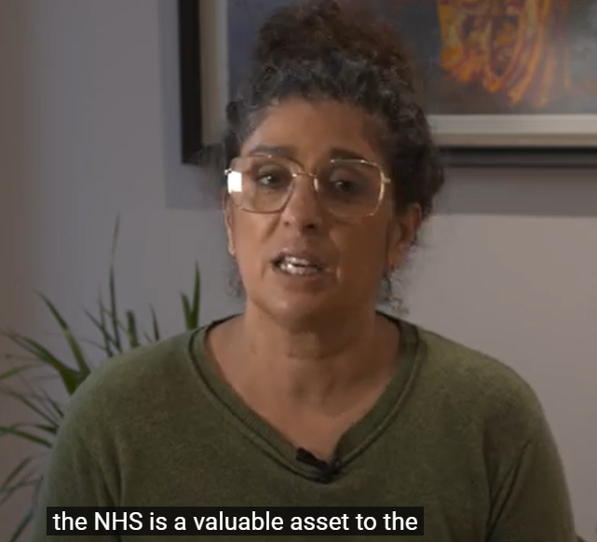

14/10/2024 | The NHS needs to change.  Our local NHS wants to know what you think the biggest priorities are.  Tell us your thoughts by completing this short survey: https://letsgetbetter.online/w1 | Social media post 1  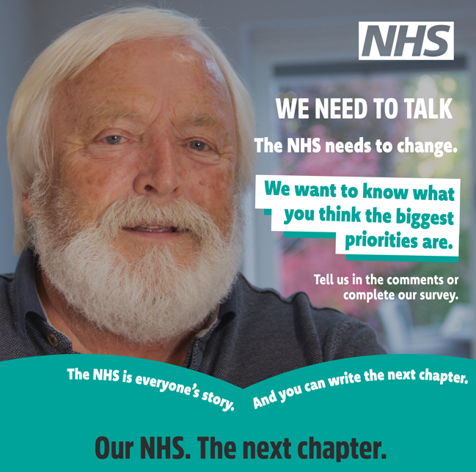  ALT TEXT:  Close up of older male face. Bottom of the image is two arches in a teal colour which depicts an open book with the wording – The NHS is everyone’s story. And you can write the next chapter. Captioned NHS – We need to talk. The NHS needs to change. We want to know what you think the biggest priorities are.

21/10/2024 | Are there any services currently provided by the NHS that shouldn't be provided in the future?  We want to know your thoughts on ways in which the NHS can change. Help us by completing this short survey: https://letsgetbetter.online/w2 | Social media post 2  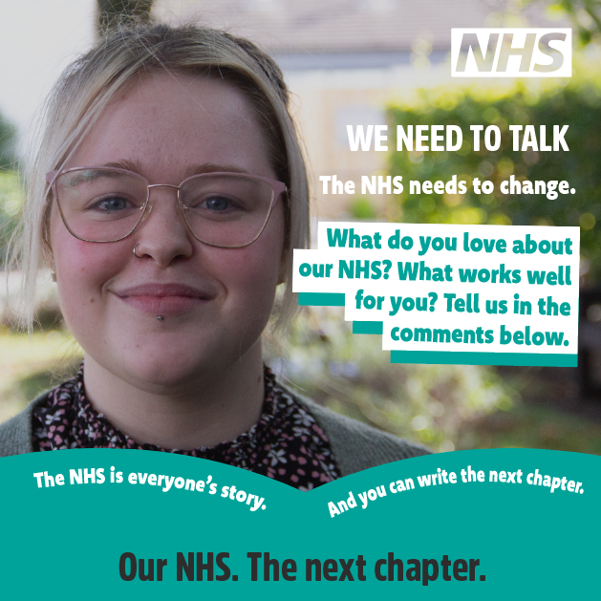  ALT TEXT:  Female close up of face. Bottom of the image is two arches in a teal colour which depicts an open book with the wording – The NHS is everyone’s story. And you can write the next chapter. Captioned NHS – We need to talk. What do you love about our NHS? What works well for you? Tell us in the comments below.
28/10/2024 | When thinking about NHS services what is most important to you and your family?  We're helping our NHS partners by gathering your thoughts on ways in which the NHS can change. Help us by completing this short survey: https://letsgetbetter.online/w3 | Social media post 3  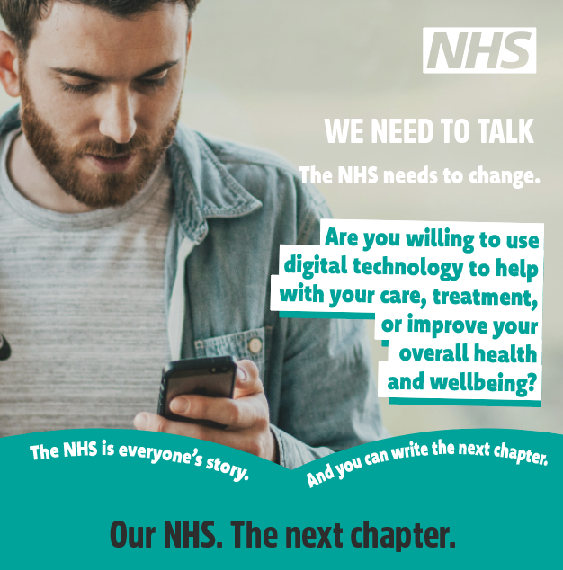  ALT TEXT:  Male looking down on phone depicting digital technology and health. Bottom of the image is two arches in a teal colour which depicts an open book with the wording – The NHS is everyone’s story. And you can write the next chapter. Captioned NHS – We need to talk. Are you willing to use digital technology to help with your care, treatment, or improve your overall health and wellbeing?

04/11/2024 | Being responsible for your own health and wellbeing is really important and taking time to look after yourself can stop people becoming dependant on NHS services.  What could you do more of to better look after yourself and family.  Complete the survey here: https://letsgetbetter.online/w4 | Social media post 4  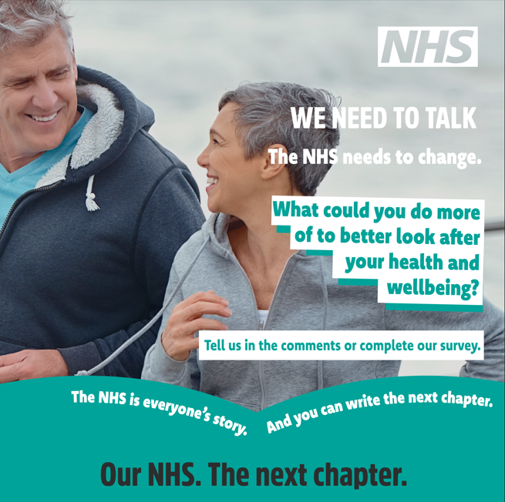  ALT TEXT:  Close up of middle aged male and female running. Bottom of the image is two arches in a teal colour which depicts an open book with the wording – The NHS is everyone’s story. And you can write the next chapter. Captioned NHS – We need to talk. What could you do more of to better look after your health and wellbeing?

