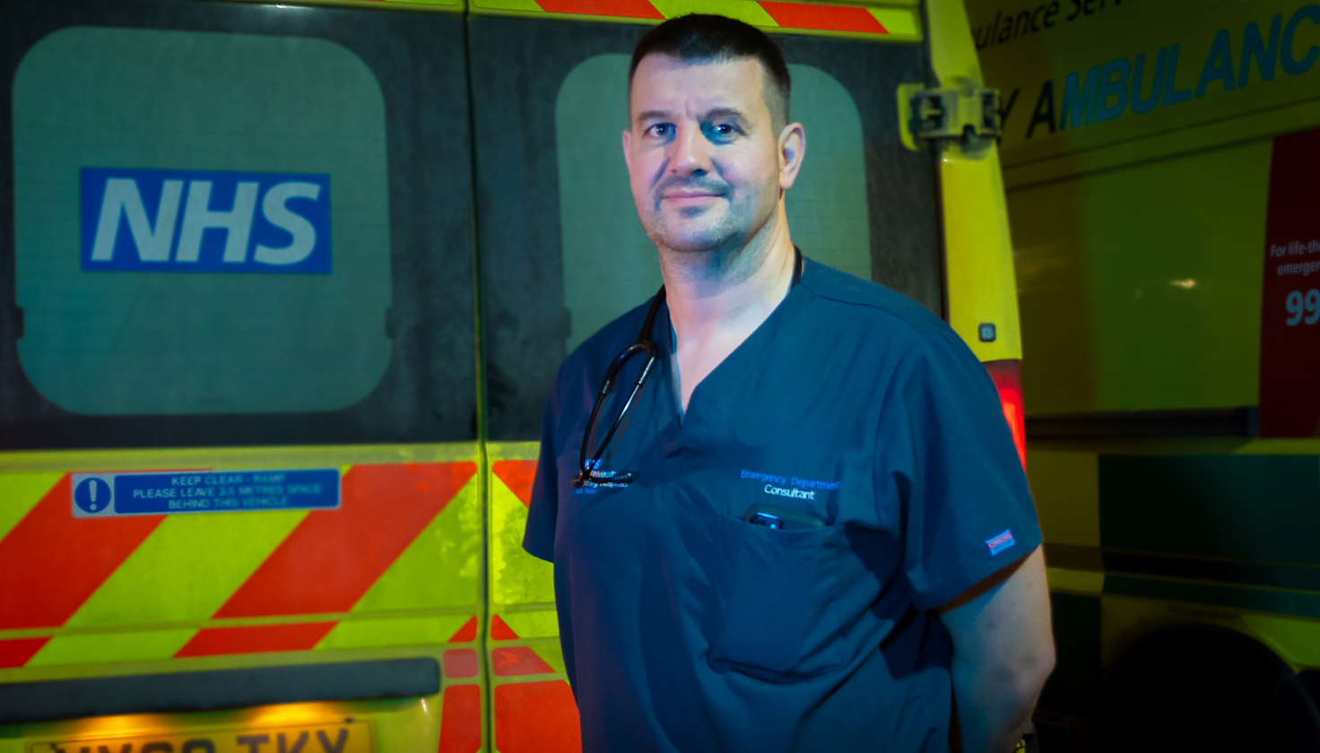

**Picture caption: Dr Ben Rayner, consultant in emergency medicine at Hull Royal Infirmary and chief of service for NHS Humber Health Partnership’s Major Trauma Network Care Group**

**Web copy**

Health leaders in Humber and North Yorkshire are urging people to get vaccinated to "get winter strong".

Thousands of people in our area have already received one or more vaccines for COVID-19, flu and respiratory syncytial virus (RSV), but there is concern that some eligible people have not yet come forward.

Dr Ben Rayner (pictured), consultant in emergency medicine at Hull Royal Infirmary and chief of service for NHS Humber Health Partnership’s Major Trauma Network Care Group, said: "Every year, many of those at greater risk of getting seriously ill from winter viruses do not get their vaccines. Some will end up in this very hospital. Tragically, some will die.

"The threat of these viruses is very real – and the best protection against these dangerous illnesses is vaccination – so it is crucial that anyone eligible comes forward for their vaccine appointment when they can to protect themselves and those around them."

Dr Nigel Wells, NHS Humber and North Yorkshire Integrated Care Board's (ICB) Executive Director for Clinical and Professional added: "Respiratory viruses, such as flu, usually reach their peak over the festive and new year period. Nobody wants to miss out on the festive celebrations with their friends and family this winter and the vaccines provide the best possible defence.

"It is important to top up your protection, even if you have had a vaccine or been ill with flu or COVID-19 before, as immunity fades over time and these viruses change each year."

Those eligible for a free NHS flu and COVID-19 vaccine include:

* People with certain long term health conditions
* People aged 65 and over
* Pregnant women
* People living in a care home for older adults

Parents of children who are aged two or three (on or before 31 August 2024) should contact their GP surgery to book their child’s flu vaccination.

School-aged children (from reception to Year 11) will usually be offered their flu vaccinations at school. For most children the vaccine is a nasal spray, not an injection. It is quick and painless.

Pregnant women are now eligible for the RSV vaccine and should also get their whooping cough vaccine. Both vaccines are passed through the placenta to the baby protecting them in the first few months of life and can stop them from becoming seriously ill. Pregnant women should speak to their GP practice or maternity team for more information.

People can check their vaccine eligibility and find a local vaccination centre at [www.letsgetvaccinated.co.uk](https://gbr01.safelinks.protection.outlook.com/?url=http%3A%2F%2Fwww.letsgetvaccinated.co.uk%2F&data=05%7C02%7Ctim.readman%40nhs.net%7C43ce4b5e90fa40cdd5f008dcfd91b112%7C37c354b285b047f5b22207b48d774ee3%7C0%7C0%7C638664049378594075%7CUnknown%7CTWFpbGZsb3d8eyJWIjoiMC4wLjAwMDAiLCJQIjoiV2luMzIiLCJBTiI6Ik1haWwiLCJXVCI6Mn0%3D%7C0%7C%7C%7C&sdata=dqKMJfQgG8SUf7WvLN28A0Z%2FewFrOIxcLouhuozDOi8%3D&reserved=0)

The Government has also decided that, as in previous years, the COVID-19 and flu vaccines will be offered to frontline health and social care staff, with staff in care homes for older adults being offered the COVID-19 jab.

For the first time, the vaccine for RSV, a common cause of coughs and colds which can be dangerous to older people and young children, is also available to those aged 75 to 79. It is more effective for people to have the RSV vaccination on a different day from any flu or COVID-19 vaccinations.

NHS flu and COVID-19 vaccination appointments are available through the NHS App and [website](https://www.nhs.uk/nhs-services/covid-19-services/covid-19-vaccination-services/book-covid-19-vaccination/), or by calling 119 for free. Flu vaccines will also be available from many local pharmacies and some GP practices.

**Bulletin copy – short**

People in Humber and North Yorkshire are being encouraged to get vaccinated to "get winter strong".

Thousands of people in our area have already received one or more vaccines for COVID-19, flu and respiratory syncytial virus (RSV).

Those eligible for a free NHS flu and COVID-19 vaccine include:

* People with certain long term health conditions
* People aged 65 and over
* Pregnant women
* People living in a care home for older adults

People can check their vaccine eligibility and find a local vaccination centre at [www.letsgetvaccinated.co.uk](https://gbr01.safelinks.protection.outlook.com/?url=http%3A%2F%2Fwww.letsgetvaccinated.co.uk%2F&data=05%7C02%7Ctim.readman%40nhs.net%7C43ce4b5e90fa40cdd5f008dcfd91b112%7C37c354b285b047f5b22207b48d774ee3%7C0%7C0%7C638664049378594075%7CUnknown%7CTWFpbGZsb3d8eyJWIjoiMC4wLjAwMDAiLCJQIjoiV2luMzIiLCJBTiI6Ik1haWwiLCJXVCI6Mn0%3D%7C0%7C%7C%7C&sdata=dqKMJfQgG8SUf7WvLN28A0Z%2FewFrOIxcLouhuozDOi8%3D&reserved=0)

Parents of children who are aged two or three (on or before 31 August 2024) should contact their GP surgery to book their child’s flu vaccination.

School-aged children (from reception to Year 11) will usually be offered their flu vaccinations at school. For most children the vaccine is a nasal spray, not an injection. It is quick and painless.

Pregnant women are now eligible for the RSV vaccine and should also get their whooping cough vaccine. Both vaccines are passed through the placenta to the baby protecting them in the first few months of life and can stop them from becoming seriously ill. Pregnant women should speak to their GP practice or maternity team for more information.

The Government has also decided that, as in previous years, the COVID-19 and flu vaccines will be offered to frontline health and social care staff, with staff in care homes for older adults being offered the COVID-19 jab.

For the first time, the vaccine for RSV, a common cause of coughs and colds which can be dangerous to older people and young children, is also available to those aged 75 to 79. It is more effective for people to have the RSV vaccination on a different day from any flu or COVID-19 vaccinations.

NHS flu and COVID-19 vaccination appointments are available through the NHS App and [website](https://www.nhs.uk/nhs-services/covid-19-services/covid-19-vaccination-services/book-covid-19-vaccination/), or by calling 119 for free. Flu vaccines will also be available from many local pharmacies and some GP practices.

**Bulletin copy – long**

Health leaders in Humber and North Yorkshire are urging people to get vaccinated to "get winter strong".

Thousands of people in our area have already received one or more vaccines for COVID-19, flu and respiratory syncytial virus (RSV), but there is concern that some eligible people have not yet come forward.

Dr Ben Rayner (pictured), consultant in emergency medicine at Hull Royal Infirmary and chief of service for NHS Humber Health Partnership’s Major Trauma Network Care Group, said: "Every year, many of those at greater risk of getting seriously ill from winter viruses do not get their vaccines. Some will end up in this very hospital. Tragically, some will die.

"The threat of these viruses is very real – and the best protection against these dangerous illnesses is vaccination – so it is crucial that anyone eligible comes forward for their vaccine appointment when they can to protect themselves and those around them."

Dr Nigel Wells, NHS Humber and North Yorkshire Integrated Care Board's (ICB) Executive Director for Clinical and Professional added: "Respiratory viruses, such as flu, usually reach their peak over the festive and new year period. Nobody wants to miss out on the festive celebrations with their friends and family this winter and the vaccines provide the best possible defence.

"It is important to top up your protection, even if you have had a vaccine or been ill with flu or COVID-19 before, as immunity fades over time and these viruses change each year."

Those eligible for a free NHS flu and COVID-19 vaccine include:

* People with certain long term health conditions
* People aged 65 and over
* Pregnant women
* People living in a care home for older adults

People can check their vaccine eligibility and find a local vaccination centre at [www.letsgetvaccinated.co.uk](https://gbr01.safelinks.protection.outlook.com/?url=http%3A%2F%2Fwww.letsgetvaccinated.co.uk%2F&data=05%7C02%7Ctim.readman%40nhs.net%7C43ce4b5e90fa40cdd5f008dcfd91b112%7C37c354b285b047f5b22207b48d774ee3%7C0%7C0%7C638664049378594075%7CUnknown%7CTWFpbGZsb3d8eyJWIjoiMC4wLjAwMDAiLCJQIjoiV2luMzIiLCJBTiI6Ik1haWwiLCJXVCI6Mn0%3D%7C0%7C%7C%7C&sdata=dqKMJfQgG8SUf7WvLN28A0Z%2FewFrOIxcLouhuozDOi8%3D&reserved=0)

Parents of children who are aged two or three (on or before 31 August 2024) should contact their GP surgery to book their child’s flu vaccination.

School-aged children (from reception to Year 11) will usually be offered their flu vaccinations at school. For most children the vaccine is a nasal spray, not an injection. It is quick and painless.

Pregnant women are now eligible for the RSV vaccine and should also get their whooping cough vaccine. Both vaccines are passed through the placenta to the baby protecting them in the first few months of life and can stop them from becoming seriously ill. Pregnant women should speak to their GP practice or maternity team for more information.

The Government has also decided that, as in previous years, the COVID-19 and flu vaccines will be offered to frontline health and social care staff, with staff in care homes for older adults being offered the COVID-19 jab.

For the first time, the vaccine for RSV, a common cause of coughs and colds which can be dangerous to older people and young children, is also available to those aged 75 to 79. It is more effective for people to have the RSV vaccination on a different day from any flu or COVID-19 vaccinations.

NHS flu and COVID-19 vaccination appointments are available through the NHS App and [website](https://www.nhs.uk/nhs-services/covid-19-services/covid-19-vaccination-services/book-covid-19-vaccination/), or by calling 119 for free. Flu vaccines will also be available from many local pharmacies and some GP practices.