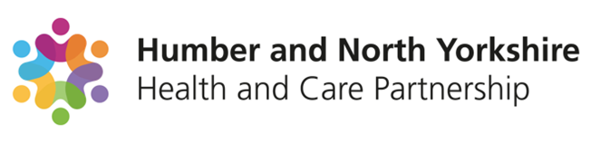

**Humber and North Yorkshire**

**Mental Health, Learning Disability and Autism Inpatient Quality and Safety Three-Year Strategic Plan**

**Contents Page**

1. Background/Context
   1. Key actions for systems
   2. Scope of the programme
   3. Key enablers
2. HNY MHLDA Collaborative
   1. Our Leadership
   2. Our Partners
   3. HNY Patch
   4. Collaborative Plan on a Page
3. HNY MHLDA Programme Governance
   1. Monitoring of the Plan
4. HNY ICB Position
5. SDF & MHIS
6. HNY Context
   1. Humber and North Yorkshire current bed stock
   2. Benchmarking
      1. Adult Mental Health Assessment and Treatment units
      2. PICU
      3. Mental Health Older People’s beds
      4. Rehabilitation
      5. Adult Learning Disability and Autism
7. Independent Sector

7.1 Market Management

1. Our Plan on a Page
2. Quality Assurance
3. Commissioning
4. Out of area Hospital Placements
   1. Out of Area / outside of natural clinical flow definition
   2. Humber and North Yorkshire Out of Area Hospital Placements
5. Focus on Flow and Discharge Planning
6. Urgent and Emergency Care
7. Community Services
8. Reducing Restrictive Interventions

15.1 Update to CQC Notifications

1. Key Lines of Enquiry
2. Housing Strategy
3. Section 117
4. Stakeholder Involvement

19.1 Coproduction & Engagement

1. Outcomes Framework
2. Risks & Mitigations

Workstream Detail.

1. **Background/Context**

NHS England launched a national quality and safety programme for mental health, learning disabilities and autism inpatient settings in 2023, supported by several commissioning and guidance documents. NHS England have asked Integrated Care Boards to co-produce three-year strategic plans to localise services, improve the quality of care and consider different models of care to support this. The diagram below outlines the problem, impact and ask of Systems.

**1.1.** **Key actions for systems**

Alongside co-producing the 3-year strategy, ICB’s must:

* Know where all our people are placed out of area
* Know what it will take to bring them home and to do it
* Think differently about the models of care that are commissioned ensuring they are in line with the new guidance
* Support providers to participate in the Culture of Care programme
* Support the development and implement new early warning signs processes

**1.2. Scope of the programme**

Inpatient services in scope include:

* Adult acute
* Older adult acute
* Rehabilitation
* Learning disabilities and autism

Through the programme, the system will collaborate across several programme areas for example, community mental health and urgent and emergency care to address gaps across the pathway which are impacting on inappropriate or unnecessary inpatient stays.

**Service that are currently out of scope include, secure hospital placements, CAMHs inpatient placements and residential community placements.**

**1.3. Key enablers:**

* Workforce retention and growth
* Quality of estates and environments
* Data and outcomes
* Housing solutions
* Co-production
* Market development

1. **HNY MHLDA Collaborative**

Our collaborative aims to join up services to better support our population with their mental health, learning disabilities and autism needs and make the best use of the resources at our disposal.

We work with colleagues from across all health and social care settings, including the voluntary care and social enterprise sector.

* 1. **Our Leadership**

**Brent Kilmurray**, Chief Executive, Tees, Esk and Wear Valley NHS Foundation Trust; Chair of the Humber and North Yorkshire Health and Care Partnership Mental Health, Learning Disabilities and Autism Collaborative, Humber and North Yorkshire Mental Health and Learning Disability Lead/ICB Board Partner.

**Alison Flack**, Programme Director, Mental Health, Learning Disabilities and Autism Collaborative.

* 1. **Our Partners**

The diagram below showcases the many partners we collaborative with across our programme areas.

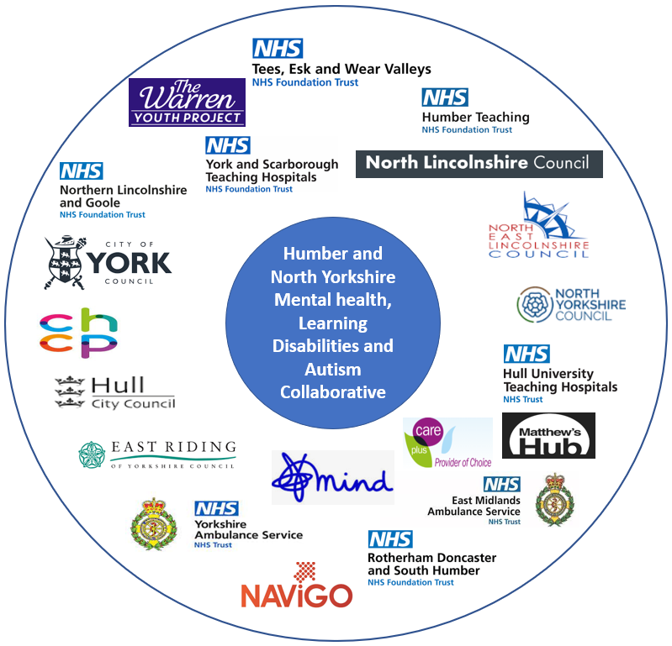

* 1. **HNY Patch**

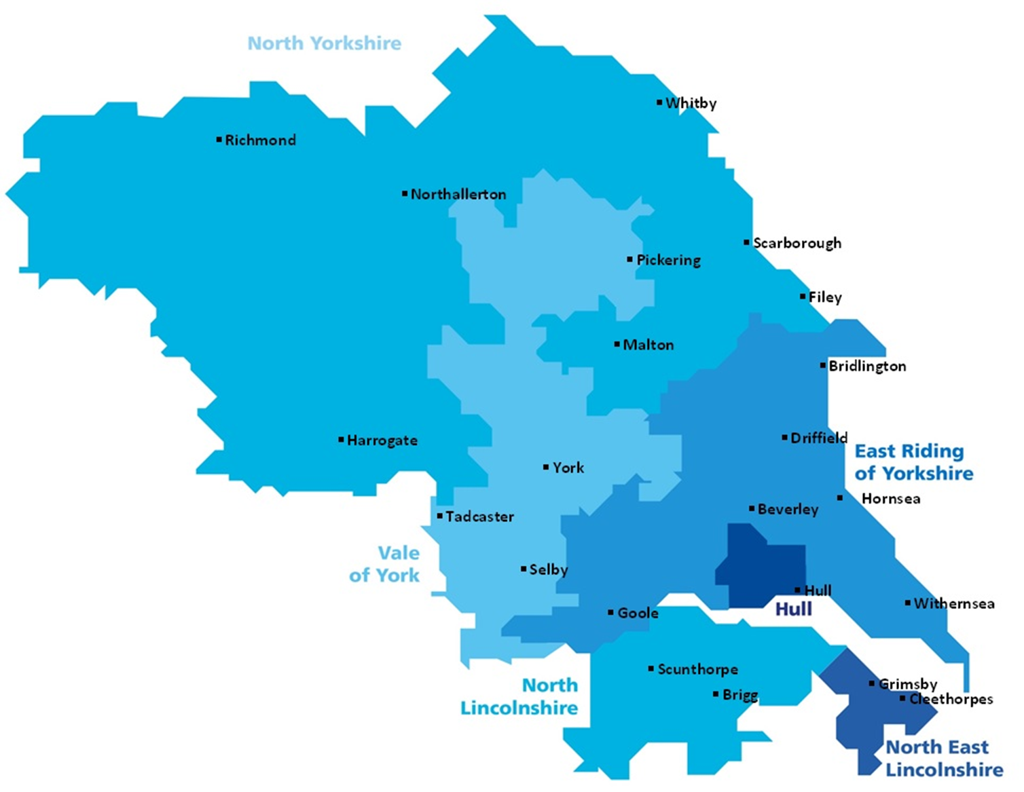

* 1. **Collaborative Plan on a page**

The diagram below outlines the collaboratives plan of a page and the many different programme areas of work underway.

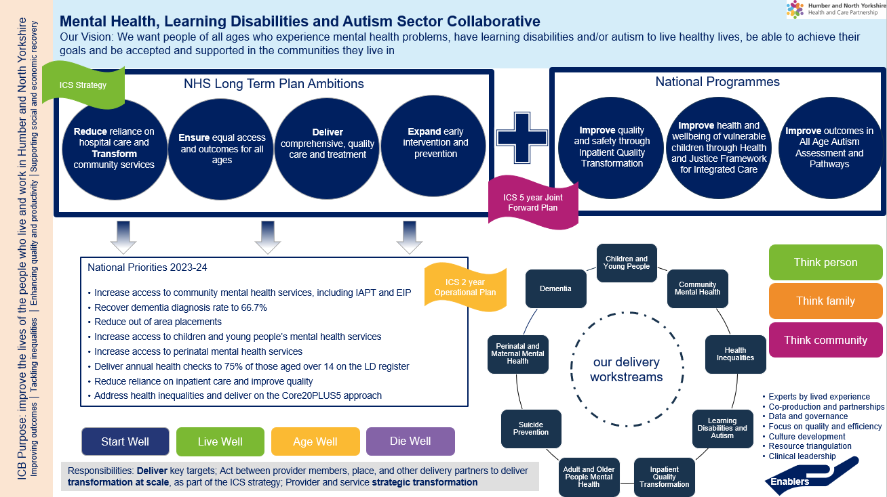

1. **Humber and North Yorkshire Programme Governance**

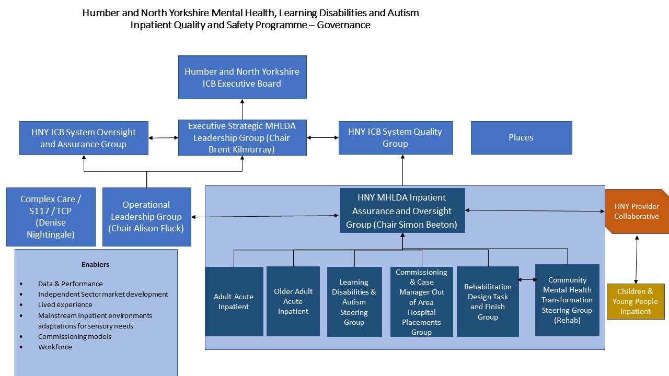

* 1. **Monitoring of the Plan**

Simon Beeton, Chief Executive at NAViGO has been identified as the Senior Responsible Officer (SRO) for the programme. The plan is accompanied by a detailed programme plan maintained by the programme manager within the MHLDA Collaborative. The MHLDA Inpatient Oversight and Assurance Group has responsibility for the implementation and success of this programme of work. The plan will be reviewed and refreshed on an annual basis with all key stakeholders including people with lived experience to ensure it continues to meet the needs of our population and workforce.

1. **Humber and North Yorkshire ICB Position**

The ICB is committed to improving mental health, learning disability and autism services for our population. This led to an independent review undertaken by Carnell Farrell which recommended that out of area placements be prioritised within the ICB, recognising the quality improvement and cost savings potential. A separate independent review undertaken by Grant Thornton for the entirety of the system, also identified out of area placements as one of ten priorities for the system. The ICB is dedicated to improving services, repatriating patients closer to their loved ones and preventing future out of area admissions.

We will respond appropriately to the newly published planning guidance for 24/25 as per the below:

* ‘Improve patient flow and reduce average length of stay in adult acute mental health wards, delivering more timely access to local beds. The mental health discharge challenge identified 10 high impact actions to drive improvements in flow and reduce delayed discharge. We ask systems to focus their improvement resources on those initiatives that will drive the biggest improvements locally.
* Support improvements in the quality and safety of all-age inpatient care, by finalising and publishing system 3-year plans to localise and realign inpatient care in line with the mental health inpatient commissioning framework by June 2024.’ (NHSE 24/25 Planning Guidance)

1. **SDF and MHIS**

Subject to confirmation of national planning guidance, the ICB will continue to meet the MHIS requirements over the next few years. The ICB is targeting a significant reduction in OOA placements and associated costs however, in order to maintain the integrity of the MHIS, it is anticipated that this will need to be offset by redirecting spend into local mental health services. This will be achieved through a combination of reinvesting or redirecting spend into local services.

The ICB Executive Board have supported the reinvestment of uncommitted MHLDA SDF totalling £9.2M over the next 3 years. This includes the £1.1M bundle associated with this programme. This means that by 2026/27 we will be recurrently reinvesting the £1.1M in local mental health services to meet the aims of this plan.

1. **Humber and North Yorkshire Context**
   1. **Humber and North Yorkshire current bed stock**

The table below displays the type and number of beds commissioned across Humber and North Yorkshire.

|  |  |  |  |  |  |  |
| --- | --- | --- | --- | --- | --- | --- |
| **Provider** | **Location** | **Unit** | **Ward** | **Type** | **M/F** | **Number of beds** |
| Navigo | Grimsby |  | Brocklesby Lodge  Hope Court | Rehabilitation |  | 7  13 |
| Grimsby |  | Grimsby Grange and Manor | Older adult acute long stay |  | 12 |
| Grimsby |  | Janine Smith Suite | Older adult acute long stay - **enhanced nursing care and support to individuals with complex needs** |  | 10 |
|  |  | Konar Suite | Older Adult Acute phase of mental health |  | 12 plus 1 non commissioned |
| Grimsby | Harrison House | Meridian Lodge | Adult Acute |  | 11 |
| Grimsby | Harrison House | Pelham Lodge | Adult Acute |  | 11 |
| Humber | Hull |  | Maister Lodge | Older adult - organic | 7 each m/f | 14 |
| Cottingham | Castle Hill | Mill View Lodge | Older adult – functional | Female only | 9 |
| Cottingham | Castle Hill | Mill View Court | Adult MH – ATU | Mixed | 15 |
| Hull |  | New Bridges | Acute | Male | 18 |
| Hull | Inspire (CAMHS) |  | CAMHS general admission and PICU (4 beds) | Mixed | tbc |
| Hull | Miranda House | Avondale | Assessment unit | 7 each m/f | 14 |
| Hull | Miranda House | PICU | Intensive Care Unit | 7 m and 3 f | 10 |
| Hull |  | Westlands | Inpatient assessment and treatment | Female | 18 |
| Hull |  | Townend Court | LD inpatient assessment and treatment |  | 11 but max 7 due to complexity |
| Hull | Townend | Beech | Adult MH rehab | 3m 2f | 5 |
| Hull | Maister Court | Maister court | Older age functional male | male | 5 beds |
| RDaSH | North Lincs Scunthorpe | Great Oaks | Mulberry House | Adult Acute Assessment/Treatment | Mixed | 17 |
| North Lincs Scunthorpe | Great Oaks | Laurel Ward | Assessment/Treatment for Older People with organic and functional Mental Illness | Mixed | 13 |

|  |  |  |  |  |  |  |
| --- | --- | --- | --- | --- | --- | --- |
| TEWV | York | Foss Park Hospital | Minster | AMH | M | 18 |
| York | Foss Park Hospital | Ebor | AMH | F | 18 |
| York | Foss Park Hospital | Moorcroft | MHSOP (functional) | Mixed | 18 |
| York | Foss Park Hospital | Wold View | MHSOP (organic) | Mixed | 18 |
| Scarborough | Cross Lane Hospital, | Danby | AMH | M | 13 |
| Scarborough | Cross Lane Hospital, | Esk | AMH | F | 13 |
| Scarborough | Cross Lane Hospital, | Rowan Lea | MHSOP (mixed) | Mixed | 20 |
| Malton | Malton Community Hospital | Springwood | MHSOP complex care | Mixed | 14 |
| The Orchards, | The Orchards, | The Orchards | Adult (“Type 1”) Rehab | Mixed | 9 |

* 1. **Benchmarking**

Analysis has taken place where possible and linked back to the impact on OOA placements. A summary is included below:

* + 1. **Adult Mental Health Assessment and Treatment units**

All areas are marginally below national benchmark mean in terms of number of beds available, however variation within HNY is relatively low. The data suggests that North Yorks are not requiring OOA placements for this bed type, however further review of the data is required.

|  |  |  |  |  |
| --- | --- | --- | --- | --- |
| **AMH Assessment & Treatment** | **NEL** | **NL** | **Hull/ER** | **NYY** |
| **Beds** | 22 | 17 | 65 | 62 |
| **Weighted 18-64 population** | 118,074 | 119,460 | 377,623 | 433,172 |
| **Beds per 100,000 weighted population** | 18.63 | 14.23 | 17.21 | 14.31 |

*National benchmark mean is 22.69, therefore all areas are in the lower quartile.

* + 1. **PICU**

The local provision is varied, and the data suggests that the Humber 4 are mostly impacted by this and requiring OOA placements. North Yorkshire and York are not requiring PICU OOA placements. Gender split is also impacting upon available beds within the Hull/ER provision. National data suggests that Humber have the highest rates of emergency readmissions within 30 days at 18% compared to rest of NEY.

Partnership working between Lincolnshire NHS Foundation Trust and Humber NHS Teaching Foundation Trust is being discussed to deliver single gender PICU provision for the wider patch.

|  |  |  |  |  |
| --- | --- | --- | --- | --- |
| **AMH Rehab** | **NEL** | **NL** | **Hull/ER** | **NYY** |
| **Beds** | 0 | 0 | 10 | 0 |
| **Weighted 18-64 population** | 118,074 | 119,460 | 377,623 | 433,172 |
| **Beds per 100,000 weighted population** | 00.00 | 0.00 | 2.65 | 0.00 |

* + 1. **Mental Health Older People’s beds**

Large variation within HNY with some Places commissioning more than double the number of beds by weighted population. Further review of whether this variation is warranted or unwarranted is recommended with evaluation on which alternative models offer best value for money and particularly high bed availability in NEL. East Riding and Hull patients are mainly affected by this and are requiring higher number of OOA placements.

|  |  |  |  |  |
| --- | --- | --- | --- | --- |
| **MHSOP (all A&T beds)** | **NEL** | **NL** | **Hull/ER** | **NYY** |
| **Functional bed** | 24 (mixed) | 13 (mixed) | 14 |  |
| **Organic beds** | 14 |  |
| **Weighted 65+ population** | 44,172 | 53,022 | 165,914 | 210,365 |
| **Beds per 100,000 weighted population** | 52.07 | 24.52 | 16.88 | 26.62 |

*National mean 27.26 – NEL are commissioning nearly double this number of beds whilst Hull/ER are significantly below.

**NEL also have 10 older adult e**nhanced nursing care and support to individuals with complex needs commissioned via social care. Scoping work will take place to understand the social care capacity across the rest of the Places.**

* + 1. **Rehabilitation**

There are low numbers of beds available within HNY with large variation in all types of rehabilitation provision across the patch. This is clearly impacting on bed use, OOA making up 50% of placements and at least 55% of overall spend.

It is unclear which of the NHS and independent sector providers comply with the recently published guidance which describes two levels of rehab inpatient services that should be available locally. No ‘long term’, ‘continuing care’ or ‘home by default’ language/terminology for units/placements should be used.

There are currently patients admitted to at least 15 wards that describe themselves as a type of rehab placement that should not be supported. A full review of current provision, value for money, quality, compliance with guidance, and develop costed models to meet gaps based on HNY needs will be undertaken.

NEL are the only area not using OOA rehabilitation beds. This is due to the community model implemented a number of years ago which allows individuals to be supported within the community, either at home or within a rehabilitation house/self-contained flat.

|  |  |  |  |  |
| --- | --- | --- | --- | --- |
| **AMH Rehab** | **NEL** | **NL** | **Hull/ER** | **NYY** |
| **Beds** | 13 | 0 | 5 | 0 |
| **Weighted 18-64 population** | 118,074 | 119,460 | 377,623 | 433,172 |
| **Beds per 100,000 weighted population** | 11.01 | 0.00 | 1.32 | 0.00 |

* + 1. **Adult Learning Disability and Autism**

The national TCP programme has led to significant bed reductions in recent years. Only Hull/ER have commissioned LDA beds within the HNY footprint with difficulties in utilising the full capacity of the unit due to complexities within the current patient group and the available provision not meeting need.

|  |  |  |  |  |
| --- | --- | --- | --- | --- |
| **A&T beds – adult LD** | **NEL** | **NL** | **Hull/ER** | **NYY** |
| **Beds** | 0 | 0 | 11 | 0 |
| **Weighted 18-64 population** | 118,074 | 119,460 | 377,623 | 433,172 |
| **Beds per 100,000 weighted population** | 00.00 | 0.00 | 2.54 | 0.00 |

1. **Independent Sector**

The spreadsheet embedded below identifies the independent sector beds located within the Humber and North Yorkshire footprint to be added.

A snapshot analysis from February 2024 identified that HNY were occupying 10% of the beds available on the patch.



* 1. **Market Management**

There are wide variations in provision provided by the independent sector, how the provision is accessed, care packages and costs associated with them. In HNY we will undertake a market management piece to undertake the following:

* Build effective relationships,
* Review service offers in line with the commissioning framework and quality standards,
* Cease use of spot contracts by commissioning services, monitoring outcomes, and negotiating fair and consistent pricing
* Extend workforce training and development opportunities to the staff

.

1. **Our Plan on a Page**

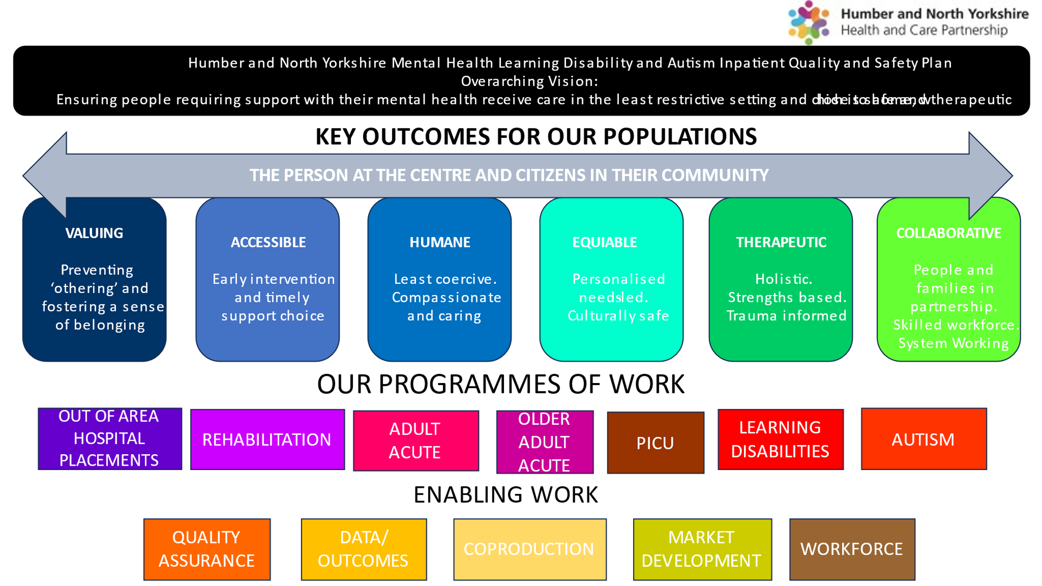

1. **Quality Assurance**

The work outlined in this plan will be underpinned by quality and safety. We will do this by developing a Quality Framework in-line with the National Case Management Standing Operating Procedure.

We will ensure the system participates in the development of the national Early Warning Signs programme and implementation.

Analysis has been undertaken on the latest CQC reports for each independent sector provider where we have patients placed which is included below. However, many providers have not been inspected for some time – this raises concerns where there have been ratings of ‘requires improvement’.

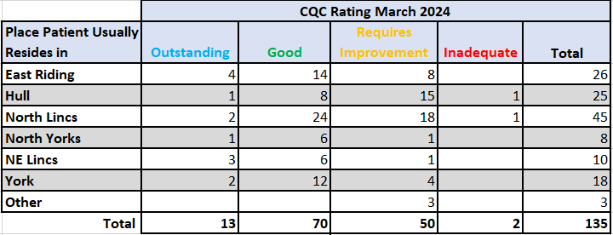

The table below shows the lengths of stay by placement type which again raises concerns with regards to quality. Deep dives are taking place to understand the position, understand what patients require and work to reduce lengths of stay overall significantly.

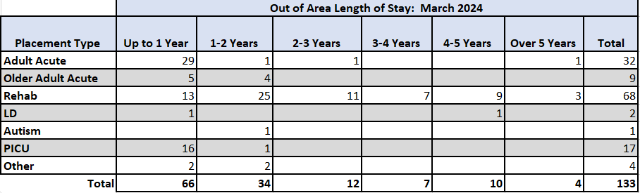

We acknowledge that the lengths of stay for many of the patients included above are not acceptable, particularly for those in rehabilitation placements. We commit to repatriating patients safely into their local communities.

We have also implemented a central spreadsheet for the collection and sharing of provider concerns, shared intelligence and where required the decision- making process when placing in one of these providers, as well as oversight actions to take place to ensure patients are safe. The NHS England regional mental health team are keen to adopt this approach across the North East and Yorkshire region for sharing on a broader footprint.

1. **Commissioning**

The way in which we commission placements differs from Place to Place, with some areas having a section 75 agreement in place with the local mental health provider for parts of the pathway.

We are developing a proposal to establish a host provider to centralise commissioning and quality oversight for all Humber and North Yorkshire Out of Area Hospital Placements. This will improve the oversight and use of financial resources and will work as a system to ensure savings are be reinvested into local mental health services. This will also allow sharing of clinical oversight and assurance in line with the Quality Framework referenced earlier, improving patient experience and outcomes.

We will commit to ceasing the use of spot contracts in time to support improved oversight and quality of care as evidence shows that use of spot contracts increases risk of closed cultures and poorer outcomes.

1. **Out of area Hospital Placements**
   1. **Out of Area / outside of natural clinical flow definition**

As a system we will be adopting the national definitions for ‘out of area’ or ‘outside of natural clinical flow’ as outlined below:

* If there is a commissioned service for the population and someone accesses a bed outside of their usual place of residence, this **would** then be classed as inappropriate.
* However, if there is not a commissioned service and the patient is then placed in the closest facility which provides this service, this **would not** be inappropriate, and would be with within ‘natural clinical flow’.
* If the patient cannot be placed in the closest unit providing the required service, for example due to capacity issues, and the patient is placed further afield, this **would** also be classed as inappropriate.
* If the bed is not commissioned, or there is not a contract in place with another provider to deliver the service, the patient must be placed in the nearest provision that provides it. This is to enable continuity of care principles to be adhered to, i.e. care managers can still visit the patient and records can be accessed.
  1. **Humber and North Yorkshire Out of Area Hospital Placements**

Repatriating patients and ceasing inappropriate out of area hospital placements is a key priority for the ICB.

To gain a comprehensive understanding of where all HNY’s people are placed outside of the HNY area, or within an independent provider within area, a central data collection process has been implemented which allows us to see placements type, lengths of stay, protected characteristics, and cost amongst other things. This is now being collected monthly (from December 2023) which feeds a system wide dashboard to support us in understanding the trends, and more importantly to support us to see where targeted effort is required to repatriate patients and develop local services to cease further out of area placements.

The latest activity information is included below. The data is showing that the number of people being admitted is increasing, as are the lengths of stay and overall spend.

The data is showing that the numbers overall are increasing both in terms of number of patients OOA and lengths of stay.

As of May 2024 there are 152 patients placed either out of area or outside of natural clinical flow, split by placement type in the chart below.

50% of the overall placements are within a ‘rehabilitation’ placement type and all placed with an independent sector provider with an average length of stay of 2.5 years and longest length of stay 7.5 years.

Placements are located around the country including Leeds, Northhampton, East Midlands, Kent, Leicester, Cambridge which clearly hinders recovery and connection to their community and loved ones.

We know there are people who are clinically ready for discharge within our local wards, creating increased pressure on pathways resulting in unnecessary out of area placements.

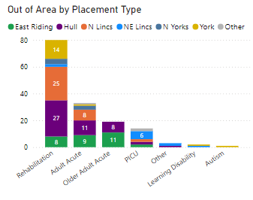

Overall, as of May 2024, there are 22 patients with a learning disability or who are autistic represented across all the above placement types and therefore are under the remit of the Transforming Care Programme who are closely linked to this work and plans moving forward.

The graphs below give an estimate of spend across Place and Placement Type. However, caution should be noted due to gaps in some spend which we are working to understand.

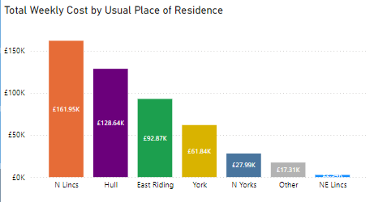

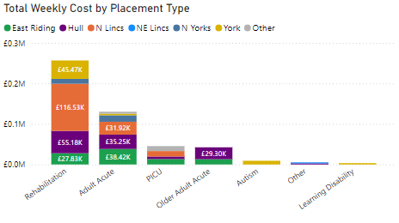

1. **Focus on Flow and Discharge Planning**

We will maintain a key focus on patient flow and discharge planning across the whole system and via each workstream outlined by implementing the 10 high impact discharge initiatives shown below to reduce bed days, CRFD, re-admissions and patient outcomes.

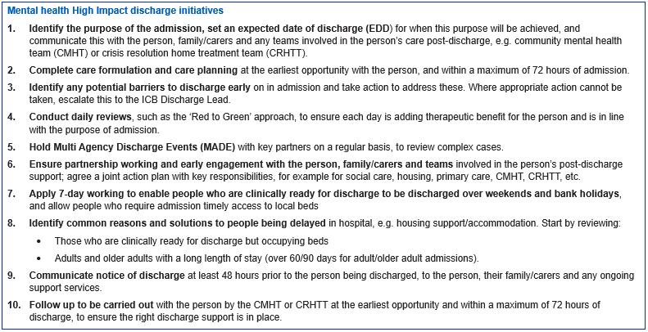

.

1. **Urgent and Emergency Care**

The extract below shows the percentage of CRFD in each provider (not by place).

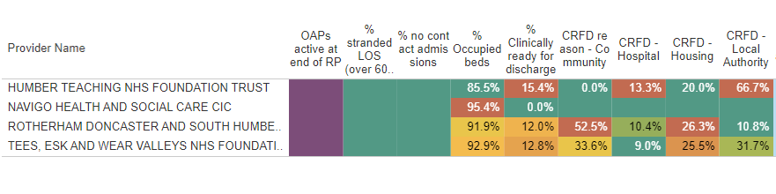National data shows that as a HNY system in March 2024, 9% of people within beds locally were medically fit for discharge.

There are variances across HNY in terms of Community Mental Health and Urgent and Emergency Care Provision. These variances and gaps in services within the community are impacting upon inpatient lengths of stay and out of area placements.

A benchmarking of the current crisis alternatives across HNY (which can be found below) has highlighted unwarranted variation in provision. There is a correlation between the number of emergency department mental health attendances and the crisis provision with areas that have greater access having lower attendances. Further analysis based on population need will help inform the reduction in variation across the system and improve access.



* Mental health related ED attendances – 2.7% (per 100,000 population >18)
* Mental health attendances spending more than 12 hours in the department – 24%
* Out of all 12 hour waits in the department, 4% were mental health related
* National data shows that HNY have the second highest proportion of admissions with no previous contact at 16%.
* National data is also showing that bed occupancy across HNY in April 2024 is 91%

1. **Community Services**

A summary of the 2023 national benchmarking report is included below:

* Referrals to CMHT – NL 4th lowest in the Country. All six areas are below the national mean
* Acceptance to CMHT – NL lowest in the region, NEL also below national mean. Hull/ER and NYY are all above the national mean
* Caseloads for CMHT – all regional caseloads below national mean, particularly NL, NEL and HFT slightly below too
* Contacts in CMHT – NL 5th lowest in the country and lowest in the region
* Total staff in CMHT – NEL highest in the region, with both NEL and Hull/ER higher than national mean. NYY lowest in the region and 3rd lowest in the country. NL just below national mean
* High bank/agency spend in Hull/ER and NL
* Hull/ER have highest rates of adult acute admissions in the country, NYY are 2nd, NEL 5th, NL 11th – all of which are above the national mean.

The differing services available, staffing, caseloads and potential criteria to services is creating inequities across HNY for our population.

1. **Reducing Restrictive Interventions**

A number of our providers have developed local level RRI dashboards to monitor RRI and hot spots in terms of ward, time of day and types of RRI (for example chemical restraint, physical restraint, seclusion and long- term segregation – including ‘care away from others’).

Where providers don’t have a local dashboard, we will work to support them to develop this.

Providers are implementing local plans to reduce use of RRI and it is part of the outcomes framework included in this plan to monitor as a system.

* 1. **Update to CQC Notifications**

We will Providers to implement the following requirement following the live consultation: ‘Providers registered with CQC who operate mental health units are required to notify CQC within 72 hours so far as reasonably practicable when they use any of the following forms of restrictive practice: physical, mechanical chemical restraint, and isolation (which includes seclusion and segregation), as defined in the [Mental Health Units (Use of Force) Act 2018](https://www.legislation.gov.uk/ukpga/2018/27/enacted).’

1. **Key Lines of Enquiry**

Each of the main providers with Place ICB support within HNY have self-assessed against the 49 Key Lines Of Enquiry (KLOE) published by NHS England to provide a baseline. The graph below demonstrates the overall baseline position as of June 2024 for the system.

This will be repeated on an annual basis to monitor impact of the plan on the key outcomes.

1. **Housing Strategy**

Local Place housing strategies to be developed based on key overarching principles developed by the collective system. This is to take into account local nuances and different system set ups. The local strategies will be co-produced with the local population, ensuring differing demographics in each area are factored in.

1. **Section 117**

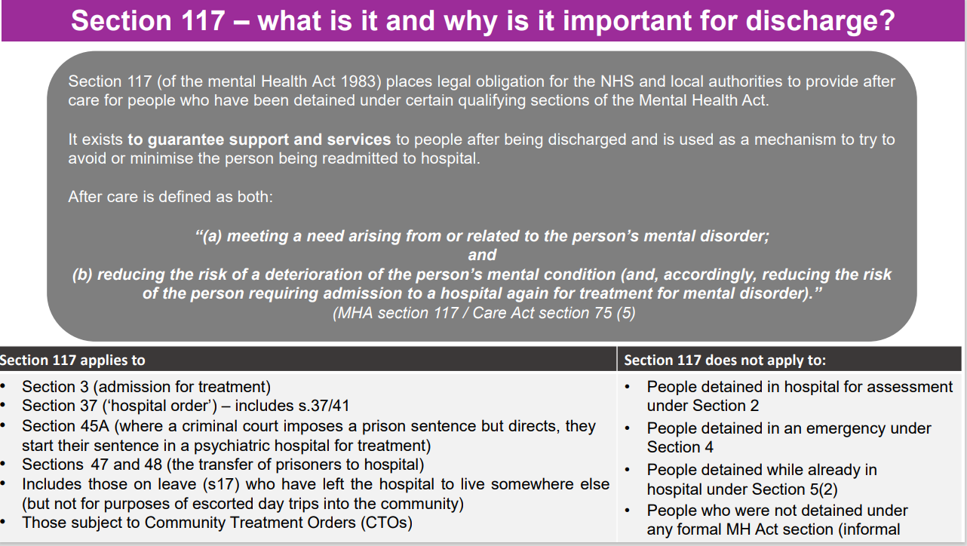

The Out of Area dashboard shows that 77% of patients are entitled to section 117 aftercare, therefore a seamless and consistent pathway across the system will be implemented using to ensure 117 aftercare planning is picked up as part of discharge planning at the point of admission in accordance with the mental health high impact discharge initiatives.

1. **Stakeholder Involvement**

In order to make the plan a success, many stakeholders have been engaged in the programme from the beginning. This includes Place leads & Directors, mental health providers, the ICB Executives, the Nursing and Quality Directorate and people with lived experience. Directors of adult social care, housing directors, housing providers and VCSE organisations are also involved in the planning.

A number of workshops have taken place including a full day face to face event in April 2024 with more than 70 people in attendance, with good representation from each local system, people with lived experience and representation from the regional and national NHS England Team. Breakout sessions took place to build up plans which are reflected within this document.

* 1. **Coproduction and Engagement**

We recognise the importance and significance of working collaboratively to make real change, which can not be achieved without also working collaboratively with people with lived experience and their loved ones.

People with lived experience will continue to have the choice to be involved through the local provider coproduction groups which will feed up into a system wide group held with the programme manager and the coproduction leads from each provider. This is to prevent duplication, maximise the expertise that we have at a local level but whilst supporting shared learning and opportunities to work together where it makes sense.

The KLOE’s were amended with someone with lived experience and the coproduction leads and turned into a survey to be completed by people with lived experience and their loved ones through local coproduction groups, people currently staying on local mental health wards and through HealthWatch. Results of this survey will be considered as part of the on-going work.

Providers lead their own engagement and coproduction work as referenced earlier, including HFT distributing an inpatient mental health survey. The latest results can be found below:



1. **Outcomes Framework**

The framework below outlines what we will measure as a system to understand the impact of the plan against the six key national outcomes for the programme. There will be further work to define and refine the framework.

|  |  |
| --- | --- |
| **What** | **How** |
| **Outcome One Valuing – preventing ‘othering’ and fostering a sense of belonging** | |
| Num OOA by placement type  Num of re-admissions  Patient & family feedback | OOA Dashboard  MADE events |
| **Outcome Two Accessible – early intervention and timely support, and Choice** | |
| Num of OOA  Num of planned admissions  Num placed in an inappropriate bed (in or out of area)  Use of none ‘approved’ beds/providers  Live bed stock utilisation | OOA dashboard  Provider/commissioner reporting  OOA data/Provider reporting  Patient & family feedback  Provider reporting |
|  |  |
| **Outcome Three Humane – least coercive, compassionate, and caring** | |
| Restrictive practices including chemical & physical restraint, seclusion and CAFO  Length of stay  Num and length of CRFD  Patient and family feedback | Provider/Commissioner reporting |
| **Outcome Four Equitable – personalised, needs led, culturally safe** | |
| Purposeful admission  LDA admissions to general MH wards  Patient involved in care planning  rapid discharge planning | Patient and family feedback  Provider/Commissioner reporting  ? |
| **Outcome Five Therapeutic – holistic, strengths based, trauma informed** | |
| Therapeutic interventions offered  Strength based activities offered | Provider reporting  Quality assurance  Patient and family feedback |
| **Outcome Six Collaborative – People and families in partnership, skilled workforce, system working** | |
| Patient and family involved in care & discharge planning  Shared professional responsibility  Therapeutic skills / training gaps  Vacancies | Provider reporting |

1. **Risks and mitigations**

The programme holds a comprehensive risk register and mitigations which can be found below.



Additional risks will be added by workstream as we move through the programme.

|  |  |  |  |
| --- | --- | --- | --- |
| **Workstream One – Out of Area / Outside of Natural Clinical Flow Hospital Placements**  **Vision – To cease inappropriate Out of Area / Outside of natural clinical flow hospital placements, improve flow within the system inpatient provision, and to improve quality and outcomes for patients.**  **Local Context – High variation in beds available, high OOA usage, lengths of stay, complex commissioning arrangements in place in some areas and high spend** | | | |
| **Key Milestone** | **Output** | **Responsible** | **Deadline** | |
| Gather information on where all our people are placed out of area | Full understanding of patient need, quality oversight and spend | MHLDA Collab | **Ongoing monthly** | |
| Dashboard developed | To support oversight of patients, spend, trends and plans | MHLDA Collab | **Ongoing monthly** | |
| Implement system wide MADE events to retain focus, improve escalation and share learning | Support pro-active discharge planning, reduce bed days, shared learning | MHLDA Collab | **Q3 2024** | |
| Proposal to be developed to establish central commissioning and quality function | Improved utilisation of system bed provision, redirection to appropriate services in area, improved tracking of spend, reinvestment into mental health services | Humber NHS Teaching Foundation Trust with partners | **July 2024** | |
| Establish detailed plans for repatriation of current OOA patients | Improved outcomes for patients, better use of finances – support strategic direction of future models of care | Place/Providers | **Q3 2024** | |
| Local housing strategies in place | More appropriate housing available to support speedy repatriation, reduce delays in CRFD, improved patient outcomes | Place Directors / DAS’s | **Q2 2024** | |
| Quality Framework in-line with National SOP developed and implemented | Consistent and robust quality oversight, improved patient experience and outcomes | MHLDA Collab with Nursing Directorate | **Q2 2024** | |
| Adopt the High Impact Discharge Initiatives | Improve patient flow and outcomes | Place/Providers | **Q3 2024** | |
| Independent sector Market Management | Reduce variation, maximise local capacity, improve quality and spend | MHLDA Collab | **Q4 2024** | |

|  |  |  |  |  |  |  |  |  |  |
| --- | --- | --- | --- | --- | --- | --- | --- | --- | --- |
| **Workstream Two – Rehabilitation**  **Vision - Services will be commissioned so that everyone who presents with a mental health rehabilitation need will be able to access the appropriate inpatient/community provision locally.**  **To improve patient outcomes by maximising their independence in the community through optimising the structure of the inpatient and community mental health rehabilitation pathways.**  **Local Context -** There are low numbers of beds available within HNY with large variation in all types of rehabilitation provision across the patch. This is clearly impacting on bed use OOA making up more than 50% of placements and at least 55% of overall spend.  It is unclear which of the NHS and independent sector providers comply with the recently published guidance which describes two levels of rehab inpatient services that should be available locally. No ‘long term’, ‘continuing care’ or ‘home by default’ “locked rehabilitation” language/terminology for units/placements should be used.  There are currently patients admitted to at least 15 wards that describe themselves as a type of rehab placement. A full review of local provision, independent sector provision to ascertain value for money, quality & compliance with guidance.  It is recognised that the needs of the people remaining in out-of-area rehabilitation placements may not immediately be met by existing local community services. Therefore, we will work with local providers to develop costed models to meet the gaps based on HNY needs, including learning from other national models which has resulted in zero Rehab OOA placements. | | | | | | | | | |
| **Key Milestone** | | **Output** | | **Responsible Lead** | **Timeframe** | | | | | |
| Gather information on patients OOA in a rehab placement | | Full understanding of patient need, quality oversight and spend | | MHLDA Collab | **Will continue to be collected monthly** | | | | | |
| Receive the last case manager review report & CPA on each person in MH rehabilitation OOA bed. | | Quality oversight of each person in an OOA bed. | | MHLDA Collab via HNY ICB case managers department. | **Q2 2024** | | | | | |
| Scoping of all HNY place based MH rehabilitation pathways, strategies & transformation plans. | | Review the current provision against the National Commissioner Guidance for adult MH Rehab inpatient services. | | MHLDA Collab | **Q3 2024** | | | | | |
| Agree a collective definition of ‘rehabilitation’ | | Shared understanding and vocabulary of Rehabilitation | | MHLDA Collab | **April 2024 – completed, national definition will be used.** | | | | | |
| Dedicated clinical assembly across HNY – Mental health rehabilitation led by RCP rehabilitation lead. | | Targeted clinical assembly to create specialist interest focus. | | MHLDA Collab | **June 2024** | | | | | |
| Establish specialist interest group across HNY with key terms of reference | | Local place/provider/lived experience/carer leadership of rehabilitation programme. | | MHLDA Collab | **Q2 24/25** | | | | | |
| Local Place/providers to Review current housing provision | | Future proof housing options to support timely discharge from hospital to provide targeted supportive housing intervention.  Joint strategic needs assessment. | | MHLDA Collab / Joint with complex care directorate / Local Authorities /housing associations/VCSE. | **Q3 24/25** | | | | | |
| Local Place/providers to Review current intensive/assertive outreach models. (Intensive, assertive and comprehensive service to individuals with complex, severe and enduring mental health difficulties) | | NHSE requesting feedback on AOT provision. | | MHLDA Collab | **Q3 24/25** | | | | | |
| Engagement & Co-production on models of care. | | People with lived experience and their loved one’s co-produce models of care | | MHLDA Collab and provider partners  (Strategic co production group & via Specialist interest group) | **On-going** | | | | | |
| Scope other mental health rehabilitation models used within the country and best practice, outcomes of these models. | | Elements of best practice/innovation and outcomes. | | MHLDA Collab | **Q3 24/25** | | | | | |
| **Workstream Three – Adult Mental Health Assessment and Treatment units / PICU**  **Vision – To ensure that individuals are supported at the earliest stage, resulting in fewer admissions, reducing lengths of stay required and reducing OOA placements.**  **Local Context – Adult Mental Health Assessment and Treatment units / PICU** –For Adult Mental Health Assessment and Treatment units all places are marginally below national benchmark mean in terms of number of beds available, however variation within HNY relatively low. For PICU beds, the local provision is varied, and the data suggests that NEL and NY patients are mostly impacted by this and requiring OOA placements.  **PICU** – the local provision is varied which is impacting on OOA placements. National data suggests that Humber FT have the highest rates of emergency readmissions within 30 days at 18% compared to rest of NEY. | | | | | | | |
| **Key Milestone** | | **Output** | | **Responsible** | | | **Deadline** | |
| Gather information on patients OOA in an acute placement | | Full understanding of patient need, quality oversight and spend | | MHLDA Collab | | | **Will continue to be collected monthly** | |
| Review data against local crisis alternatives | | Understanding of potential lack of crisis alternatives in the community resulting in higher use of inpatient beds | | MHLDA Collab | | | **June 2024** | |
| Engagement & Co-production on potential solutions/models of care | | People with lived experience and their loved one’s co-produce models of care | | MHLDA Collab and provider partners | | | **On-going** | |
| Explore shared provision across the system/cross system | | Split of provision by gender to enable full bed capacity to be utilised | | All | | | **Q4 2024** | |
| Develop same sex PICU provision across the Humber 4 and Lincolnshire system – working collectively with Lincolnshire, Humber FT, Navigo and Rdash | | Maximised bed use for presenting need – fewer OOA PICU beds used. | | Providers | | | **2024/25** | |
|  | |  | |  | | |  | |
| **Workstream Four – Older Adult Acute**  **Vision – For care to be available as close to home as possible with the shortest lengths of stay as possible.**  **Local Context –** There islarge variation within HNY with some Places commissioning more than double the number of beds by weighted population, with particularly high bed numbers available in NEL. Further review of whether this variation is warranted or unwarranted to be undertaken with evaluation on which alternative models offer the best quality/ value for money. Hull and East Riding patients are mainly affected by this and are requiring higher number of OOA placements.  Engagements across HNY has identified a number of key themes relating to older adult mental health:   * A need for greater focus on prevention and early intervention. * A need for needs-led services rather than age-led services. * Making every contact count – a need to maximise opportunities across HNY to promote ageing well. * A need to improve collaboration across community, primary, secondary and specialist care. * Wide scale variation in access to support and services across HNY.   There is a changing demographic across HNY which is likely to continue to change over coming years. Consideration needs to be given to changes in local need including: local demographics/needs/priorities, Functional vs organic, male/female/mixed sex wards and LGBTQ+ needs, cultural differences, language differences, age-appropriate care, diagnosis (Autism, LD, Complex Emotional Needs, and Young onset dementia.) Anecdotally, Hull is an outlier for Huntington’s Disease with higher prevalence than other areas. | | | | | | | |
| **Key Milestone** | **Output** | | **Responsible** | | | **Deadline** | | |
| Gather information on patients OOA in an acute placement | Full understanding of patient need, quality oversight and spend | | MHLDA Collab | | | **Ongoing-monthly** | | |
| Full review of all HNY Older adult provision against the National Commissioner Guidance for older adult inpatient services | Report outlining gaps in provision, plans and recommending next steps | | MHLDA Collab | | | **Q2 2024** | | |
| Scoping of existing engagement and coproduction groups across HNY and ensuring they are given the opportunity to be involved in the programme. | Share understanding of existing groups and wider public engagement. | | MHLDA Collab and programme partners | | | **Ongoing** | | |
| Engagement & Co-production on potential solutions/models of care | People with lived experience and their loved one’s co-produce models of care | | MHLDA Collab and programme partners | | | **On-going** | | |
| Scoping of current in and out of hospital provision currently and predictive modelling for future demand/prevalence taking into account the changing needs and demographics of our population. | Full oversight of current provision and plans to future proof services. Future prevalence modelling to inform longer term planning. | | MHLDA Collab and programme partners | | | **Baseline by March 2025** | | |
| Community asset mapping:  Assets: Maximise use of VCSE, make sure everyone knows what is available and how it can be accessed. Better use of VSCE and building bigger more diverse volunteer network. E.g. use of volunteers to do regular check-in calls based on the Dementia Forward model in NY. | Prevention focussed model to reduce the need for inpatient admission and support safe and timely discharge. | | MHLDA Collab and programme partners | | | **On-going** | | |
| Education and training needs analysis across all health and care settings (in line with the HNY Dementia strategy) – focussed on older adult mental health. | Full understanding of the current training offer to inform training plans. | | MHLDA Collab and programme partners | | | **Q4 2024** | | |
| Develop community champions in local areas reflective of the diversity across HNY i.e. Eastern European communities, Indian communities, LGBTQ+, coastal and rural, neurodiverse. | Ensure inclusive and equitable offer to all | | MHLDA Collab and programme partners | | | **Q4 2024** | | |
| Local costed plans developed in line with the system specification. | Local plans developed to meet the needs of local populations | | Place/Providers | | | **2024-25 – staggered approach** | | |
| HFT – developing model to provide 4 additional male functional beds locally | Repatriation of individuals and prevention of further admissions | | HFT | | | **Q4 2024** | | |
| Develop an Older Adult Acute MH steering group to lead and monitor the above actions. | Regular review of progress towards actions. | | MHLDA Collab | | | **To commence July/Aug 24** | | |

|  |  |  |  |
| --- | --- | --- | --- |
| **Workstream Five – Learning Disability Assessment and Treatment Services**  **Vision –** To improve the quality of current inpatient facilities and offering services closer to home, whilst establishing services that can be delivered through community-based care, reducing the reliance on inpatient admissions and robust community involvement throughout inpatient admission. A transformation that is leading improvement through greater accountability and citizen involvement.  **Local Context – Summary**   * Across the ICB footprint individuals with a Learning Disability, who require inpatient care and treatment, have been placed in inpatients services far from home and their natural communities. This is due to the lack of availability of suitable local assessment and treatment services. * Some of these individuals have also been cared for in facilities far from home and in some cases, beyond the clinically necessary time due to lack of local community resources needed for appropriate discharge planning closer to home. * Additionally, many of these individuals have a reduced access to the necessary community support while in hospital. * The capacity at Townend Court, a locally based Assessment & Treatment service in Hull, is currently providing care to a reduced number of patients due to the complexity of their clinical presentations. For some time, Townend Court has provided care and treatment for a total 3 patients, who have required adjusted makeshift environments and an increase in staffing numbers. This reduction of locally available resources has resulted in patients being placed out of area. * York has no locally based service following the closure of their Assessment and Treatment Unit. * Along with personal disruption to lives of individuals and their families, there is an additional financial impact as commissioning placements out of area can be expensive to the ICB, which could prevent investment in services close to home. * New plans going forward will need to take account of improving accommodation and creating safe environments to support those individuals with acute clinical presentations. * Services will need to be autism informed to meet the care and support required by people who have a learning disability, who may also be autistic or otherwise neurodiverse. * Across the wider Humber and North Yorkshire ICB there are conversations being had about how the re-configuration of learning disability inpatient beds can provide a more quality focused and cost-effective model than its predecessor. * A working group will be established to bring partners together to review the transformation of inpatient and community based services. * Working together to develop a modernised inpatient facility that considers the unique needs of individuals requiring treatment during times of extreme distress is recognised by commissioners as a priority. * The six places within the ICB footprint have highlighted the pressures of young people (those under 18) within their areas who may in the future need to access inpatient services. * The pathways within the inpatient services will be integral directly to local based community services to prevent admissions providing intensive community-based support. * Where an admission is required for the very unwell the care plans should reflect short stays and positive early discharges. | | | |
| **Key Milestone** | **KPI** | **Responsible** | **Deadline** | |
| Establish a Focus Group to take forward the discussions on a collaborative approach across the ICB on the Quality transformation of inpatient services. | Review how inpatient care and enhanced community services could develop a more localised whole system approach to learning disability and autism service transformation. | MHLDA Collab  Place Leads | July 2024 – group  Jan 2024 - review | |
| Gather up to date information on patients OOA in assessment and treatment services and establish a regular route of this information into the MH&LDA sector collaborative. | Understand the needs of our patients to support mapping a more appropriate provision/s. | MHLDA Collab | Jul 2024 | |
| Undertake bed modelling in (places where it not already underway) and offer support to those already underway. To scope number of inpatient beds required across ICB. | To determine a safe number of specialised beds to support the unwell when hospital-based treatment is required. | MHLDA Collab  Place Leads | Aug 2024 | |
| Scope the current services and gaps across the ICB including local inpatient and community-based support. | Identify what’s working well with a view to share good practice, including reasonable adjustment practices.  Identify areas for development including increasing day activities, respite, safe space (crisis pad) and home-based treatment opportunities and options. | Place Leads  ICB Nursing and Quality Directorate | Nov 2024 | |
| Establish an overall Learning Disability and Autism Co-production group alongside staff teams and external stakeholder. | To ensure voices are heard on new models of care and any reshaping is fit for purpose. This will prevent ‘othering’ and fostering a sense of belonging for people with learning disabilities and autism in creating holistic, strengths based, trauma informed services inclusive of inpatient care. | MH, LD&A  Place Leads | Feb 2025 | |
| Have an overview and check the effectiveness of Dynamic support registers in highlighting the risk of community placement breakdown. | Ensure each place has engaged in development of proactive tracking of high-risk patients. | MHLDA Collab  ICB Nursing and Quality Directorate | Oct 2024 | |
| Review across the ICB the current community focussed care services that are underway to reduce a need for hospital admissions. | To understand the progress of community based intensive support available to reduce the risk of placement breakdown. | MHLD Collab  ICB Nursing and Quality Directorate | Feb 2025 | |
| Promote Culture of Care National Programme participation for local provider | Participation of local NHS and Independent providers in the National Culture of Care programme | MHLDA Collab | Apr 2024 | |
| Monitor the use of restrictive practice within services | Check services have care plans in place to reduce the inappropriate use of restrictive practices.  Ensure restrictive practices are at a minimal level, utilising alternative methods of de-escalation, enhancing early intervention to reduce risk of escalation | MHLDA Collab  Provider Leads | November 2024 | |
| Workforce Planning and review of new ways of working across Health and Social Care to develop an integrated approach to care delivery particularly for people with high support needs. | To seek a collaborative model of care delivery where health and social care can work in partnership to support individual people with longer term high support needs. | MHLDA Collab  Place Leads | May 2026 | |
| Expand on current provision of therapeutic provisions, ensuring we meet the needs of our population. | To have a wide range of individual and group psychological / therapeutic services for persons with learning disabilities that is personalised, needs led, culturally safe; pre, during and post hospital stay and have the workforce in place to do so. | MHLDA Collab  Place Leads | Jan 2026 | |
| Co-production group review and amend policy and procedure to inform practice, learning from others | Invite people with lived experience to be included in the development of transformation plans from the onset. Continue to seek their views throughout the programme through meaningful engagement opportunities. | MHLDA Collab  Place Leads | Nov 2024 | |

|  |  |  |  |
| --- | --- | --- | --- |
| **Workstream Six – Autism MH inpatient Care**  **Vision –** To promote and establish reasonable adjustments within place-based inpatient and community service for autistic people, reducing the barriers that autistic people face in inpatient units and ensure they have access to community support before and after their hospital stay. Facilitate specialised training for the workforce to be better able to address the unique needs of the neurodiverse population. Establish and deliver increased community- based care that reduces the reliance on inpatient admissions. A transformation that is leading improving through greater accountability and citizen involvement.  **Local Context –**   * Across the ICB footprint autistic people are struggling in accessing mainstream MH inpatient services as many provisions explicitly do not meet the support and care needs of neuro diverse individuals. * Additionally, this population faces increase challenges when placed in medical inpatient beds. Staff often lack understanding of autistic patients’ sensory and communication needs. * This can result in the creation of makeshift environments within Mental health services and acute hospital wards that are not suitable for their wellbeing and risk being a restricted space, promoting restricted care. * A lack of reasonable adjustments increases the risk of the individual becoming behaviourally distressed and increases their risk of harm to themselves and others. * Additionally, many of these individuals have a reduced access to the necessary community support while in hospital. This increases their isolation and opportunity to remain connected to their essential support structures. * The inability to meet the needs of the individual can result in significant delay in their transfer to community services as they become delayed in hospital-based care. * Improving the diagnostic pathways is beginning to identify an increasing population. * The HNYY ICB are working collaboratively to develop a singular Autism Diagnostic Pathway across the footprint to establish equity in access to diagnostic support. * The national Oliver McGowen Mandatory Training on Learning Disability and Autism is being rolled out across the HNY ICS as a standardised approach to increasing the awareness of the needs of Autistic people accessing services. * An audit of Autism informed services has commenced at the York CAMHS inpatient service and will be rolled out to Hull CAMHS services. * Across the wider Humber and North Yorkshire ICB, we are having early conversations on how we can better support autistic people who become unwell and need to access MH inpatient facility and how to do that within area. An audit of care is being developed. * We are also discussing how we can improve the environment of medical inpatient wards for people with autism and how to expand the community resources to decrease their vulnerability to being hospitalised for ASD related issues. * The care of Autistic people requires a lifespan approach that works collaboratively across health, social care, education, the independent voluntary sector, and other stakeholders putting the individual their family and carers at the centre of the support structure. | | | |
| **Key Milestone** | **Outcome** | **Responsible** | **Deadline** | |
| Gather up to date information on patients OOA in assessment and treatment services and establish a regular route of this information into the MH&LDA sector collaborative. | Understand the needs of our patients to support mapping a more appropriate provision. | MHLDA Collab | Jul 2024 | |
| Review the current numbers of Autistic people accessing local MH Services. | To identify the current patient flow with a focus on reasons for individual admission to help establish and learn if there are themes that can be linked to improving community-based support. | MHLDA Collab  Place Leads  ICB Nursing and Quality Directorate | Jan 2025 | |
| Undertake bed modelling in places where it is not already underway and offer support to those already underway. | To determine the frequency of beds accessed in mainstream MH services to support the unwell when hospital-based treatment is required. | MHLDA Collab  ICB Nursing and Quality Directorate | Aug 2024 | |
| Establish an overall Autism /Neuro Diverse Co-production group alongside staff teams and external stakeholder. | To ensure voices are heard on new models of care and any reshaping is fit for purpose. This will prevent ‘othering’ and fostering a sense of belonging for autistic people in creating holistic, strengths based, trauma informed services inclusive of inpatient care. | MHLDA Collab  Place Leads | Feb 2025 | |
| Promote Culture of Care National Programme participation for local NHS and independent providers. | Participation of local providers in the culture of care programme. | MHLDA Collab | Apr 2024 | |
| Monitor the use of restrictive practices within services supporting Autistic individuals | Check services have care plans in place to reduce the inappropriate use of restrictive practices. Ensure restrictive practices are at a minimal level, utilising alternative methods of de-escalation, enhancing early intervention to reduce risk of escalation | MHLDA Collab | May 2025 | |
| Roll out the Oliver McGowan mandatory training on learning disability and autism across the ICB footprint. | Inpatient staff being better equipped in how to address the needs of autistic patients. | MHLDA Collab | April 2026 | |
| Expand on current provision of therapeutic provisions, ensuring we meet the needs of our population | To have a wide range of individual and group psychological / therapeutic services for persons with learning disabilities that is personalised, needs led, culturally safe; pre, during and post hospital stay and have the workforce in place to deliver this. | MHLDA Collab  Place Leads | Jan 2026 | |
| Roll out of the National Autism Training across Mental Health Services | Our mental health workforce are equipped with the knowledge of how Autism can present in those with a Mental Health condition and the best way to provide therapeutic care and treatment for these individuals. | Providers | March 2026 | |
| Environmental audits are carried (where not already done so) and adjustments to provisions are accordingly. | Our inpatient settings have Autism Informed environments taking account of sensory needs. | Providers | Jan 2025 – audits  Dec 2026 - adjustments | |

**Workstream Seven – Workforce**

**Background**

As might be expected, workforce is identified as a key enabler in this programme of work. Workforce will be a crucial part of the considerations and discussions around how inpatient services are transformed to become the new, bold, and radical reimagined model of care needed for the future. Workforce will be paramount within the exploration and acceleration of different therapeutic offers, including community-based alternative to admission and a culture within inpatient care that is safe, personalised and enables patients and staff to flourish.

Work has recently commenced to gain a clearer understanding of the HNY Inpatient workforce and the staffing make-up across the ICS. This preliminary work has taken data from the recent round of operational planning 2024-25 from Humber Teaching FT, Navigo CIC and Tees, Esk & Wear Valleys FT (TEWV) and York & Scarborough FT. It is hoped that data will also be available for Rotherham, Doncaster & South Humber (RDaSH) once the final submissions are completed. In the meantime, data has been taken from the NHSE Workforce Intelligence Portal (WIP) for RDaSH, until the equivalent data source is made available. The NHSE WIP has also been used to gather information around other key workforce measures such as, workforce demographics, sickness rates, turnover and leaver rates.

Work is also underway to align the data with the recommendations of the Long Term Workforce Plan (LTWP, 2023) under the three priority areas: Train, Retain and Reform. From the LTWP, we know that the mental health and learning disability workforce demand is growing the fastest at 4.4% annually, and whilst training and educating more staff is crucial, if the NHS does not embed the right culture and improve staff retention, the workforce shortfalls will continue to persist. Similarly, it is clear that there must be a significant shift and focus on different ways of working, to enable clinicians to spend more time with patients providing high quality care. The LTWP emphasises key areas to be addressed such as digital and technological innovations, bringing people into the workforce more efficiently, educating and training the workforce differently, optimising multidisciplinary teams and upskilling the workforce. Arguably, new ways of working will be the most crucial and pertinent part, not only the LTWP ambitions, but more importantly, of this quality transformation programme, given that the need for change has been acknowledged and we cannot continue to do as we have always done.

Although further work and more in-depth analysis is needed, work to date highlights the following across the providers:

‘Acute Inpatient’ data recorded by providers from the recent operational planning 24/25:

* Variance in overall numbers of workforce within all of the main providers
* Variance in vacancy rates
* Disparity in staffing make-up of the multi-disciplinary teams
* Variance in the use of bank and agency staff and the subsequent cost to the providers
* Difference in profession/role needed within bank and agency usage

Data taken from NHSE WIP (please note: this is whole provider data, and is not specific to inpatient service areas, RDaSH includes both HNY and SY ICS’ and TEWV includes both HNY and NENC ICS’):

* Variance in overall sickness rates
* Mental health reported as the main reason for sickness across all providers and are above the national average, totalling a loss of 13,341 days absence in the month of February 2024.
* Variance in turnover rates (out of Trust and out of ICS) and leaver rates

**Next steps:**

Work to date is only preliminary in nature. Further work is planned to refine the information and to shape the workforce agenda within this overall programme:

* Relationships and rapport will be forged with relevant services, team leads and stakeholders. Information will need to be sense checked to ensure robust information is being used to inform and steer the subsequent priority work areas.
* Further work is needed in relation to the LTWP under the 3 main priorities aligned to the programme’s relevant KLOEs:

**LTWP - Train:**

**Suggested areas to be explored (although not exhaustive):**

* + Align the data with the ambitious projections set out in the LTWP for the increase in professions needed to meet the growing future demands on services such as, MH Nurses the needing to increase from a baseline of 5714 in 2022 by 38% by 2028, and by 93% by 2031.
  + The LTWP modelling is underpinned by:
    - By ONS demographic growth projections and growing complexity of needs and historical trends.
    - The ambition to move care upstream and deliver more NHS care out of hospitals will increase demand in the community.
    - The additional demand required to improve access and performance.
    - For mental health, growth rates based on the NHS Mental Health Implementation Plan (2019) and Mental Health Investment Standard (2020).
  + Are we planning to meet increase needed? Attracting students onto traditional courses? Using innovative ways to train and educate differently? Capitalising on existing workforce to train and educate?
  + Are we able to free up current staff to progress, develop and upskill, to ensure broader/flexible skill set within teams?
  + Scope out current educator and placement capacity across the patch and identify barriers/issues as well as potential solutions such as, educating and training differently and implementing innovative ways to bring people into the workforce and develop existing staff, to enhance retention and upskill current workforce to meet demand.

**LTWP - Retain:**

**Suggested areas to be explored (although not exhaustive):**

* + Are we doing enough to look after our staff? Is this equitable across the system?
  + Consider focus on health and wellbeing given the main reason for sickness being mental health and accounts for significant number of days absent?
  + Consider review of NHS Staff Survey results and identify key themes and areas for improvement.
  + Consider working with ICB Retention Lead and People Promise Managers on initiatives to encourage retention of staff e.g. Stay and Grow Questionnaires, flexible working, and CPD. It is acknowledged that the NHS’s retention programme has helped to reduce the number of people leaving, however, this needs to be built upon to continue to deliver the changes needed so that the country’s biggest employer remains an attractive and fulfilling place to work.
  + How are we balancing the risk around retention improvements not happening (or quickly enough) to meet the overall supply targets set out in the LTWP?
  + Consider culture diagnostic work to establish ‘current culture’ versus ‘desired state’ – need to link in with culture leads from Culture of Care Standards (RC Psy) to avoid duplication.

**LTWP - Reform:**

**Suggested areas to be explored (although not exhaustive):**

Link Reform work into relevant KLOEs:

Does the whole system work together to support people in crisis including making sure this is in an appropriate environment? Do services across your local system support whole pathway working in practice?

Is there whole system, multidisciplinary team working to support people to receive care, treatment and support in the most appropriate and least restrictive environment?

Is the quality and culture of inpatient provision (both in and out of area) monitored?

Is Trauma informed practice a core component of service developments?

Have you mapped and identified existing assets within systems (including examples at neighbourhood and place) and harnessed them in support of the plan?

Have you engaged local community, voluntary and faith groups to grow networks and encouraged a sense of community ownership to transform local services?

* Are we ensuring a system wide approach to workforce planning, which includes all NHS commissioned services including those within the independent and voluntary sector.
* Is there opportunity to discuss what should constitute the ‘ideal’ MDT make-up for an acute inpatient team? Or rationale for differences?
* Are we using wider multi-agency MDTs to their full potential (e.g. Social Care and VCSE)?
* Further work needed to understand safer staffing levels issues/solutions.
* Have we got the right skills, in the right place at the right time (in line with expertise/skills & knowledge and what is best for the patient)? to ensure people have access to a full range of multidisciplinary interventions and treatments. Consider targeted Calderdale Framework projects to address this.
* How embedded is concept/use of trauma-informed care?
* Is the workforce diverse/relatable? Are we ensuring our workforce becomes diverse for the future?
* Are we engaging with the wider ICB Inclusion work/agenda?
* What training does the workforce receive with regard to health inequalities and risk factors associated with poorer MH?
* How embedded are Experts by Experience/Lived Experience, Peer Support Workers and Peer Support Groups within the workforce?
* Opportunities to trial a pilot with an individual provider(s) on targeted areas of priority?