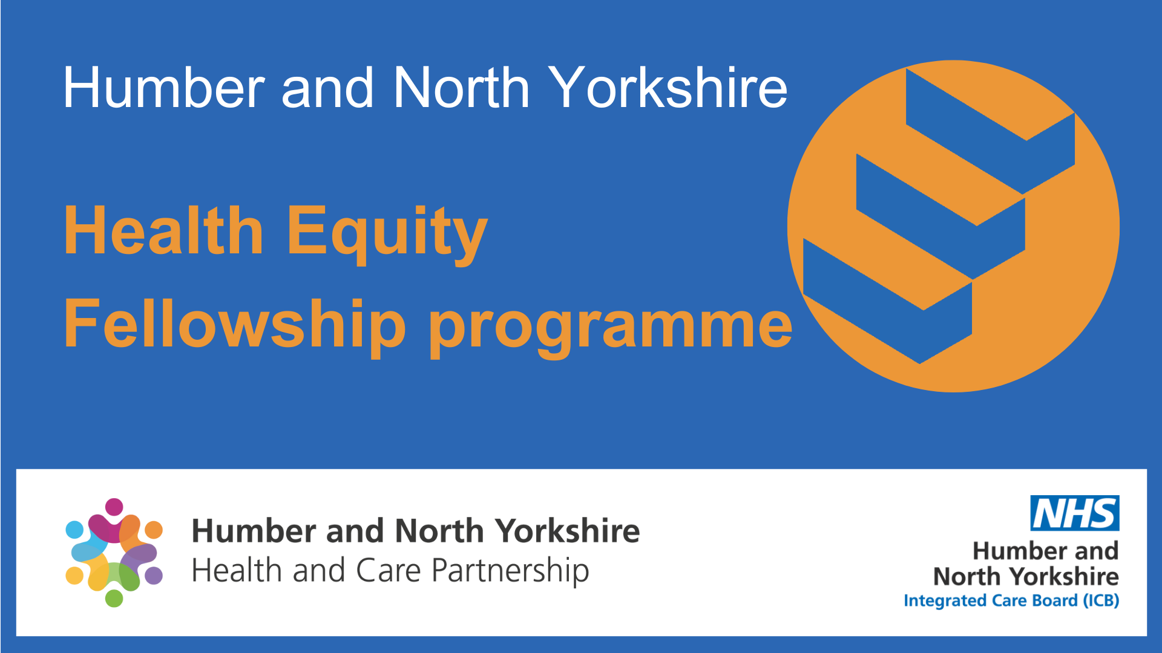

**Humber and North Yorkshire Fellowship:**

**Volunteer Mentor Brief and  
Expression of Interest**

Mentors are a vital aspect of the [Health Equity Fellowship - Humber and North Yorkshire Health and Care Partnership](https://gbr01.safelinks.protection.outlook.com/?url=https%3A%2F%2Fhumberandnorthyorkshire.org.uk%2Four-work%2Fhealth-equity-fellowship%2F&data=05%7C01%7Cmichelle.hall41%40nhs.net%7C0d0961c941b745e2746b08dbec1d328f%7C37c354b285b047f5b22207b48d774ee3%7C0%7C0%7C638363382562331270%7CUnknown%7CTWFpbGZsb3d8eyJWIjoiMC4wLjAwMDAiLCJQIjoiV2luMzIiLCJBTiI6Ik1haWwiLCJXVCI6Mn0%3D%7C3000%7C%7C%7C&sdata=RssNw4dmP8%2FkOprrts9oPcogniWycMN%2BCXCK4Xbmodc%3D&reserved=0)

The purpose of the role is to:

* Provide support and guidance for Health Equity Fellows during their time on the programme (April 2025 to March 2026)
* Assist fellows in refining, delivering, and evaluating their project, which they will undertake during their time on the fellowship.

**As a HNY Health Equity Fellowship Mentor, you will support the programme by:**

* Providing support to your assigned fellow/s focused on exploring issues related to developing and delivering their fellowship project*
* Providing support to your assigned fellow/s focussed on exploring issues related to the[Health Equity Fellowship - Humber and North Yorkshire Health and Care Partnership](https://gbr01.safelinks.protection.outlook.com/?url=https%3A%2F%2Fhumberandnorthyorkshire.org.uk%2Four-work%2Fhealth-equity-fellowship%2F&data=05%7C01%7Cmichelle.hall41%40nhs.net%7C0d0961c941b745e2746b08dbec1d328f%7C37c354b285b047f5b22207b48d774ee3%7C0%7C0%7C638363382562331270%7CUnknown%7CTWFpbGZsb3d8eyJWIjoiMC4wLjAwMDAiLCJQIjoiV2luMzIiLCJBTiI6Ik1haWwiLCJXVCI6Mn0%3D%7C3000%7C%7C%7C&sdata=RssNw4dmP8%2FkOprrts9oPcogniWycMN%2BCXCK4Xbmodc%3D&reserved=0)
* Providing broader support and advice regarding public health
* Participating in the Fellowship Community of Practice
* Working with the Population Health team to promote and raise the profile of the HNY Health Equity Fellowship Programme and Fellows
* Providing updates to the project manager as required.

**\***Project support may include assisting your assigned fellow/s with:

* Identifying a population health and inequalities problem
* Evaluating its significance
* Designing interventions to address the problem/answer the question posed
* Interpreting data collected
* Making relevant connections across the partnership where necessary
* Preparing a written report and oral presentation of the results

**HNY Health Equity Fellowship Mentors must commit to the following:**

* To meet (*virtually or face-to-face*) with their assigned fellow/s on a monthly basis for the duration of the programme
* To supervise assigned fellow/s in the preparation of a research project report, including fellows’ project plan, interim project report, and final project report
* To provide feedback on their assigned fellow/s draft project report allowing time for them to make changes before submitting their final report
* To submit a testimonial of their assigned fellow/s’ achievements at the end of the programme

*The time commitment is typically 1 hour per month* (minimum) *of contact time per fellow, plus time for reviewing the listed assignments* (project plan, draft project report, final project report, & final presentation), *and any extra time you would like to spend researching useful resources for your fellow/s.*

**How to volunteer as a mentor:**

To register your interest as a mentor, please email **[hnyicb-ery.populationhealthandprevention@nhs.net](mailto:hnyicb-ery.populationhealthandprevention@nhs.net)** by **9th March 2025** with the following information:

|  |  |
| --- | --- |
| Name |  |
| Job title |  |
| Organisation |  |
| Contact details |  |
| The maximum number of fellows you can mentor  (*e.g., 1, 2,* …) |  |
| Short bio,  Please provide info on your area of interest/expertise  (***100 words max.*** *– this is so we can assign you to an appropriate fellow*) |  |
| Which of these areas matches your expertise and interest? | Inclusion Health (Gypsy, Roma and Travelers, Migrant Health, Homelessness, other marginalised groups)  Intelligence  Research  Leadership  Strategy  Commissioning  Transformation  Health literacy  Prevention  Physical health  Mental health  Trauma-informed practice  Children and Young People |

Mentors and fellows will be matched based on professional area of expertise and fellows’ chosen project topic.