

Lung Cancer Awareness Month 2024:
Communications and Engagement toolkit
November is Lung Cancer Awareness Month and the Cancer Alliance is encouraging people, particularly aged 55 and upwards, to get in touch with a GP if they notice a cough of three weeks or more, in addition to other symptoms, including fatigue and shortness of breath. People should also be aware of unusual changes in their bodies.

To promote the campaign, we have developed a toolkit that can be utilised throughout November 2024.

This toolkit includes:

- Media release
- Newsletter/bulletin copy
- Social media posts
- Downloadable multimedia assets (video and images): https://we.tl/t-66hyq3fjHJ

Please share this across your networks, so that the message can be amplified across the region.
If you need any further information about the campaign, please email the team at comms.hnycanceralliance@nhs.net.
News Release
For immediate release

Humber and North Yorkshire Cancer Alliance’s giant inflatable lung to tour the region this Lung Cancer Awareness Month

Members of the public in Hull, Bridlington, Scunthorpe, Scarborough and York are being encouraged to get to grips with lung cancer – literally – by Humber and North Yorkshire Cancer Alliance this November.

For Lung Cancer Awareness Month, the Cancer Alliance is taking a three-metre-tall inflatable lung on tour across the region to supermarkets, shopping centres and other community spaces to spark conversation and raise awareness of the signs and symptoms of lung cancer. Here’s where the lung will be.

Friday, 8 November | Freeman Street Market, Grimsby | 10am-2pm
Wednesday, 13 November | North Point Shopping Centre, Hull | 10am-2pm
Monday, 18 November | The Summit, Selby (Cancer Café) | 10am-2pm
Tuesday, 26 November | The Ironstone Centre, Scunthorpe | 10am-1pm
Friday, 29 November | Monks Cross Shopping Park, York | 10am-2pm

Lung cancer is the third most common cancer in the UK. Around 18,600 men and 16,100 women die from lung cancer in the UK every year, making it the biggest cancer killer in the UK.

The majority of lung cancer diagnosis cases happen between the ages of 70 and 74, but cases rise rapidly from 55 onwards. Lung cancer is rare in people under 40. 79% of lung cancer cases are preventable, and 72% are caused by smoking.

Early detection of lung cancer is key. People diagnosed with the disease in its earliest stages are nearly 20 times more likely to survive for five years than those whose cancer is caught late.

Unfortunately, seven in 10 cancer patients are being diagnosed too late – often because there are no signs or symptoms during the early stages of the disease.

Dr Stuart Baugh, Clinical Programme Director for the NHS Targeted Lung Health Check programme in Humber and North Yorkshire, said: “The large inflatable lung is a great tool for helping people to understand how the lungs work, what lung cancer is, and how it looks inside the body.

“There’s no doubt it’ll turn heads this November, but we hope it will also get people thinking about lung cancer and help encourage contact with a GP if someone thinks they may be showing signs or symptoms.”

Dr Marcia Pathak, a GP from Raj Medical Centre in Grimsby, urges people to take note of the six signs of lung cancer.

She said: “If you’ve had a cough for three weeks or more, please see a GP – especially if you also have one or more of the following symptoms as well:

- fatigue
- shortness of breath
- chest pain
- weight loss
- appetite loss

“Often, people struggle on with a cough, thinking it’s a cold, flu or COVID-19. But if it’s been three weeks, don’t sit on that symptom, or any other changes causing concern.”

Retired nurse Sue Woodward, 73, from York, North Yorkshire, was diagnosed with lung cancer in 2022 – but her symptom was unusual.

"I didn't understand why, at 71, having long since gone through the menopause, I was waking up with night sweats, so I decided to see my GP,” she said.

“Luckily, they were sympathetic and referred me to York Hospital on the variable symptoms' pathway. The hospital arranged a CT scan, and in April 22 following biopsy they identified a tumour in my right lung, which had spread to other nodes in my central chest area.

“The tumour was removed from the lung, but cancer remained in my central chest area. But here I am in 2024, having had amazing support and treatment, and at my last scan, nothing was showing at all!

"It just shows that even though there are traditional symptoms for lung cancer, it can also become apparent in less obvious ways. I consider myself highly lucky. Please, if you notice any differences to your body, don't wait, because it might be too late otherwise.”

Lung cancer awareness will be spread far and wide across the region at engagement sessions – and across the Cancer Alliance’s social media channels too. Follow the Cancer Alliance on Facebook and X (formerly Twitter) to help share their messages.

If you or a loved one needs information on, or support for lung cancer, visit the Cancer Alliance website to be signposted to local lung cancer support groups.

You can also help the Cancer Alliance by completing surveys on cancer experience of care, and attitudes to cancer.

Visit the Cancer Alliance’s Lung Cancer Awareness Month page to find out more.

Ends

Bulletin/Newsletter copy

Members of the public in Hull, Bridlington, Scunthorpe, Scarborough and York are being encouraged to get to grips with lung cancer – literally – by Humber and North Yorkshire Cancer Alliance this November.

For Lung Cancer Awareness Month, the Cancer Alliance is taking a three-metre-tall inflatable lung on tour across the region to supermarkets, shopping centres and other community spaces to spark conversation and raise awareness of the signs and symptoms of lung cancer. Here’s where the lung will be.

Friday 8th November | Freeman Street Market, Grimsby | 10am-2pm
Wednesday 13th November | North Point Shopping Centre, Hull | 10am-2pm
Monday 18th November | The Summit, Selby (Cancer Café) | 10am-2pm
Tuesday 26th November | The Ironstone Centre, Scunthorpe | 10am-1pm
Friday, 29 November | Monks Cross Shopping Park, York | 10am-2pm

Lung cancer is the third most common cancer in the UK. Around 18,600 men and 16,100 women die from lung cancer in the UK every year, making it the biggest cancer killer in the UK.

The majority of lung cancer diagnosis cases happen between the ages of 70 and 74, but cases rise rapidly from 55 onwards. Lung cancer is rare in people under 40. 79% of lung cancer cases are preventable, and 72% are caused by smoking.

Dr Stuart Baugh, Clinical Programme Director for the NHS Targeted Lung Health Check programme in Humber and North Yorkshire, said: “The large inflatable lung is a great tool for helping people to understand how the lungs work, what lung cancer is, and how it looks inside the body.”

Dr Marcia Pathak, a GP from Raj Medical Centre in Grimsby, urges people to take note of the six signs of lung cancer.

She said: “If you’ve had a cough for three weeks or more, please see a GP – especially if you also have one or more of the following symptoms as well:

- fatigue
- shortness of breath
- chest pain
- weight loss
- appetite loss
Retired nurse Sue Woodward, 73, from York, North Yorkshire, was diagnosed with lung cancer in 2022 – but her symptom was unusual.

"I didn't understand why, at 71, having long since gone through the menopause, I was waking up with night sweats, so I decided to see my GP,” she said.

“Luckily, they were sympathetic and referred me to York Hospital on the variable symptoms' pathway. The hospital arranged a CT scan, and in April 22 following biopsy they identified a tumour in my right lung, which had spread to other nodes in my central chest area.

“The tumour was removed from the lung, but cancer remained in my central chest area. But here I am in 2024, having had amazing support and treatment, and at my last scan, nothing was showing at all!

"It just shows that even though there are traditional symptoms for lung cancer, it can also become apparent in less obvious ways. I consider myself highly lucky. Please, if you notice any differences to your body, don't wait, because it might be too late otherwise.”

Lung cancer awareness will be spread far and wide across the region at engagement sessions – and across the Cancer Alliance’s social media channels too. Follow the Cancer Alliance on Facebook and X (formerly Twitter) to help share their messages.

Visit the Cancer Alliance’s Lung Cancer Awareness Month page to find out more.

Ends

Social media
You can support the campaign by sharing posts on our Facebook page and our X page.
Below are some suggested social media posts that you can use on your channels.
All the social media resources can be downloaded here.

Copy | Media
If you’ve had a cough for three weeks or more, contact your GP practice. It’s probably nothing serious, but it could be a sign of cancer. If it is cancer, finding it early makes it more treatable and can save lives. For more info, visit bit.ly/4fllGRp. #lungcancerawarenessmonth | 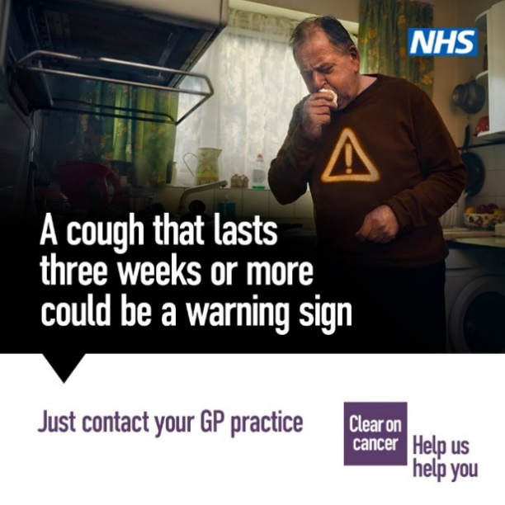  PRO22801_NHS_LungCancerAug2021_1x1_kitchen
If you’ve noticed a family member or a friend coughing for three weeks or more, encourage them to contact their GP practice. It's probably nothing serious, but if it is lung cancer, finding it early makes it more treatable and can save lives: bit.ly/4fllGRp.  #lungcancerawarenessmonth | 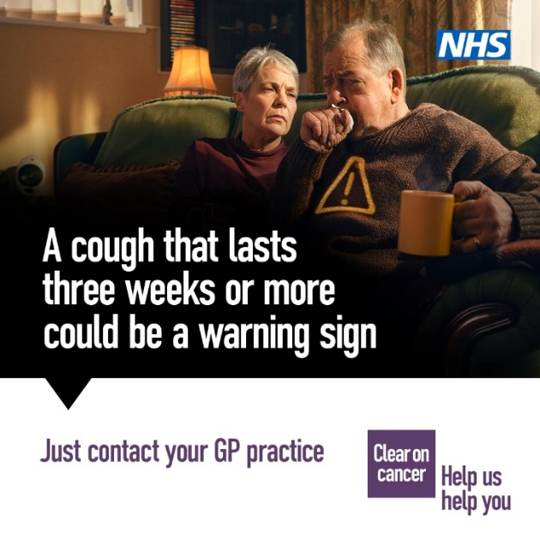  PRO22801_NHS_LungCancerAug2021_1x1_living_room
It’s #lungcancerawarenessmonth and the Cancer Champions programme will be running bite-sized lung cancer education sessions to raise awareness about the disease.  Sign up here. | 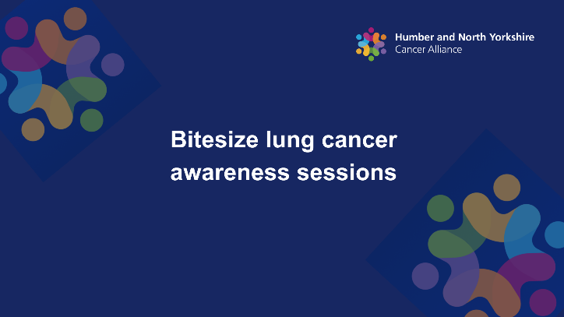  Bitesize lung cancer awareness sessions
If you’ve had a cough for three weeks, it could be a sign of lung cancer. It’s probably nothing serious, but if it is cancer, finding it early makes it more treatable. Your NHS wants to see you. Contact your GP practice. For more info: bit.ly/4fllGRp.  #lungcancerawarenessmonth | 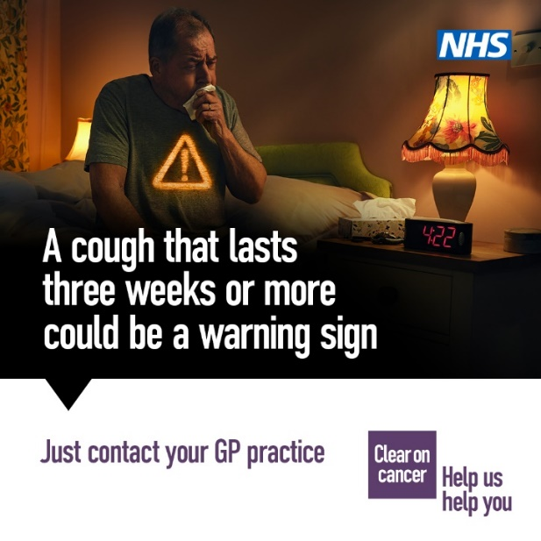  PRO22801_NHS_LungCancerAug2021_1x1_bedroom
A persistent cough is just one possible sign of lung cancer.  Make sure you know the rest...  Visit bit.ly/3Un9WFS for more information.  #lungcancerawarenessmonth | 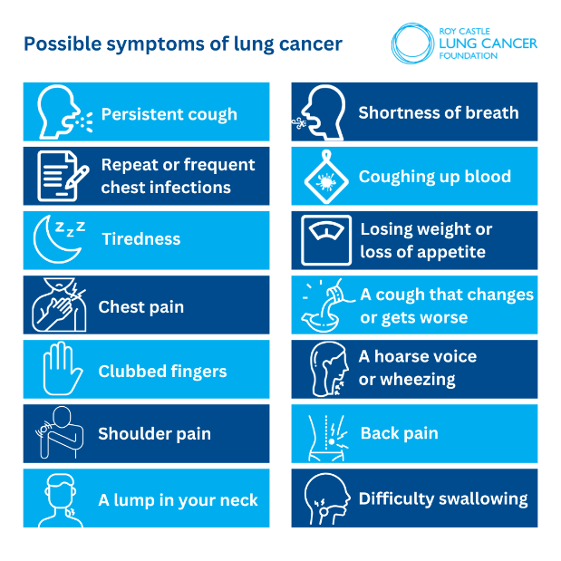  Roy Castle Lung Cancer Symptoms
Smoker  Ex-smoker  Non-smoker  Never smoker  EVERYONE can get lung cancer #letgoofthelabels #lungcancerawarenessmonth | 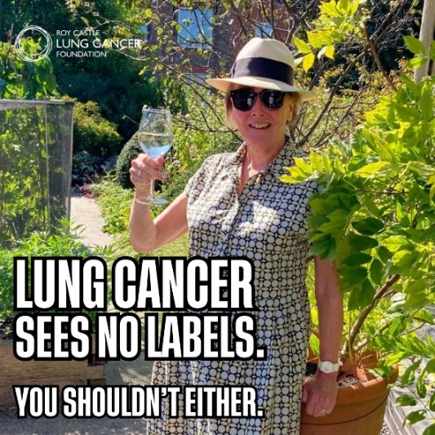  Lung cancer sees no labels

