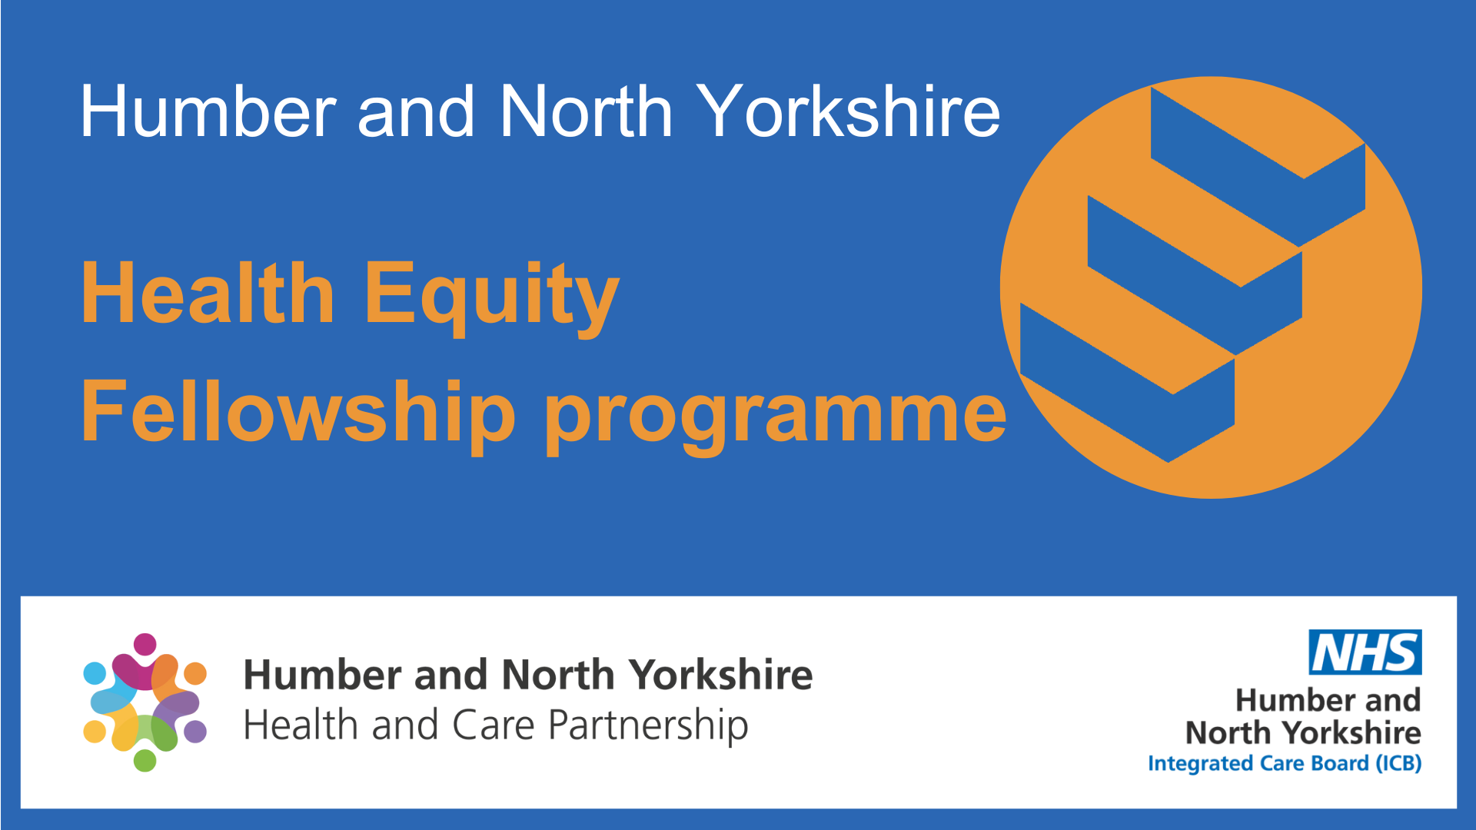

**Health Equity Fellowship 2025**

**Information pack**

Contents

Background 2

Timeline 3

Fellowship expectations 4

Benefits for organisations… 4

Benefits of being a fellow… 6

Programme objectives 7

To apply you must 7

Foundation Programme in Public Health 8

Who should apply? 9

How to apply? 10

Selection criteria and process 12

Frequently asked questions (FAQs) 13

FAQ: Applying for the programme 13

FAQs: Accessibility 14

FAQs: Funding 14

FAQs: Dedicated one day per week 15

FAQs: Your project 16

FAQs: Fellowship training 17

For more information 18

# Background

We’re excited to start the second year of our Health Equity Fellowship Programme! In 2024, we launched the first fellowship for Humber and North Yorkshire. We appointed 31 fellows who worked on projects to help reduce health inequalities and make Humber and North Yorkshire an equity-informed system. These projects are making real changes.

This information pack will give organisations, employers, and our workforce details about:

* The Health Equity Fellowship programme
* Benefits of being a fellow
* Benefits for organisations that support fellows
* How to apply
* FAQs and more

**We are looking to recruit 50** **Health Equity Fellows.**

# Timeline

Information pack available 7 November 2024

Applications open 13 November 2024

Event: first virtual information event 27 November 2024

Event: second virtual information event 11 December 2024

**Applications close** 24 January 2025,

**(Extended to 14th Feb 2025)**

Recruitment panel 27-30 January 2025

Notify applicants of outcome February 2025

Fellowship start date April 2025

# Fellowship expectations

The Health Equity Fellowship will take place from April 2025 to March 2026.

* Fellows will dedicate one day each week to attend training and work on a project.
* Projects will focus on population health and health equity, with a list of possible projects provided.
* Projects may be completed at the fellow’s usual workplace or as part of broader efforts across the area. Fellows will submit an interim and final report.
* Meetings and trainings may be in person at a central location or online via MS Teams. Fellows must attend all sessions, so they should be able to travel and have access to a device and internet.

# Benefits for organisations…

**Fellowships will:**

* Help employees learn new skills, feel more confident, and build strong connections with people and groups in Humber and North Yorkshire.
* Support both professional and personal growth, at no cost to the fellow’s workplace.
* Adapt to the changing needs of employees, workplaces, and the communities they serve.
* Give employees the confidence and motivation to improve their work.

**Fellows will:**

* Gain valuable experience and learn from mentors and experts.
* Receive guidance and support to grow professionally.
* Learn practical skills through hands-on experience.
* Become champions in their organisations to support growth in their area.

**Fellows will bring back to their organisations:**

* New ideas, strategies, and fresh perspectives.
* Involvement in community work and social responsibility.
* Contributions that will help their organisation succeed in the future.

# Benefits of being a fellow…

* Build your knowledge and skills by completing a project in your chosen area.
* Have a mentor to support you, helping you learn and connect with others in Humber and North Yorkshire.
* Receive free Public Health training run by Barnsley Council/ NHSE.
* Get specialised training in your area with access to materials and learning opportunities.
* Grow your professional network by working with other fellows.
* Connect with teams in our six Places (East Ridings of Yorkshire, Hull, York, North Yorkshire, North Lincolnshire, North East Lincolnshire)
* Meet experts and join programmes that drive positive change.
* Publish your project on our website and partner websites.

# Programme objectives

* Identify and address health inequalities.
* Build champions for equity across Humber and North Yorkshire.
* Create a network of health equity fellows.
* Share learning and best practices across the region.
* Support our goals to reduce health inequalities, which have become more urgent due to COVID-19 and the rising cost of living.
* Take a whole-system approach to tackling health inequalities, from leadership to community services. This fellowship will equip people in Humber and North Yorkshire with the knowledge, skills, and courage to create fairer organisations and communities.

# To apply you must

* Be passionate about health equity.
* Seek the knowledge, skills, and courage to create more equitable organisations and communities.
* Want to become health equity champions and work with others to achieve change.
* Be committed to the delivery of a Health Equity Fellow project.

# Foundation Programme in Public Health

**The Foundation Programme in Public Health** is a training created by the Yorkshire and Humber School of Public Health. It helps health and social care workers learn more about health inequalities to better support population health projects.

**Benefits of the programme:**

* Basic knowledge and understanding of health inequalities.
* Insight into how current roles can be adjusted to tackle health inequalities.
* Understanding of how new health policies can help reduce inequalities.
* Knowledge of how working together across systems can address inequalities.
* Improved quality and impact of health promotion, protection, and prevention efforts.

See the [website pages](https://sway.office.com/rMyGw3Ox3inkPnJq?ref=Link&loc=mysways) for more information about the programme.

Email: [FPPHquiries@barnsley.gov.uk](mailto:FPPHquiries@barnsley.gov.uk) if you have any enquiries about the programme.

# Who should apply?

Our Health Equity Fellowship programme is open to all colleagues from all sectors, health, social care, local authority and the voluntary and community sector across Humber and North Yorkshire irrespective of your current job role, grade or profession. There are no specific educational requirements.

**To apply you must:**

* Be passionate about health equity.
* Want to become a champion and achieve change.
* Be committed to the delivery of a fellowship project.
* Agree to carry out formal learning as part of the fellowship.
* Confirm prior support from your current organisation that you will have protected time to take part fully in the fellowship.

# How to apply?

**Applications open on Wednesday 13 November 2024 and close on Friday 24 January (extended to 14 February) 2025**. Send your completed application to [hnyicb-ery.populationhealthandprevention@nhs.net](mailto:hnyicb-ery.populationhealthandprevention@nhs.net)

In your statement of interest, please include the following:

* **Personal Information:** Your name, contact details, current role and organisation, location, and ethnicity.
* **About You:** A brief introduction and your motivation for applying.
* **Current Challenges:** Describe the challenges you face in your role and how you plan to learn and grow through the fellowship to address these.
* **Experience:** Share any relevant work, volunteering, or community contributions that will help you during the fellowship.
* **Future Development:** Explain how you plan to continue developing your knowledge and skills after completing the fellowship.
* **Project Idea:** Provide an initial idea for a fellowship project.
* **Support Confirmation:** Include confirmation of support from your employer and line manager.

You can submit your expression of interest in any format that works for you, such as a written form, video, or audio recording. The [Health Equity Fellowship - Humber and North Yorkshire Health and Care Partnership](https://humberandnorthyorkshire.org.uk/our-work/health-equity-fellowship/) page will have everything you need to apply, including the statement of interest form, accessible formats, and project examples.

# Selection criteria and process

The Fellowship will develop and support fellows from across Humber and North Yorkshire. It will equip you with the knowledge, skills, mentors, and networks to advance capability, capacity and intelligence in your chosen area, across your organisations and communities.

During the selection process we will consider:

* Demonstrated prior commitment and passion in your chosen fellowship programme.
* How you will help improve outcomes for people who live and work in Humber and North Yorkshire.

Selection panels for each area will score applications against the following criteria:

* Strength of statement of interest, including your personal motivation and commitment to chosen fellowship speciality.
* How you will continue to apply learning following the fellowship in your workplace or community.
* Quality of your proposed fellowship project.
* Confirmation of support from your line manager.

You may need to attend an interview if fellowships are oversubscribed.

We will also seek to recruit fellows from across Humber and North Yorkshire that reflect a variety of professional backgrounds and are representative of the communities we serve.

# Frequently asked questions (FAQs)

# FAQ: Applying for the programme

**Is the fellowship open to volunteers?**

Yes, we welcome applications from all partners from voluntary, community and social enterprise (VCSE) organisations.

**How did it work for VCSE colleagues last year?**

We had a number of VCSE partners who applied and are in the process of completing their Fellowship projects. The case studies from the 2024-25 projects will be published on [Health Equity Fellowship - Humber and North Yorkshire Health and Care Partnership](https://humberandnorthyorkshire.org.uk/our-work/health-equity-fellowship/).

**Can I apply if I run my own project and don’t have a line manager?**

Yes, just sign the application on behalf of yourself.

**I can't find the application, where is it located?**

Statement of interest forms will be available on the [Health Equity Fellowship - Humber and North Yorkshire Health and Care Partnership](https://humberandnorthyorkshire.org.uk/our-work/health-equity-fellowship/).

**Why is the scheme only offering a limited number of places to participants?**

We are limited by training place numbers, mentors and supervisory capacity, so we have based place numbers around what each programme can support.

# FAQs: Accessibility

**Will the fellowships provide adjustments and accessible information?**

By law, we must produce accessible versions of all information and publications. If you apply and need additional support, then we will make sure we can do what we can to meet your needs.

The training providers are also committed to accommodating any accessibility requirements and specific needs that you have. We will discuss this in advance, so we understand what is required.

Please contact [iphp.fellowshipenquiries@nhs.net](mailto:iphp.fellowshipenquiries@nhs.net) if you have any queries or questions regarding this.

# FAQs: Funding

**Does the programme provide funding for backfill?**

Not for statutory organisations. Funding may be available to support applications from the voluntary community social enterprise sector to backfill time for successful applicants.

**Who would fund any required project costs?**

Additional funding is not currently available to cover fellowship projects. When agreeing projects, we will take resource into consideration and where this may come from.

Many projects will have to be cost neutral or reinvestment projects or will need to have the caveat that we, you know, this might be something we need to do or should be done, but we need to find the resource to go with it.

**Are the costs to cover the fellowship day per week paid for by the scheme or the department/organisation the fellow has come from?**

All salary costs would come from the employing organisation. As a result, all applicants will need to agree this in advance with your employing organisation and line manager.

**What are the costs associated with the fellowship?**

There is no cost required to be a fellow or for any of the support and training provided. The costs for your organisation will be related to releasing you for one day a week to undertake the programme, project, and training.

# FAQs: Dedicated one day per week

**How much time will the fellowship take?**

The fellowship will run for 12 months. You will need to spend one day a week on fellowship training and on delivering a fellowship project.

**Is it confirmed what day fellows need to take and does it have to be on a day I would be employed on by my employer?**

Days will, on the whole be flexible. For dates that are set, we’ll give you notice in advance. It does not have to be an employed day.

**What constitutes one day a week?**

7.5 hours is a working day.

**How many cohorts are you planning?**

The first Health Equity Fellowship Programme is still ongoing. We currently have 31 fellows doing the Fellowship programme. We are launching the second year of our Fellowship programme and plan to continue this in future.

**How will you incorporate people working part time?**

There is an expectation for all fellows to undertake a fellowship project as part of the programme, regardless of whether you work full or part time. However, if you have any specific requirements, we will discuss these with you and how that fits in with your working day.

# FAQs: Your project

**What is the project population focus?**

Projects can focus on any population you choose or work with. We are happy to help successful applicants work through projects. Applicants are welcome to test out any project ideas with us.

**Will you publish and share learning and information from projects?**

Yes, we will publish projects on our websites and evaluate the fellowship.

**Should projects be at organisational level or departmental level?**

Projects can focus on any level/part of an organisation.

**Do I have a say in which project to take part in?**

Yes, you will be asked for your project ideas in your application. We will support you to refine and develop your project once selected to the scheme.

**How often will I meet with my mentor?**

We would expect you meet once a month, but you can meet more frequently if both of you choose. You will arrange and agree these directly with your mentor.

**Will there be any report writing in the project?**

As part of your fellowship project, we expect fellows to complete an interim report halfway through the fellowship and a final report at the end. Your mentor will assist you with these reports, provide feedback and we will provide guidelines. There is flexibility if a written report is not for you.

# FAQs: Fellowship training

**What does the Foundation Programme in Public Health course work look like?**

It is compulsory for applicants to take part in the Foundation in Public Health course which covers key topics and ideas. This training will help with the development of fellowship projects. There are six, three hours training sessions in total; covering a range of public health skills. Training sessions will include teaching, but you will also be expected to participate in group work as well in every session.

All fellows are required to undertake the training. Fellows that do not attend a minimum of five of the six sessions will not complete the fellowship. Participants who attend all four public health training sessions, will receive a certificate from Barnsley Council/ NHSE which highlights learning outcomes from all sessions, plus CPD credits that you can use in personal development plans or equivalent plans in due course. This training is accredited by Royal Society of Public Health.

**Will there be any other training outside of the Foundation Programme sessions?**

Yes, we welcome requests for any other training you think might help with your project and learning.

All fellows will also have the option of attending trauma-informed training from Dr Warren Larkin as part of the fellowship programme.

# For more information

**For general enquiries about the programme, Foundation Programme, interim and final report submissions:**

[iphp.fellowshipenquiries@nhs.net](mailto:iphp.fellowshipenquiries@nhs.net).

Please copy [hnyicb-ery.populationhealthandprevention@nhs.net](mailto:hnyicb-ery.populationhealthandprevention@nhs.net)

in all communications.

**Specific enquiries, e.g. feedback, mentoring and further support:**

[hnyicb-ery.populationhealthandprevention@nhs.net](mailto:hnyicb-ery.populationhealthandprevention@nhs.net)