# 

**Information for Managers**

**Contents**

What is the Humber and North Yorkshire Collaborative Staff Bank? 2

What does this mean for our services? 2

Which roles and services are included? 2

What does this mean for our own bank workers? 3

How and when will members of the Humber and North Yorkshire Collaborative Staff Bank be able to book shifts? 3

What will this look like on your roster? 3

Will I still be able to use agency workers? 4

What do I do when a West Yorkshire Staff Bank worker arrives on my ward for a shift? 5

Is there anything else I need to do in terms of ID checks or training? 5

Do I need to support any travel arrangements for staff from different Trusts? 5

When do I need to finalise HNY Collaborative Staff Bank shifts on my roster? 5

How do I cancel a shift? 6

How will I find out if a HNY Collaborative Staff Bank worker has cancelled a shift with us? 6

What will the roster look like for a member of substantive staff who has joined the HNY Collaborative Staff Bank and booked a CloudStaff shift? 6

What if I don’t want a substantive member of my team to work a particular CloudStaff shift? 7

## What is the Humber and North Yorkshire Collaborative Staff Bank?

The Humber and North Yorkshire (HNY) Collaborative Staff Bank (CSB) is a new staffing initiative that will support well-trained and experienced staff work across collaborating NHS Trusts within our region.

It’s a collaborative project that involves three local trusts. While each trust will keep their own staff banks to cover their own services, the Humber and North Yorkshire Collaborative Staff Bank will advertise any unfilled shifts from all three trusts to a wider pool of workers.

The ambition of the collaborative is to support us getting our staff to where we need them most, ensuring staffing levels remain safe and quality of care is maintained. Collaborative Staff Banks are designed to reduce reliance on agency workers, cutting agency spend, whilst delivering a larger, reliable, and well-trained group of temporary workers. The Collaborative Staff Bank also offers our workforce greater flexibility to work additional hours at a location convenient to them, building experience of healthcare delivery in other organisations.

Collaborative Staff Banks have been shown to deliver benefits across lots of NHS services in the UK. Our collaborative wants to understand the potential benefits for our region, across the different staff groups. We will be starting our Collaborative Staff Bank with Nursing and Midwifery workforce, and will look to grow to include more staff groups over time.

Our first Collaborative Staff Bank group will include staff from the following settings:

* Humber Health Partnership
  + Hull University Teaching Hospital: (1) Hull Royal Infirmary & (2) Castle Hill Hospital
  + Northern Lincolnshire and Goole: (3) Scunthorpe General Hospital, (4) Diana Princess of Wales Hospital (Grimsby) and (5) Goole and District Hospital
* York and Scarborough Teaching Hospital NHS FT: (6) York Hospital, (7) Scarborough Hospital, (8) Bridlington Hospital, (9) Malton Community Hospital, (10) Selby War Memorial Hospital, (11) Nelson’s Court, (12) St Monica’s and, (13) White Cross Court

## What does this mean for our services?

The Humber and North Yorkshire Collaborative Staff Bank will help our services fill vacant shifts, without the need to use agency workers. It will provide us with access to a greater number of available and well-trained health and care workers with experience of working across services in our region.

## Which roles and services are included?

Initially, the Humber and North Yorkshire Collaborative Staff Bank will cover Nursing & Midwifery roles for bedded areas (i.e. B2-6 staff). This is the first staff group to test a Collaborative Staff Bank, with the ambition to include other staff groups (for example AHPs and Medics) in the future (more information will be provided when this happens).

## What does this mean for our own bank workers?

Shifts will be offered to our own bank workers first. If they remain unfilled, they will then be offered to members of the Humber and North Yorkshire Collaborative Staff Bank, before (if appropriate) going out to agency as a last resort.  
  
All bank workers across collaborating organisations will be given the opportunity to join the Humber and North Yorkshire Collaborative Staff Bank should they want to. For details on how to join staff members should be directed to the [HNY CSB website](https://humberandnorthyorkshire.org.uk/our-work/workforce/collaborative-staff-banks/), or contact their local Trust Bank Office for more information.

## How and when will members of the Humber and North Yorkshire Collaborative Staff Bank be able to book shifts?

Members of the HNY Collaborative Staff Bank will be able to book shifts across any of the collaborating trusts via the same platform they currently book shifts in their home trust (i.e. Employee Online / Loop)

To support staff working across our collaborative we are using a new tool called CloudStaff. CloudStaff supports our rostering systems “talking to each other” so that staff can view and book appropriate shifts based on their home trust staff record (role & expertise).

Shifts will automatically be sent to CloudStaff if not filled – timings for release to CloudStaff depend on your local trust (i.e. Internal Bank, Collaborative Staff Bank, Agency). If you have any questions about timings or suitability, please contact your e-rostering team.

All HNY Collaborative Staff Bank Shifts must be managed via our electronic system (i.e. Employer Online / Loop) to ensure staff payment – we operate a zero-tolerance policy.

## What will this look like on your roster?

You can see what stage your shifts are at by looking at the icon or colour of the shift.

* Green shows a shift is with your home bank workers
* A cloud icon in the bottom right corner of a shift shows it’s currently open to HNY Collaborative Staff Bank members (see screenshot below).
* Purple shows a shift is with agency

If a bank shift has been sent to CloudStaff but you no longer need this shift to be filled, or if you are filling the shift locally, you will need to ‘re-set to Bank’ before you ‘re-set to local fulfilment’.

If a HNY Collaborative Staff Bank worker is working a shift on your ward you will see a cloud icon next to their name:

You can click on their name on the roster to see more details about the person and which trust they are coming from.

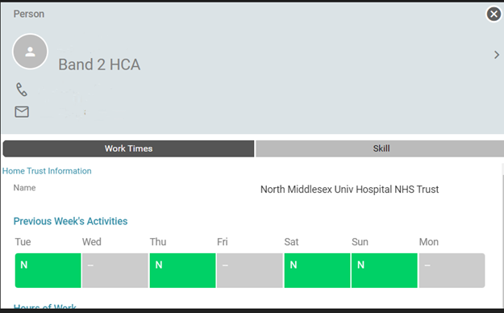

Please be assured that all trusts recruit to the same standard for pre-employment checks and a lot of work has been undertaken to ensure workers from each trust have equivalent levels of skill and training.

## Will I still be able to use agency workers?

One of the aims of the HNY Collaborative Staff Bank is to reduce our reliance on agency workers, and shifts will now be offered to members of the HNY Collaborative Staff Bank (where possible) before they are made available to agencies (if appropriate). Being a member of the bank therefore increases a person’s chances of being able to continue to pick up their favoured shifts. If you work regularly with particular agency workers that you know and trust, and you are keen for them to continue working shifts with you, we encourage you to talk to them about the benefits of joining your Trust Staff Bank and HNY Collaborative Staff Bank, in accordance with Trust conversion practices.

## What do I do when a HNY Collaborative Staff Bank worker arrives on my ward for a shift?

When they arrive for their shift, a HNY Collaborative Staff Bank worker must be wearing an NHS Photo ID badge, and should be dressed appropriately in their Home Trust uniform. It has been agreed that HNY Collaborative Staff Bank workers will wear the uniform provided by their home trust for any shifts that require a uniform. This agreement is underpinned by a review of uniforms across Trusts.

Before they start work on your ward, the nurse in charge must check their photo ID badge and follow your usual local induction practices.

## Is there anything else I need to do in terms of ID checks or training?

No. All collaborating trusts recruit to the same standard for pre-employment checks, and these will have been done before a person is allowed to join the bank and book shifts with you. The only thing you need to do is check their photo ID badge and complete any local induction (in accordance with local procedures/templates).

Collaborating Trusts have reviewed and approved procedures to support movement of staff across organisations, including employment checks, training and competency to ensure that workers have appropriate levels of training that are sufficient and equivalent. Training records will be maintained by an individual’s home trust, with compliance monitored and restrictions applied if an individual does not meet the requirements for the Collaborative Staff Bank.

## Do I need to support any travel arrangements for staff from different Trusts?

When booking a HNY Collaborative Staff Bank shift the worker is accepting the location of work and any personal travel expenses incurred to work that shift. If the location of work changes following booking with insufficient notice, for example they are asked to work at a different hospital within the Trust, travel arrangements will be made to facilitate work in a new location. You may be asked to support these arrangements in accordance with normal practice.

## When do I need to finalise HNY Collaborative Staff Bank shifts on my roster?

To allow for differing pay schedules across the three trusts, all shifts will need to be finalised weekly.

Please ensure shifts are finalised as soon as able to ensure there are no delays in payment.

## How do I cancel a shift?

If you no longer need cover for a shift that is booked by a HNY Collaborative Staff Bank worker (identified by the cloud icon above), please let your local Trust Bank Office know, so they can explore alternative options with the HNY Collaborative Bank worker.

Please ensure you give as much notice of cancellation as possible – any shifts cancelled within HNY Collaborative Staff Bank late notice period (4 hours prior to shift) will incur a cancellation fee.

## How will I find out if a HNY Collaborative Staff Bank worker has cancelled a shift with us?

If a HNY Collaborative Staff Bank worker cancels a shift (including short notice cancellations), you will be notified in accordance with your Trusts usual procedures.

We will be monitoring any short-notice cancellations to determine success of the HNY Collaborative Staff Bank.

## What will the roster look like for a member of substantive staff who has joined the HNY Collaborative Staff Bank and booked a CloudStaff shift?

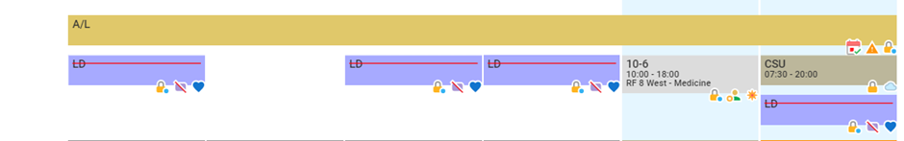If a substantive member of staff has joined the HNY Collaborative Staff Bank, they will also be able to pick up CloudStaff shifts. If they have picked up a shift at a different trust, this will show on their roster as a CloudStaff unavailability (CSU).

You can click on it to see more detail, including which trust the shift is booked at.

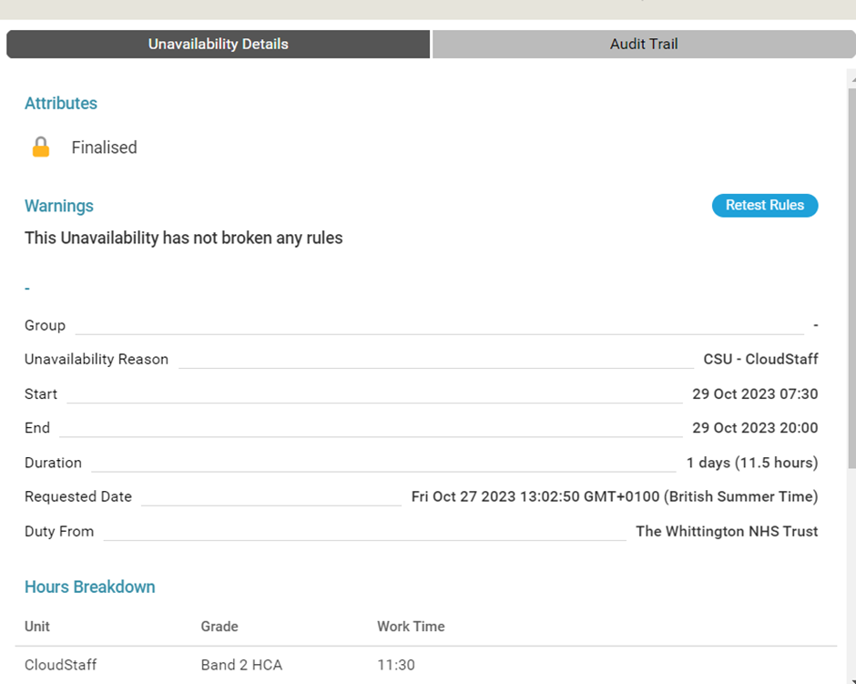

## What if I don’t want a substantive member of my team to work a particular CloudStaff shift?

If you have concerns about a substantive member of your team working a CloudStaff shift, then please discuss this with them first. You can also contact your Trust Bank Office for help and advice.