**Ask Listen Do**

**Making conversations count**

**in health, social care and education**

Top tips for families and carers

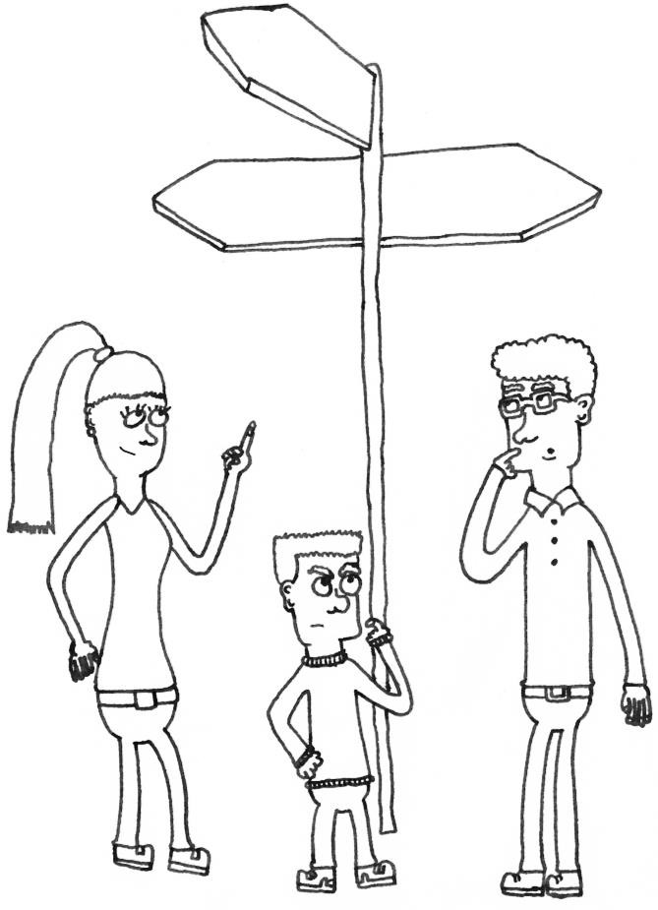

**Concerns**

**Complaints**

Making feedback, concerns and complaints easier

for families and carers of children, young people and adults

with a learning disability, autism or both

**Welcome**



This is an NHS England project supported by:

* Local Government

Association

* Local Government and Social Care Ombudsman
* Association of Directors

of Adult Social Services

* Parliamentary and Health

Service Ombudsman

* Department for Education

National Helpline

* Care Quality Commission
* NHS Improvement
* Inclusion East
* PBS4

Many thanks to Bringing Us Together and all the family carers and other carers who helped with this booklet.

Thanks too to my colleague David Gill, for his fantastic illustrations.

Giving feedback, raising concerns and making complaints can be difficult and time consuming. When you care for someone with a learning disability, autism or both, as I do, this can be even harder. A whole range of challenges can arise during the lifetime of a person with a learning disability, autism or both across education, health and social care, through childhood to adulthood.

As someone who has experience of giving feedback, raising concerns and making complaints for my son, I know how difficult it can be to make your voice heard and how long it can take for positive change to happen. Getting our messages across is really important so that people who work in, manage and commission these services really understand what we are saying. Even though this may be difficult for lots of reasons, it is your absolute right to be heard.

These top tips are about giving feedback, raising concerns and

making complaints across education, health and social care. Some organisations handle this well, while others have much more work to do. There are tips for dealing with often complex and sometimes difficult systems while looking after yourself.

This booklet is designed to help families, parent carers and other

carers to:

* be confident about having conversations with people in all the organisations involved in the lives of those they care for, and
* feel more empowered to understand and navigate the

complex systems of feedback, concerns and complaints.

In developing these top tips, families and carers wanted

organisations to:

* understand the complex lives of families
* think holistically about all the commitments families have
* think about how it feels to be a parent carer
* be aware of the whole picture when they speak to families

and carers, and

* treat them as equal partners, in the spirit of co-production.

Co-production is part of laws such as the Children and Families Act 2014 and Care Act 2014. This means organisations need to support people and families to influence the support and services received, and make sure people can influence the way that services are designed, commissioned and delivered.

## Mary Busk, Family Carer Adviser, NHS England

**What do we mean by…**



It is important to understand the difference between giving feedback, raising a concern or making a complaint

**Concerns**

**Complaints**

so you can make the best use of your time and get the best outcomes

for the child, young person or adult you care for.

**Feedback**

This means being able to say what you like or do not like about the care, education or support being given - good or bad. You can do it by talking to someone or filling in a feedback form. All feedback should always be encouraged and welcome. Organisations should ask for people’s feedback and use it to improve their services. They should also tell you how they have done this.

**Concern**

You should raise a concern if you are worried or unhappy about something. You should talk or write to someone about it to see if they can sort it out straight away. You should be able to do this with any member of staff and they should help you. They might need to tell someone else. Someone should be able to tell you quickly if**,** or how**,** it has been sorted out.

**Complaint**

If you do not think your concern has been sorted out or you have not been listened to, you can complain. You can ask for help from advice or advocacy organisations or use sample letters. This is a formal legal process and organisations have a certain number of days to respond to your complaint and say what they will do. If you are unhappy with the outcome you can go through a number of different stages, depending on the nature of the complaint, ending with the Local Government and Social Care Ombudsman, Parliamentary and Health Service Ombudsman, SEND Tribunals, Judicial Reviews or the Department for Education.

If a young person or adult can give feedback, raise concerns or make a complaint themselves this must be supported. When doing this on behalf of someone you care for make sure they are involved and informed as much as possible in line with the Mental Capacity Act.

It is also important to know what to do if a person is not safe. The police can help if a crime may have taken place such as abuse or theft. If a concern is about someone not being safe or poor care, this could be a safeguarding concern and must be acted on. Safeguarding teams in local authorities help protect children, young people and adults whose disabilities make them more vulnerable. You should contact these teams directly about this.

s

**Top tips Giving feedback**

* + Feedback includes compliments as well as ideas or

requests for improvement

* + Believe in the value of feedback and engaging in positive conversations, as working together is better and less stressful than working against one another
  + Understand that a lot of legislation (e.g. the Children and Families Act) and regulation is based on partnership working which requires feedback
  + Understand the different ways to give feedback:
    - Direct to practitioners - and ask how feedback is

collected and dealt with

* + - To organisations (e.g. survey)
    - To third parties (e.g. Care Opinion, NHS Choices, Ofsted, CQC)



# Examples

**of feedback**

* Ask if feedback records the disability of the child, young person or adult. If it does not how will they know about your individual needs?
* It is good to have mutual respect and positive

communication:

|  |
| --- |
| **Health** |
| My child finds waiting difficult as he/she has autism. Can they be seen on time please? |
| **Social care** |
| Thank you for the activities, I really like them. |
| **Education** |
| I appreciate the feedback about the speech and language session in school. |

* + “Can I give you some feedback please?”
  + Tell the good as well as the bad
  + Keep the child, young person or person you care for at the centre of the conversation
* Ask about co-production - working together strategically from start to finish as equals – including involving children and young people, adults and families in developing feedback mechanisms (e.g. citizens panels) and “nothing about me/us without me/us”
* Ask what difference the feedback is going to make and for evidence of what they are going to do differently e.g. “You said, we did” statements
* Use conversations to build relationships and mutual

respect

**Raising a concern**

**Top tips**

* Don’t be afraid to raise a concern, you have a right to
* Airing a concern early on can stop it from becoming a

lengthy complaint later

* Use a positive tone which is assertive, but however

frustrated you feel, avoid sounding aggressive.

* Remember you are a parent/carer and it’s OK to reflect

that and your worries

* Document your concerns – evidence is always good
* Try to reflect things that are working, as well as your

concerns, and offer solutions, for example:

* + Talk in terms of outcomes (e.g. can we help my

child not bite himself?)

* + Explain that resolving the concern is important to building confidence and trust and building partnerships



* Ask for transparency and seek solutions together

|  |
| --- |
| **Health** |
| I am worried you are not taking me seriously because my child has a learning disability. |
| **Social care** |
| We are concerned about the lack of contact with our family member. |
| **Education** |
| I am concerned my child is not making progress at SEN support. |

* If you have meetings to raise concerns, prepare before

hand, write down the main points

* Seek help and advice if you need it e.g. from the organisation, advocacy and advisory organisations, councillors, MPs, regulatory bodies and Ombudsman services
* Have someone with you to give support if you need it

# Examples of concerns

**Top tips Making a complaint**

* Find out or ask for the organisation’s complaints policy (they

must have one)

* If the complaint covers more than one area of education, health

or social care, ask who will deal with that and how

* Follow the complaint process and be aware of the time limit you have for complaining, as well as the time in which the organisation must respond to you
* Be clear you are making a complaint and focus on one topic at a

time

* Always explain what you want to happen and the harm that will

be caused if it doesn’t or hasn’t

* Include “I understand you need to reply by…….”.



# Examples of complaints

|  |
| --- |
| **Health** |
| I was refused treatment because of my disability and no reasonable adjustments were made |
| **Social care** |
| My son’s care plan is not being followed. |
| **Education** |
| My child is not getting the provision set out in his/her education, health and care plan. |

* Don’t let the complaint drift (there are legal deadlines)
* Be careful about the ‘style’ of your complaint – be assertive but

polite

* Ask someone you trust to look at your complaint if you need

some help

* You or the person you care for may be entitled to an advocate – ask the organisation and if you have any problems, report this back to the organisation and ask for more help
* Ensure that the complaint is received and acknowledged
* Expect consistency in relation to:
  + Communication, including about process and stages
  + Timescales
  + Seeking consent
* If you lose confidence in the process, speak up and involve

organisations that can help, your local councillor and/or MP

* Be aware there may be more than one stage to the complaint

process, giving you the further right to reply

* There are ways to take a complaint further eg. if you’re unhappy with the organisation’s final decision or if the organisation has not responded as it should have done (see back page).

**In summary**



**Top tips**

|  |  |
| --- | --- |
| **About you**  **Always be polite**  **Be positive about yourself -**  **YOU know the person you care for**  **You are somebody that can bring about change**  **Don’t be apologetic for wanting the best**  **Don’t blame yourself ever Build confidence in having**  **conversations with people who can**  **effect change**  **Concerns and complaints are emotive issues – you may need to find ways to manage this**  **Try as hard as you can to keep a sense of humour** | **Coping**  **Pick your battles and know what you can deal with through feedback, concerns and, if necessary, complaints**  **Find positives in the negatives and learn to forgive**  **For meetings, insist on paperwork in**  **advance**  **You’re never alone, look for support locally. Join your local parent carer forums (www.nnpcf.org.uk) and family or parent support groups – have a bigger voice together!**  **It can take a long time to resolve a formal complaint - look after yourself so it doesn’t take over too much**  **Sometimes you have to let go and move on** |
| **Be knowledgeable**  **Find out your rights, know the law Ask for reasonable adjustments if you**  **or the person you care for need them**  **Have a notebook/diary and record (briefly) meetings, phone calls, letters received**  **Make notes before attending a meeting so you don’t get muddled or forget to mention things**  **Know the strengths and weaknesses of your argument and the likely challenges**  **Look for sources of jargon-busting**  **information** | **Be empowered**  **Don’t be afraid - your voice/views should shape local services**  **Have high aspirations for services and for the expectations of them for the person or people you care for**  **Refer to the person by name – personalise it**  **You know the person you care for – don’t let anyone tell you that you don’t**  **Build relationships and allies and reflect your journey in discussions with them so they understand you and your family as human beings**  **Know who you can ask for help** |

**Who can I ask for help?**



## Support and information groups

Contact [www.contact.org.uk](http://www.contact.org.uk/)

National Deaf Children’s Society [www.ndcs.org.uk](http://www.ndcs.org.uk/)

National Autistic Society [www.autism.org.uk](http://www.autism.org.uk/)

**Concerns**

**Complaints**

Ambitious about Autism [www.ambitiousaboutautism.org.uk](http://www.ambitiousaboutautism.org.uk/)

Cerebra [www.cerebra.org.uk](http://www.cerebra.org.uk/)

Together for Short Lives [www.togetherforshortlives.org.uk](http://www.togetherforshortlives.org.uk/) Mencap [www.mencap.org.uk](http://www.mencap.org.uk/)

Challenging Behaviour Foundation [www.challengingbehaviour.org.uk](http://www.challengingbehaviour.org.uk/)

Bringing Us Together [www.bringingustogether.org.uk](http://www.bringingustogether.org.uk/)

Healthwatch [www.healthwatch.co.uk](http://www.healthwatch.co.uk/)

Citizens Advice [www.citizensadvice.org.uk](http://www.citizensadvice.org.uk/)

## Advice and Information about SEND 0-25

IPSEA [www.ipsea.org.uk](https://www.ipsea.org.uk/)

Your local SENDIASS service (for children and young people 0-25)

[www.councilfordisabledchildren.org.uk/find-your-local-ias-service](http://councilfordisabledchildren.org.uk/find-your-local-ias-service)

## Taking a complaint further

The Local Government and Social Care Ombudsman [www.lgo.org.uk](http://www.lgo.org.uk/) The Parliamentary and Health Services Ombudsman [www.ombudsman.org.uk](http://www.ombudsman.org.uk/)

SEND Tribunals [www.gov.uk/courts-tribunals/first-tier-tribunal-special-](http://www.gov.uk/courts-tribunals/first-tier-tribunal-special-educational-needs-and-disability)

[educational-needs-and-disability](http://www.gov.uk/courts-tribunals/first-tier-tribunal-special-educational-needs-and-disability)

Department for Education

[www.gov.uk/government/organisations/department-for-education](http://www.gov.uk/government/organisations/department-for-education)

## Other useful regulatory and statutory bodies

Ofsted [www.gov.uk/government/organisations/ofsted](http://www.gov.uk/government/organisations/ofsted)

CQC [www.cqc.org.uk](http://www.cqc.org.uk/)

Feedback and complaints about an NHS service

[www.england.nhs.uk/complaint](http://www.england.nhs.uk/contact-us/complaint)

**To raise a concern, make a complaint, log feedback or make a compliment at the Humber and North Yorkshire ICB, please contact:**

**Email:** [**hnyicb.experience@nhs.net**](mailto:hnyicb.experience@nhs.net)

**Telephone: 01482 957750**