2

It’s good to say how you feel, please tick one box below to tell us about your experience:

Feedback Concern Complaint

When did it happen?

Date:

Name of the place or service where the incident happened:

I am writing about:

 What happened to me

 What happened to somebody I support/care for

My name is:

What can we do to help you? (what reasonable adjustment can be made to support you?)

What would your desired outcome be?



What happened and how did it make you feel?

To feedback to us you can give this form to the person in charge at the place/service you are talking about

Or email us on[hnyicb.experience@nhs.net](mailto:hnyicb.experience@nhs.net)

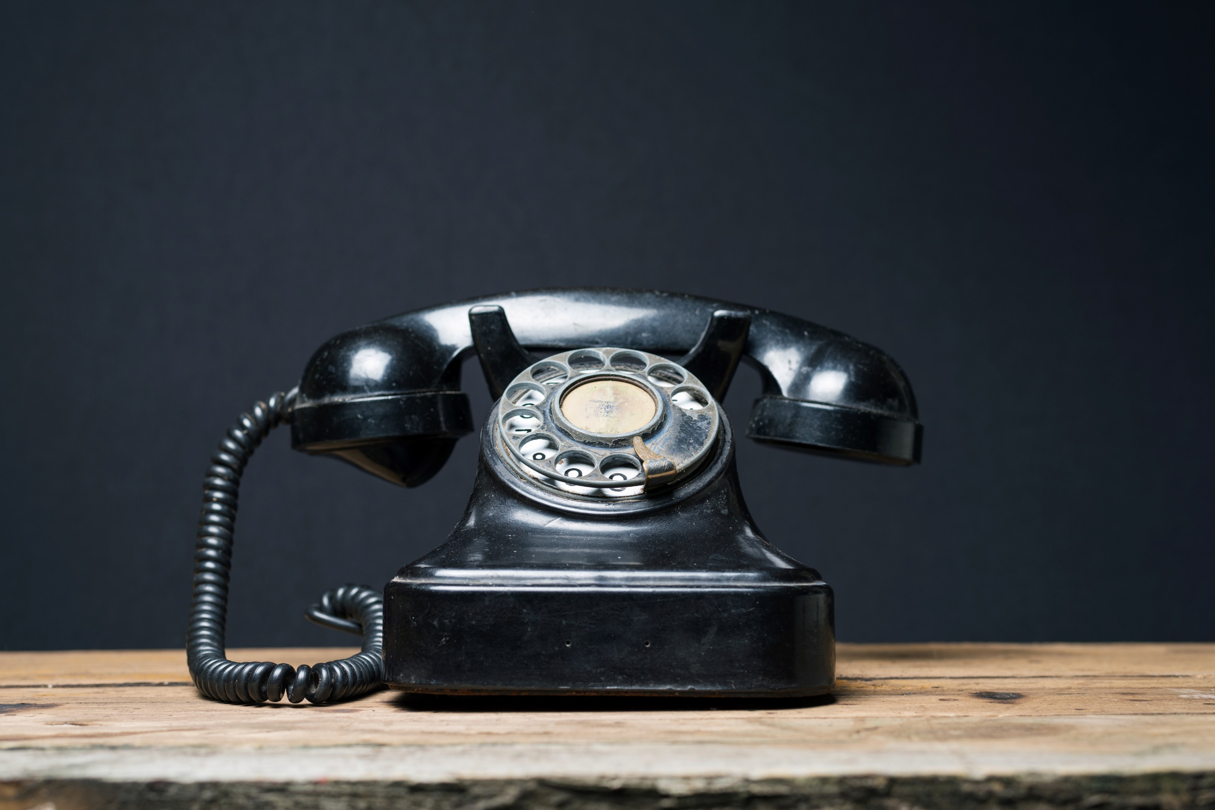 Or Telephone us on 01482 957750

Thank you for your time in providing your valuable feedback



Thank you.

If you want us to contact you, or someone else, please tell us how:

Address:

 Telephone:

Email: