Bank holiday repeat prescription toolkit
Dear Primary Care colleagues,
As the Easter Bank Holiday approaches, we anticipate that local urgent and emergency care systems will experience increased pressure due to a rise in demand for repeat prescriptions. Our data, along with anecdotal feedback, indicates that many individuals with regular prescriptions often find themselves “caught out” by the Easter weekend, particularly with reduced primary care and pharmacy services. As a result, these patients frequently turn to NHS 111 and urgent care services to request limited supplies of their medication.
To help alleviate this local pressure, we kindly ask for your support in reminding patients to order their repeat prescriptions well in advance of the Easter weekend using this toolkit.

Patient text message:
Please send the below message to your patients by text message and/or the NHS App:
Don’t get caught out by the Easter Bank Holiday! If you take regular medication, order your repeat prescription well in advance to avoid running out. As Easter approaches health services become busier and processing times may be longer than usual. If possible, use the NHS App or GP Online Services to order.

Copy for newsletters and websites
Don't get caught out this Easter Bank Holiday Weekend
As the Easter Bank Holiday Weekend (Friday, 18 April – Monday, 21 April) approaches, now is the time to check how much of your regular repeat medication you have left.
In the run-up to Easter, services can get increasingly busy. If your medication is due to run out during the bank holiday period, it’s a good idea to order it now.
To avoid any last-minute issues, aim to order your medications at least one week in advance. This allows enough time for your GP practice to issue your prescription and for the community pharmacy to prepare your medicines.
The quickest and easiest way to order repeat medicine is via the NHS App or GP Online Services – you can do this 24/7 from the comfort of your own home, without having to leave the house.
Don't get caught out over the bank holiday weekend; check your medicines today.

GP TV screens:
We have created a short video for you to upload to your GP TV screens. It is store on the HNY Partnership Website on the Campaign Hub Section. You can download it here.

Social media content
We have prepared a suite of social media images for use on your channels; we suggest the following text alongside the images. Feel free to use your own wording relating to how you prefer patients to order repeat prescriptions, if this differs from what we have suggested.
Download the materials here: Easter Bank Holiday 2025 Campaign Material
Suggested text
🐣 Don’t Get Caught Out This Easter!
💊 If you take regular medication, make sure to order your repeat prescription in advance to avoid running out during the Bank Holiday weekend. ⏰
➡️ Use the NHS App or GP Online Services for a quick and easy order. 💻📱
Get prepared and make the most of the bank holiday. 🐣
#EasterReady #RepeatPrescription #NHS #PlanAhead
Image suite
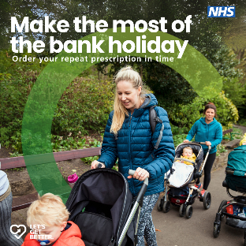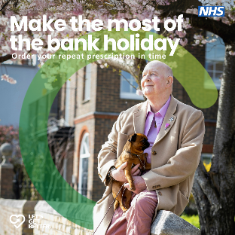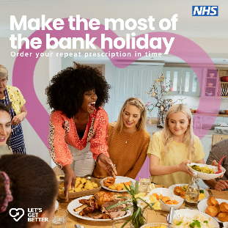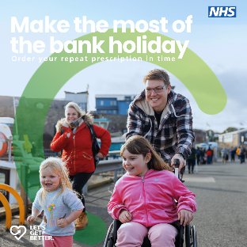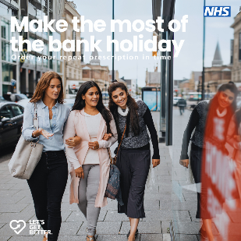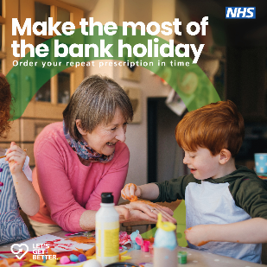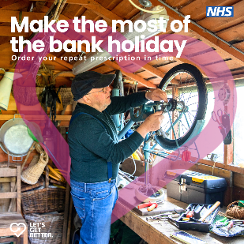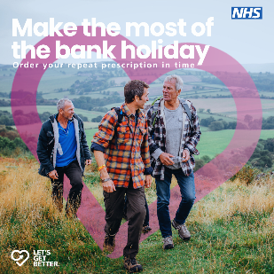

Please also support by sharing posts from our Facebook and Instagram pages.

