# **Guide to Recording Specialist/Red Drugs in SystmOne and EMISWeb**

Several medications are prescribed and/or supplied directly to patients by organisations other than GP practices. Typically, these include specialist drugs prescribed solely by secondary care or other specialist providers, for example, biologics, methadone and clozapine.

Clinicians in General Practice should be aware that these medicines are being prescribed elsewhere to:

* Support clinical decision-making.
* Avoid interactions or other risks when a new medication is prescribed.
* Provide a full drug history to other providers to support e.g. medicines reconciliation.
* Recognise any adverse events associated with the medication not prescribed directly by General Practice and taking appropriate actions.
* Aid decisions about, e.g. vaccinations required.

Patient safety incidents have occurred due to GP Practices not knowing about specialist medicines prescribed by other providers; hence, it is important for GP practices to maintain a record of these medications in their clinical system.

# **Guide to Recording Specialist/Red Drugs in SystmOne**

SystmOne has the facility to record red drugs prescribed by specialists on the

patient’s clinical record. This guide will show you how to display the red drug in a separate section of the patients’ medication list.

1. Select the patient and **right click** on the **Medications** tab on the clinical tree.

From the popup list that appears select **Record Other Medication.**

.

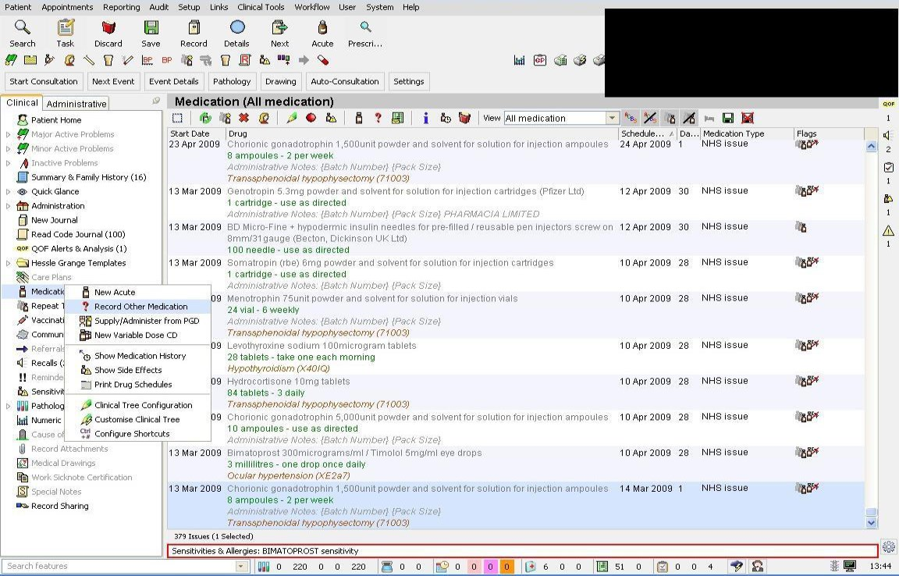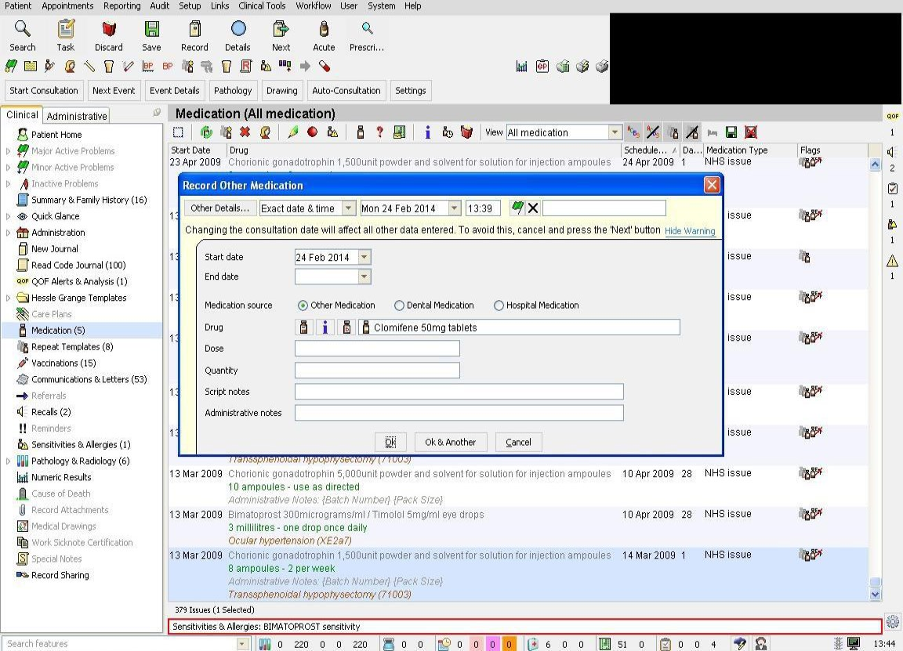

2. In the popup window that appears search for the drug the patient has been prescribed by entering its name in the **drug** box.

3. Once the drug has been selected, select the correct medication source option i.e. hospital, dental or other e.g. methadone or complete the other boxes as follows:

- ***Dose:*** *CONSULTANT/SPECIALIST PRESCRIBED: DO NOT ISSUE* - **Quantity:** *ZERO (or lowest possible quantity possible e.g. 1 tablet or 1ml)* - ***Administrative notes:*** *Prescribed by hospital*

When complete click **OK**

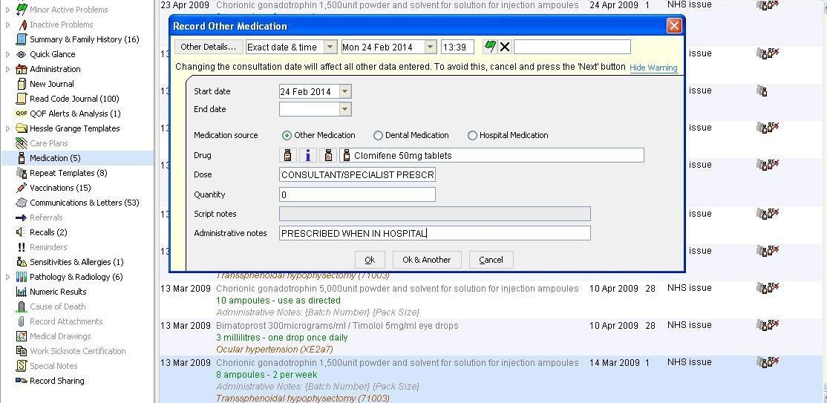

*CONSULTANT/SPECIALIST PRESCRIBED: DO NOT*

*ISSUE* *ZERO (or 1 tablet, 1 ml)*

*Prescribed when in hospital*

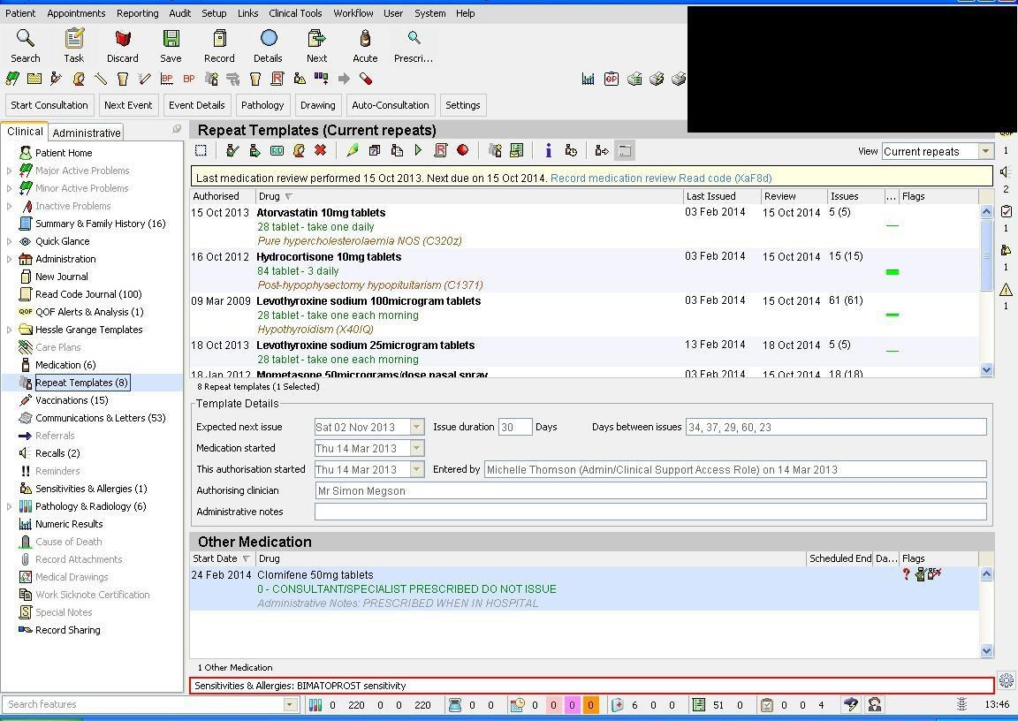

4. The red drug will be displayed in a separate section beneath the Repeat Template medication list. The medication will not be issued but the system will flag up potential interactions and give a complete record of the patients’ current treatment.

# **Guide to Recording Specialist/Red Drugs in EMISWeb**

EMIS currently lacks robust and fully appropriate functionality, so it is essential that all practice staff adhere to this guidance and avoid inadvertently issuing prescriptions for these medicines.

**Instructions:**

1. Open ‘Medication’ tab

2. Select ‘Add Drug’ icon and enter drug details

3. Complete the other required details of the non-practice drug:

- **‘Dose’:** SUPPLIED BY SPECIALIST – NOT TO BE ISSUED BY GP

**- ‘Quantity’**: Enter lowest possible quantity possible, e.g. 1 tablet or 1ml **- ‘Rx Types’**: Select ‘Acute’ or ‘Repeat’

4. **Select ‘Issue’**. This will open another window.

5. **Go to the ‘Change All’** tab; select **‘Record Hospital (No Print)’** from the drop-down menu (see next page)

6. Then click on ‘Approve and complete’.

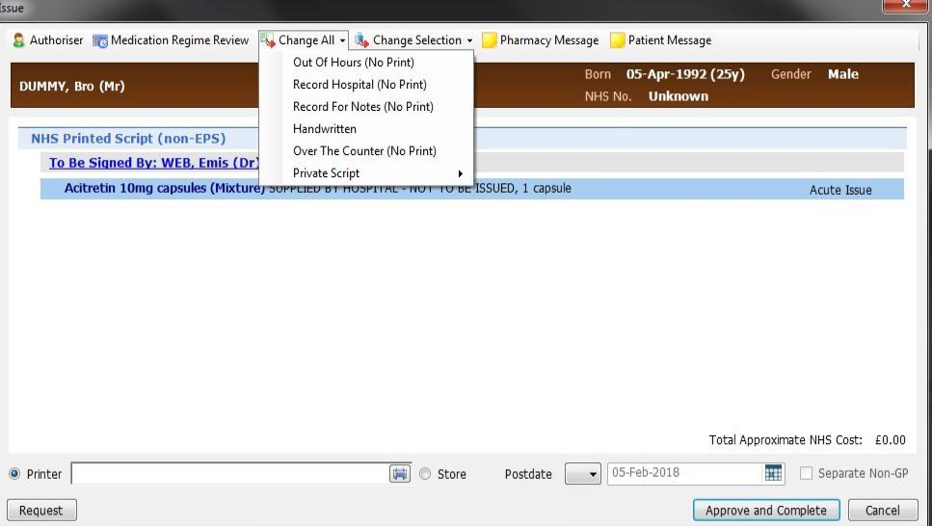

7. The RED drug will now be displayed in a different section of the medication screen to that of GP Practice issued medications

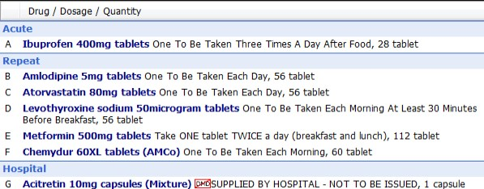

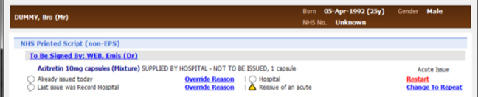8. If you wish to issue the hospital drug, a warning appears in the ‘**Approve and Complete**’ print box stating it was ‘**issued by hospital**’.

***There is still a potential risk to issue a red drug in error, hence, the above entry instructions must be strictly adhered to.***