COVID 19 Spring Booster Social Media Assets
The COVID 19 Spring Booster is now available. The eligibility is the same as for Spring 2024:
- Adults aged 75 years and over
- Residents in ca care home for older adults
- Individuals aged 6 months and over who have a weakened immune system.
Please see below assets with suggested copy for organisations to use across their social media channels.
Example post | Alt Text | Graphic
COVID-19 can still cause serious illness and even be life-threatening particularly for older people and those with a weakened immune system.  The COVID-19 Spring booster is available now for anyone aged 75 and over, or who has a weakened immune system.  The vaccine provides protection against the virus and helps reduce the risk of serious illness and hospitalisation.  Whether you or a family member is eligible, or you’re caring for someone who is, then either call 119 or visit nhs.uk/get-vaccine to book your guaranteed appointment now.  Protect yourself and your loved ones with the COVID-19 vaccination. | Older white man showing his upper arm, displaying a small plaster.  Text reads: COVID-19 can still cause serious illness.  Are you aged 75 or over?  Book your spring booster vaccination now! | 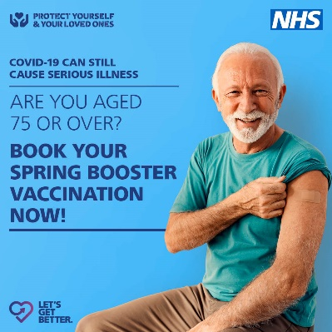
 | Older white woman showing her upper arm, displaying a small plaster.  Text reads: COVID-19 can still cause serious illness.  Are you aged 75 or over?  Book your spring booster vaccination now! | 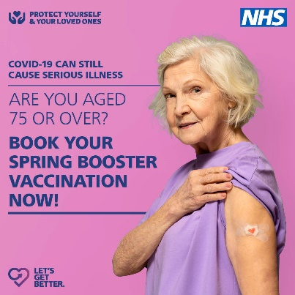
 | Middle aged white woman wearing a sleeveless top displaying a small plaster on her upper arm.  Text reads: COVID-19 can still cause serious illness.  Do you have a weakened immune system?  Book your spring booster vaccination now! | 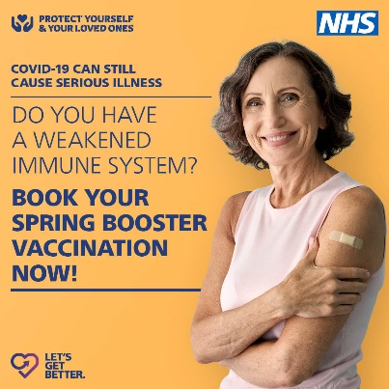
 | Young black man showing his upper arm, displaying a small plaster.  Text reads: COVID-19 can still cause serious illness.  Do you have a weakened immune system?  Book your spring booster vaccination now! | 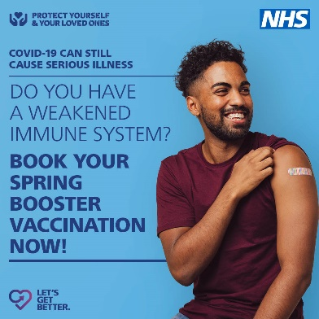
 | Young white woman wearing a vest top, displaying a small plaster on her upper arm.  Text reads: COVID-19 can still cause serious illness.  Do you have a weakened immune system?  Book your spring booster vaccination now! | 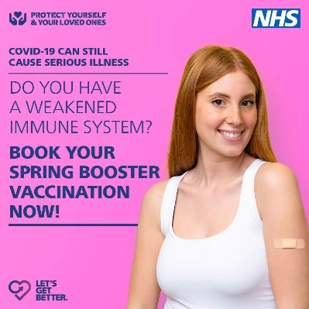

All posts to link through to nhs.uk/bookcovid

