**Single System Formulary Alignment**

**Fast-tracked applications for consultation as part of the System Recovery Plan - Commissioning, Medicines & Referral Optimisation.**

**Supported, at pace, by 'System Leaders' – Chief Executives.**

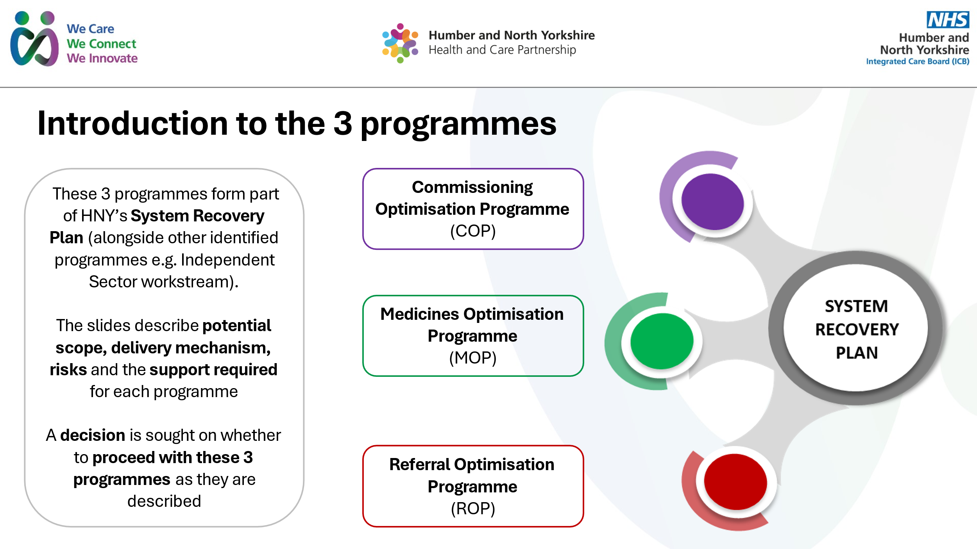

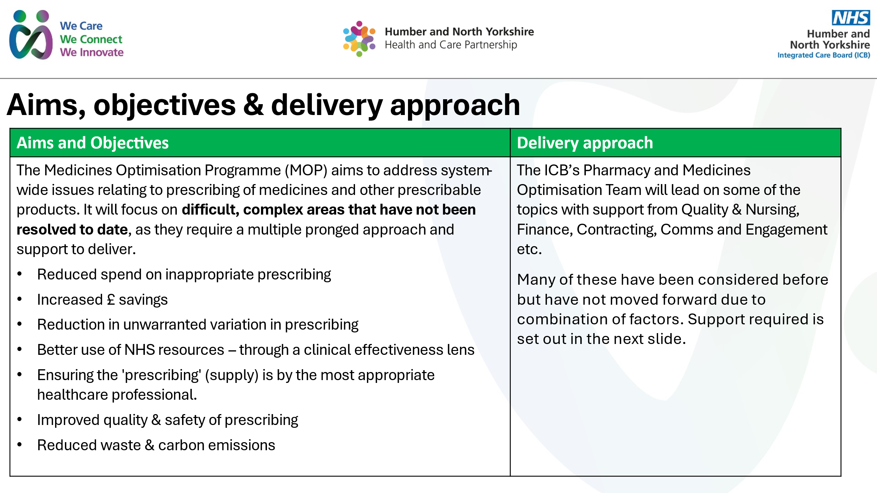

This paper asks Medicines Formulary Group to approve moving to the consultation stage on several key areas of low priority prescribing to expedite the alignment of HNY formulary.

Reference: <https://www.england.nhs.uk/long-read/items-which-should-not-routinely-be-prescribed-in-primary-care-policy-guidance/>

Some of the recommendations are deliberately more restrictive, as HNY is a national outlier in some of the areas, with high spending and very limited evidence for clinical effectiveness.

| **Drug** | **Why** | **Proposed RAG status** |
| --- | --- | --- |
| Lidocaine patches | Lidocaine patches are considered a 'low priority' medicine and are listed as part of [NHS England » Items which should not be routinely prescribed in primary care](https://www.england.nhs.uk/medicines-2/items-which-should-not-be-routinely-prescribed/).  There is very limited clinical evidence for their use.  We spend £460,000 per year on lidocaine patches  We are outliers: Data source: <https://openprescribing.net/measure/lplidocaine/icb/QOQ/> | Do not prescribe – not routinely commissioned. |
| Liothyronine | The cost ranges from £55 - £152 per 28-day supply. This is in comparison to the preferred treatment option for hypothyroidism, levothyroxine, which is £0.73 – £2.68 per 28 days.  The ICB spends £510,000 per year on liothyronine. Humber and North Yorkshire ICB is one of the highest prescribers of liothyronine, significantly higher than the national average:  <https://openprescribing.net/measure/lpliothyronine/icb/QOQ/>  Liothyronine is only recommended for use in specific circumstances: <https://www.england.nhs.uk/long-read/liothyronine-advice-for-prescribers/>   * follow [NHS England prescribing advice on liothyronine](https://www.england.nhs.uk/long-read/liothyronine-advice-for-prescribers/) when initiating or reviewing the prescribing of liothyronine * the recommendations do not apply to patients who have already been reviewed by an NHS consultant endocrinologist * all other patients currently taking liothyronine should be reviewed by an NHS consultant endocrinologist to determine future treatment plans * new patients with overt hypothyroidism whose symptoms persist on levothyroxine may be prescribed liothyronine after a 3-month or longer review by an NHS consultant endocrinologist  |  |  |  |  | | --- | --- | --- | --- | | Product and strength | DT price (May 2025) | Quantity | Price per tablet/capsules | | Liothyronine 10microgram capsules | £65.00 | 28 | £2.32 | | Liothyronine 10microgram tablets | £152.44 | 28 | £5.44 | | Liothyronine 2.5microgram capsules | £205.43 | 100* | £2.05 | | Liothyronine 20microgram capsules | £55.00 | 28 | £1.96 | | Liothyronine 20microgram tablets | £62.20 | 28 | £2.22 | | Liothyronine 25microgram tablets | ? | 100** | - | | Liothyronine 5microgram capsules | £55.00 | 28 | £1.96 | | Liothyronine 5microgram tablets | £83.27 | 28 | £2.97 | | Red – specialist use only for specific indications, as per NHSE guidance.  A review by an endocrinologist has to be completed an NHS endocrinologist working as part of NHS services.  Only commission most cost-effective versions of liothyronine. Currently, this is liothyronine capsules. |
| Levothyroxine | Only commission most cost-effective versions of levothryroxine.   |  |  |  |  | | --- | --- | --- | --- | | Product and strength | DT price (May 2025) | Quantity | Price per tablet/capsules | | Levothyroxine sodium 100microgram capsules | £72.99 | 50* | £1.46 | | Levothyroxine sodium 100microgram tablets | £0.61 | 28 | £0.02 | | Levothyroxine sodium 12.5microgram tablets | £12.34 | 28 | £0.44 | | Levothyroxine sodium 25microgram capsules | £57.41 | 28* | £2.05 | | Levothyroxine sodium 25microgram tablets | £0.73 | 28 | £0.03 | | Levothyroxine sodium 50microgram capsules | £46.01 | 28* | £1.64 | | Levothyroxine sodium 50microgram tablets | £0.60 | 28 | £0.02 | | Levothyroxine sodium 75microgram tablets | £2.68 | 28 | £0.10 | | Expensive products - Do not prescribe – not routinely commissioned. i.e. do not prescribe levothyroxine capsules or 12.5mcg tablets.  Green =  25mcg, 50mcg, 75mcg and 100mcg tablets only. Tablets can be halved if needed. |
| Co-proxamol | Items where no prescribing is appropriate (that is, no exceptions apply)  Items where no prescribing is appropriate because there are significant safety concerns or there is no evidence of clinical effectiveness for all patient populations.  Recommendations   * Do not initiate in primary care. * Deprescribe in patients currently prescribed this medicine.   <https://www.england.nhs.uk/long-read/items-which-should-not-routinely-be-prescribed-in-primary-care-policy-guidance/> | Do not prescribe – not routinely commissioned. |
| Glucosamine & chondroitin | Do not prescribe – not routinely commissioned. |
| Herbal treatments and other natural products | Do not prescribe – not routinely commissioned. |
| Homeopathy | Do not prescribe – not routinely commissioned. |
| Minocycline for acne | Do not prescribe – not routinely commissioned. |
| Omega-3 fatty acid compounds - excluding icosapent ethyl | Do not prescribe – not routinely commissioned. |
| Silk garments | Do not prescribe – not routinely commissioned. |
| Aliskerin | Do not initiate in primary care.  Deprescribe in patients currently prescribed this item.  Prescribe only if no other item or intervention is clinically appropriate.  Prescribe only if no other item or intervention is available. | Do not prescribe – not routinely commissioned. |
| Bath and shower preparations for dry and pruritic skin conditions | Do not initiate in primary care.  Deprescribe in patients currently prescribed this item.   * substitute with ‘leave-on’ emollients. | Do not prescribe – not routinely commissioned |
| Dosulepin | Do not initiate in primary care.  Deprescribe in patients currently prescribed this item.  Prescribing decision should be made after a multidisciplinary team discussion, risk assessment, fully documented. | Do not prescribe – not routinely commissioned |
| Doxazosin (prolonged release) | Do not initiate in primary care.  Deprescribe in patients currently prescribed this item. | Do not prescribe – not routinely commissioned |
| Lutein and antioxidants | Do not initiate in primary care.  Deprescribe in patients currently prescribed this item. | Do not prescribe – not routinely commissioned |
| Oxycodone and naloxone combination product | Do not initiate in primary care.  Deprescribe in patients currently prescribed this item.  Prescribing decision should be made after a multidisciplinary team discussion | Do not prescribe – not routinely commissioned |
| Paracetamol and tramadol combination product | Do not initiate in primary care.  Deprescribe in patients currently prescribed this item. | Do not prescribe – not routinely commissioned |
| Perindopril arginine | Do not initiate in primary care.  Deprescribe in patients currently prescribed this item. | Do not prescribe – not routinely commissioned |
| Rubefacients, benzydamine, mucopolysaccharide and cooling products (excluding NSAIDs and capsaicin) | Do not initiate in primary care.  Deprescribe in patients currently prescribed this item. | Do not prescribe – not routinely commissioned |
| Trimipramine. | Do not initiate in primary care.  Deprescribe in patients currently prescribed this item.  Prescribing decision should be made after a multidisciplinary team discussion, risk assessment, fully documented. | Do not prescribe – not routinely commissioned |
| Immediate release fentanyl | * Do not initiate in primary care. * Deprescribe in patients currently prescribed this item. * Prescribe only if no other item or intervention is clinically appropriate. * Prescribe only if no other item or intervention is available. * Prescribe only if for an indication named in this guidance. * the recommendations do not apply to patients undergoing palliative care treatment and where the recommendation to use immediate release fentanyl, in line with the [NICE Guideline opioids in palliative care](https://www.nice.org.uk/guidance/CG140), has been made by a multidisciplinary team and/or other healthcare professional with a recognised specialism in palliative care | Red – specialist use only  UNLESS for palliative care and then amber specialist recommendation. |
| Needles for pre-filled and reusable insulin pens.  Cost >£5 per 100 needles | These recommendations do not apply when the cost is <£5 per 100 needles   * Do not initiate in primary care. * Deprescribe in patients currently prescribed this item. * Prescribe only if no other item or intervention is clinically appropriate. * Prescribe only if no other item or intervention is available. * Prescribe only if for an indication named in this guidance. | Do not prescribe – not routinely commissioned |
| All travel vaccines | Exceptions: only the following vaccines may be administered on the NHS exclusively for the purposes of travel, if clinically appropriate:   * + cholera   + diphtheria/tetanus/polio   + hepatitis A   + typhoid. * Do not initiate in primary care. * Deprescribe in patients currently prescribed this item. * Prescribe only if no other item or intervention is clinically appropriate. * Prescribe only if no other item or intervention is available. * Prescribe only if for an indication named in this guidance. | Do not prescribe – not routinely commissioned |

Where a proposed traffic light status is not supported through the APC consultation process, stakeholders will be requested to provide alternatives to support the implementation of the low priority prescribing measures.