Optional Template– Interim and Final report for Health Equity Fellowship
Project Details
Project Name | ‘No Pressure’
Mentor | Tom Dolman
Start Date | May 2024
Summary/Abstract – FINAL REPORT
This project entitled ‘No Pressure’ was developed to capture blood pressure readings opportunistically on two patient groups in Hull - a city in the north of England. The two patient groups, due to their ethnicity are understood to have a higher prevalence of hypertension and to potentially experience health inequalities and/or poorer outcomes. Using a Community Pharmacy service specification, a total of 47 patients received opportunistic blood pressure monitoring as part of the No Pressure project. The project was delivered over two days in two mobile clinic settings, with the first being held in a hotel accommodating men from a global ethnic majority group who are seeking asylum. The second mobile clinic was held at a women’s group in a community centre who provide support services to the community with an emphasis on Black, Asian and Minority Ethnicity groups. Of the 47 people who took part, there were 34 blood pressure readings that were classed as NORMAL. One person was symptomatic of low blood pressure and their blood pressure reading was classed as LOW. 12 people had a blood pressure reading that was classed as HIGH. There were other health concerns for some participants identified as part of the project and this stimulated some health promotion and education conversations with signposting to further support. The project results yielded 25% of the participants had high blood pressure readings and these were referred for ambulatory blood pressure monitoring (ABPM), as stipulated in the service specification. The limitations of the project and attached resource meant that there was little opportunity to follow up each patient to explore the outcome of their ABPM and subsequent treatment/care. This would be a recommendation for further work and future opportunistic hypertension case finding. The results did however demonstrate the value of opportunistic hypertension case finding as the participants who had high blood pressure readings were asymptomatic at the time of monitoring and would not have had further exploration of their blood pressure without these clinics – potentially placing them at risk of hypertension related health problems.
Introduction | “Hypertension (high blood pressure) is when the pressure in blood vessels is too high (140/90 mmHg or higher). It is common and can be serious if not treated” (WHO, 2023). It is well documented that Cardiovascular Disease (CVD) is one of the leading causes of premature death in England, and that hypertension is a risk factor for CVD. WHO estimate 46% of adults with hypertension are unaware that they have the condition – hence the importance of opportunistic casefinding.  Treatment for hypertension is very effective at lowering blood pressure and at improving outcomes and significantly reduces the risk of heart attacks, stroke, heart failure and all-cause mortality (National Kidney Foundation, 2024). The Core Twenty PLUS FIVE is a strategy to reduce health inequalities with one of the five clinical priorities being to improve opportunistic hypertension case finding (NHS England, 2021).  It is well known that there are health inequalities experienced by the Global Majority (also known as the non-white community or Black, Asian, Minority Ethnic BAME group), with one inequality being a higher prevalence of hypertension. The modifiable contributions to hypertension include excess dietary salt, obesity and diet, excess alcohol consumption, low physical activity, deprivation, mental health and excess stress WHO, 2023. The non-modifiable characteristics are reported to be ageing, ethnicity, gender and genetics.  There is a national service specification produced by NHS England which supports Community Pharmacies to provide a free blood pressure monitoring service - available for anyone to access, but locally this relies on people attending community pharmacy sites to access this. There are reported barriers to accessing health services experienced by the Global Majority/Non-White population and subsequently there is a poor uptake of the blood pressure monitoring community pharmacy service locally by this population.  This project combines the identification of hypertensive patients in a northern city in England, with reducing a health inequality of a community who have a protected characteristic, outreaching the existing community pharmacy model to areas populated by global majority groups.
Central aim of the project | Opportunistic hypertension casefinding of a global majority community in a city in the North of England.
Methodology, results, conclusion | Prevalence rates for hypertension locally have been extensively researched using data collection from local and national prevalence sources. Population of global majority data extracted from Joint Strategic Needs Assessment (JSNA), and link to hypertension (both diagnosed and undiagnosed) scrutinized from the Office of National Statistics data available.  Similar projects that have been developed regionally and nationally have been reviewed and in particular the lessons learnt from these have been useful.  Meetings with Fellowship Project Mentor have been useful to reflect on other models of hypertension case finding – and examples from their experiential evidence have been used to inform this project.  The Community Pharmacy National Service Specification has been used as a framework for the mobilisation of this project as the infrastructure and ethics have been ratified, including escalation and risk management. The project will also benefit the Community Pharmacy service locally from an income generation perspective, and therefore it was deemed appropriate to utilise this model by outreaching their services – with the aim of raising the profile of community pharmacy services through opportunistically case finding hypertensive patients.  The Local Medical Council (LMC), Primary Care network and Global Majority supporting agencies have been consulted to ensure the pathway for patients is clear and to maintain professional relationships between all stakeholders. A session presenting the plan was delivered to local GPs at a Protected Time for Learning event, and the project was presented to the Service User Voice Group (Patient participation and engagement forum).
Purpose and Overview of the Project
Background/context
The problem | Hypertension is reported to affect 22% of the UK adult population. Life expectancy is 12.7 years lower for men and 10.2 years lower for women in the most deprived areas of Kingston upon Hull than in the least deprived areas (Hull JSNA). In addition to this, the rates of under age 75 mortality from cardiovascular disease in Hull is worse than the England average (British Heart Foundation). In the 2021 census 22,024 (8.2% of the Hull population) were from a global majority group (excluding white minorities). The JSNA identifies that there is ‘often a lack of information in relation to the health and wellbeing needs of people from global majority heritage, and some members of this community may experience language barriers and other barriers in relation to accessing services’.  Although Hull is becoming increasingly more culturally diverse, the above figures of people living in Hull who are from the non-white global majority are lower than the UK average . Of those people, the highest proportion of people from global majority groups live around Hull city centre, the east of the city centre and in the University neighbourhood.  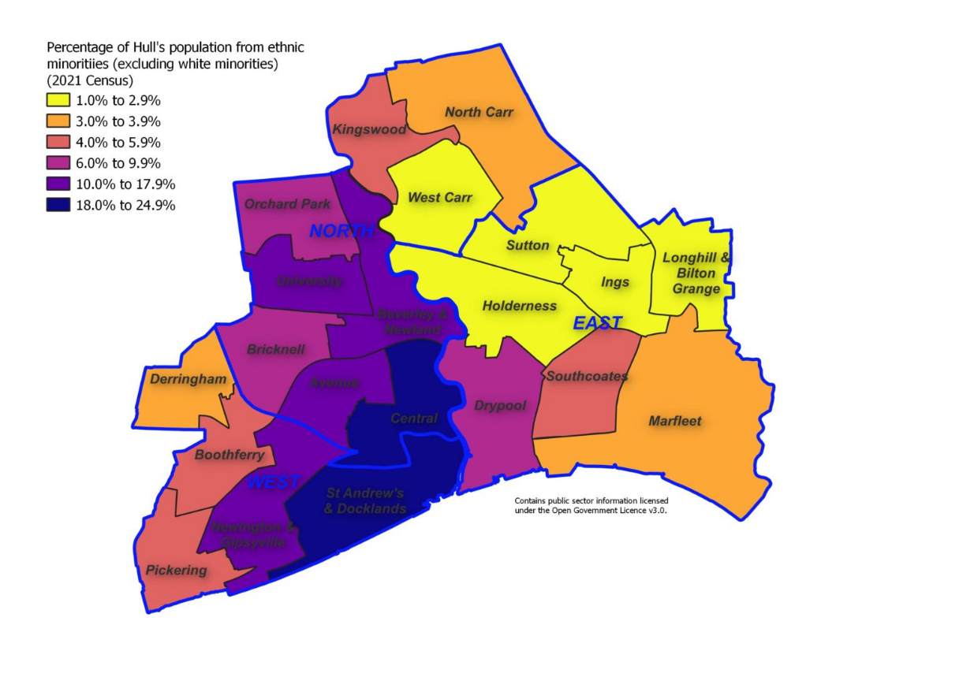  The above map depicts the demographic population of the global majority community in Hull. For the purposes of this project, the central and university areas of Hull were chosen as they are the most densely populated with people from global majority groups.  The existing pathways with threshold for escalation were clearly stipulated in the service specifications to ensure the project was safe and compliant with risk management.
Key assumptions and interdependencies | A similar project in Barnsley called “How’s Thi’ Ticker?” reported that a third of the people who had an opportunistic blood pressure undertaken were escalated for further assessment. The hope was that this project would yield similar results that demonstrated a proof of concept for outreach into the community to opportunistically casefind hypertension. There was an acknowledgement that this could potentially increase patient flow to the GP practices – and therefore the GPs were informed of the project and assurance was given in relation to escalation pathways through A&E or Urgent Treatment Centres. Due to the small scale of the project, this did not present itself as a large concern – however future projects which are larger in scale will require assurance that the infrastructure is able to cope with a potential increase of patients requesting same day appointments to address concerns, whether these be actual or perceived.
Overall purpose of this project | To establish if an outreach model of community pharmacy increases opportunistic hypertension casefinding in the global majority community of Hull.

Why it needs to be done | The City of Hull has a population of approximately 260,000 people. If prevalence rates are accurate in estimating 30% of adults are hypertensive, that equates to around 78,000 people with high blood pressure in Hull. In terms of the global majority community in Hull, we know that hypertension disproportionately affects global majority populations, such as those of African, South Asian, and Caribbean descent, in Hull. Prevention through screening and opportunistic case-finding can help reduce the elevated risk of hypertension-related complications in these communities by providing early diagnosis and treatment.  Lives and Events Prevented: Focusing on these populations could result in a significant reduction in strokes, heart attacks, and deaths, thereby helping to improve equity in healthcare outcomes in the global majority population across Hull.  The NHS spend £2.1 billion annually treating hypertension related conditions (NHS England).  The Stroke Association reported that in 2015 the average societal cost of a significant stroke per person is as follows: £45,409 in the first 12 months after stroke (cost of incident stroke), plus £24,778 in subsequent years. In addition to the financial impact, the other associated costs are reduced employment opportunities, psychological harm of the patient and their loved ones, and reduced quality of life.  The World Health Organisation (2021) claim hypertension related death is a worldwide problem, stating that we need to ‘act now’ to tackle hypertension, in order to save lives and reduce the financial and non-financial burden that uncontrolled hypertension can cause.
Opportunities and Challenges | Professionals and communities benefiting from this project.  Opportunities include –  - Professional networking, collaborating with services in partnership  - Reducing stigma of accessing healthcare and increasing uptake of screening  - Making Every Contact Count (MECC) agenda filtration,  - Enhanced patient health literacy and navigation of available services,  - Improved patient access and community relationships with health services, enhancing patient literacy/autonomy and self-efficacy of patients.  - Potential avoidance of catastrophic episodes of illness related to hypertension, longer term reduced costs of acute stroke and post stroke care.  - Increased uptake of community pharmacy services by showcasing aspects of their services patients may otherwise have little knowledge of.  Challenges include:  - Potential poor patient engagement/participation with project – communities may be suspicious of health professionals reaching out to their community and ‘safe space’.  - Lifestyle/cultural education challenges – high salt content diet, low uptake of exercise and potential resistance to change in behaviour and culture.  - GPs may be overwhelmed and unable to respond to newly identified need which may cause additional stress on infrastructure in primary care.  - There is an acknowledgement as part of the project that there are other reasons people may present with high blood pressure readings, which include health anxiety, commonly referred to as ‘white coat syndrome’ and therefore high blood pressure readings may cause unnecessary stress to the patients. This was explained prior to taking a blood pressure reading and is the reason ABPM was offered to obtain a clearer blood pressure monitoring profile.  - Sustainability – how can this be maintained and rolled out within other communities if successful?
Desired results of the project | Identification and escalation of hypertension in individual people within a global majority community of Hull. This is a proof of concept to establish if we are able to mobilise the community pharmacy blood pressure checks into places frequently accessed by a targeted community. The team who were present to monitor blood pressures also provided health promotion and lifestyle adjustment information to ensure we maximised the ‘right place, right time’ spirit of the MECC agenda.  Ultimately the reduction in stroke, cardiovascular disease and premature death would be a longer term aim for the project if it is permanently established.
Brief description of methodology used | Local Medical Council consultation, discussions with Chief Pharmacist, Fellowship research for prevalence – Fingertips, EpipHNY, WHO intelligence and ICB data. Discussion with people who had their blood pressure to obtain qualitative information about the barriers for them accessing health care.
Theory of Change – OPTIONAL: INTERIM REPORT
The chosen settings for the clinics needed to be in suitable venues located in the centre of the most densely global majority populated wards within Hull. The planning phase of the project was robust and due diligence was applied to ensure this project was a helpful contribution to the system, impacting positively on the lives of the community. The ‘action phase’ was the physical act of undertaking the blood pressure monitoring, which was led by the Professional Lead for People with Protected Characteristics (undertaking the Health Equity Fellowship) and the Pharmacy team (as per the Service Specification for Community Pharmacy) . The evaluation included reflection of the outreach clinics and analysis of the data that was extracted from the blood pressure and demographic of those who engaged.
Findings | 12 out of 47 people were identified as having high blood pressure readings (25% of participants) over two clinics. All 12 were referred for ABPM. 1 patient was referred for medical assessment due to low blood pressure and symptomatic presentation.  Income generation by community pharmacy for each participant who met the criteria for the organisation to claim tariff.
Inputs | 1 x afternoon clinic in the centre of Hull at the hotel used to accommodate people from a global majority who are seeking asylum.  1 x Pharmacy Technician, 1 x Registered Pharmacist and 1 x Project Leader (Registered Nurse)  1 x morning clinic in a community support hub Women’s group 1 x Pharmacy Technician, 1 x Registered Pharmacist and 1 x Project Leader (Registered Nurse).  Interpreters and easy read documentation used to ensure robust communication and assessment.  Incentives provided included promotional low value gifts such as pens, hats and mugs.  Risk assessments for each clinic setting took place prior to the clinics to ensure safety and compliance with the community pharmacy service specification.
Activities undertaken | A blood pressure monitoring clinic with 2 readings taken on each participant. (Left arm and then right arm). Record sheet completed to support income generation and claiming for each participant who met the criteria. Liaison with GP informing them of the BP readings. Collation of the results and feeding back to the Service User Group (patient engagement panel), and strategic leaders within the Professional Lead’s employing organisation.
Impact | Opportunities to deliver health promotion and education around maintaining a healthy blood pressure will support knowledge and enable patients to make informed choices and lifestyle adjustments. Patients become familiar with accessing community pharmacy services. Potential hypertension referrals to treat to target and reduce risk of stroke and other hypertension related disease or mortality causes.
Outputs | 47 people participated over two days. Income generation, raising the profile of the community pharmacy service, opportunity for MECC conversations and signposting to health services. Relationships between health services and inclusion health groups strengthened and subsequent health monitoring/screening events have been planned for August 2025.

No Pressure Project
Evidence and theory underpinning project | Whilst the project was still in the planning phase, all stakeholders were approached to ensure patient pathways and escalation of risk was considered as paramount. The project was originally anticipated to commence in around November/December 2024, however this was extended until February 2025 due to other work pressures and diary commitments.  There was an initial reluctance from one of the groups approached to host the clinic, as they were concerned their members would not wish to participate in the project. This concern was addressed by visiting the site before the clinic, and explaining that their members would be offered a blood pressure but that there was no pressure for them to engage. The gifts/incentives were suggested to encourage people to come forward to find out more about the project and open the dialogue about factors contributing to hypertension. There are arguments that claim that offering incentives to patients is deemed by some as unethical practice (Hodson et al; 2023) however it has been stipulated throughout that participation in the project was entirely voluntary, and the promotional goods were of very little value.  There was also a professional acknowledgement that there would potentially be concerns raised by GP colleagues who may experience an increased demand for project participants (their patients) requiring further contact/assessment within primary care, thus placing further pressure on them. With this in mind, the Local Medical Council (LMC) was approached and a presentation delivered to raise awareness of the project and provide assurance of the threshold for escalation to primary care. This was met with some valid questions from GPs– and the project was approved.  The below slide images are taken from the presentation about the No Pressure Project.  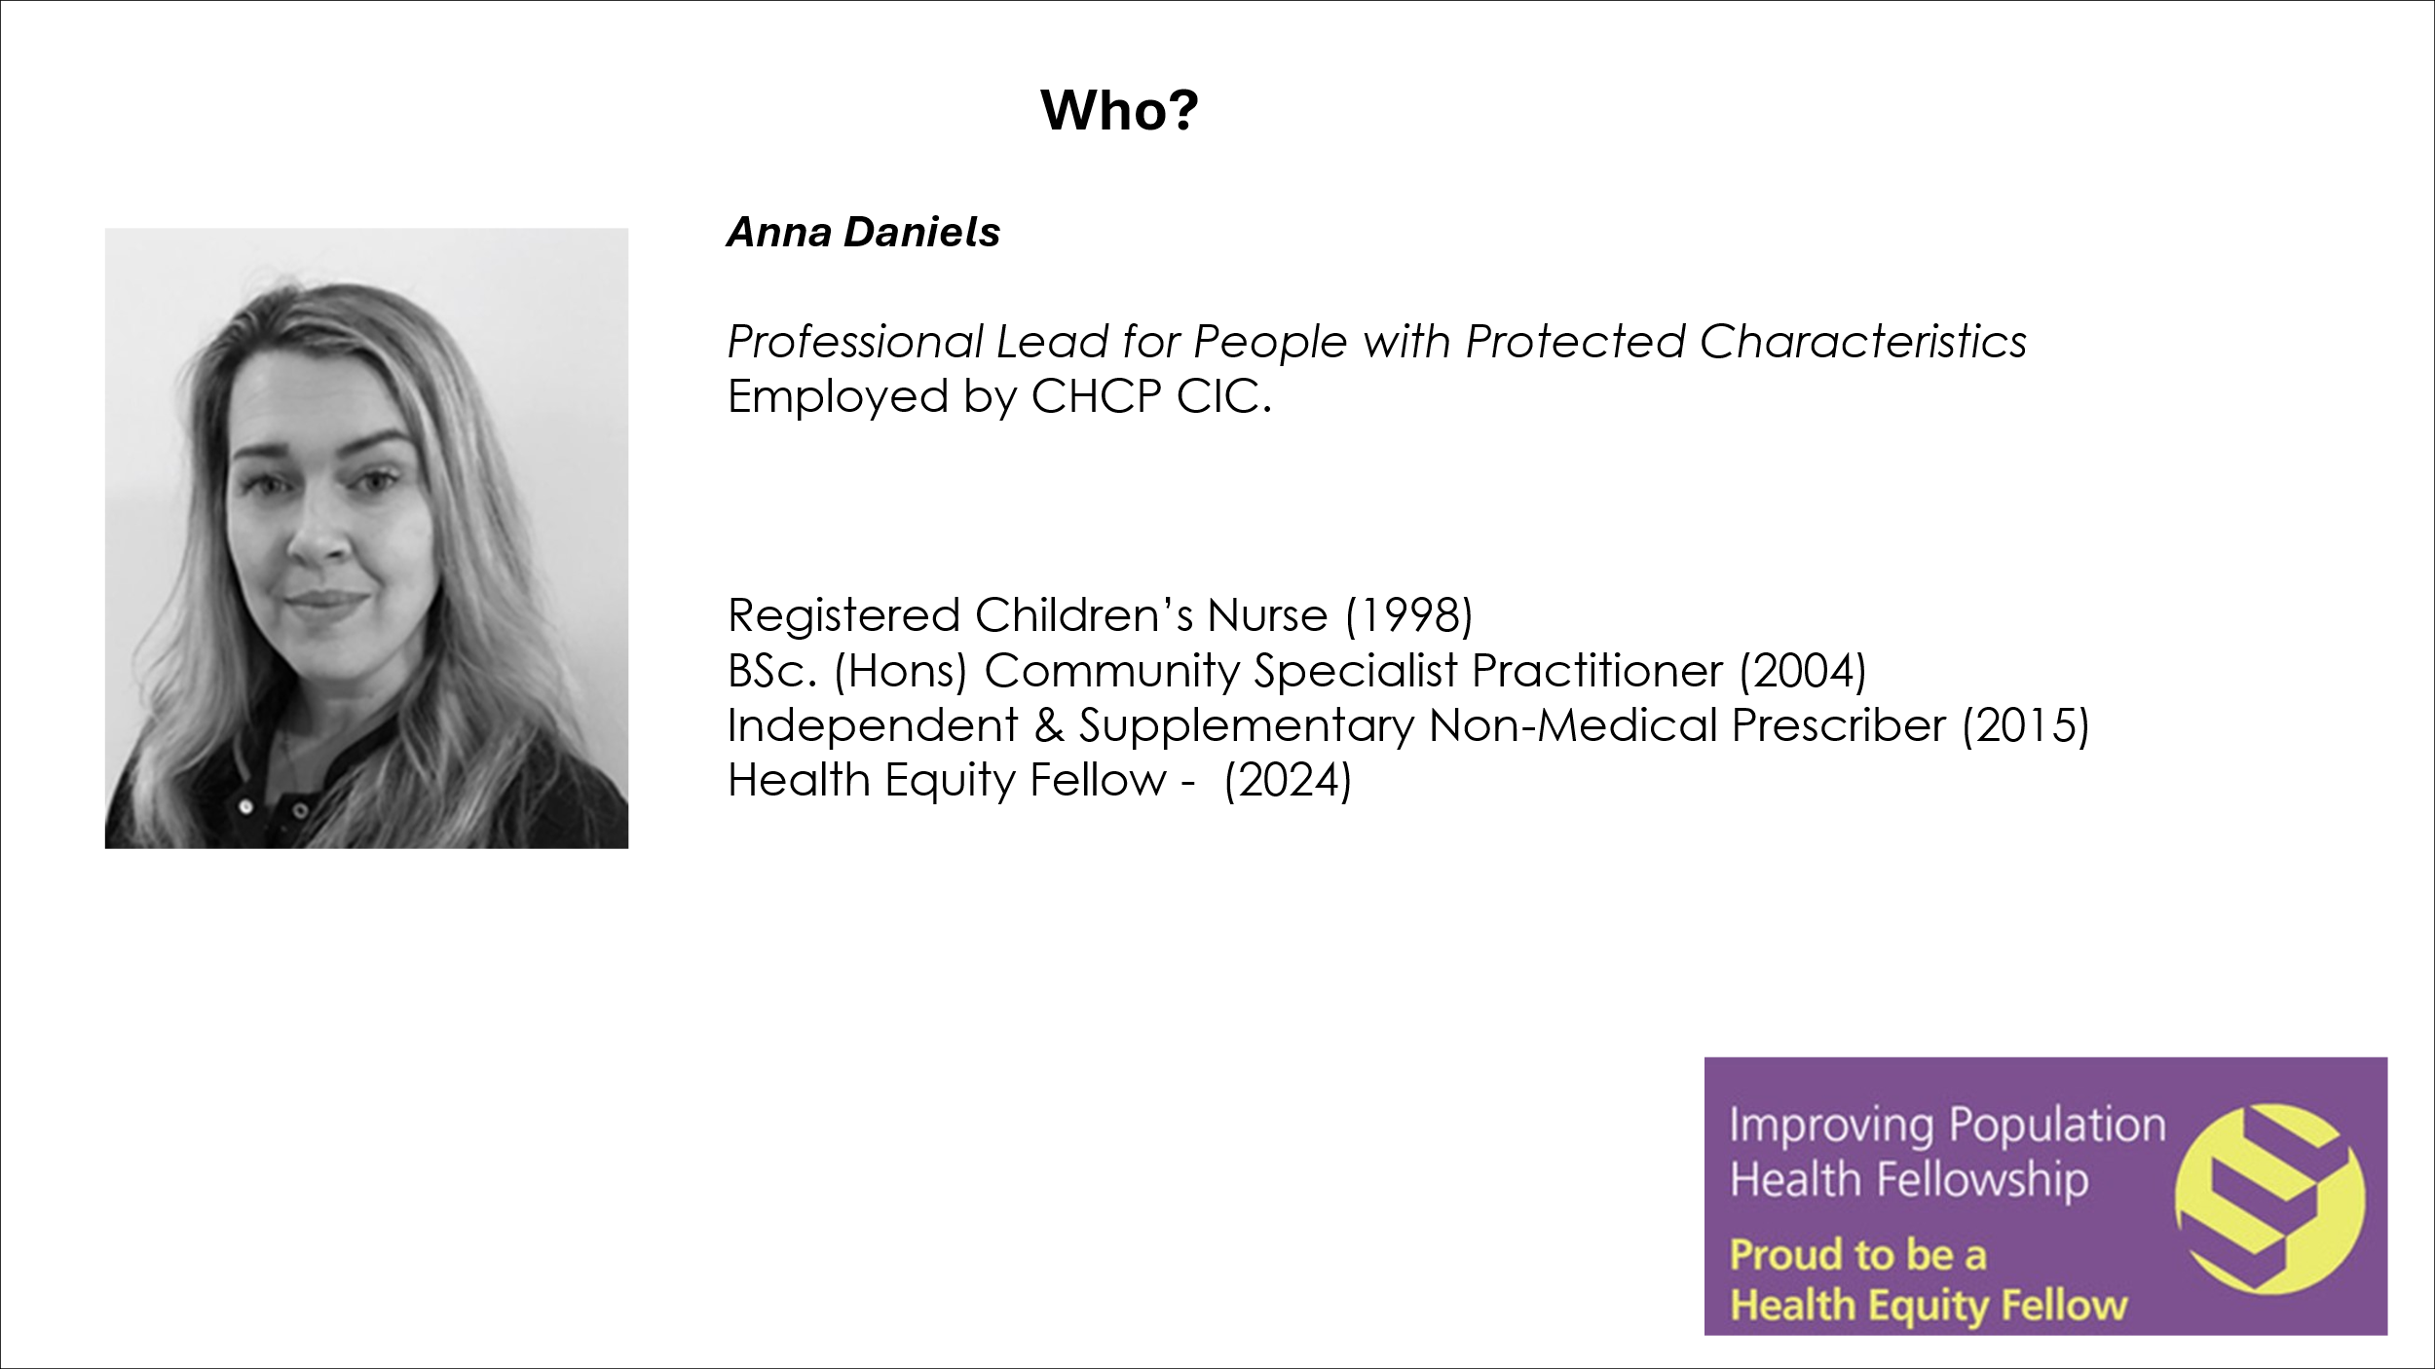  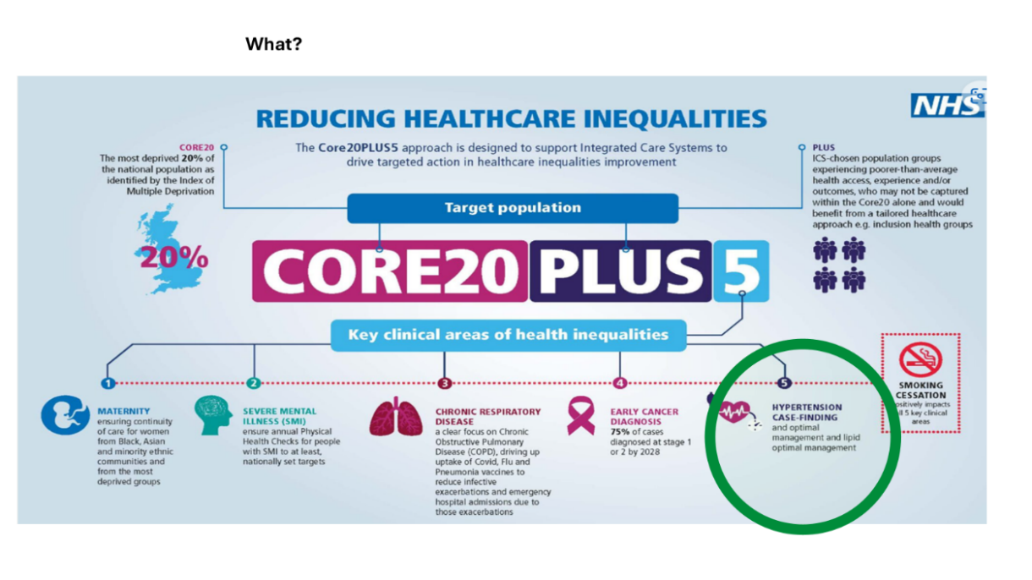  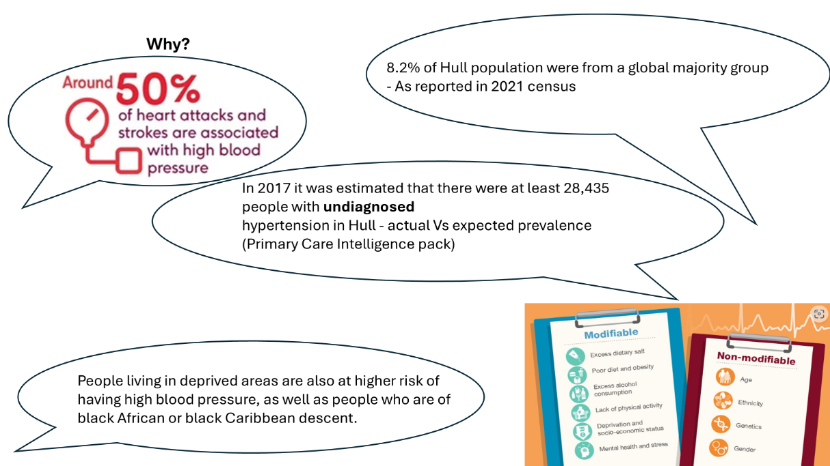  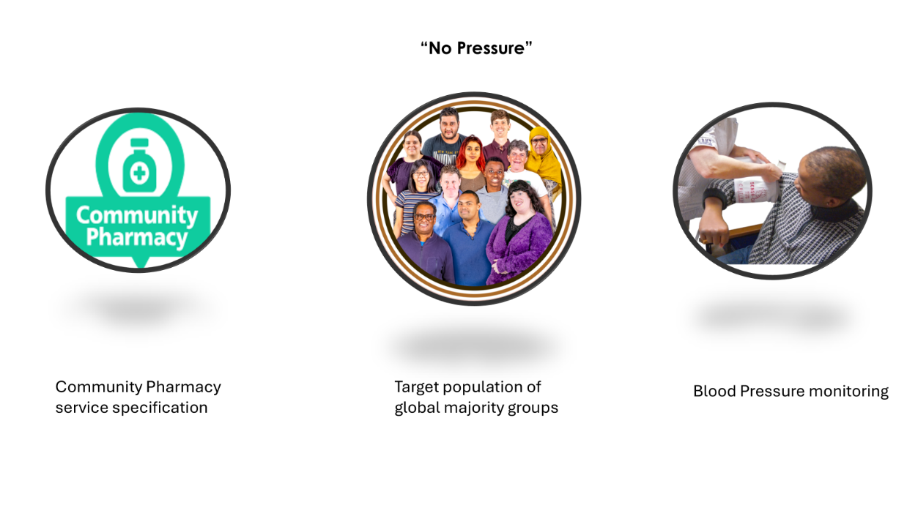  The Community Pharmacy Service Specification stipulated distinct criteria to be met when facilitating outreach clinics for hypertension case finding. This assurance took place prior to the mobilisation of the clinics in the form of risk assessments.  It is known the global majority population have an increased risk of hypertension and associated health risks, and it was predicted prior to mobilisation of the clinics that as with similar national projects, there would be an identified cohort of people with high blood pressure readings who would require further testing.  It was therefore important that there were clear pathways to follow in these instances. The service specification provides clear thresholds for further monitoring as illustrated below:  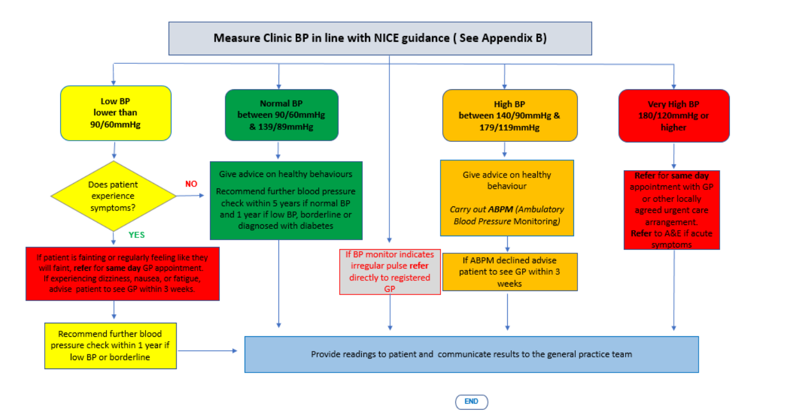NHS England: NHS community pharmacy hypertension case-finding advanced service,  ( Version 2, 2023)  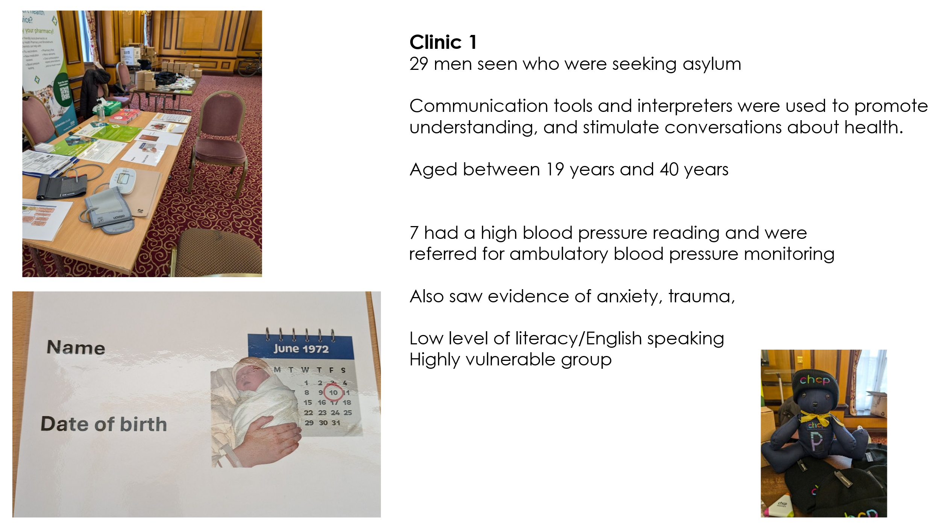  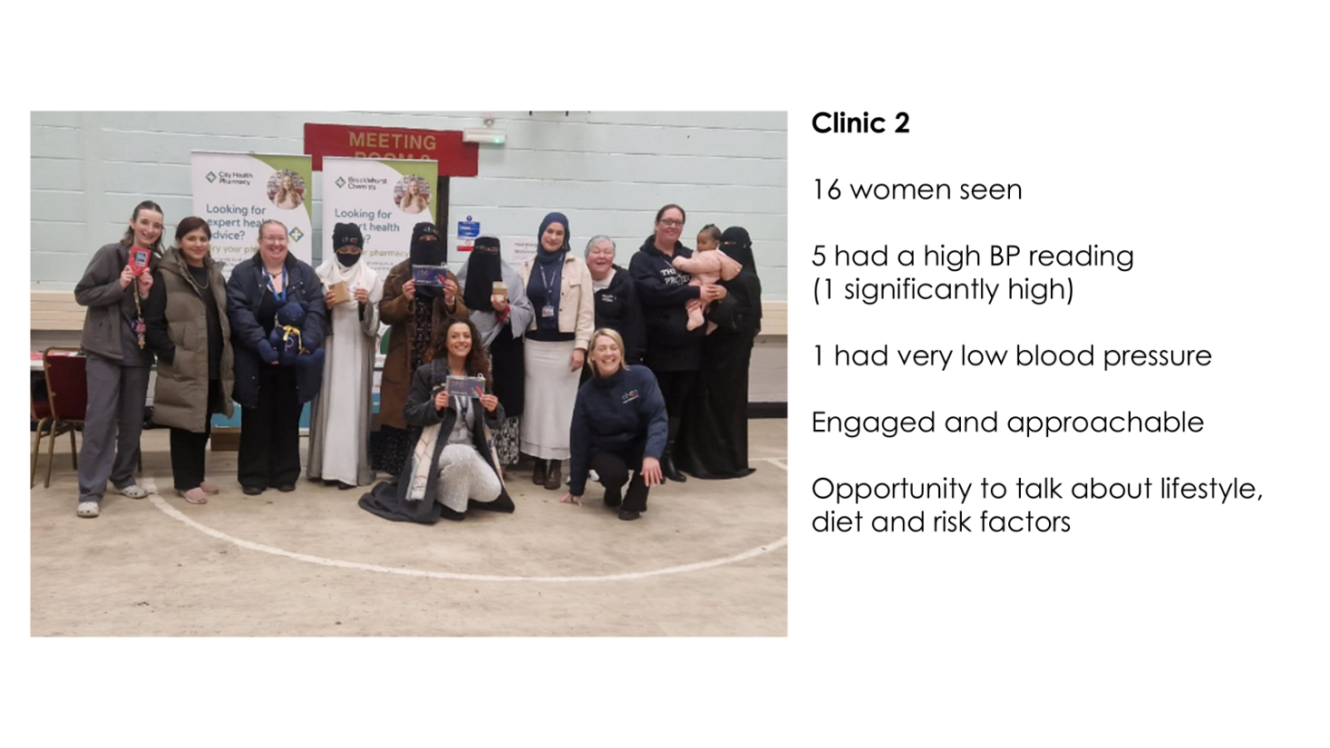
Explain your key findings, results, | 25% of the people who had their blood pressure recorded required referral for ambulatory blood pressure monitoring. There was very little understanding from the participants about their higher prevalence for hypertension, or indeed what contributes to healthy blood pressure. There was also poor understanding of symptoms of blood pressure problems. The clinic for asylum seekers also showed that many of the men who participated had experienced significant trauma (both physical and emotional) and some voiced that their health was a low priority for them as they were pre-occupied with prioritising their physical safety, the welfare of their families and their hopes for permanent, lawful settlement in the UK. All participants were attracted by the ‘free, low value gifts’ and said it would encourage them to engage in further screening if incentives were offered.
Describe achievements, changes and difference made, impact | It was encouraging to see there was an appetite from colleagues within the health system to facilitate this project. There appears to be acknowledgement that this could have a potential impact on quality and longevity of life for the global majority population of Hull. The clinics were well attended, and the participants were keen to have their blood pressure checked. Both clinic settings were friendly and accepting of the team who were facilitating the clinics. Subsequent meetings and events have been set up to deliver health screening to health inclusion groups across the city.
Further work | This model of outreach was successful, however it was only a small scale project. The use of outreach community pharmacy hypertension case finding has validity, and a recommendation of this project is to facilitate regular outreach blood pressure clinics locally, particularly to inclusion health groups who are underserved. MECC topics should also be promoted as part of outreach, to ensure every opportunity to support health outcomes is maximised. A recommendation would be for a patient to be tracked on their journey through the clinic, to establish outcomes for them which wil further strengthen the proof of concept.
Conclusion – FINAL REPORT
This section brings the entire project report together, summarising your argument and why it is significant
Original ambition | The original aim of the project was to facilitate a hypertension case finding outreach clinic in a health inclusion group. There were two clinics facilitated and a community pharmacy service specification was used as this was an already established model with governance, record keeping, patient registration and escalation pathways having already been nationally and locally ratified.
Summarise the key themes | People who are from a global majority group report there are barriers to them accessing health care, which includes screening for hypertension. When the participants of this project were asked about the barriers to accessing health care, the reasons given included language barrier, suspicion of professionals, stigma of attending for health care, anxiety, difficulty navigating the health system and lack of prioritisation of personal health. When services were taken out to the places they were connected to, the participants reported they felt more comfortable and confident. As a result of the 2 clinics, one Quarter (25%) of participants required referral for ambulatory blood pressure monitoring and received support to access this. Participants were keen to engage and particular interest was given to the low value promotional goods supplied– as they stimulated conversation and interest, allowing the health professionals to explore people’s understanding of their own health. Partnership working was robust within this project, with relationships being key to the successful planning and mobilisation of the clinics.
Summarise your thoughts | This project was really motivating and fulfilling on both a personal and professional level. The participants were keen to engage and find out more about their health and the impact blood pressure had on their whole body. Some of the experiences the participants shared with the team who were taking their blood pressure, provided real insight into the barriers faced by these communities. A key learning point from this project is the real value opportunistic screening can have. The opportunity to detect disease early, provide education about the impact of lifestyle on health - and stimulating dialogue with people who have health inequalities is an invest to save concept. Some of the participants had multiple unmet need – and the clinics allowed them space and time to concentrate on their own health, something which many reported they do not routinely do. The success of the clinics has resulted in developing further opportunistic events, for example a ‘health drop in’.  There are many misconceptions about the local asylum seeking population, and the project gave me an opportunity to explore some of these. I spoke to some highly literate, skilled men who reported their experiences of seeking asylum, and personal vulnerability. The conditions in which they live in the UK are difficult, and often not conducive to good physical or mental health. The stigma of seeking asylum in addition to understanding health services in this country, is for many very challenging.
future actions or work needed | Future work includes a proposal for rollout of community pharmacy opportunistic hypertension case finding in other communities who are at risk of health inequalities. There are already partnerships established to maximise opportunities to engage underserved groups such as Rough Sleepers, Sex Workers, Gypsy, Roma and Traveller groups, those who experience food poverty and those with serious mental illness. This will be done through the platform of Integrated Neighbourhood Health Partnerships locally. Each Neighbourhood Health Partnership has intelligence at a neighbourhood level to understand need, barriers, challenges and community strengths to provide a bespoke outreach model for each area. It would be useful to extend the reach of the project to establish subsequent engagement and outcomes for individual patients to establish the longevity and effectiveness of hypertension case finding.  Continued engagement with leaders/people and groups who have protected characteristics and health inequalities is vital - to continue to respond to local need, and support collaborative working.

