Interim and Final report for Health Equity Fellowship (2024/25)

Project Details
Project Name | "Shout out to CYP voice" CYP voice and engagement in addressing health inequalities.  I commenced the fellowship with a project supporting the recycling of NHS technology to address the Health Inequalities of Children and Young People (CYP) accessing diabetes technology. Unfortunately, due to existing contracts within the ICB and limited engagement with key stakeholders I have decided to not continue this project within the fellowship (though continue to pursue this within my role).
Mentor | Leon Green, Associate Director of Population Health Intelligence, HNY.
Start Date | April 2024
Summary/Abstract – FINAL REPORT
The summary / abstract provides the reader with an overview of all covered in the project report. Even though a summary is placed at the beginning of a project report, you can only write it once your entire report is complete.
Introduction | NHSE deliverables and standards of care for asthma, diabetes and epilepsy act as a blueprint and support addressing health inequalities faced by CYP with long term conditions (LTC). Data, when available, drives decision making and enables the understanding of the changing landscape of managing long term conditions for CYP. It should be noted that there is variable data available across the LTC, with particular reference to children with epilepsy where there are very limited data dashboards to aid the understanding of supporting children with epilepsy. However, whilst data can direct our focus on Health Inequalities and where this may impact on our population, it cannot tell us how to support closing the gap and address the wider determinants of health, unique to those populations experiencing them.
Central aim of your project | The aim of this project is to establish a strategic framework to facilitate and engage co-production to address health and inequalities for CYP living with long term physical conditions.
Methodology, results, conclusion | Mapping of voice & engagement for CYP with LTC. Whilst there is fantastic work happening across the ICB, this was often in silo and had limited reflection of CYP living with long term physical conditions. This was also a challenge for our clinical teams across the CYP clinical networks, reinforced by the very limited reach to CYP with lived experience through the NHSE 'Connectors' Programme (Insights report, January-May 2024). A health inequalities bid for a CYP forum was submitted but unsuccessful, however working with system partners, enabled alignment of the ambition across the CYP transformation programme and VCSE partner, Healthwatch.  The forum aims to be system wide to optimise resource and a single point of liaison with the ICB that promotes the interface to other networks, simultaneously promoting the forum and current support where this is available. The forum would support the roles of colleagues in health, social care and education whilst supporting our CYP to benefit from the value of volunteering, impacting and shaping future design of the forum and services. There is much work to do to promote this group and ensure representation from our communities, covering a geographical and socio-economic variance across the ICB. My current role aligns to be able to support this forum ensuring that areas raised, are addressed and supports offering opportunities to the group and the Healthwatch team to continue to grow its implementation and success.
Introduction: Purpose and Overview of the Project Brief – INTERIM REPORT
Provide background, context, and an outline for your chosen project
Problem the idea is seeking to solve or address (if any) and population group | National drivers such as the long-term plan, the CORE20+5 framework identifies our key areas and priorities to support CYP with Long Term Conditions. As part of HNY Joint forward Plan (2023-2028) and strategic ambition of the ICB, the proposal will "support work to develop and deliver a consistent and effective voice and influence for children and young people across the ICB and ensure those involved are representative of our diverse communities."  Addressing health inequalities by understanding communities’ needs and developing solutions with them is the golden thread throughout design and delivery of services. This is echoed by extensive research that reinforces CYP have knowledge, skills, experiences, and ideas to develop solutions that best meet their needs and support their health and wellbeing. Yet, it seems apparent that service delivery and design is often without the engagement of CYP as system partners.  "Without insight from CYP who use, or may use, services, it is impossible to make truly informed decisions about service design, delivery and improvement." (Working in Partnership with People and Communities: Statutory Guidance, July 2023). This is pertinent to creating services that are responsive to recognised needs but that also acknowledge emerging trends that are concerns and challenges to CYP.
Key assumptions and interdependencies | - CYP want to engage with forum design and development.  - Stakeholders wish to be part of supporting engagement with CYP.  - Working across the ICB/ICP.  - Ability to feed into existing youth groups.  - Clinical network engagement.  - Ability to ensure HNY unique geography and demographics are represented.  - Ensuring representation of CYP that is reflective of HNY diverse population and communities.
What is the overall purpose of this project? Aims? | To enable the voice of CYP at a strategic level within the ICB, to support addressing accessing to health care and health inequalities, representing HNY's unique geography and population.
Why it needs to be done? / Why it should be done now? | To support CYP co-production for CYP with Long term physical health conditions. This is required and supported at national and local level but without a mechanism to enable this to be heard and influence at a strategic level. It is an opportunity for CYP to have their voice heard in relation to accessing Health and the challenges faced by CYP living with long term conditions. This in turn will help shape how we design and deliver services and address the challenges within the system with a health inequalities lens.  The ICB has the golden ambition of radically improving children’s wellbeing, health and care. This can only be achieved by understanding the challenges for CYP to shape our future generations.
Opportunities and Challenges? | - Working across an entire ICB  - Engagement of clinical networks  - Ensuring representation of CYP across the ICB, especially those CYP in underserved communities.  - To ensure health inequalities are a key focus to the work, aligns with CORE20+ framework.  - Support clinical networks with co-production of services.  - Funding.  - Networking with ICP partners.  - Enhance current connectors programme and support a sustainable approach to continuation of the programme past the currently funded pilot.  - Learn from Mental health forum and support some joint working opportunities where possible and as the forum develops.  - Ensure safeguarding in place for CYP
Desired results of the project? | To develop a framework to engage the co-production of CYP with physical long term conditions.
Brief description of methodology used? | Initial mapping across the LTC regards the engagement of CYP voice and where this is available to support co-production in the design and influence of service provision. This demonstrated the limited CYP voice across the LTC's.  The methodology for this piece of work is a qualitative approach to supporting establishing and engagement of a CYP forum. An initial launch working with the VCSE sector is going ahead 31.10.24 to explore how CYP would like to shape the forum and establish the support to build on this.
Theory of Change – OPTIONAL: INTERIM REPORT
A Theory of Change is a way of mapping and visualising the future goals you want for your project which is fundamental to its design. It helps to set out; A clear link between the activities you want to do to achieve your goals; What needs to be in place to ensure your activities link to your goals; how you will know whether you have achieved your goals. It helps to test how plausible and feasible are your goals and provides a framework from which you gather data, learning and insight on your journey to prove how you are achieving your goals
Outcomes | To have a CYP LTC forum across the ICB to ensure there is co-production to the challenges and celebrations in addressing health inequalities.  To establish a forum that is able to be reflected in the clinical networks  A forum that is heard and acted upon within the ICB  The ICB is accountable for sharing feedback to the forum on progress/updates across the system.  A forum that is able to be sustainable and able to generate income to support its members and work.  A forum that supports the personal development/skills /aspirations of CYP.
Inputs | Time  Collaboration with partners to support establishing a launch and ongoing development.  Advertisement of the forum and reaching seldom heard groups working across the ICP to support this.  Funding streams
Activities undertaken | Mapping of engagement across CYP Long term conditions  Networked with VCSE sector lead for ICB  Written Health inequalities bid to support a proposal  Networked with AYPH- Forum costings  Networked with National CYP forum – can they support any CYP in HNY in their current networks.  Networked with Healthwatch- developed proposal to take forward Forum  Networked with clinical leads for asthma, epilepsy and diabetes.  Network with local and national charities for CYP with LTC ie epilepsy, asthma, diabetes.
Impact | To be determined by outcome of initial launch in October.
Outputs | Soft launch of a forum meeting in Hull with Health Watch leading the programme, to support engagement across clinical networks and ICB.
Body of the report INTERIM REPORT and FINAL REPORT
This section provides the detail of your work analysis, data, and graphics
Provide the evidence and theory behind your project | 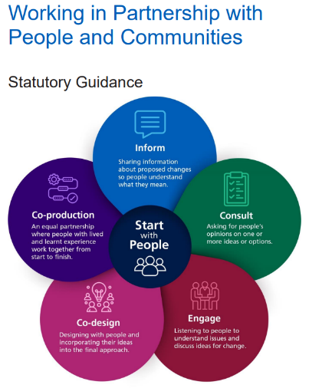  Working in partnership with people and communities is statutory guidance for integrated care boards, NHS trusts and foundation trusts. Addressing health inequalities by understanding communities’ needs and developing solutions with them is the golden thread throughout design and delivery of services. This is echoed by extensive research that reinforces CYP have knowledge, skills, experiences, and ideas to develop solutions that best meet their needs and support their health and wellbeing. Yet, it seems apparent that service delivery and design is often without the engagement of CYP as system partners.  "Without insight from CYP who use, or may use, services, it is impossible to make truly informed decisions about service design, delivery and improvement." (Working in Partnership with People and Communities: Statutory Guidance, July 2023).  This is pertinent to creating services that are responsive to recognised needs but that also acknowledge emerging trends that are concerns and challenges to CYP for example vaping.  Across physical LTC, CYP are not reliably or equitably co-producing the solutions that reflect their needs and ways to approaching addressing health inequalities in HNY. The connectors programme recent report highlighted the imbalance of gaining access to CYP voice of those children with LTC, compared to those CYP sharing views linking to mental health. (Core 20+ connectors, Insight report Jan – May 2024)  The voice of CYP with physical LTC requires a platform to co-produce the solutions and methods to addressing health inequalities in our communities, unique to HNY.  The ICB has a duty to ensure to create a mechanism that supports the strategic co-production of service delivery and design, and that voices of children and young people are represented in our shared decision making. This includes the function to be challenged on our current delivery and design. CYP hold the resource to tackling health, social and education barriers as they are living in and understanding of the root causes. As part of the ICB strategy, CYP are our golden ambition and yet CYP are not equally represented or heard across our system. HNY ICS needs a CYP voice and engagement forum to challenge and shape how we design and deliver on health inequalities.
Explain your key findings, results, | System wide analysis:  Most long-term conditions are developed in childhood. In comparison to similar countries, the UK has one of the highest rates of 16-24 year olds living with a long-term condition (Cheung, Hagell and Shah, 2019). Approximately a quarter (23%) of 11–15 year olds in England reported that they lived with a long-term illness, disability or medical condition in 2020. (The Association for Young People’s Health, 2021). It has been estimated that 1.7 million children and young people have either asthma, diabetes or epilepsy (NICE, 2020).  Within HNY we have estimated 13,750 with LTC from the clinical priorities* made up of:  - 884 cases of diabetes, 98% T1 and 2% T2 (NPDA 2021/2022). Type 1 diabetes is a lifetime condition that is often diagnosed in late childhood or adolescence.  - 1869 estimated with epilepsy. Epilepsy is the commonest significant neurological disorder affecting children and young people.  - 11,000 estimated with asthma. Asthma is the most common long term medical condition affecting children and young people (CYP) in the UK.  -Limitations to this data are not inclusive of children and young people attending South Tees who reside in HNY. For those CYP with asthma we know this is only an estimate given the challenges with diagnostics for CYP and that this figure is likely to be underrepresented for those without a diagnosis. There are limitations to the Epilepsy 12 audit, it demonstrates current cohorts of new CYP and captures the first year of care.  *This estimate does not include those CYP with other physical LTC such as neuromuscular conditions, cardiac, renal, cystic fibrosis and cancers. The author recognises all CYP with LTC should be reflected in future developments of the forum.  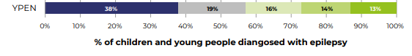  Percentage of children and young people diagnosed with epilepsy in cohort 4 by deprivation quintile and country/network. (Epilepsy 12 Published by the RCPCH Version 1.0: 13 July 2023)  - Amongst those CYP with epilepsy who have a diagnosis of epilepsy, up to a third continue to have seizures despite treatment. (Chen Z et al. (2018). Treatment outcomes in patients with newly diagnosed epilepsy treated with established and new antiepileptic drugs: a 30-year longitudinal cohort study. JAMA Neurology 75:279-286)  - Epilepsy is associated with a higher risk of mental health problems. 37% of children with epilepsy have a co-existing mental health disorder, a higher prevalence than found in other long term childhood conditions. Davies S, Heyman I, Goodman R (2003) A population survey of mental health problems in children with epilepsy. Developmental Medicine and Child Neurology 49; 292-5 Despite this, the Epilepsy12 audit of paediatric organisations found that only 12.8% (19/148) Trusts/Health Boards in England and Wales provided mental health provision within epilepsy clinics. (Royal College of Paediatrics and Child Health (2018) Epilepsy 12: National Clinical Audit of Seizures and Epilepsies for Children and Young People. 2018 National Organisational Audit Report. 2018: Healthcare Quality Improvement Partnership.)  - Not all emergency admissions to hospital for epilepsy or seizures are avoidable. However, there is evidence that education, support with epilepsy medications, and emergency seizure management plans can reduce emergency admissions. Patel AD, Wood EG, Cohen DM. (2017) Reduced emergency department utilization by patients with epilepsy using QI methodology. Pediatrics, 139 (2) p. e20152358  - There is a higher prevalence of learning disabilities and neurodevelopmental conditions (for example, attention deficit hyperactivity disorder and autism spectrum disorder) in CYP with epilepsy than in the general population. Population and person insight, model.nhs.uk  - CYP with type 1 diabetes from minority ethnic communities have higher HbA1c. This is the average blood glucose levels for the last 2-3 months.  - Significantly lower use of insulin pumps or real-time continuous glucose monitoring systems was recorded among black children. 2019-2020 NPDA audit. (National CYP Diabetes Network, 2020; Catherine et al, 2021).  - Children and young people with type 1 diabetes living in the most deprived areas are more likely to have suboptimal diabetes management and more likely to have an emergency hospital admission (RCPCH, 2023a).  - CYP with diabetes have increased hospital admissions, particularly affecting older young people aged 14 – 24 years. (RCPCH, 2023a).  - "Specific to diabetes, and perhaps for groups experiencing more marginalisation, are the messages around heightened stigma, and cultural pressures in relation to different food cultures and how these interact with self-management of diabetes and ability to respond to clinic instructions". Diabetes-Scoping-Review-Nov-2023.pdf (ayph.org.uk)  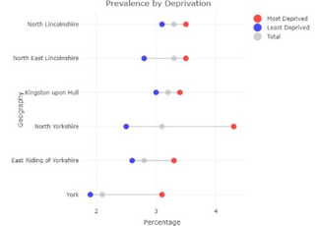  - Asthma is also the most common reason for urgent admissions to hospital in children and young people in England. Furthermore, emergency admissions for asthma are strongly associated with deprivation. (Children, young people and families’ experiences of chronic asthma management and care, ayph).  - Asthma prevalence tends to be highest in the most deprived deciles.  The involvement of groups such as, for example, those living in care, or from LGBTQ+ communities, or young carers, is very limited in existing work and we know little about their needs. This is a major gap in understanding Diabetes-Scoping-Review-Nov-2023.pdf (ayph.org.uk).  These health inequalities cannot be overcome by health services alone. There are pockets of good practice with particular focus groups across HNY and many of the clinical services supporting these children are all striving to individually gather the voice of CYP within their services. This duplication is not an efficient use of resources within services already at or over capacity delivering clinical care and are short lived pieces of work such as surveys and questionnaires. As a collective across asthma, epilepsy and diabetes, CYP voice cannot just be collected to say we have informed CYP, but rather be engaged with, to be instrumental in shaping how we address health inequalities and so much more by reaching into our underserved communities, linking with programmes across the ICS.  Outcome of analysis – Priority identified:  This proposal is ICB wide. The ICB has the golden ambition of radically improving children’s wellbeing, health and care. This can only be achieved by understanding the challenges for CYP to shape our future generations.  If we do nothing, we continue to lose the coproduction opportunities and talent of our young people to help shape how we overcome the health inequalities and understanding of the lived experience of CYP with LTCs that can be embedded at a strategic level.  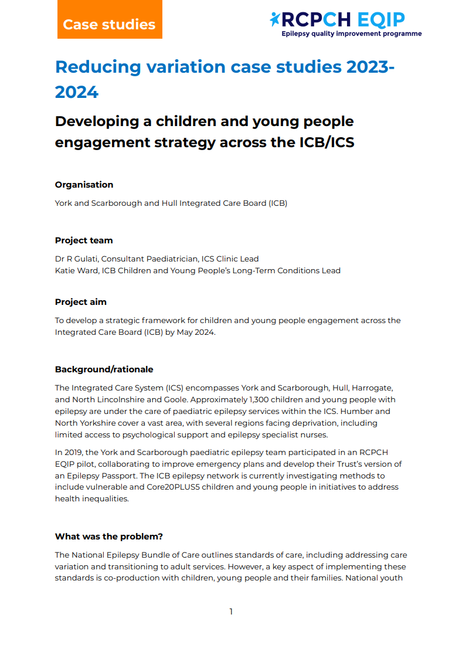  A recent EQIP (Epilepsy Quality Improvement Plan-Extract below) in May 2024, undertaken in HNY, highlighted the need to establish CYP voice as the golden thread to developing coproduction in HNY for CYP with Epilepsy. By undertaking this collaboratively across the long term conditions there is benefit to the delivery of the system including sustainability and resource. Shared experiences of peers and learning across the long term conditions is also crucial for both CYP and providers.  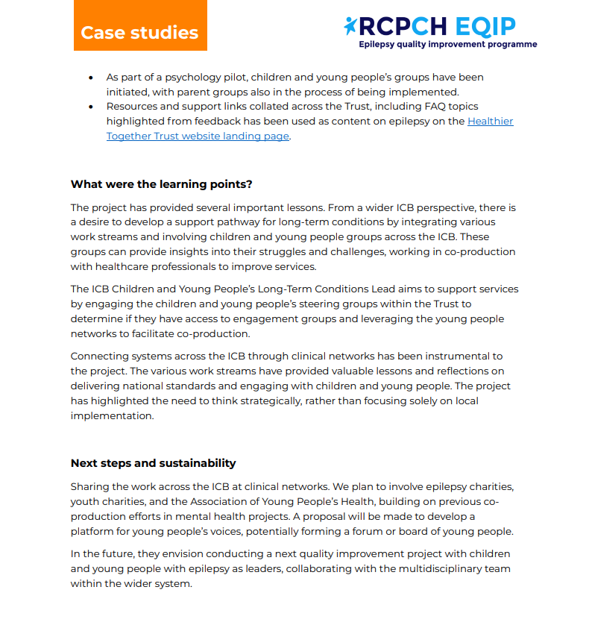  Benefits to the system:  - This would avoid duplication of resources and enables a stronger collective voice.  - Challenges for CYP with long term physical health conditions are multifaceted across our ICS, in education, social care and health services. Enabling the voice of CYP with long term physical health conditions would be a resource across the ICS.  - This also provides future opportunities and funding for the forum in working across the partnerships of the ICS.  - Support providing data for CYP LTC that can be shared across the system to support championing work for CYP with LTCs.  - Support ICB strategy and ambitions for CYP  - Connectivity and engagement across the ICS including our VCSE colleagues.  - Support consistent qualitative data and intelligence to gain a focus for HI work.  - Support a collective population health focus for children, reducing the long-term impact LTC has on a child's life course ie school attendance.  Benefits to the CYP  - Feeling valued, their voices heard, especially those CYP who are underserved and underrepresented.  - Collect data and intelligence to support a focus for HI work that impacts their own communities.  - Opportunities to be supported to gaining skills in connecting with their communities, building confidence and gaining employability within their communities.  - Strengthening access to careers in health and care.  - Opportunities to develop links in relation to other programmes such as Connectors, young volunteering, and peer to peer work that forum members might like to do.  - Peer support.  Without a co-ordinated mechanism, CYP voice remains underrepresented for those with LTCs. The forum would enable:  - Shared experiences of YP across the LTC's to be effectively utilised across the ICS  - Experiences unique to the specialism to be shared and learn from good practice across the specialities.  - Core themes, challenges and celebrations across the workstreams can be brought together to provide a voice that is collective.  - Efficient use of resource both in our YP's time and in the workforce and skills of the team supporting the forum.  The forum can have impact at all levels from an operational and strategic level. For example, developing resources/literature, service design, quality improvement and tackling health inequalities.  There are clearly lifelong implications for promoting good health in childhood and for those CYP with long term conditions the management of these conditions in childhood has implications on future adult health. It is recognised that access to and experience of services will impact on how individuals re-engage with NHS services in the future. Yet, research has shown that a third of children struggle to understand information given to them from healthcare staff and over half of children do not feel like they are involved in decision-making around their health and care. (Babies, children and young people's experience of healthcare NICE guideline Published: 25 August 2021 www.nice.org.uk/guidance/ng20)  A CYP forum is an efficient use of resources to ensure we are not replicating work across the system and will enable a wider network to support the ICS, particularly education and social care. It will not only benefit YP but the system itself that aims to serve these populations. This is also referenced in the NHS Long Term Plan.  ‘We will…encourage NHS organisations to give greater access for younger volunteers…and an increased focus on programmes in deprived areas, and for those with mental health issues, learning disabilities and autism.’ NHS LTP page 90: ‘We must … support a renewed focus on increasing longer-term volunteering opportunities in the NHS. NHS: People Plan 2020/21 page 35:  It has been evidenced that many youth forums have been a stepping stone for YP to understand future work roles within the NHS, and the value of volunteer roles. " Young volunteers not only have a positive impact within the NHS, but the experience they gain is often beneficial for them. For example, by developing skills such as team working and problem-solving which are crucial for future success in education and the workplace" NHSEngland.nhs.uk/get-involved/get-involved/volunteering.  There are various youth groups across our ICS supported through schools, community groups, voluntary groups and charities. Some of these will be supporting CYP with LTC. The mental health collaborative has an established youth forum of which there will be elements of joint working to be developed and learning from their journey to establishing this. National groups such as epilepsy, diabetes and asthma charities hold national and regional support for CYP and their families and reflect the voice of CYP. However, this does not reflect within our own unique geography, demographics and population or succinct mechanisms to feedback into the ICB.  Potential solutions to take the proposal forward:  This forum should be an interface with ICS, supporting all stakeholders and involvement in decision making across health, education and social care. The forum will be a hybrid model of face to face and online meetings and events to develop a forum that is supportive, safe and enabling to both showcase and develop the skills of both the CYP and HNY workforce. The forums model and approach to delivery will be scoped and agreed within the task and finish group to ensure there is an agreed format and delivery that suits the challenges and unique geography of HNY.  With the current connectors programme (funded for 1 year as part of gaining CYP voice) this would be a progression on this work for those connectors who would like to do more and help shape and support the future development of the programme at the end of the pilot. Working with Healthwatch they have been keen to develop the CYP voice in their work and aligns with their own programme. Although ICB wide there are clearly barriers to an initial launch given the significant varied and span of the geography of HNY ICB. An initial launch in Hull will be undertaken to make a small start towards bigger goals of place groups and ICB wide meetings.  Exit strategy / sustainability.  As part of the proposal, I would like to incorporate a research element within the proposal to help shape the measurement of impact of the group to support evidencing the long term impact of CYP participation in both qualitative and quantitative terms.  By creating a CYP forum for LTC this can be a driving mechanism to address variability, inequity and reliability of the services and support we develop for CYP, with CYP. To understand barriers to care, the quality and experience of care, behavioural risks to health and the wider determinants of health that impact on our CYP living with long term conditions, asthma, epilepsy and diabetes a forum needs to be supported at a strategic level to reflect the ICB strategy and ambitions for CYP.  Risks associated with proposal.  Barriers and challenges have been taken from a recent engagement work funded by the Children and Young People’s Transformation Programme at NHS England (Engaging young people in NHS service delivery and development Results from a sector survey and interviews Lizzie Wortley, Ann Hagell, Association for Young People’s Health Louca-Mai Brady, University of Hertfordshire April 2024)  - A lack of understanding about the aims and importance of the work.  - Lack of understanding of the skills needed.  - Difficulty of achieving appropriate representation.  - Lack of leadership and investment.  - Management of expectations about what the young people are there to do.  - Understanding young people’s life stage and priorities  - Challenge of responding to varied needs and preferences.  - Lack of investment in measuring impact.  - Safeguarding- supporting a forum that ensure YP feel safe to share their views with governance to escalate concerns.  Additional governance  - Start Well Board  - HNY CYP Alliance  - HNY CYP Epilepsy, Diabetes and Asthma Clinical Network  - Place Boards  This forum would reflect the very core values within the HNY Long term plan in both supporting the engagement and participation of CYP and a key mechanism to tackling health inequalities with a focus on the CORE20+5 framework.
Describe achievements, changes and difference made, impact | Current achievement is having VCSE partners on board to lead establishing and developing forum as this aligns with their own current CYP programme of work.  Launch event to be held 31.10.24. Support rolling out the forum and local meetings at "place" across the entire ICB supported by individual Healthwatch teams and myself as representation from the ICB.  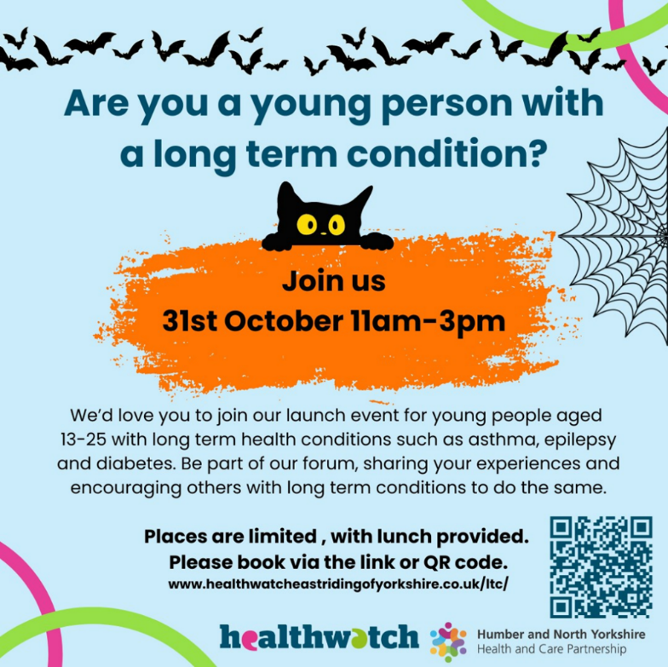
Provide any recommendations | Applied for grants to support the development of the forum (notice of outcome - January 2025) to reach across the Healthwatch within the ICB to ensure we reflect the differing challenges across our unique geography.
Conclusion – FINAL REPORT
This section brings the entire project report together, summarising your argument and why it is significant
Restate original ambition | To provide a strategic framework for the voice and engagement of CYP in the co-production of services and tackling health inequalities for CYP living with physical long term conditions.
Summarise the key themes | Delivery of Launch with Healthwatch of an inaugural Outcomes of the launch- in October 2024. Plans for two more events in February 2025.  Common themes are:  - Clarity in communication for pathways and how/when/who/what happens next  - Flexibility to improve accessibility of services and appointments  - Increase and consistency of staffing to build relationships with patients  - Improvement of wait times and support whilst waiting  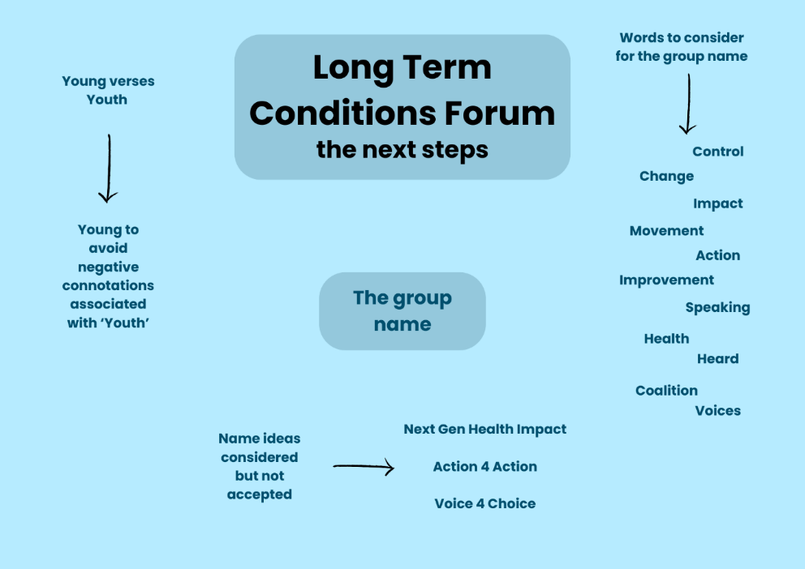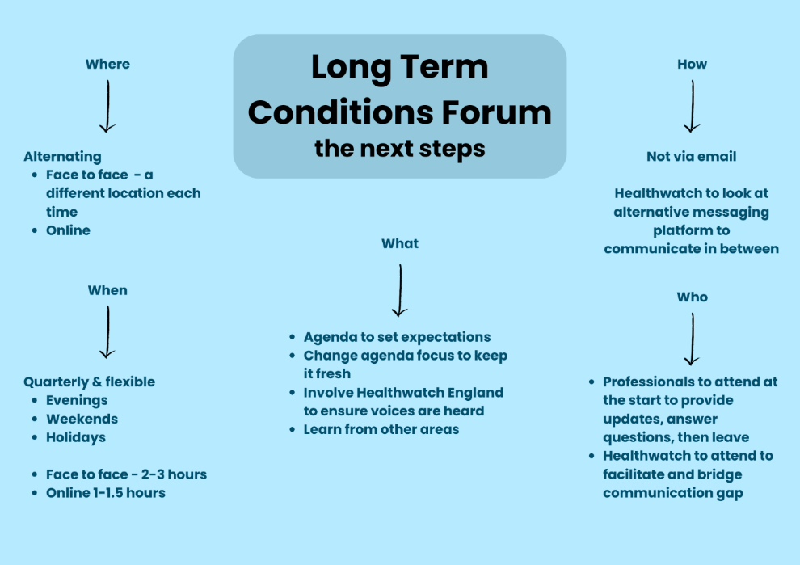  Celebrations - Able to demonstrate an activity to YP to show how they can impact on services. Activity included looking at transition page on Healthier Together website (a resource for CYP and their families) and they identified what else they would like on the page and links to the transition document. Requested quotes/ videos to show YP experiences of transition.  Also linked in with place as they have identified with care leavers the understanding of being able to access appointments and if this could be worked on by YP and on the healthier together site. Develop "how to guides".  Continued challenges.  Funding to support Partnership working across the VCSE sector, without which this would not be happening.
Summarise your thoughts | There are many barriers to working at scale across an ICB with a vast and varied geography and no financial resource to offer. I have to acknowledge that this is not the work of the author but of the many colleagues working across Healthwatch who have delivered this proposal. I am in the fortunate position to be in a role that has enabled me to and continue to, champion the role of CYP voice and the work Healthwatch are undertaking. Networking with colleagues across our own ICB/ICP but also that of ICBs delivering care to our CYP, ie tertiary centres has all contributed to the current successes of this forum. Long may it continue and develop!
Describe any future actions or work needed | 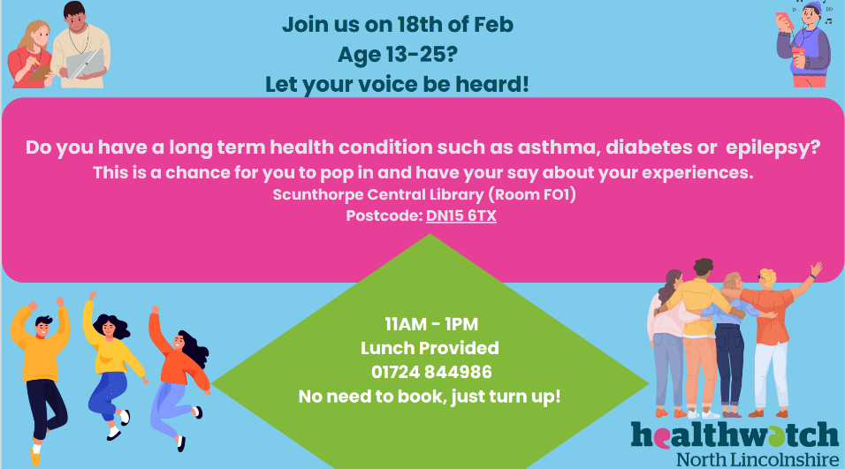  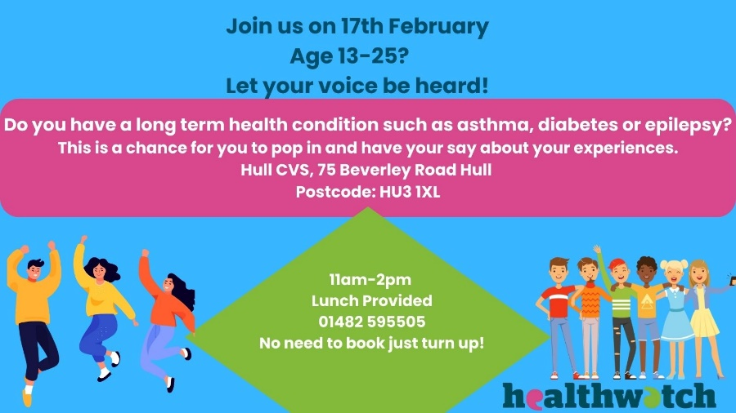  Future planning….  - Utilise resources -ICS Health Inequalities Engagement Framework, Self assessment and improvement tool.  - Trauma Informed framework - communication and continual design of the forum.  - Ensuring representation of communities and ICB Plus groups.  - Opportunities for financial resource.  - Insights data in HNY.  - Plans for South and North Bank groups to be held in the February holidays. (Hull and Scunthorpe)  - Source varied opportunities for CYP.  - ie H.Together website- Transition & Diabetes landing page, oral health campaign, asthma campaign, day surgery unit, “How to guides”  - Consider Universities within the ICB geography that may support evaluation/research to the forum.

References:
Butler AM, Hilliard ME, Titus C, et al. (2020) Barriers and facilitators to involvement in children's diabetes management among minority parents. J Pediatric Psychology 45:946–56.
Cheung R, Hagell A, Shah R (2019). International comparisons of health and wellbeing in adolescence and early adulthood. Available at: https://www.nuffieldtrust.org.uk/research/internationalcomparisons-of-health-and-wellbeing-in-adolescence-and-early-adulthood
The Association for Young People’s Health (2021). Key data 2021, Physical health conditions. Available at: https://ayph-youthhealthdata.org.uk/key-data/physical-health-conditions/long-term-conditions
Epilepsy 12 Published by the RCPCH Version 1.0: 13 July 2023)

Royal College of Paediatrics and Child Health (2023a) National Paediatric Diabetes Audit (NPDA) Report on care and outcomes 2021/22 London: RCPCH
Catherine JP, Russell MV, Peter CH (2021). The impact of race and socioeconomic factors on paediatric diabetes. EClinicalMedicine. 2021 Nov 6;42
Type 1 diabetes in communities that experience marginalisation | RCPCH Diabetes-Scoping-Review-Nov-2023.pdf (ayph.org.uk)
Evans M, May Ng S (2021). Widening health inequalities related to type 1 diabetes care in children and young people in the UK: A time to act now. Available at: https://pubmed.ncbi.nlm.nih.gov/34109677

Engaging young people in NHS service delivery and development by ayph | May 23, 2024 Available at : Engaging young people in NHS service delivery and development - ayph
Jeremy Sachs & Emma Rigby March 2021 Children, young people and families’ experiences of chronic asthma management and care Themes from engagement work. Available at: CYP-Families-Experiences-of-Asthma-Management-Engagement-Report.pdf (ayph.org.uk)

Managing long-term conditions in the community, NICE. Available at: Managing long-term conditions in the community | NICE impact children and young people’s healthcare | Reviewing the impact of our guidance | Measuring the use of NICE guidance | Into practice | What we do | About | NICE
NICE (2020). NICE impact children and young people’s healthcare. Available at: https://www.nice.org. uk/about/what-we-do/into-practice/measuring-the-use-of-nice-guidance/impact-of-our-guidance/ niceimpact-children-and-young-peoples-healthcare/ch2-managing-long-term-conditions-in-children

Working in Partnership with People and Communities: Statutory Guidance. July 2023

