Title: Community Inclusion Nursing Team

Author: Laura Inglis, Matron

Date: March 2025

1. **Summary:**

**Purpose**

This report outlines the role, impact, and future plans of the Community Inclusion Nursing Team (CINT) in addressing healthcare barriers faced by homeless individuals in North Lincolnshire.

**Background**

* Homeless individuals experience significantly higher rates of chronic health issues but struggle to access healthcare.
* The Community Inclusion Nursing Team (CINT) was developed to improve healthcare accessibility and outcomes for this population.

**Key Initiatives and Impact**

* **Drop-in Clinics:** Operated three times weekly at The Forge, offering direct healthcare services.
* **GP Integration:** A dedicated GP appointment per day for homeless individuals, reducing Emergency Department (ED) reliance.
* **Referral Network:** Connecting patients to housing, mental health, social services, and specialist care.
* **Clinical Services:** Includes wound care, diabetic screening, blood tests, prescribing, and emergency care (e.g., Naloxone administration).
* **Training & Development:** Staff trained in homeless health needs, linking with national networks like the Queen’s Nursing Institute.
* **Financial & System Benefits:** Reduced ED visits, lower hospital admission rates, and improved patient outcomes.

**Achievements & Future Plans**

* The team won an Equality, Diversity, and Inclusion Award and have secured one-year additional funding.
* Plans to expand services for sex workers, refugees, asylum seekers, and recently released prisoners.
* **Service Enhancements:** More partnerships, further training, and improved community engagement.

**Challenges & Risks**

* Need for long-term funding to sustain and expand services.
* Without continued investment, reliance on ED and acute care will increase, worsening health inequalities.

**Case Studies**

Illustrates the direct impact of CINT on homeless individuals, including successful medical interventions and social support that prevented hospital admissions and improved long-term health.

1. **Background**

National research and evidence demonstrate that people who are or have been homeless experience multiple and chronic health problems at a significantly higher rate than the general population, yet these same people face barriers to accessing health care when and where they need it. Health inequalities are systemic and unfair, with avoidable differences across the population and between different groups within society (The Kings Fund 2022).

Health Care Inclusion is the process of including disadvantaged groups in healthcare activities, services, and policies within local communities. The aim is to eliminate discrimination and ensure everyone has access to the support and facilities that they require to improve their lives and feel included in society.

Diagram 1: NHS England Inclusion Health Principle.

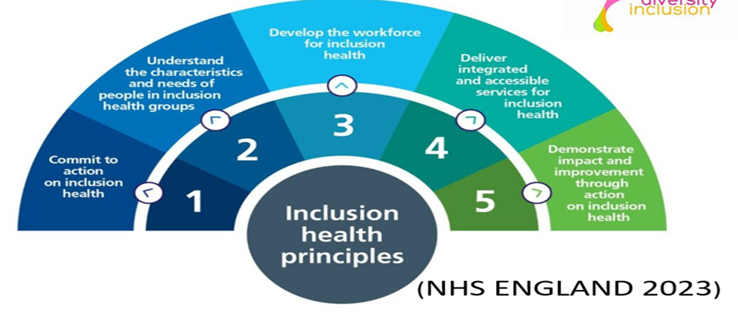

The North Lincolnshire homeless population should fall within the NLAG community services core offer of the community nursing service as the current criteria is inclusive of anyone who is registered with a North Lincolnshire GP. However, this patient group often experience barriers to accessing primary and community healthcare. Many do not have access to phone or internet and therefore are not contactable when trying to access General Practice. Lack of engagement with services is often seen, due to chaotic lifestyles and inability to adhere to planned appointments. Services then have no means of contacting these patients.

1. **Overarching objective**

The overall aspiration is to improve healthcare outcomes and patient experience for homeless people within Northern Lincolnshire with the aim to engage and include homeless people in appropriate health care, predominantly primary care, and relevant specialist services.

It is crucial to improve social factors for individual patients and work closely with The Forge charity, Victor House, and other homeless and inclusion provisions, which would be vital to bring about improved health outcomes and a reduction in the instability and chaos experienced by a high proportion of homeless patients.

1. **Community Inclusion Nursing Team (CINT)**

NLAG community services have developed a pilot ‘proof of concept’ community inclusion nursing team which is distinct to its core offer of community nursing, with the objective of addressing health care inclusion for homeless patients experiencing barriers to engaging with healthcare services.

The team offers support to people not registered with a GP as well as those registered. The process of registration can take up to two weeks causing barriers in accessing healthcare when required therefore homeless people are more likely to attend the hospital Emergency Department as first point of contact.

The team currently offer a drop-in clinic 3 times a week at The Forge Day Centre. The team have accepted on average 18 new referrals per month. and to date have reviewed c.54 patients per month. This equates to c.645 people seen to date. These people would likely have attended ED if this service wasn’t available.

Over the year, a total of 216 referrals were made to the Community Inclusion Nursing Team, of which (90 %) 196 were accepted. They have completed a total of 645 contacts from 196 individual patients (3.2 Per patient). 582 were face to face contacts with 60 completed via telephone.

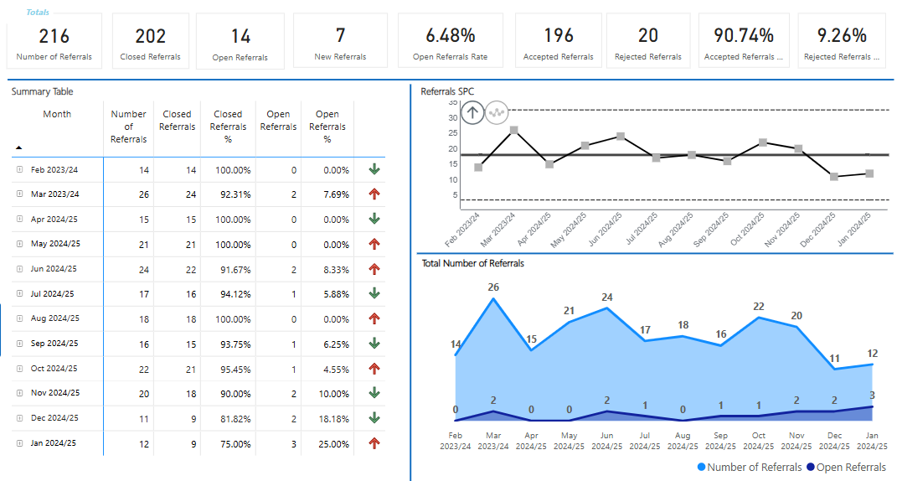

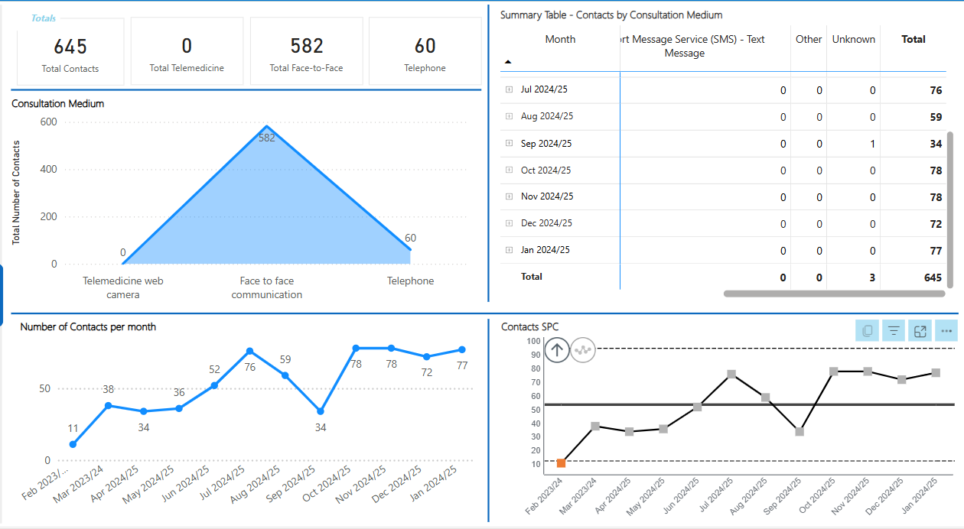

The general health element was the missing piece to the jigsaw at The Forge, as this service supports the homeless population of Scunthorpe to ensure they are included in all aspects of life but had been struggling to get buy in from both general nursing and General Practice.

The CINT team and The Forge have worked collaboratively to develop this service offer, which most recently has resulted in achieving regular GP input and support with Ashby Turn Practice.

The practice is piloting one dedicated appointment per day to be allocated to an identified homeless patient with a long-term condition. The appointment will be allocated on the day following discussion with the CINT and will reduce the lack of engagement caused by appointments being allocated too far in advance

Through this support provided by primary care, the CINT are able to support homeless patients to register with a GP and are able to demonstrate the positive impacts across our system and lead engagement with primary care colleagues.

**4.1 Process**

Referrals are received via telephone, email or drop-in clinics at The Forge or Victor House. Outreach is utilised when not in clinics in an attempt to get homeless patients to engage.

Assessments are carried out as required.

Clinical interventions undertaken include:

* Observations B/P
* Wound Care
* Ear Assessments
* Diabetic screens
* Doppler / lower limb assessments, measure for stockings
* Prescribing
* Phlebotomy
* Photograph wounds / wound assessments
* Pressure area checks – ordered cushions
* Administration of Naloxone.

Patients are supported to attend appointments and signposted to the right help / support. The CINT act as a chaperone at health appointments when required.

Onward referrals are made to:

* GP practice – local and out of area
* SDEC
* A&E
* Podiatry
* Dentist
* MIND / Crisis mental health team.
* Housing / Council
* Counselling
* We are With you.
* Therapy services
* Social Prescribing
* CRT – GP
* Hospital secretaries.
* Diabetes nurses.
* Ward staff
* Talking Therapies
* Wound clinic / TVN
* Social Services
* Bladder and Bowel Team

1. **Training and Development**

The CINT have also had the opportunity to complete nationally recognised educational sessions on how to support homeless people. They are also an active member of the Queen’s Nursing Institute Homeless and Inclusion Health Programme network. One Member of the team had the opportunity to undertake the Humber and North Yorkshire fellowship programme 2024 with opportunity to attend formal Public Health Training, and learning gained though this fellowship will be applied to the CINT service.

1. **Clinical benefit**

* Health needs met earlier than if not attended the service, preventing deterioration and reducing needs.
* Patients redirected from ED to community SPA.
* Patients can manage their symptoms through support and advice provided by CINT and CRT GP.
* Increased use of technology and remote clinical assessment to review and treat.

Even at this early stage, the CINT has demonstrated that it can effectively engage homeless people who present with complex needs and bring about positive change both for the individuals themselves and the wider health service. This highlights that innovative multi agency working is crucial to achieving better outcomes for this client group. Service data demonstrates that interventions from the CINT are bringing about a reduction in impact on hospital services and an increased utilisation of primary and community health services.

1. **Impact Analysis**

ED attendances and hospital stays were reviewed for 6 service users who had been referred to the Community Inclusion Team. The data is as follows:

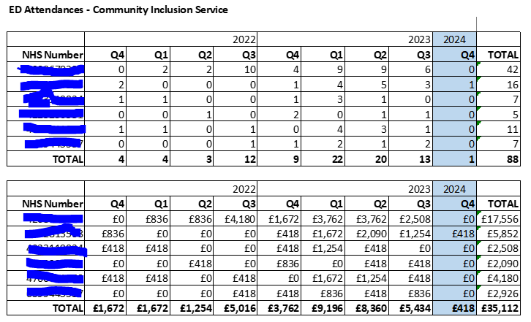

The Community Inclusion Nursing Team was implemented in December 2023, therefore quarter 4 23/24 is taken as the period the service was live.

Between January 2022 and March 2024 this cohort of 6 service users have collectively attended ED at Scunthorpe General Hospital a total of 88 times. Pre CINT this was an average of 11 ED attendances per quarter for these six service users. During quarter 4 23/24 whilst known to CINT, there was 1 ED attendance for this cohort of service users.

The average cost of an ED attendance at a major ED department receiving investigation and treatment starts at £418 (Kings Fund 2024). Between January 2022 and March 2024, the cost associated with ED attendances for this cohort was £35112. Pre CINT pilot, this cost was an average of £4598 per quarter fort these 6 service users. During Quarter 4 23/24 while known to CINT the ED attendance cost was £418.

Between January 2022 and December 2024, this cohort of six service users incurred a total of 20 acute hospital bed days. The cost associated with these bed days was £6900 (based on an average cost of £345 per day (Department of Health and Social Care 2023). During quarter 4 23/24 while known to CINT, there were no bed days incurred by this cohort of service users

Examples of case studies demonstrating the impact on service users are included as appendices in section 16.

1. **Reporting arrangements**

**ISPACE**

**(Integrated Commissioning Executive Group)**

**ISPAC**

**Working Group**

**Health Inequalities Steering Group**

**Community Inclusion Nurse Team Project Group**

1. **Proposed Next steps**

* **Frequent attenders in ED**

There is need to scope the health needs of the homelessness population within North Lincolnshire and begin to develop and test out innovative responses for those homeless people who frequent attend the Emergency Department. To reduce attendance and to offer a service to homeless people who are admitted to hospital providing specialist advice to staff within the hospital to manage the inpatient stay and reduce re-admission rates.

* **Integrated care approach**

This would involve furthering the integrated care approach to patient care including housing, social services and third sector agencies working with homeless people it would give us the opportunity to improve partnership working between the acute healthcare services, primary and community care. To do this, the team will work closely with the newly appointed Homeless Officer, employed by Northern Lincolnshire Council. This will help identify in a timely manner those patients who are admitted onto wards at Scunthorpe General Hospital. To help coordinate all aspects of care whilst the patient is in hospital offering special advice where required and working with the hospital to facilitate a safe, appropriate, and timely discharge.

By working closely with The Forge charity, the team will be able to work proactively and flexibly to engage frequent ED attenders in the community and support them with issues including accessing appropriate healthcare and any other issue that contributes to frequent attendants at Northern Lincolnshire and Goole NHS trust.

* **Service development opportunities**

The service can evolve further and new ideas on how to achieve this include:

* working closer with North Lincolnshire Council
* further training and development within the hospital environment
* increase service user patient involvement capturing and developing their ideas about how the service should be delivered.
* Liaise with other community services including Community urgent response team and therapies.

Building system partnerships and collaborative working across health, social care, and third sector organisations is key to developing an offer that supports the health needs of this patient group. In the short period of the pilot, the CINT has established networks and collaborative working relationships with several key stakeholders including:

* The Forge
* We are with you
* The Arc
* Victor House
* Blue door
* MIND
* Specialist Social Worker
* Temporary Accommodations
* Communications Team
* GP Practices
* Safeguarding

HNY ICB Place based colleagues and Local Authority colleagues also support delivery of this service.

1. **Quality Impact Assessment of non-investment**

The safety and experience of these patients will be impacted if sustainable investment is not provided for this service by:

* **Safety**: Homeless patients have chronic health problems and have a chaotic unstable life therefore, at higher risk of using acute health services when experiencing a deterioration in health.
* **Experience of care**: Homeless patients often are afraid of stigmatisation and non- prioritisation of their health problems due to discrimination previously experienced. CINT are aware of these structural barriers and the impact it can have. Care can be improved by showing compassion, dignity, and respect. Feedback would be gained from patients who have engaged with the service.
* **Effectiveness of care**: We feel that this dedicated service would improve outcomes and reduce health care in the homeless community in our area. This in turn would enhance quality of life and help homeless patients to recover following episodes of ill health.

The Community Inclusion Nursing Team would like to expand the nurse-led service delivering integrated, multi-disciplinary outreach care to marginalised populations, including the homeless, sex workers, vulnerable migrants, and individuals recently released from prison. The initiative seeks to address health inequalities within inclusion health groups by providing proactive and responsive health interventions, disease control, and access to wider health and social care.

1. **Patient Impact:**

**Early Intervention**: Timely identification and management of health needs, preventing deterioration and reducing future care requirements.

**Reduced Pressure on Emergency Services**: Patients redirected from Emergency Department (ED) to this service via the Community Single Point of Access.

**Empowered Self-Management**: Patients will gain the skills and knowledge to manage their symptoms effectively through tailored support and advice.

**Innovation in Care Delivery**: Increased use of technology and remote clinical assessments to review and treat.

**System-Wide Benefits:**

**Reduced ED Utilisation**: Fewer attendances by high-intensity service users, easing the burden on emergency care.

**Shorter Hospital Stays**: Streamlined interventions to minimise inpatient durations.

**Prevention of Adverse Outcomes**: Mitigation of complications and long-term disabilities through proactive care.

**Improved Care Pathways**: Enhanced efficiency through reduced "Did Not Attend" (DNA) rates and better resource allocation.

This targeted intervention will not only address immediate health needs but also contribute to the sustainability of health services by reducing demand on overstretched healthcare services in North Lincolnshire and benefit groups:

* Homeless / rough sleeper population
* Sex workers
* Refugees
* Asylum seekers
* Prisoners (newly released)

1. **Workforce**

All Community nursing teams are currently experiencing workforce shortages and staff burnout which is taking its toll on hard working, and overstretched professionals who are under sustained pressure. Staff currently working within CINT all expressed concerns and low morale with a loss of passion for their roles.

Since working with the homeless they feel empowered, morale has improved, and they feel they are able to care for the patients with the time, compassion, and respect they deserve. Huddles and supervision sessions are rostered into their day due to the emotive nature of the role. Insight days have been offered to wider community nursing team focusing on inclusivity and homelessness to be able to share knowledge, build relationships and break down barriers and stigma targeting groups who wouldn’t normally access services.

Working with the wider community will provide the opportunity to educate about service provision and help signpost and work collaboratively to improve practice, reduce health inequalities for the wider community, promote social inclusion and in turn lead to better outcomes.

1. **Achievements**

The team were nominated for a Golden Stars Award and had the opportunity to showcase the excellent work they have been delivering. The Excellence in Equality, Diversity and Inclusion award for Northern Lincolnshire and Goole NHS Trust was won by the Community Inclusion Nursing Team.



1. **Financial benefit**

Investing in the proposal not only yields significant clinical improvements but also offers substantial financial benefits and cost savings across the healthcare system, including:

* Reduced high intensity user ED attendance and admission
* Reduced hospital length of stay
* Prevention of complications and long-term disability
* Enhanced efficiency of care pathways (i.e. reduced DNA rates)
* Optimisation of resource allocation

In summary, investing in this service offers substantial financial benefits and cost savings across the healthcare system (see impact analysis of CINT on ED attendance). By reducing hospital stays, preventing complications, enhancing care efficiency, and optimizing resource allocation, this initiative not only improves patient outcomes but also promotes fiscal sustainability and value-based care delivery.

The Community Inclusion Nursing Team has successfully secured funding for a further 12 months with an increase to help develop the team. Without funding, the cessation of the existing services poses critical risks to hyper marginalised communities, including high-intensity users, leading to increased long-term care needs. Patients will solely rely on ED, GPs and acute care, exacerbating existing pressures and increasing waiting time during winter. In addition to this, the collaborative approach provided by the existing provision in NL would be dismantled, leaving gaps in care coordination and support for high-risk populations. The team need to secure long-term funding as Failure to sustain and enhance the service could reflect poorly on our commitment to addressing health inequalities within Northern Lincolnshire.

1. **Conclusion**

The Community Inclusion Nursing Team (CINT) has demonstrated significant progress in addressing the healthcare disparities faced by homeless individuals and other marginalized groups in North Lincolnshire. Through a proactive and integrated care approach, the team has successfully engaged vulnerable populations, improved access to essential healthcare services, and reduced the reliance on acute care facilities such as the Emergency Department.

The collaboration between CINT, local healthcare providers, social services, and charitable organizations like The Forge has been instrumental in delivering person-centred care. The evidence presented in this report highlights the positive impact of this initiative, from improved health outcomes to financial efficiencies within the healthcare system.

However, sustaining and expanding this service remains a critical challenge. Continued investment is necessary to prevent service gaps that could lead to increased emergency care usage, poorer health outcomes, and greater strain on already overstretched healthcare services. Strengthening partnerships, securing long-term funding, and expanding outreach to other at-risk groups will be key to the ongoing success and growth of CINT.

In summary, the CINT initiative is a model of best practice in inclusion health, proving that a dedicated, community-based approach can transform lives while enhancing the efficiency of the wider healthcare system. Ensuring its sustainability will be essential in continuing to break down barriers and promote equitable healthcare access for all.

1. **Appendices**

**Case studies for the cohort of six service users used in Impact Analysis:**

**Patient 1 – ‘Neil’**

Neil, who was identified during a High Intensity User meeting at the Emergency Department (ED), has alcohol-related decompensated liver disease. Recently, he has been hospitalized multiple times for the drainage of abdominal ascites, a procedure performed in the Planned Investigation Unit. Neil is currently awaiting a TIPS procedure in Leeds and is not known to any community health professionals. Since he does not meet the criteria for the district nurse service (as he is not housebound), it was agreed that we would visit him to assess his needs.

Neil lives alone in temporary accommodation (a B&B). He has three daughters and one son, but he only maintains contact with one daughter who helps with his laundry and shopping. He also has a close friend who takes him to his home for an evening meal every night. Neil is struggling with personal hygiene and dressing himself.

With Neil's consent, we referred him to social services for carer support. We also referred him to his housing support worker to find suitable accommodation, and to the community bladder and bowel team for his incontinence issues, which were previously managed by his daughter. The bladder and bowel team assessed him within a week of the referral.

Neil's housing support worker has started background checks to find him alternative accommodation. During one visit, I found his abdomen severely distended with ascitic fluid, causing him pain and breathlessness, which required a 999 ambulance call. Neil was hospitalized, and a plan was made for a permanent drain to be inserted, allowing us to manage the drainage in the community and reduce hospital admissions.

On a subsequent visit, Neil’s daughter had ceased communication with him, leaving him without help for laundry or shopping. He had no money, no food, and his friend was on holiday for two weeks. We obtained a food voucher and visited two food banks to secure food for him. A joint visit by health, housing, and social services was arranged. Social services set up carers to visit twice daily, and housing helped reinstate his PIP payment. All services continue to collaborate to support Neil with his health, housing, and social needs.

**Patient 2 – ‘Michael’**

Michael, a Type 1 diabetic, approached us because his blood sugars were consistently low. He takes one type of insulin three times a day and another type daily. After eating breakfast and lunch at The Forge Project, he had no access to a kitchen at his temporary accommodation due to anxiety about discussing the issue with the landlady. We facilitated a visit to the accommodation, and she granted him access to the kitchen for evening meal preparation.

Michael's last HBA1C blood test, taken four months ago, was out of the normal range and had not been addressed. He had been attending ED due to feeling unwell with high blood sugars. With his consent, we arranged for another HBA1C test and contacted the Diabetic Specialist Nurse (DSN) at the hospital. She scheduled an appointment to review his insulin doses, and we also consulted the diabetic nurse at his GP practice to adjust his doses. His blood sugars are now stable.

Michael was also concerned about a callus on the sole of his left foot, which we addressed by making him a podiatrist appointment. He attended the appointment and has since requested another referral. Additionally, he was worried about his eyesight and thought he was due for a diabetic retinal eye screening. We arranged the screening, which he attended.

**Patient 3 – ‘Tony’**

Tony, who had been sleeping on the streets for two consecutive nights, presented with a chesty cough, green sputum, shivers, and body aches. His observations revealed pyrexia. We secured a same-day GP appointment, where he was diagnosed with a chest infection and prescribed antibiotics and Paracetamol. Seeing a healthcare professional allowed Tony to obtain accommodation for the night, and he is now in temporary housing. Tony mentioned he would typically go to the ED with these symptoms.

**Patient 4 – ‘John’**

John became homeless following the breakdown of his relationship and had sold his car due to financial constraints. His GP practice was out of town, making it difficult for him to schedule an appointment. He was attending a housing hub where we held a drop-in clinic. John had been experiencing headaches for a week and was worried about his blood pressure, especially given his history of a Cerebro-Vascular Accident four years prior. He was already taking Ramipril 2.5mg daily.

When we checked his blood pressure, John was hypertensive. We sent a red flag task to his GP to review his medication. The following morning at The Forge Project, his blood pressure had further increased, and he was experiencing palpitations, indicating tachycardia. We sent another red flag task, resulting in his GP increasing his Ramipril dose to 3.75mg daily. The GP discussed the changes with John over the phone and sent a new prescription to a local pharmacy. The GP also recommended a follow-up blood pressure check, U&E blood tests, and an ECG, all of which were scheduled.

**Patient 5 – ‘Jack’**

Jack, who was homeless and living in a tent, visited us at The Forge Project. He reported a sore on his right buttock and his second toe on his left foot. Jack had previously received antibiotics and Naproxen for his toe but was no longer registered with the GP practice. On examination, his foot, which had previously had three toes amputated due to IV drug use, required dressing. The wound appeared clinically infected. We performed a wound assessment, photographed the wound, and our GP prescribed antibiotics, which Jack collected from a local pharmacy.

Due to his unregistered status, Jack would have otherwise visited the ED. We also addressed the issue of his orthotic inner soles, which were confiscated at a police station. We contacted the police to retrieve them and arranged a new appointment with the orthotic department. Additionally, we helped Jack register with a local GP practice. Currently, one GP practice allocates a daily appointment to patients at The Forge, which helps manage acute and chronic conditions. The plan is to involve more GP practices in offering appointments.

**Patient 6 – ‘Paul’**

The Forge staff expressed concern about Paul, who had visited for the first time and was planning to sleep in a park as he felt unwell. He had spent the previous three nights in a cemetery. His NEWS score was 9, indicating possible sepsis, prompting a 999 ambulance call. Paul was diagnosed with acute tonsillitis and received IV antibiotics and fluids. He was discharged with oral antibiotics and is now feeling much better. Without this intervention, Paul might have collapsed and potentially faced an avoidable death. Tragically, six homeless patients died in 2023 within a week of discharge from our acute hospitals.

1. **References:**

Crisis Health & Wellbeing Knowledge Hub. <https://www.crisis.org.uk/ending-homelessness/homelessness-knowledge-hub/health-andwellbeing/#:~:text=People%20who%20have%20experienced%20homelessness,common%20and%20often%20go%20untreated> (accessed on 09/01/2025

Department of Health and Social Care (2023) Written question and answer: Cost of hospital beds, UK Parliament. Available at: https://questions-statements.parliament.uk/written-questions/detail/2023-03-14/165361 (Accessed: 28/02/2025)

NHS ENGLAND (2023) A national framework for NHS – action on inclusion health. (Accessed on 09/01/25)

The King's Fund (2024) 'Key facts and figures about the NHS'. Available at: <https://www.kingsfund.org.uk/insight-and-analysis/data-and-charts/key-facts-figures-nhs> (Accessed: 28/01/2025).