**Background**

Why it needs to be done? / Why it should be done now?

Throughout the last 100 years our environments have changed and are now designed to make our lives physically easier: motorised transport, lifts, washing machines and increased use of screen for work, education, and recreation. It’s no surprise that over a quarter of us are classified as inactive (Less than an average of 30 minutes a day for children and less than an average of 30 minutes a week for adults – Sport England Active Lives 23/24 and 22/23). While many people may know that physical activity is good for them, they struggle to meet the recommended amount of movement.

Physical inactivity is one of the leading risk factors for noncommunicable diseases mortality. People who are not active enough have a 20% to 30% increased risk of death compared to people who are sufficiently active. The infographic below demonstrates the current WHO guidelines on physical activity and sedentary behaviour for all age groups.

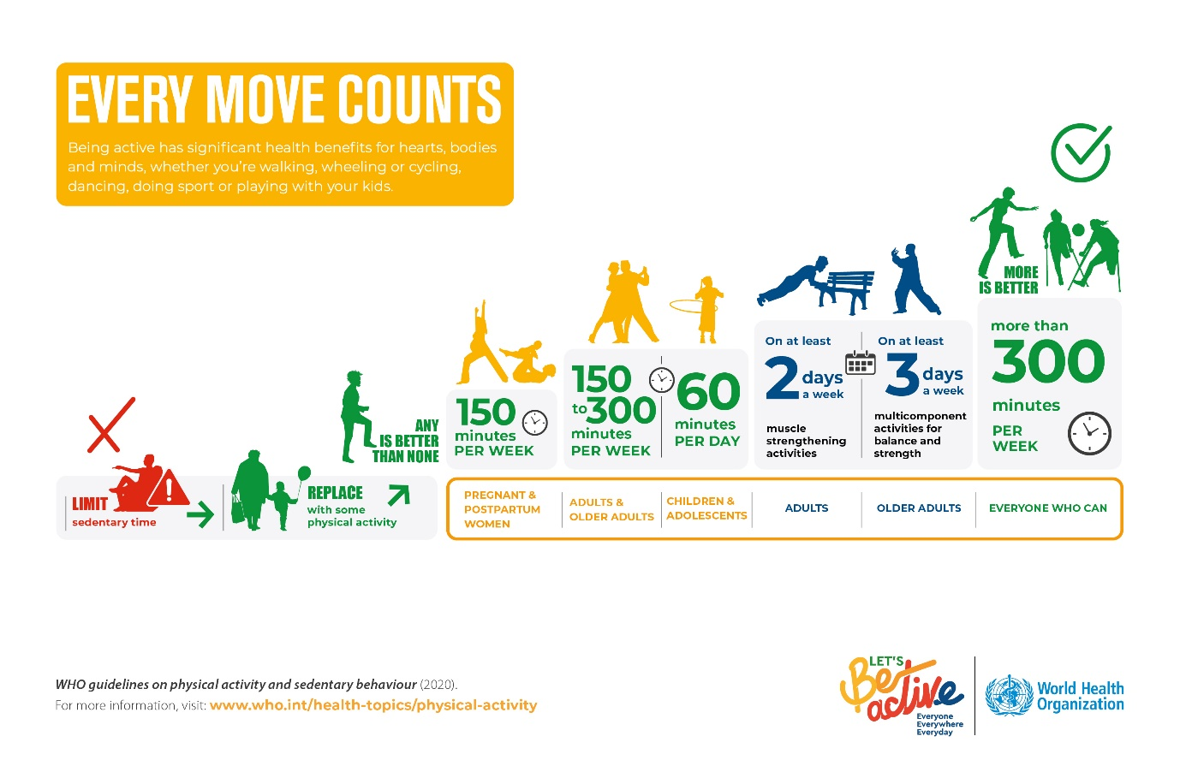

Every year, leading an active lifestyle prevents 900,000 cases of diabetes and 93,000 cases of dementia (the leading cause of death in the UK) – a combined saving of £7.1 billion to the UK economy (Sport England, n.d.)

Movement can provide more benefits than protecting us from poor physical health outcomes. It’s good for our mental wellbeing, connects and strengthens communities, and has huge value to the nation’s economy: we know that for every £1 spent on community sport physical activity generates nearly £4 for England’s economy and society (sport England, Why movement matters). A healthy population is a productive one. Today, the mental and physical health of our workforce has never been more important as we look to build, and rebuild, vital industries and support our national economy through incredibly challenging times.

Movement, sport, and physical activity can increase attachment to place by creating a sense of pride and belonging to where we live. Local community clubs and groups can play a crucial role in addressing isolation by providing opportunities for social connection and shared experiences. “It can be hard to quantify these outcomes, but the economic value of this community building and social trust has been estimated at £14.2bn” (Sport England, why moving matters). A large body of research shows that social isolation and loneliness have a serious impact on physical and mental health, quality of life, and longevity. The effect of social isolation and loneliness on mortality is comparable to that of other well-established risk factors such as smoking, obesity, and physical inactivity. (WHO - Social Isolation and Loneliness (Social Isolation and Loneliness (who.int))

The evidence shows that people who get active have greater levels of happiness, life satisfaction and feeling worthwhile. They’re also less likely to feel anxious. For many of us, this is thanks to the social interaction involved in sport and activity – as we meet and make new friends and share uplifting moments together, whether playing a game in a park, or being part of a team in a local league – while for others it’s about discovering a greater sense of self-worth and resilience, or a combination of these and other positive factors (Sport England, why movement matters)

**Inequalities**

There are many things that influence a person’s ability to be active and the activity levels of different population groups These factors can be related to the individual or wider social, cultural, environmental, and economic determinants that influence access and opportunities to be active in safe and enjoyable ways. (World health organisation, June 2024)

Understanding which characteristics influence activity levels is crucial. The Inequalities Metric identifies which characteristics have the most impact on minutes of activity.

For adults these are:

* Disabled people and those with a long-term health condition
* Age 65 or over
* Lower socioeconomic groups (NS-SEC 6-8)
* Asian, Chinese and Black adults
* Pregnant women and parents of children under one year
* Adults of Muslim faith.

For children and young people these are:

* Girls
* Other gender for those secondary-aged
* Low affluence
* Asian and Black children
* Lack of park/field or outdoor sports place for secondary-aged children.

(Sport England)

**Local context**

Adult Activity Levels

The proportion of adults in North Yorkshire who are physically active is reported as 71.8% (2022/23 data), which is 1.7% higher than 2020/21 (70.1%. The North Yorkshire average continues to be statistically significantly better than the England average (67.1%).

The diagram below illustrates the district level prevalence for 2015/16, to the latest 2022/23 data for North Yorkshire. Due to local government reorganisation (April 2023) there is no district level data available for adults from 2022/23 onwards.

The table below highlights physical activity levels in adults from the Active Lives Adult Survey for 2015/16 to 2022/23:

|  |  |  |  |  |  |  |  |  |
| --- | --- | --- | --- | --- | --- | --- | --- | --- |
|  | 2015/16  % | 2016/17  % | 2017/18  % | 2018/19  % | 2019/20  % | 2020/21  % | 2021/22  % | 2022/23 |
| England | 66.1 | 66.0 | 66.3 | 67.2 | 66.4 | 65.9 | 67.3 | 67.1 |
| North Yorkshire |  |  |  |  | 70.9 | 70.0 | 70.1 | 71.8 |
| Craven | 72.0 | 74.3 | 72.5 | 75.2 | 76.1 | 72.1 | 68.8 | - |
| Hambleton | 73.1 | 69.2 | 67.7 | 71.1 | 72.1 | 69.5 | 67.8 | - |
| Harrogate | 68.8 | 73.1 | 66.1 | 72.9 | 70.6 | 73.9 | 73.3 | - |
| Richmondshire | 71.2 | 74.5 | 79.7 | 72.2 | 75.3 | 72.8 | 76.5 | - |
| Ryedale | 69.3 | 70.0 | 68.1 | 70.7 | 70.0 | 65.9 | 71.2 | - |
| Scarborough | 63.8 | 62.1 | 71.3 | 66.7 | 69.4 | 67.3 | 65.4 | - |
| Selby | 72.4 | 65.8 | 68.3 | 67.9 | 66.3 | 66.1 | 68.8 | - |

Source: Office for Health Improvement and Disparities (based on the Active Lives Adult Survey, Sport England*)*

Children & Young People Activity Levels

The proportion of children and young people in North Yorkshire who are physically active is reported as 50.1% (23/24 data), which is 1.7% higher than 2022/23 (47.1%). The North Yorkshire average statistically similar to the England average (47.8%).

There have been a number of significant political changes within North Yorkshire over the past 2 years which have the opportunity to create the right conditions for a whole systems approach to physical activity.

Local Inequalities

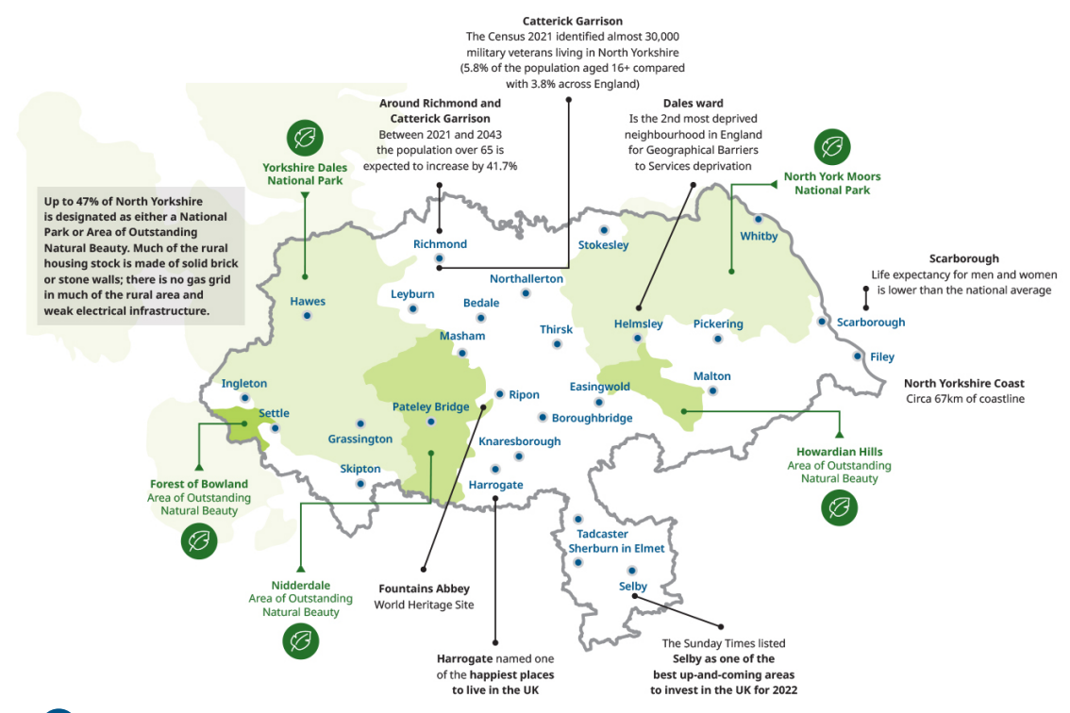

(North Yorkshire Director of Public Health Annual Report 2023-24)

There were 77 residents per square kilometre in North Yorkshire in 2021, up from 74 per square kilometre in 2011. This is the equivalent of there being around two football pitches per resident. Although a beautiful backdrop for tourism and a strong motivation for residents to spend time outdoors it also creates deep-rooted challenges linked to accessibility, isolation and creates challenges delivering key services (UK Shared Prosperity Fund – Investment plan).

The gap in life expectancy varies across the county between our most and least deprived wards, with a **gap of up to 15.5 years** between highest and lowest wards.

25% of residents are over 65 with projected trend and inward migration of older people to the area, this figure is expended to increase to almost a third by 2035.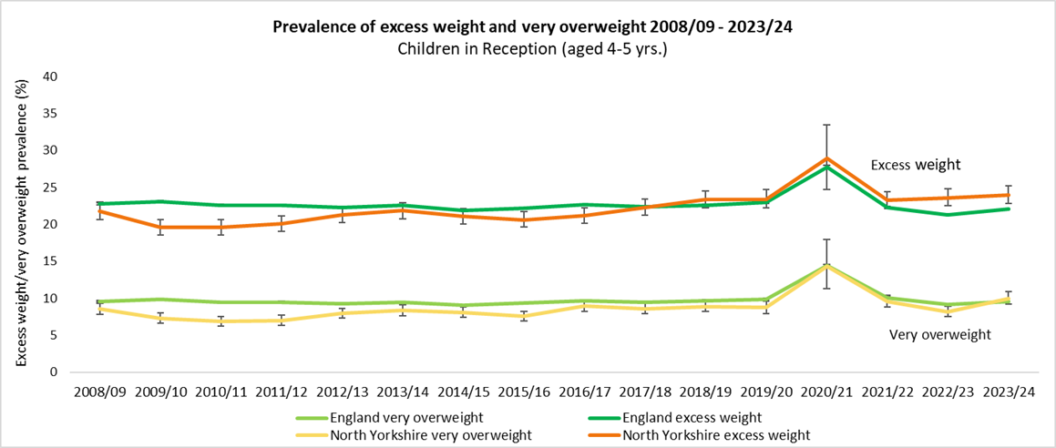

Obesity rates in our youngest children have risen almost 2% in just a year and are now above the national average. North Yorkshire rates of excess weight have been above national average for a number of years.

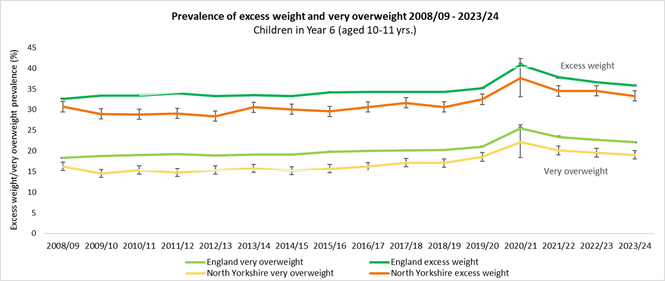

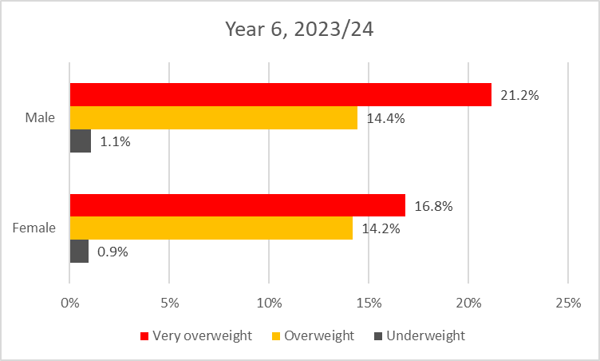NY rates of excess weight and very overweight (obesity) are below national averages and have reduced slightly since the previous year. But they are still higher than pre-pandemic levels.

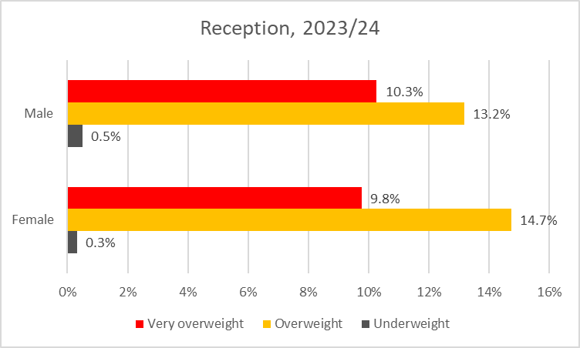

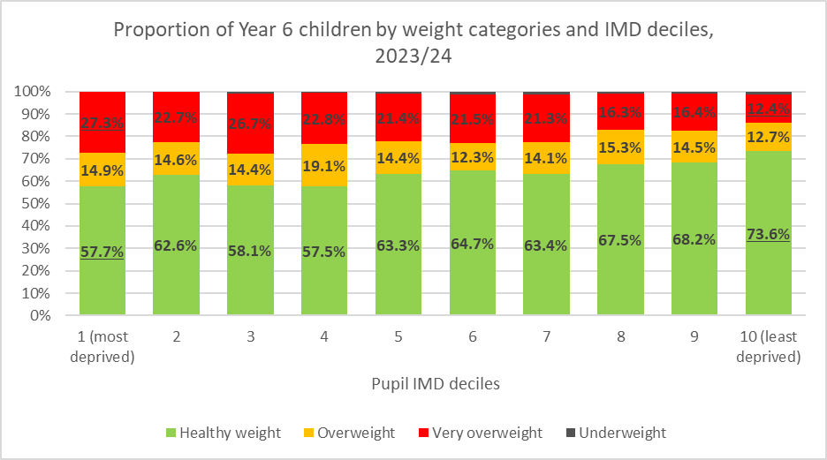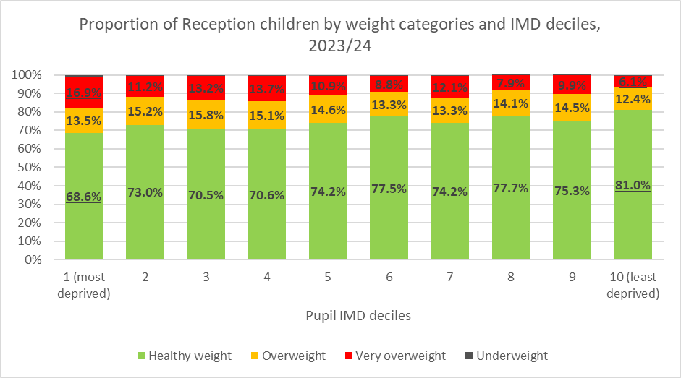Gender differences are persisting, particularly between the older boys and girls. 16.8% of girls and 21.2% of boys aged 10-11 years are classed as very overweight (obese).

Inequalities are increasing, particularly in the younger children. The prevalence of obesity in children in the most deprived areas is 10.8% higher compared to those in the least deprived areas. There was only a 4.3% difference in 2022/23. The prevalence of very overweight for children in the most deprived areas is 14.9% higher compared to those in the least deprived areas. There was only a 12.4% difference in 2022/23.

Strategic Leisure Review

The new North Yorkshire Council launched in 2023 as part of the government’s restructuring of local government in England. This newly-formed unitary local authority has been created by merging the previous district councils of Craven, Hambleton, Richmondshire, Ryedale, Scarborough, and Selby. As part of this process the new Council inherited one of the largest leisure portfolios in the country. With each former district managing these facilities in different ways (outsourced private companies, in-house teams and a trust all used). There was a need to review current services and determine a new operating model. Following the review an in-house model was selected with the aim to “provide clarity and consistency for customers” and have a “renewed focus on physical and mental health and wider wellbeing.” (North Yorkshire Council). The model below is not just about what happens in leisure centres but promotes a strong integration between physical facilities (sport and wellbeing hubs), sports development and place-based delivery. The approach recognises the contribution of physical activity to preventative health and the potential for greater partnership in prevention with the NHS, securing more resources to reduce downstream pressure on the system.

North Yorkshire and York Combined authority

The newly formed North Yorkshire and York Combined authority. The Mayor’s vision to make healthy and resilient communities, that are connected to opportunity, where people live in warm and affordable homes, where people are connected to the outdoors and where there are safe places for all. There are clear opportunities for physical activity and movement to support this vision.

North Yorkshire Sport (Active Partnership)

North Yorkshire Sport (Active Partnership) has recently begun their journey in taking a place-based approach. Activity Communities Managers have a focus on the following areas (Broughton Road, Selby Town, Colburn and Castle Ward in Scarborough). Spending time to understand the issues, interconnections and relationships and coordinating action and investment to improve the quality of life for that community.

North Yorkshire Sport has established a great reputation with health and social care partners, providing them with recognised physical activity interventions to support:

* Condition specific concerns where exercise sessions help individuals manage their condition.
* Exercise sessions which help address strength, balance, and coordination concerns of older participants.
* Inclusive, informal participation exercise sessions to address loneliness and isolation concerns.

These programmes have become sustainable in some areas being delivered by leisure providers and community groups but in other locations these sessions have finished after the funding period leaving gaps in provision across the county.

**National Contexts**

Sport England

Despite investment from governments and councils and various interventions physical activity inequalities remain stubbornly static. Individuals have their own hopes, worries and personal circumstances, and form part of a larger social, economic, and political system that shapes what we see as achievable and the opportunities available to us. It is essential that we understand that many of the things that stop people from being active are just not in their power to change. The places, people, policies, and societal norms that make up the system we live in have a large role in influencing our behaviour and the choices we make. National programmes often can’t tackle the barriers that can often exist at a local level, and top-down interventions don’t lead to sustainable change.

In 2016 Sport England set out a plan to test a new way of working that looked to tackle the causes and not the symptoms of inactivity. By working across and influencing all layers of the system in order to tackle the barriers to inactivity at every level of our society. This would mean collaborating with communities to learn how to create a new way of co-creating change. Sport England set out a framework to identify 12 pilot areas to test out their new approach. The local delivery pilots were tasked with understanding how taking a whole systems approach to physical inactivity in a place could address the stubborn inequalities that exist among the least active.

The work is underpinned by an asset-based community development approach, starting with what's strong, not with what's wrong in in places. The local delivery pilots were also tasked with connecting the system to more of itself supporting it to work towards a more common goal.

How we move, connect, think and feel during movement and physical activity plays a crucial role in shaping our physical literacy. By doing activities that we enjoy, find meaningful, and value, we deepen our connection with movement and physical activity, and foster an ongoing commitment to maintain an active lifestyle. with high levels of physical literacy are twice as likely to engage in sport and physical activity and adults who feel strongly that they have the ability to be active, the opportunity to be active and enjoy being active are also more likely to be active.

To help more people be active it's important everyone involved in the provision of sport and physical activity understands that there's more to it than helping someone develop their physical movement skills. We must also consider how a person moves, connects, thinks and feels about movement and how their environment, culture, community or places and spaces they move in can powerfully influence their relationship with movement in both positive and negative ways.

By understanding what contributes to a person’s physical literacy, we can adapt and evolve our policies, practices and programmes to ensure it meets all of their needs.

Whole systems approaches

Public Health England describe a whole systems approach as “A local whole systems approach responds to complexity through an ongoing, dynamic and flexible way of working. It enables local stakeholders, including communities, to come together, share an understanding of the reality of the challenge, consider how the local system is operating and where there are the greatest opportunities for change. Stakeholders agree actions and decide as a network how to work together in an integrated way to bring about sustainable, long-term systems change” (Public Health England, 2019).

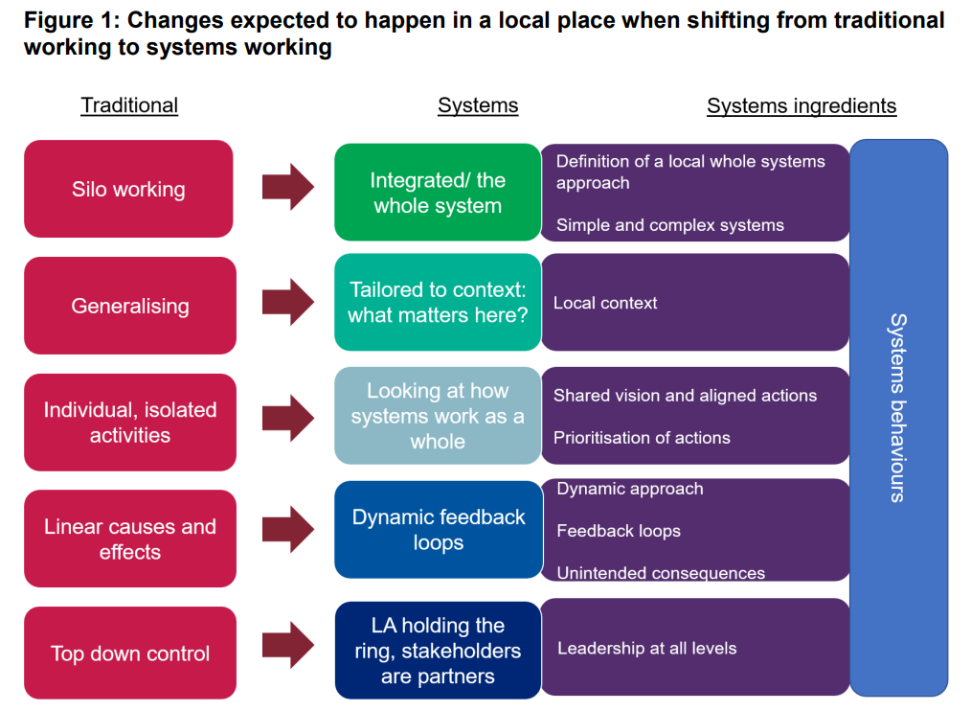

(Taken from Whole systems approach to obesity, 2019)

Creating positive change in our communities requires strong leadership at every level of the system. Building and directing momentum from the bottom up is vital, but without the support of stakeholders it can quickly start to fade. Promoting distributed leadership is one of the main challenges we face but is also the key that could unlock the entire process of systems change.

Sport England Principles:

1. Progress moves at the speed of trust.
2. Stubborn on the vision, flexible on the detail
3. Holding our nerve
4. Bridging the empathy gap
5. Say ‘yes’ to mess.
6. Going where the energy is
7. We can’t solve problems with the same mindset that created them.
8. It doesn’t have to be perfect to be better.

Practicalities of systems change:

* Shared purpose
* Understanding Lived experience
* Distributed Leadership
* Capacity to reflect.
* Top Cover
* Test and Learn
* Power Shift
* Having the right questions
* Understanding the system, you are trying to shape.
* Start with the questions not the answers.

**Purpose**

The purpose of undertaking this work is to have a collaborative system approach to physical activity and movement in North Yorkshire that positively impacts on population health, the environment, and the economy, through distributed leadership. We will focus on areas where movement can create the biggest impact throughout life stages and life experiences; enabling all North Yorkshire communities to engage in joyful movement that leads to a population that is stronger for longer in mind and body.

**The Approach**

What is “The System”?

A system can be described as a collection of interdependent and interconnected parts. If something happens to one part of the system, other parts of the system will be affected (Whole systems approach to obesity, 2019).

The below diagram was developed in conjunction with active partnership colleagues and public health colleagues to help stakeholders visualise how they fit into the North Yorkshire system. The diagram recognises inequalities, the key areas we want to explore as well as acknowledging the intersectionality of population groups and action areas.

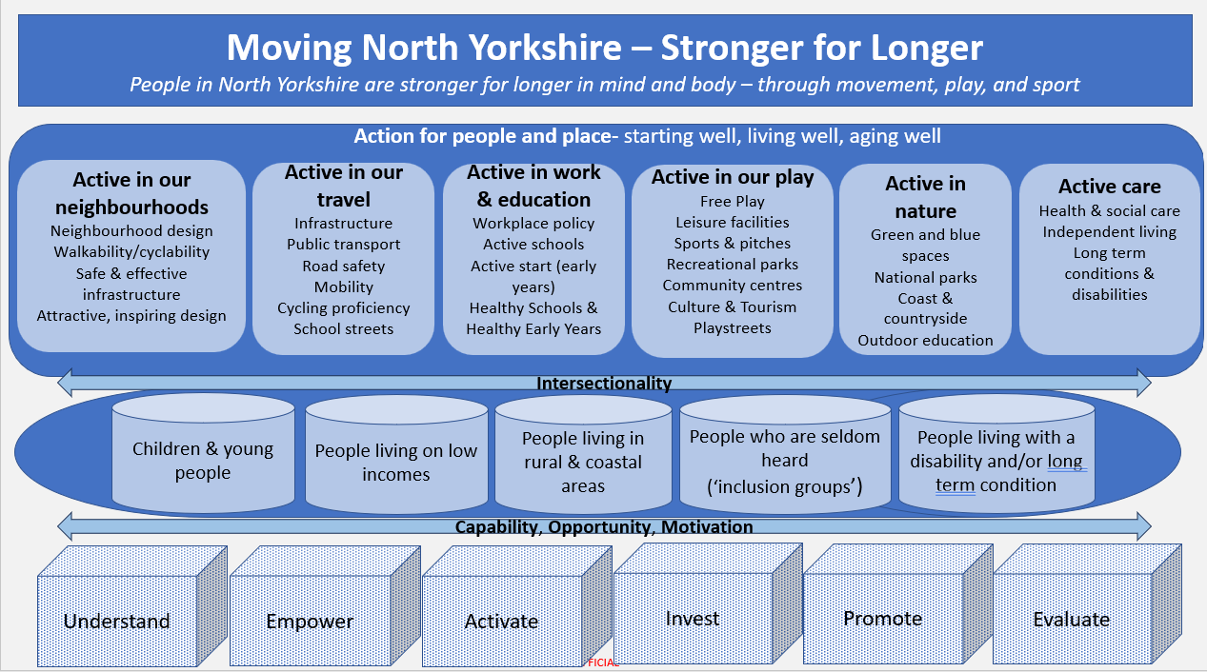

3 horizons approach

The three horizons approach has been utilised in North Yorkshire whilst developing a whole systems approach to food. We will be looking to undertake a similar process with the physical activity system. The figure below depicts the first horizon yielding over time to a third horizon via transitional activity in the second horizon.

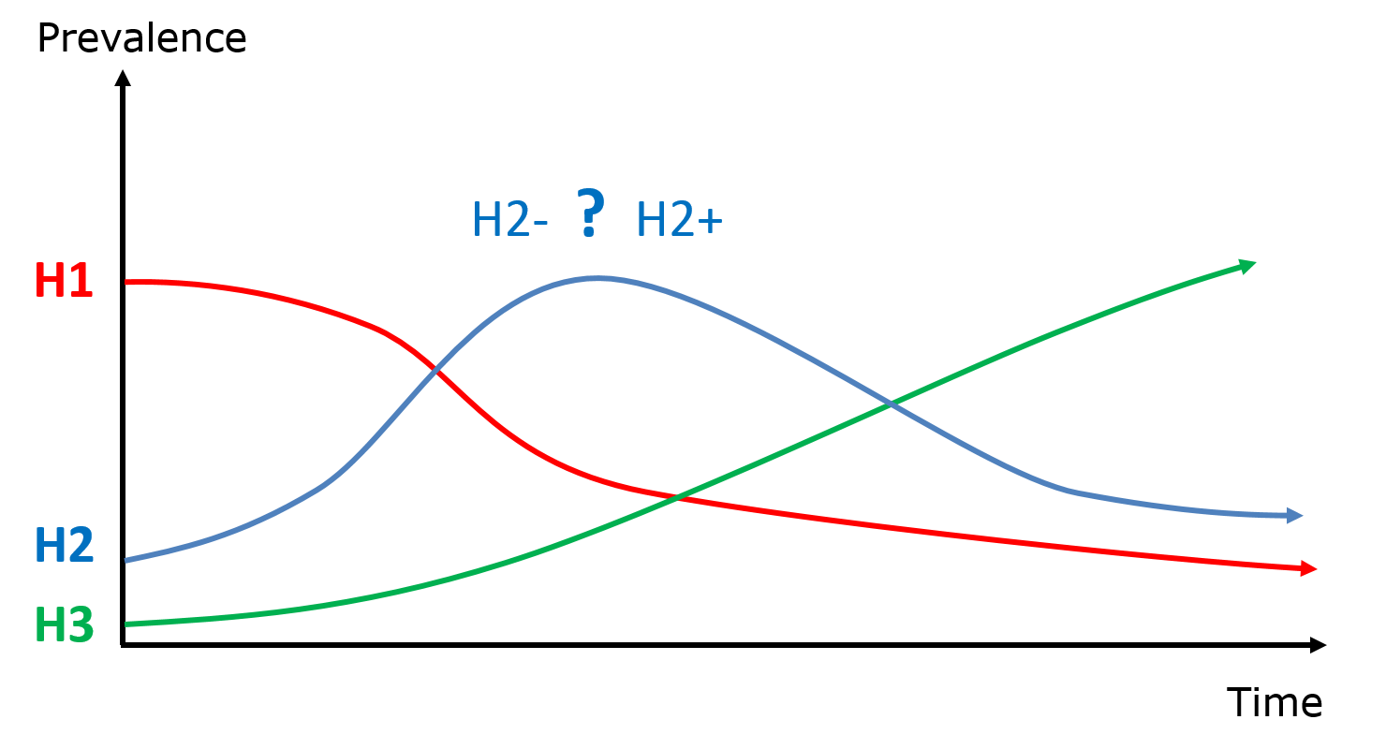

The first horizon (H1): This signifies the current state and the way things are done now. The third horizon (H3): is the emerging pattern that will be the long-term successor to the current first horizon. The second horizon (H2): This represents a time of transitional activities and innovations This second horizon is significant, as it provides the transformation for more radical 3H systems to emerge. “Some innovations (H2+) will help extend the H1 systems and facilitate the emergence of H3 systems. Many innovations will fail, and others (H2-) will be absorbed back into the H1 systems and contribute only to marginal or incremental change. (Sharpe et al, 2016)

Systems leadership

When working in a complex system such as physical activity. Developing systems leadership will be an imperative part of the work we are about to undertake. Systems leadership is a network of people from different levels and places, working collaboratively around a shared vision to create change. Building relationships, shared values and trust, is essential to addressing the challenge of reducing inactivity and enabling active lives for all. No one single organisation or sector alone has the answer. There’s no simple process or procedure to so valuing diverse perspectives from lots of different people who collectively are part of the solution. This means supporting and developing people to enable a transformation in the culture, skills, knowledge, confidence and permissions needed to work in this way.

**Progress to date**

18/9/24 – Moving NY team presented to Public Health, Involvement and Governance Leadership Team

The leadership team are familiar with our suggested approach as a similar approach had been taken within the food system over the past 2 years. The leadership was supportive and recognised lots of links into broader agendas around commercial determinants, planning, behavioural science and the National Child Measurement Programme findings.

Recruitment to partnership group

The partnership group will be the strategic lead for developing the work and the framework. As a working group (containing member of the public health team, active partnership and the sport and active wellbeing team, the asset list was developed to include people from with the system that have strategic influence within our action areas (below)

* Active in our neighbourhood
* Active in our travel
* Active in work and education
* Active in our play
* Active in nature
* Active in our care

We group then met with those identified to explain the work we were looking to undertake and ensuring we addressed how their work aligned with our vision for the future. The outcome of these meetings has been overwhelmingly positive with only a few not understanding how their work fits into what we are striving to achieve. We believe that as we progress with the work and support the development of leadership across the system these stakeholders will see their role more clearly.

7/11/24 - Initial Partnership meeting

The first partnership was held in November 2024 with great representation from across the system. We introduced the idea of a whole systems approach and asked one of Sport England original “Local Delivery Pilots” (Get Doncaster Moving) to present on the work that they had undertaken so far. This provided a the group an example of how this work could develop. Andrew Maddox that has overseen this work provided the key points below:

* Key advice is to stand firm and stich to your key principles, despite challenges.
* This Strategy and Process will take time and progress.
* There are **two Key principles** that are relevant**:**
* **Changes are long lasting –** This is not just about changing the delivery but changing the system and mechanisms that enable the delivery.
* **Anyone can be a leader –** Leadership is distributed, and the Network as a whole is responsible for this work.
* The team utilise a principle of the backbone function. There are four fundamental areas:
* **Team –** Small team that provides a backbone function to support the progress.
* **Residents** – Cocreation developing using processes like appreciative inquiry process, ensure to create with residents (Work with approach, not do to them)
* **Board** – Our Structure is a very governance structure, and an advisory board is involved that provides three functions:
* **Checks -** Check what is being done.
* **Challenges –** identify challenges (is it the right thing to do?) or identify areas of interest that are not included.
* **Unlocks –** opens doors to teams or deliverers that the team cannot get through to.
* **Network –** The network is several organisations or groups that come together in separate ways to work as a collective.

Following this the attendees were asked their reasoning for being involved in the journey we are about to undertake and the below wordle represents the responses:

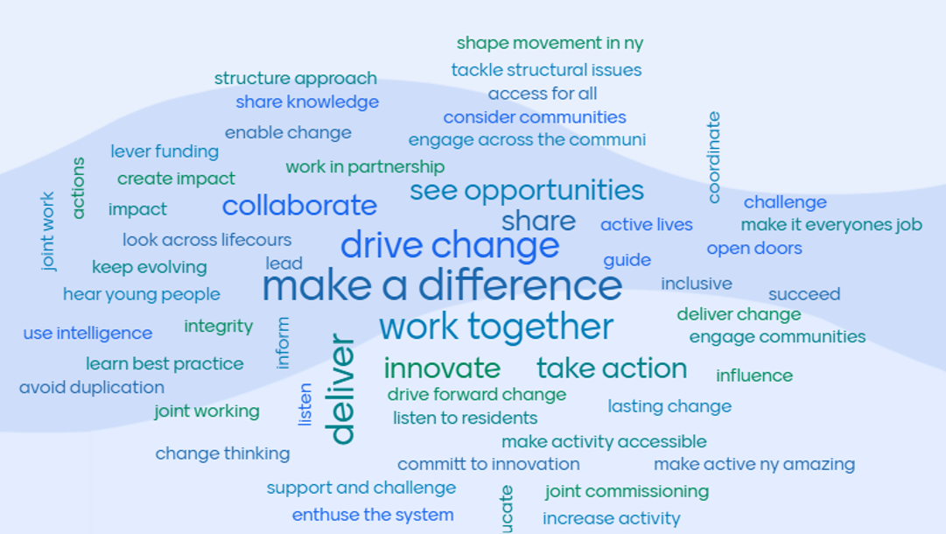

Terms of reference were agreed including the agreement that accountability for the work would sit with the Health and Wellbeing Board.

Partners were invited to share updated from their respective areas of work which included:

Update on the local transport plan - It is on the horizon –Awaiting guidance from the department for transport. Linking the MNY with the local transport plan is wider thinking and pushing the boundaries to what is normally done. Aims to build a wider view into how much impact can be made and gain support from members and senior management to push decisions.

Director of Public Health’s Annual report was shared, and it was highlighted that there was a recommendation about physical activity in older people. Would benefit from support to implement this recommendation and be able to report back in a year’s time.

Active travel mentioned as an area of interest and how this may link into the Carbon neutral fund that the combined authority is hoping to launch in the near future.

There were also discussions around other offers/recommendations for support in different areas and connections. This led to talks of possible separate meetings to further discuss and follow up between the areas. This highlighted the need to track these developing connections within the evaluation process.

The group also discussed and recognised that there is a place for the funding attached to learning to support the work and that Health and wellbeing should be the centre for economic and skill strategies within the System. The social Impact of creating several opportunities to get people engaged and learn through active play is important to the combined authority with the funding to bring these opportunities into fruition.

The wide representation of those in attendance and the keen engagement and new connections made within this meeting bode well for the development of the program going forward.

9/1/25 – Moving NY team presented to Health and Adult Services Leadership

The context, system diagram and approach was presented to the Health and Adult Services leadership Team. The response was extremely supportive and positive and felt the work aligned well with current policies and direction of travel across the wider Council and the systems beyond. Helpful suggestions to connect into the HDRC work and the White Report that has just been released were made, along with ensuring community are linked into the work.

Many of the suggestions for potential connections, were already aligned with the work which reinforced that the people identified on our asset list (and therefore included in either the partnership group and the working groups) were indeed the right system partners.

The final action access of the partnership group was to nominate people from within their teams/areas of work to attend the upcoming workshops that could represent the views from within that sphere of influence.

**Next Steps**

Dues to timescales of governance sign off timescales for this work have slipped and as a consequence we are just about to embark on the workshops. The illustration below maps out our next steps.

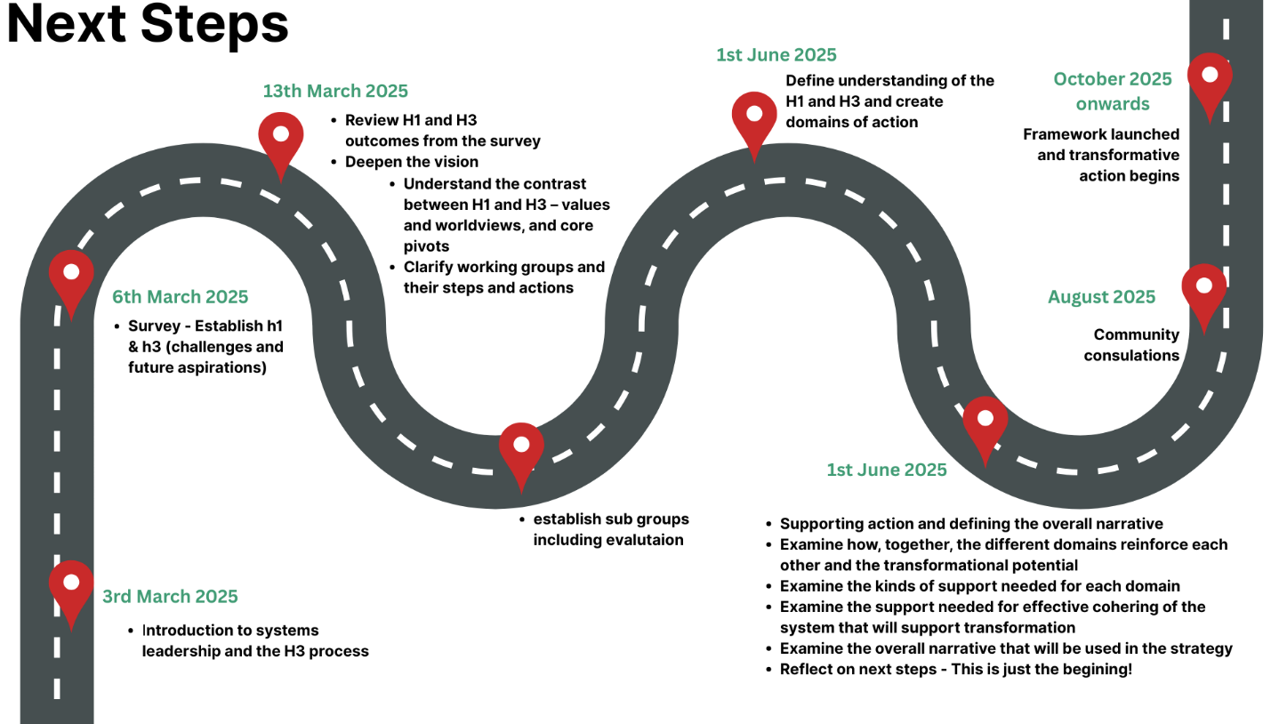

**References**

Why Movement Matters, Sport England, Accessed 11th February 2025, < [https://www.sportengland.org/about-us/uniting-movement/why-moving-matters>.n.d](https://www.sportengland.org/about-us/uniting-movement/why-moving-matters%3e.n.d).

WHO Physical Activity Fact Sheet, Accessed 12th February 2025, <https://www.who.int/news-room/fact-sheets/detail/physical-activity#:~:text=Many%20different%20factors%20can%20determine,in%20safe%20and%20enjoyable%20ways>.

WHO Social Isolation and Loneliness <https://www.who.int/teams/social-determinants-of-health/demographic-change-and-healthy-ageing/social-isolation-and-loneliness> accessed Oct 2024

North Yorkshire Council Executive, Strategic Leisure Review, 9 January 2024 <https://edemocracy.northyorks.gov.uk/documents/s25950/Strategic%20Leisure%20Review%20Report.pdf> Accessed Feb 2024

North Yorkshire Council, Strategic leisure review, <https://www.northyorks.gov.uk/your-council/consultations-and-engagement/current-consultations/strategic-leisure-review>

Public Health England (2019) *Whole systems approach to obesity A guide to support local approaches to promoting a healthy weight. Available at:* [*https://assets.publishing.service.gov.uk/media/5d396e7140f0b604de59fde9/Whole_systems_approach_to_obesity_guide.pdf*](https://assets.publishing.service.gov.uk/media/5d396e7140f0b604de59fde9/Whole_systems_approach_to_obesity_guide.pdf) *(accessed December 2024)*

Sharpe, B., A. Hodgson, G. Leicester, A. Lyon, and I. Fazey. 2016. Three horizons: a pathways practice for transformation. *Ecology and Society* 21(2):47.

North Yorkshire Director of Public Health Annual Report 2023-24 [Director of Public Health annual report 2023-2024](https://www.nypartnerships.org.uk/sites/default/files/Partnership%20files/Children%20and%20young%20people/Director%20of%20public%20health%20annual%20report%202023-24%20final%20-%20accessible.pdf)

UK Shared Prosperity Fund, North Yorkshire Investment Plan, Submission to Government 29th July 2022, https://www.northyorks.gov.uk/sites/default/files/2023-03/UKSPF%20IP%20Final%20accessible.pdf