Final report for Health Equity Fellowship
Project Details
Project Name | Increasing the uptake of the Lung Cancer Screening in North Lincolnshire Place amongst people with learning disabilities.
Mentor | Matt Greensmith
Start Date | April 2024
Summary/Abstract – FINAL REPORT
Introduction | The World Health Organisation (WHO) state that ‘health’ is defined as ‘a state of complete physical, mental and social well-being and not merely the absence of disease or infirmity’. WHO also state that ‘health equity’ is when everyone can attain their full potential for health and wellbeing.  The NHS Long Term Plan sets out the ambition around cancer early diagnosis meaning 75% of cancers are diagnosed at stages 1 and 2, rather than stages 3 and 4. As reported in the governments’ national screening blog, so far, more than 1 million people have taken up their lung cancer screening invitations and screening has diagnosed more than 5,500 people with lung cancer. Over 75% of these lung cancers were found at an early stage (1 or 2), compared to less than 30% of lung cancers detected outside of screening.  Mencap report that there was a difference in cancer screening uptakes when comparing those with and without a learning disability.  a) for breast cancer screening 52.5% of women with a learning disability access screening compared to 68% of women without,  b) for cervical screening 31.2% of women and people with a cervix with a learning disability access screening compared to 73.2% of women and people with a cervix without,  c) for bowel cancer screening 77.8% of people with a learning disability access screening compared to 83.7% of people without.  There is a lack of national data regarding the uptake of the Targeted Lung Health Check due to the fact it being a pilot project. Lung Cancer Screening is a new screening programme, and there is no national data currently available.
Central aim of your project | The Humber and North Yorkshire Cancer Alliances’ Inequalities Strategies vision is that ‘every person in Humber and North Yorkshire has an equitable opportunity to have their cancer diagnosed at an early stage and can have equitable access to treatment no matter who they are, or where they live’.  The central aim of this health equity fellowship project is to increase the number of people with a learning disability accessing Lung cancer screening in North Lincolnshire Place.  The baseline data is that the 68 people with a learning disability who were invited in Hull place, with none of these people attended their Targeted Lung Health Checks.  Secondary aims of the project are to:  - increase awareness of cancer signs and symptoms in people with a learning disability, and those who care for them.  - utilise the learning, evidence and research from this health equity fellowship pilot project to increase the number of people with a learning disability accessing cancer screening. There are three other cancer screening programmes: breast cancer, bowel cancer and cervical.  - utilise the learning, evidence and research from this health equity fellowship project to increase the number of people with a learning disability accessing screening, such as Abdominal Aortic Aneurysm (AAA) screening, and diabetic eye screening.
Methodology, results, conclusion | A search of the GP records was conducted by Care Plus Group to determine that there were people with a learning disability eligible for the Lung Cancer Screening within North Lincolnshire; without this the project would have needed to be refined. The initial search showed that there were 46 people with a learning disability code who were eligible to have a Lung Cancer Screening in North Lincolnshire. A subsequent search was completed prior to the lung cancer screening programme going live in North Lincolnshire.  A literature review was conducted in partnership with Hull University Teaching Hospital Trusts’ Library and Knowledge Services to identify examples of good practice regarding the following themes or topics; learning disability, cancer screening, health literacy, Easy Read documentation, and lifestyle behaviours such as smoking prevalence.  Following the literature review, a number of focus groups and discussions took place with a range of individuals and groups to determine barriers and solutions for people accessing screening with a learning disability within North Lincolnshire Place. These took place with the Learning Disability Partnership meeting, the Carers in Partnership meeting, North Lincolnshire Place staff members including the Transformation Managers and Senior Nurse Vulnerabilities, as well as the voluntary and community sector organisations such as Cloverleaf Advocacy, and Starlight Arts. More about the literature review and focus group feedback can be seen in the Appendix.  The Cancer Research UK ‘The Cancer Screening Process’ and several behaviour change models were used to develop recommendations to Humber Health Partnership / Northern Lincolnshire and Goole NHS Foundation Trust for the lung cancer screening process for people with a learning disability. An additional adaptation was made by Humber Health Partnership / Northern Lincolnshire and Goole NHS Foundation Trust whereby the triage telephone call was to be conducted by a nurse.  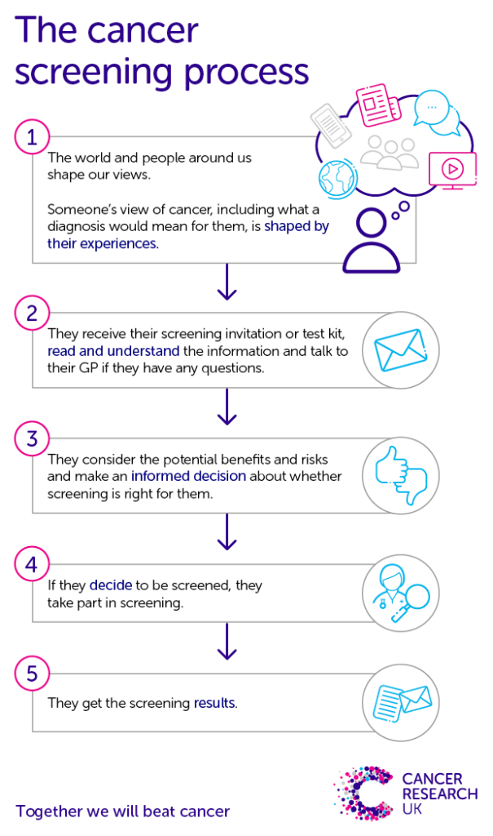  The recommendations made were as follows:  - An additional triage telephone call in advance of the initial Easy Read invitation letter being sent – determined by the lead nurse that this phone call would be completed by a nurse. A telephone call is not in the standard process for Lung Cancer Screening. This telephone call is to ensure the people with learning disabilities have capacity to have an appointment as part of Lung Cancer Screening.  - Easy Read letters sent out rather than the standard letter. The Easy Read letters were produced in partnership with and by Cloverleaf Advocacy. The Easy Read letters and documentation produced by Cloverleaf Advocacy were verified by the Humber Health Partnership / Northern Lincolnshire and Goole NHS Foundation Trust’s governance team prior to being sent out.  - 10 days after the letter sent; a phone call to be made to ask if they would like an appointment (rather than a letter) from the Lung cancer screening Team  - Explicitly stating within the telephone calls that a carer or another can attend appointments with the person (with a learning disability)  - Enabling a double slot appointment time for the initial assessment. The appointment type (face to face or telephone) would be dependent on an individual basis, ensuring the most comfortable and appropriate appointment type is in place. If the initial appointment takes place face to face, this appointment will be within a unit next to the CT Scanner.  - Enabling a smoking cessation appointment to be available for current smokers on the same day as the initial appointment, if this initial appointment is face to face.  - Enabling and scheduling a CT scan appointment if needed on the same day as the initial appointment, if this initial appointment is face to face.  - The results of the CT scan to be communicated by a telephone call prior to the result letter being sent out to assure understanding from the person with a learning disability.  When the searches were completed prior to Humber Health Partnership / Northern Lincolnshire and Goole NHS Foundation Trust sending out the invites for lung cancer screening there were 73 people with a learning disability code were eligible for the Lung Cancer Screening. There is a discrepancy between the number of people with a learning disability code between initial search mentioned previously (46 people) and the number in this search. This discrepancy is due to the time difference between the two searches. Twenty-three of these people with a learning disability were residents of a care home.  Due to a miscommunication; invitations were sent out to people with a learning disability utilising the standard process (without any of the recommendations being implemented) once the Lung Cancer Screening Programme started to be rolled out in North Lincolnshire. As a result of this, the following data was provided by Humber Health Partnership.  - 1 patient did not attend (DNA)  - 3 patients had three failed call attempts  - 2 patients had scans within the past year  - 4 patients received second invitation letters  - 1 patient received a first invitation  - 1 patient CT was not required  The Awareness and Early Diagnosis Team from the Humber and North Yorkshire Cancer Alliance delivered several adapted Cancer Champions Awareness Sessions which are targeted and focused for people with a learning disability because of this health equity fellowship. This included the following groups: Starlight Arts, Cloverleaf Advocacy at The Mount, The Birches, and Creative Support. It could be argued that these Awareness Sessions have encouraged people with a learning disability to attend their Lung Cancer Screening when invited. Targeted Awareness Sessions did not take place prior to the Lung Cancer Screening being implemented into Hull Place.  Additional work was completed to raise awareness of the lung cancer screening programme through attendance at the North Lincolnshire Complex Provider Forum (on 28th January 2025). A presentation was given at this meeting. Those in attendance had a discussion about some barriers and solutions to accessing cancer screening (for all cancer screening programmes). In addition, the offer was made to providers that the Alliance could provide face-to-face Cancer Champions Awareness Sessions for their staff, residents and / or family members.  A subsequent or follow up Cancer Champions Awareness Session was organised and delivered for Options Thorpe House on 11th February 2025. The offer for the Alliance to provide Cancer Champions Awareness session to family members was reiterated within the staff session. In doing this enabling family members of residents to have an awareness of the signs and symptoms of cancer and also promote the cancer screening programmes.  It was agreed between the Cancer Alliance and Humber Health Partnership / Northern Lincolnshire and Goole NHS Foundation Trust that the recommended adapted process would be implemented for all those previously invited using the standard process (highlighted above) except the patient who did not require a CT scan.  As confirmed by the Administration Service Manager for Humber Health Partnership Lung Cancer Screening Service; the Easy Read invites were distributed on Tuesday 18th and Monday 24th February. With the initial assessments being planned for Saturday 8th, Monday 10th and Tuesday 11th March 2025.  Positive feedback has been received from partners regarding the recommended adaptions to the standard process for inviting those people with a learning disability. Examples of this include:  - I sincerely believe that the efforts contributed by everyone in supporting patients with learning disabilities are commendable. It is truly rewarding to assist and motivate them in undergoing such a crucial screening procedure. The primary challenge has been the novelty of the initiative, as with any new project, where uncertainty is inherent. However, I am confident that, as a team, we have successfully navigated this process with relative ease. Regarding the reasonable adjustments, the primary challenge has been obtaining approval for the easy read letters to be used. This process has been prolonged due to recent changes within the care groups. However, the other adjustments were relatively straightforward, as they had already been implemented within the homeless project.  Administration Service Manager, Lung Cancer Screening Service.  The full impact and success of the recommended adapted process implementation will be seen late March and early April.
Body of the report INTERIM REPORT and FINAL REPORT
This section provides the detail of your work analysis, data, and graphics
Provide the evidence and theory behind your project | As an overview of the Humber and North Yorkshire (HNY) region the following aspects are important to note and be acknowledged.  Age  Regarding age, Humber and North Yorkshire has a higher percentage of people aged between 65 to 84, and 85+ group years of age; a lower percentage of people aged between 0 to 17 compared to England as can be seen in the graph below. The eligibility age for Lung Cancer Screening is between 55 years to 74 years and 364 days.  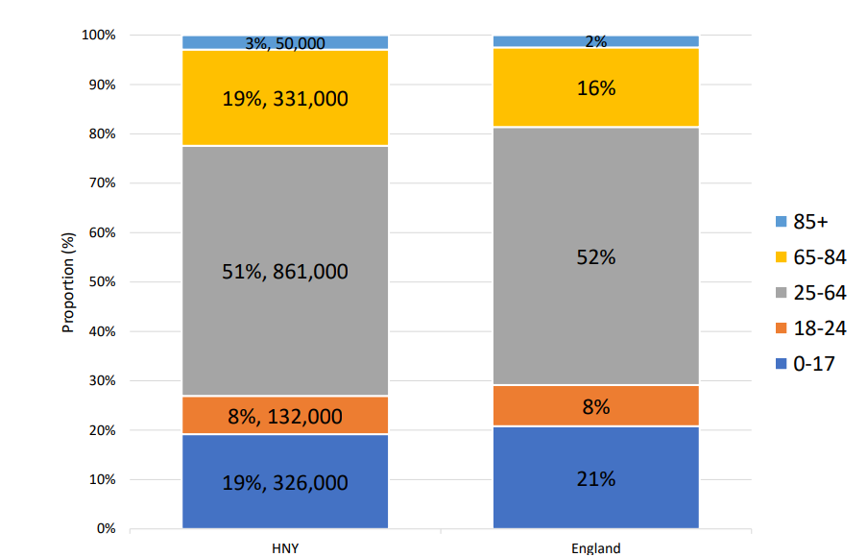  Deprivation  Regarding deprivation, across the Humber and North Yorkshire there is a variety and unusual picture across each of the deprivation deciles, rather than there being a 10% across the ten percentiles.  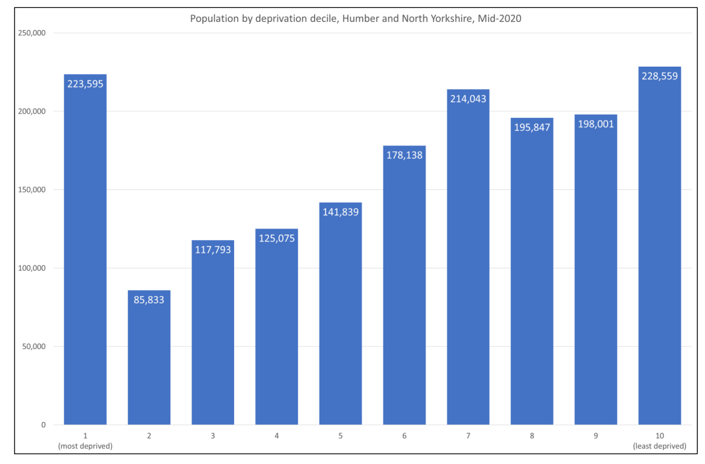  Across Humber and North Yorkshire, the six Places are:  - East Riding of Yorkshire  - Hull  - North East Lincolnshire  - North Lincolnshire  - North Yorkshire  - York.  Each Place across the area has a varied percentage of each of the levels of deprivation. Within North Lincolnshire Place, there are less people within the least deprived decile.  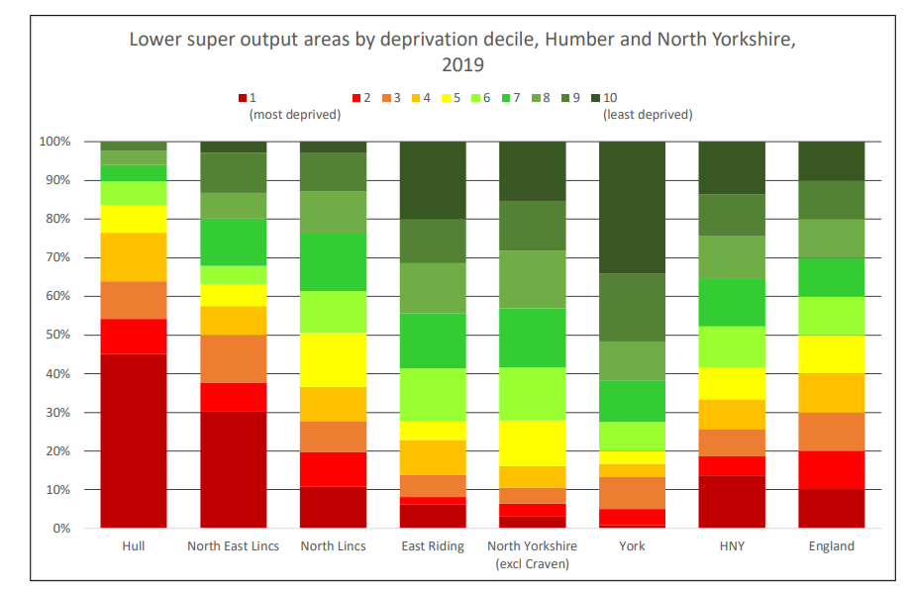  Life expectancy  As reported on Public Health Fingertips; life expectancy at birth within Humber and North Yorkshire in 2022 is 78.9 years for males and 82.8 years for females. Both these life expectancies being worse or lower than the England value; 79.3 years for males and 83.2 years for females. As reported by The Kings Fund after the North East and the North West regions, Humber and North Yorkshire has the lowest life expectancy.  There are variances in life expectancy for female and male across the six Places within the region, which can be seen in the table below with data being sourced from Public Health Fingertips. Across all six Places, the life expectancy is higher in female than male. Hull, North Lincolnshire and North East Lincolnshire Places have the lowest life expectancy for female. Hull and North East Lincolnshire Places have the lowest life expectancy for male. York Place has the highest life expectancy for both female and male.  Life expectancy (years)  Female Male  England 83.2 79.3  HNY 82.8 78.9  East Riding of Yorkshire 83.6 79.9  Hull 80.0 75.6  North East Lincolnshire 82.1 77.7  North Lincolnshire 82.7 78.8  North Yorkshire 84.1 80.4  York 84.0 80.4  Mortality and Morbidity  The Department of Health and Social Care’s Major Conditions Strategy states nationally that the following six major conditions drive 60% of mortality and morbidity in England: cancer, chronic respiratory disease, cardiovascular disease, mental ill health, musculoskeletal disorders, and dementia.  Locally within the Humber and North Yorkshire region, behind COVID-19 and circulatory disease, cancer is included as the third cause of gap in the life expectancy across Humber and North Yorkshire. Cancer has a greater percentage of contribution for females (21.7%) compared to male (15.4%).  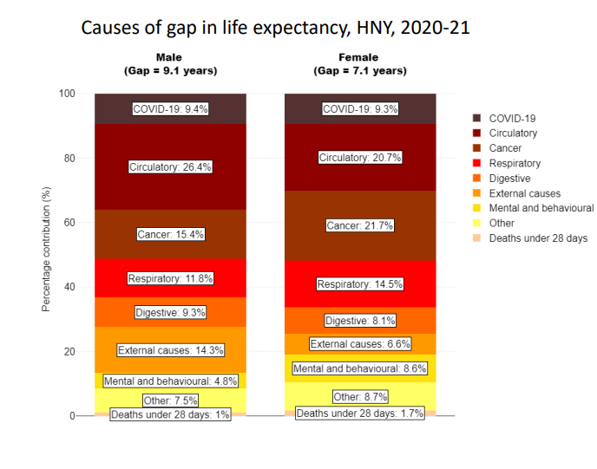  Smoking attributable mortality is significantly higher in North Lincolnshire compared to England.  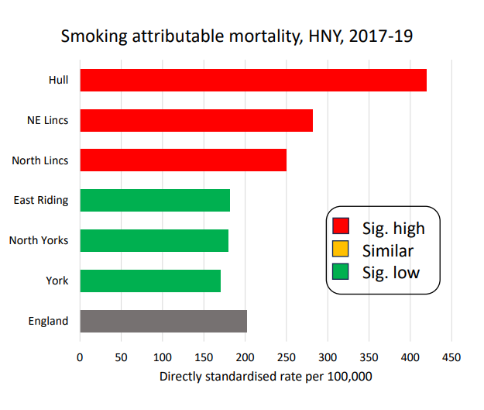  Health inequalities  Health inequalities are the differences in health and wellbeing experienced across the population. These differences are unfair and avoidable; often impacted by the wider determinants of health. The diagram below from Dahlgren and Whitehead show the wider determinants of health.  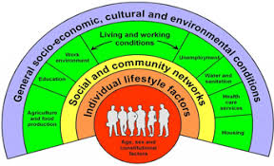  Cancer Research UK highlight ways in which cancer can be prevented, these are related to individual lifestyle factors, and social and community networks. This information and data have been utilised to raise awareness in an interactive way through playing Play Your Cards Right in the face-to-face Cancer Champions Awareness sessions and community and engagement events. The British Psychological Society states “games increase adults' engagement, and this can lead to enhanced learning” (Hamari et al., 2016), 2020.  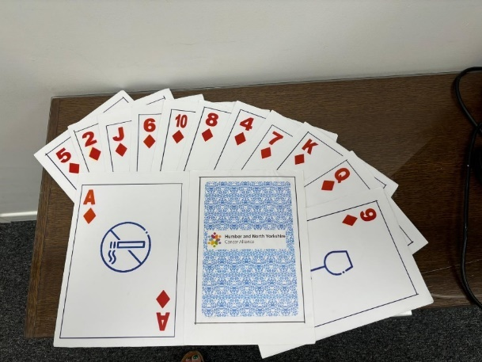  In order of the impact with the greatest at first, they are:  - Being smoke free  - Keeping a healthy weight  - Being safe in the sun  - Avoiding certain substances at work (such as asbestos)  - Being protected against certain infections (such as Human Papilloma Virus)  - Drinking less alcohol  - Eating a high fibre diet  - Avoiding unnecessary radiation  - Cutting down on processed meat  - Avoiding air pollution  - Breastfeeding if possible  - Being more active  - Minimising HRT use.  In addition to the ‘Play Your Cards Right’ game, to increase engagement and participation, the Alliance worked with Hull Men in Sheds to the production of a lung buzz game.  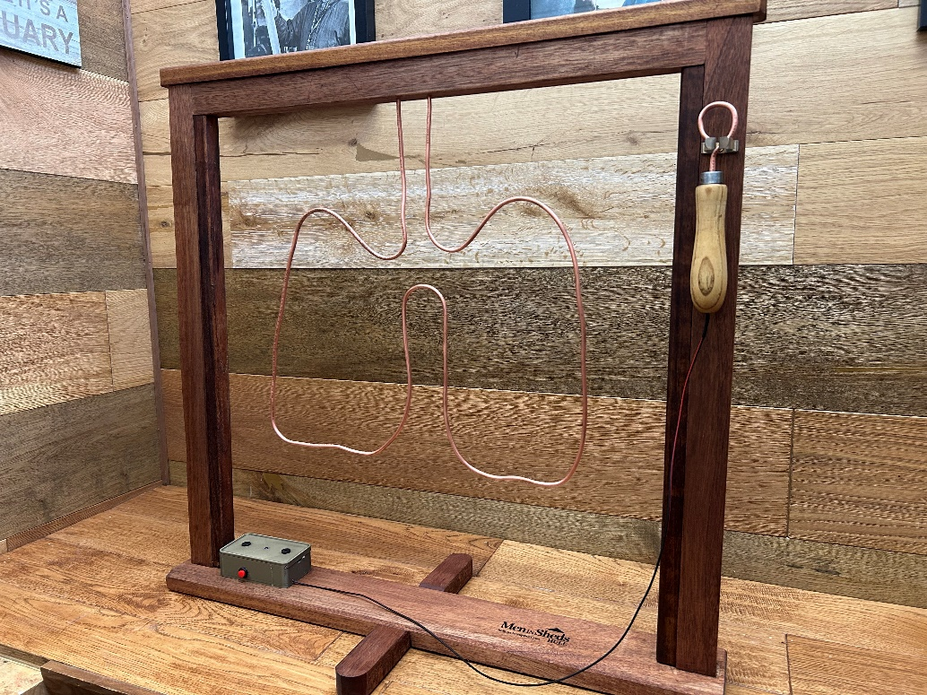  NHS England and Disability Rights Commission (2006) report people with a learning disability are four times more likely to die of something which could have been prevented than the general population. Looking specifically at smoking; being smoke free has the biggest impact on reducing risk of developing cancer. Being smoke free can prevent 15 cancers: including lung cancer. The smoking related cancers can be seen in the following infographic from Cancer Research UK.  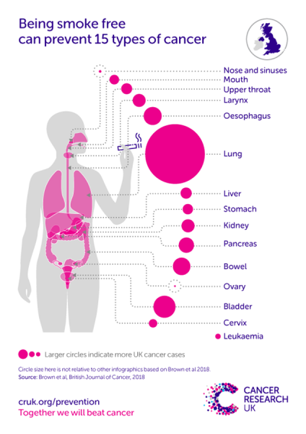  The following infographic shows how smoking causes cancer.  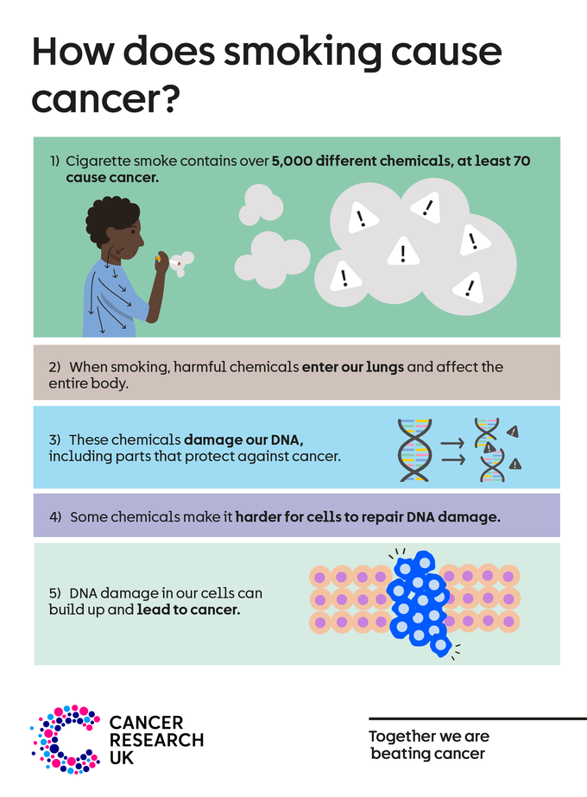  There is limited large scale data regarding smoking prevalence in people with a learning disability; there is a smaller scale Research and evidence report that states:  - Women with a learning disability are less likely to smoke than men with a learning disability.  - Those people with a mild or moderate learning disability have a higher smoking prevalence than those with a more severe learning disability.  - Those people with a mild or moderate learning disability have a higher smoking prevalence than the general population.  - Those people with a learning disability living independently in their own home had a higher smoking prevalence than those people with a learning disability living with family or friends, or in a community care facility.  A person, with or without a learning disability, is at a greater risk of developing cancer if they smoke and drink alcohol.  Cancer Screening  Within the NHS Long Term Plan, the aim is for 75% of cancers being diagnosed at Stage 1 or Stage 2 by 2028. Overall, 74% of people with a cancer diagnosis will survive for 5 or more years when diagnosed early (stage 1 and stage 2); compared to 35% when the cancer is diagnosed at a late stage (stage 3 and stage 4). The aim of the screening is to detect cancer at the earliest opportunity.  There are now four national screening programmes for cancer.  - breast cancer screening,  - bowel cancer screening  - cervical screening  - lung cancer screening (this started in February 2025).  Important to note that cervical screening is looking to prevent cancer, through the detection of the presence of HPV and cell changes, rather than identify cancers already present.  Each of the cancer screening programmes have a set eligibility criterion based upon evidence and research.  The Lung Cancer Screening programme was implemented as a national cancer screening programme from 1st February 2025, following the successful Targeted Lung Health Checks Programme. The aim of Lung Cancer Screening is to detect lung cancer as early as possible; sometimes before the person has symptoms. The eligibility criteria for the Lung Cancer Screening are the person being:  a) aged between 55 to 74 (+364 days) years,  b) current or former smoker,  c) registered and live in the area where the Lung Health Checks are taking place.  The exclusion criteria for Lung Health Check are that the person is on End-of-Life Care, have been diagnosed with lung cancer within five years, are unable to lie flat, weight restriction for anyone over 200kgs, and participants who do not have capacity to give consent.  The initial Lung Cancer Screening appointment may be in person, by telephone or online. A health professional will ask about health and lifestyle to find out more about the risk of lung cancer. This includes questions about breathing, lifestyle, and family and medical history. Height and weight measurements will also be taken. After the initial appointment, one of the following will happen.  - no further action – if the lung health check suggests you are not at higher risk of developing lung cancer, then no further action is needed,  - referral to your GP – if the lung health check finds problems with your breathing or lung health, you may be referred to your GP for a follow-up appointment to discuss this in more detail,  - offered a CT scan of your lungs – if the lung health check finds you're at a higher risk of developing lung cancer, you may be invited for a CT scan to take a detailed picture of your lungs. This might be on the same day, or you may be invited to another appointment. The lung health check team will write to your GP with details of your appointment.  As reported within the Humber and North Yorkshire Cancer Alliances’ 2023/2024 Annual Report; during the year within the three Places which have had Lung Health Checks (Hull, North East Lincolnshire and East Riding of Yorkshire);  - 27, 853 people have been invited;  - there were 11,404 initial assessments (Part One);  - 4,449 CT scans (Part Two) and  - 84 cancers diagnosed. Of these 84 cancers diagnosed; 75% were diagnosed at Stage one or Stage two.  Learning Disability and cancer screening  Mencap define learning disability as ‘a reduced intellectual ability and difficulty with everyday activities which affects someone for their whole life’. Learning disabilities are categorised as mild, moderate, severe, or profound.  Mencap report that there are 1.3 million people with a learning disability in England. Public Health England Fingertips report that for 2022 / 2023 there were 347, 840 people with a learning disability in England. This was measured by the recording on GP practice disease registers and reported through the Quality and Outcomes Framework (QOF). There is discrepancy between these two figures.  Mencap report that on average women with a learning disability die 23 years younger than the general population, and for men the difference is 19 years.  Mencap report that there was a difference in the three established cancer screening uptakes when comparing those with and without a learning disability.  - for breast cancer screening 52.5% of women with a learning disability access screening compared to 68% of women without a learning disability,  - for cervical screening 31.2% of women and people with a cervix with a learning disability access screening compared to 73.2% of women and people with a cervix without a learning disability,  - for bowel cancer screening 77.8% of people with a learning disability access screening compared to 83.7% of people without a learning disability.  Due to the current roll-out of the Lung Cancer Screening programme and recent national implementation of screening programme from a pilot project (Targeted Lung Health Checks); there is no national data regarding uptake on the Lung Cancer Screening for people with a learning disability. Within Humber and North Yorkshire Cancer Alliance area; none of the 68 people with a learning disability invited to the then Targeted Lung Health Check in Hull engaged with the service or attended an appointment. No data is currently available for people within North East Lincolnshire or East Riding of Yorkshire.  Behaviour change models  There are numerous models relating to behaviour change. Relating these to the Lung Health Check process is important to highlight potential barriers and solutions to increase uptake of the Lung Health Checks. Conversations with partners and individuals, alongside research and evidence has been used.  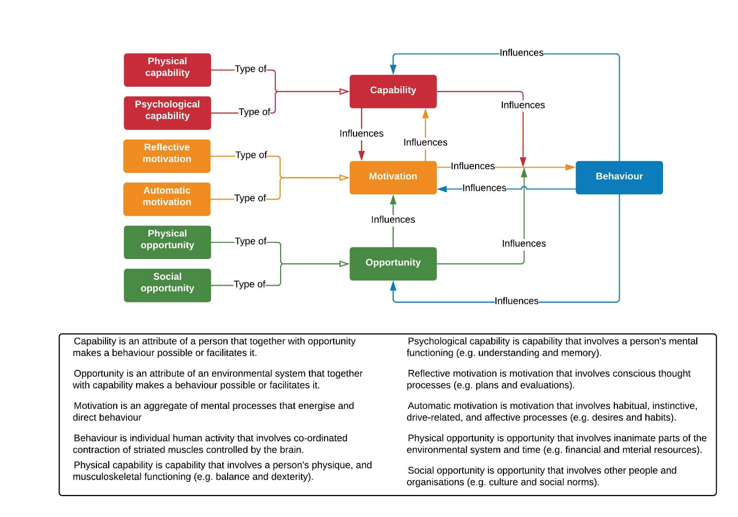  The COM-B Model (above) proposes that for a behaviour to occur; the person needs the physical and psychological capability, social and physical opportunity, and reflective and automatic motivation to complete the behaviour. For attending lung health checks the following aspects need to be considered:  - CAPABILITY  - PHYSICAL - access to a telephone, ability to answer questions asked in the initial consultation / Part One of the Lung Health Check, capability to have a telephone appointment for Part One, capability to have a CT scan, capability to get to the mobile CT scanner unit, capability or resource to attend the appointment.  - PSYCHOLOGICAL – capability to understand the various letters and other communications regarding an invitation, attending and understanding the results of the Lung Health Check, capability to remember to attend the appointment, understanding of how and when to attend the appointment (Part one and Part Two), ability to plan to attend the appointments.  - OPPORTUNITY  - PHYSICAL – opportunity to travel to attend the appointments, opportunity to attend the appointment including having a private space to answer questions on the telephone (Part One), opportunity for there to be reasonable adjustments for the appointments.  - SOCIAL – the social norm of attending appointments, including screening appointments, Annual Health Checks with community and peer network, seeing people that are relatable that attend the Lung Health Checks, opportunity for there to be reasonable adjustments for the appointments.  - MOTIVATION  - REFLECTIVE – motivation to plan to attend the appointments, motivation to determine if there is a diagnosis, motivation to stop smoking (if current smoker)  - AUTOMATIC – desire to attend appointments, including screening appointments, Annual Health Checks, habit of attending health appointments, including screening appointments and Annual Health Checks.  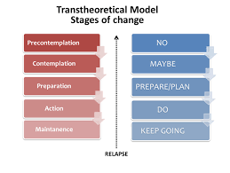  The Transtheoretical Model (above) states there are six stages of behaviour; within each of the stages there are different needs, barriers, and solutions to encourage the desired behaviour of people to have a lung health check. Important to note that relapse can occur at any stage of the transtheoretical model.  - Precontemplation or no – important to increase the awareness of Humber and North Yorkshire Cancer Alliance, Lung Health Checks, cancer signs and symptoms, and cancer screening programmes, as well as building networks and connections with a view of increasing partnership working and building rapport to become a reliable, trustworthy and respected organisation for individuals with a learning disability, their family and friend networks and also any wider networks. This could also include promoting the Alliance’s social media as a trusted and reliable source of information.  - Contemplation or maybe – as above, with a greater focus on the Lung Health Checks, and lung cancer. For example, ensuring that communications are accessible and meaningful. Communication channels could include letters, text messages, and verbal conversations (including telephone calls) when attending an appointment or scan. This could also include access to social media.  - Preparation or prepare / plan – the logistics which need to be considered when attending an appointment; for example, travel options, car / cycle parking, work and other commitments, ensuring support is available for the appointment by either a personal assistant, carer or another NHS professional.  - Action or do – implementing the plans from the preparation phase.  - Maintenance or keep going – reflecting upon attendance, and motivation to attend a future screening and or health appointment.
Describe achievements, changes and difference made, impact | Achievements made through the health equity fellowship include:  - Building and maintaining partnerships and positive working relationships with key individuals and organisations within North Lincolnshire and wider within Humber and North Yorkshire, and West Yorkshire ICB, including new ones associated with people with a learning disability.  - Active listening to people with a learning disability and those with lived experience to determine the barriers and solutions for people with a learning disability to successfully access screening. And using these barriers and solutions to make recommendations to Humber Health Partnership / Northern Lincolnshire and Goole NHS Foundation Trust for implementation when inviting people with a learning disability to lung cancer screening.  - Development of Easy Read documents in partnership with Cloverleaf Advocacy. Prior to these Easy Read documents being sent to Northern Lincolnshire and Goole NHS Foundation Trust, they were co-produced and reviewed by Cloverleaf Advocacy self-advocates and feedback was implemented. The Easy Read documents were verified and ratified by the Northern Lincolnshire and Goole NHS Foundation Trust’s governance team meeting on 12th February 2025. A copy of these Easy Read documents can be seen in the Appendix.  The recommended adaptations to the Lung Cancer Screening process are changes which have been implemented by Humber Health Partnership / Northern Lincolnshire and Goole NHS Foundation Trust.  - An additional triage telephone call in advance of the initial Easy Read invitation letter being sent – determined by the lead nurse that this telephone call would be completed by a nurse. A triage telephone call is not in the standard process for Lung Cancer Screening. This telephone call is also to ensure the person has capacity to have an appointment as part of Lung Cancer Screening.  - Easy Read letters sent out rather than the standard letter. The Easy Read letters were produced in partnership with and by Cloverleaf Advocacy. Humber Health Partnership / Northern Lincolnshire and Goole NHS Foundation Trust governance team verified these letters and documents  - 10 days after the Easy Read letter being sent; a phone call to be made to ask if they would like an appointment (rather than a letter) from the Lung cancer screening Team  - Explicitly stating within the telephone calls that a carer or another can attend appointments with the person (with a learning disability)  - Enabling a double slot appointment time for the initial assessment. The appointment type (face to face or telephone) would be dependent on an individual basis, ensuring the most comfortable and appropriate appointment type is in place. If the initial appointment takes place face to face, this appointment will be within a unit next to the CT Scanner.  - Enabling a smoking cessation appointment to be available for current smokers on the same day as the initial appointment, if this initial appointment is face to face.  - Enabling and scheduling a CT scan appointment if needed on the same day as the initial appointment, if this initial appointment is face to face.  - The results of the CT scan to be communicated by a telephone call prior to the result letter being sent out to assure understanding from the person with a learning disability.  Due to the timings of implementation, the impact of these will be identified after this report has been submitted. Although initial feedback from partners suggest that the adaptations should increase uptake.
Conclusion – FINAL REPORT
Restate original ambition | The central aim of the project is to increase the number of people with a learning disability accessing Lung cancer screening in North Lincolnshire Place.
Describe any future actions or work needed | Lung Cancer Screening  Due to the national recommendation that the former Targeted Lung Health Checks became the Lung Cancer Screening Programme there has been the opportunity to implement the changes and adaptations into new areas and Places within Humber and North Yorkshire (North Yorkshire and York), as well as when returning to the Places (Hull, North East Lincolnshire, and East Riding of Yorkshire) which have previously had the Targeted Lung Health Checks.  Screening Programmes  The learning and resources produced within the health equity fellowship to be celebrated and shared across the Lung Cancer Screening system, other cancer screening programmes namely breast cancer screening, bowel cancer screening, and cervical screening, and wider screening programmes (including Abdominal Aortic Aneurysm (AAA) screening, and diabetic eye screening).  Conversations have started with the Humber Breast Cancer Screening Team regarding how they could use the learning from this to increase uptake for females with a learning disability, and in other lower uptake groups.  Additional to the Health Equity Fellowship  Through the Health Equity Fellowship several aspects were outside the scope of the project but could be investigate further and changes made to reduce health inequalities which could have a positive impact on cancer. Thes include:  - Ensuring that people with a learning disability are on the GP disability register.  - Ensuring that people have a reasonable adjustment flag in place for any reasonable adjustment required, regardless of if they have a learning disability or are on the learning disability register.  - Ensuring people on the learning disability register are invited to have their Annual Health Check; and subsequently attending their Annual Health Check appointment.  - Ensuring people who are current and or former smokers have this marker or it is flaged on their GP Records.  - Important to note but outside the scope of this project, as reported by peer reviewed document ‘making reasonable adjustments to cancer services for people with learning disabilities’, adults with a learning disability are more likely to have a sensory impairment and / or have an autism spectrum disorder.  - Learn more about the Mental Capacity Act, Consent to treatment and person’s best interest, and establish how this links to cancer (including screening, diagnostic tests, and treatment).  - Due to the importance of communication and accessible information, investigate ways to ensure that the information presented by the Cancer Alliance is available in a variety of ways. This could include utilisation of Makaton within Cancer Champions Awareness Sessions, development of and utilisation of videos on the website, social media and within the Cancer Champions Awareness Sessions.
Appendix
Appendix One: summary of literature review and focus groups
Learning, research, and evidence regarding people with a learning disability accessing cancer screening shows:
- In 2024 the ‘ensuring health equality in lung cancer screening’ article reported in South Tyneside and Sunderland NHS Foundation Trust 31.6% of the eligible patients with a learning disability attended their lung health check. This was achieved through, working with Community Disability Teams, providing Easy Read documents, delivery of the Lung Health Checks ‘at place’ to local learning disability groups, utilising reasonable adjustment through offering double appointment slots and face to face consultations.
- In 2024 the ‘Exploring the inequalities of women with learning disabilities deciding to attend and then accessing cervical and breast cancer screening, using the Social Ecological Model - Sykes - British Journal of Learning Disabilities - Wiley Online Library’ reported that attitudes of family members, carers and unpaid carers, may have an influence of a person with a learning disability accessing and completing screening. To help and enable an individual to make an informed decision, it was found to be beneficial to have Easy Read documents, as well as a multidisciplinary approach. Another enabler of completing screening was having positive experiences and interactions with cancer screening staff and more widely health care professionals. This article highlighted the importance of the social ecological model, and to consider elements across all factors; namely individual, interpersonal, community and organisational, and policy. This article also highlights that inequalities to screening can occur at any stages of the screening pathway.
- In 2019, the ‘attitudes and perceptions of people with a learning disability, family carers, and paid care workers towards cancer screening programmes in the United Kingdom: A qualitative systematic review and meta-aggregation, stated the following reasons why women with a learning disability do not attend screening; fear, concerns over pain, and the influence of family carers and paid care workers.
- In 2014, the ‘inconsistences in the roles of family- and paid- carers in monitoring health issues in people with learning disabilities: some implications for the integration of health and social care’ article reported that within residential settings it is highlighted that there is a difference in the surveillance conducted by carers; with those people with a severe or profound learning disability receiving more and closer surveillance than those people with a mild to moderate learning disability. In the same article carers noted a difficulty in ensuring that people with a learning disability understood the health information; with carers utilising a variety of methods or tools to enable this to happen for example knowing the people and their learning disability, communication style, using pictures, using other people to explain, or using resources. There was acknowledgment carers made decisions on behalf of people with a severe or profound learning disability; this includes health and screening appointments.
- In the LeDeR 2021 report found that having an annual health check and a learning disability nurse enabled people with a learning disability to access good care. Aspects or problems with people’s care included sometimes carers were unable to notice and identify people with a learning were ill, and staff not making reasonable adjustments.
- In the LeDeR 2022 report the following aspects where notes as being good about peoples care; reasonable adjustments being in place – such as more time in the appointment or with health care professionals, a calm place to wait for the appointment, and easy-to-understand information such as Easy Read documents or videos and images – and staff working together and with the families of the person, helped people with a learning disability access good care. Aspects or problems with people’s care included waiting times for tests and treatments, and Doctors and nurses not correctly and properly completing mental capacity assessments.
- The ‘multiple approaches to enhancing cancer communication in the next decade: translating research into practice and policy’ article highlights the need for clear, understandable and actionable communication in the prevention and control of cancer.
- There are numerous barriers to screening, including cost, fear of finding cancer, anxiety, embarrassment, anticipation of pain, specific gender being present, lack of knowledge of screening and misinformation of screening, language barriers, other health issues, transportation, forgetting scheduled appointments, lack of time for screening, availability, location and convenience of service, low health literacy, stigma or taboo, religion. Specifically for the lung health checks; the following where reported; concerns about the screening/tests itself, fear of a cancer diagnosis, fatalism, fear of invasive procedures, low perceived risk of developing lung cancer. mistrust of health professionals and services, smoking-related stigma, and practically barriers such as cost, travel, time off work.
- Facilitators or solutions for screening include being health conscious, help seeking and seeking reassurance, provider endorsements.
- Mencap report based on evidence and research (Heslop et al. 2013; Tuffrey-Wijnes et al. 2013; Allerton and Emerson 2012) several barriers are stopping people with a learning disability from getting good quality healthcare. These include; a lack of accessible transport links, patients not being identified as having a learning disability, staff having little understanding about learning disability, failure to recognise that a person with a learning disability is unwell, failure to make a correct diagnosis, anxiety or a lack of confidence for people with a learning disability, lack of joint working from different care providers, not enough involvement allowed from carers, inadequate aftercare or follow-up care.
- The following barriers and solutions were determined by the North Lincolnshire Carers in Partnership meeting in June 2024 for people accessing the cancer screening programmes.
  - Culture – not appropriate due to religious beliefs maybe
  - Accessibility – location, transport, geographical, PA to support, finances, fitness general and ability - making venues more accessible, Adult Social Care to support, LPA, go to where person is, hospital transport, hospital finance fund, car parking
  - Language and communication / health promotions (are they relatable) – utilise preferred methods of communication, format, care options, clear reminders, education, work with providers, jargon – need to check understanding
  - Preconceptions of health services and professionals, including previous experience at the location – work with Learning Disability nurses
  - Part trauma and / or previous negative screening experience – clear information
  - Transport – support services, 3rd sector volunteers, criteria broaden for transport booking (and accessible booking)
  - Fear, anxiety / depression education – invitation to have an informal chat / group discussion, education and awareness, Talking Therapies, additional information in the invite letter
  - Scared – the right support, information in Easy Read, full understanding, reassurance
  - Understanding (letters) the importance of the checks / not understanding the invitation letter – Easy Read literature, someone to explain the letter / procedure (Learning Disability nurses)
  - Access – for carers / carers responsibilities – prioritising need (parent, child, carer) / not prioitising your health. How do I get there and what do I do with my cared for person befriending, user centered approach
  - Too busy – work, caring, family / generally disorganised – flexible appointments, flexible locations
  - Appointments and deadlines – making plans and what if they fail
  - Criteria, unsure if I meet it (for example smoked as a teenager) - clear information
  - Right support to have the discussion to decide and make informed choice
  - Support to understand at the appointments for example Easy Read and clear information in the appointments
  - ‘it won’t happen to me’ - information with kits, awareness raising, campaigns
  - Co-morbidities – joint appointments, link to another appointment, holistic health care – all in one centre (diagnostic centers)
  - Unknown family history and family not concerned / aware – life history, difficult conversations, sensitive communications
  - Not understanding the importance of the screening
  - Judgement – may be told to stop smoking –reduce concerns
  - Peer pressure – awareness facilitated sessions
  - Substance use / misuse
  - Mental health issues
  - Provide information about the screenings at Annual Health Checks
  - Notice boards at GP Surgeries with information about screening

The following barriers and solutions were determined by the North Lincolnshire’s Learning Disability Partnership meeting on Wednesday 7th August 2024.
- Disabled access / accessing the mobile unit – wheelchair / disabled access to appointment, overwhelming
- Limited understanding – plain English, understanding of Learning Disability and need
- Wrong address so person doesn’t receive invitation / information – more frequent updates
- Can’t read / understand the letter / talk over the phone / complex language – Easy Read, interpreters
- Honesty of smoking – change format of finding out smokers
- Feeling of anxiety, worried, fear, scared, nervous / what to expect at a CT Scan? – outreach, identified person, what support can be available in the appointment? Explanation by the professional, Easy Read documents, opportunities like LDP, present at other groups, get message into community, reassurance from trusted people,
- CT Scan unit could be claustrophobic – alternative venues to the CT mobile unit
- Lack of support
- Avoidance – engagement
- Abuse
- Mental health issues
- Travel issues – transport arranged
- Religious reason – Judaism, Shabbos
- Need comfort – fidgets
- Ask a person who knows the patients
- Letter invitation, may not understand – Easy Read version
- Family influence – make sure family fully understand importance
- Part One, making the appointment – provide easy to understand information on how to do it, telephone / personal contact before and after letter sent
- Part One , telephone appointment, may not have a phone, communication needs – face to face with support
- Part One – may not understand questions or have knowledge to answer – advocate, support
- Transport to and from CT appointment – ask at Part One, provide transport
- Don’t want to be lectured
North Lincolnshire Place partners identified the following barriers for people with a learning disability accessing the lung health check
- Part One – problems with using the telephone for the initial assessment. Could these people be offered a face-to-face initial assessment?
- Part One – issues with having to make an initial assessment. Could someone be given an appointment time?
- Part Two – getting to the CT scan, accessing transport.
- Part Two – having a CT scan.

Appendix Two: Easy Read documents from Cloverleaf Advocacy

<Patient Name>  <Patient Address>  <Today's date> | Targeted Lung Health Team  <Sender Address>  Tel: 03033 306662  E-Mail:  nlg-tr.LHCBookingTeam@nhs.net
NHS Number: <NHS number>

Dear <Patient Name>

Invitation to a Free Lung Health Check
We are working with NHS England and GP Practices in your area, to invite you to book an appointment for a FREE Lung Health Check.

Enclosed is a booklet which describes a Lung Health check in more detail.

Further information about lung health checks happening in your area can also be found at www.lunghealthcheck.org.uk.
[Is there a telephone number people can call as statistically LD adults are limited with internet use]

The lung health check appointment will be face to face with a nurse and will last approximately 20-30 minutes.

If you do not want to book an appointment or you do not want to be contacted, please let the team know using the contact details at the top of this letter.

If we do not hear from you within six weeks of the date on this letter, we will assume you do not wish to take part and will remove you from our waiting list.

To be offered a Lung Health Check you must meet the criteria;
- Be aged 55-74
- Be a current smoker or ex-smoker

If you don’t meet these criteria, please contact the team to remove yourself from our list.

If you are worried about your lung health, please contact your GP for advice.

Yours sincerely

Targeted Lung Health Team

<GP Name>
<GP Details>

<Patient Name>  <Patient Address>  <Today's date> | Targeted Lung Health Team  <Sender Address>  Tel: 03033 306662  E-Mail:  nlg-tr.LHCBookingTeam@nhs.net
NHS Number: <NHS number>

Dear <Patient Name>

Confirmation of your Lung Health Check Appointment

Thank you for booking your FREE Lung Health Check appointment.

Your appointment details are as follows:

Appointment Date: <Appointment time>
Appointment Time: <Appointment time>

If you are unable to make this appointment and want to re-arrange, please call the Lung Health Check Booking number on 03033 306662.

Monday to Friday between the hours of 08:30 – 16:30

Your Lung Health Check appointment will be conducted by a nurse and will last approximately 20 – 30 minutes. During the appointment we will ask you some questions about your health and you will need to have:
- A recent and accurate measurement of your height and weight
- A list of any current medication you are taking

More information about lung health checks happening in your area can also be found at www.lunghealthcheck.org.uk.

[Again is there a telephone number people could call to get more information]

If you have any further questions, please contact a member of the team on the above telephone number.

If you need a reasonable adjustment to help you at your appointment, please let us know.
[Insert number here if this point is manageable]
Yours sincerely

Targeted Lung Health Team

<GP Name>
<GP Details>

<Patient Name>  <Patient Details>  <Today's date> | Targeted Lung Health Team  <Sender Address>  Tel: 03033 306662  E-Mail: nlg-tr.LHCBookingTeam@nhs.net
NHS Number: <NHS number>

Dear <Patient Name>

Lung Health Check – CT Scan Required

Further to your lung health check appointment on <Appointments> I am writing to confirm that following a full risk assessment you were assessed as benefiting from a low dose CT scan.

Your CT appointment details are:

Date:
Time:
Venue:

Below is a summary of your Lung Health Check findings:

Lung Health Check Findings
Risk Scores | LLP: <Numerics>  PLCO: <Numerics>
Eligible for Low Dose CT scan | Yes
Targeted Lung Heath Team Actions
GP Actions

We will share the results of this with your GP

If you have any concerns about your lung health check, please contact the team on the number above or your local GP practice.

Please remember to see your GP if you experience any of the symptoms of lung cancer:
- A persistent cough or change in your normal cough
- Coughing up blood
- Being short of breath
- Unexplained tiredness or weight loss
- An ache or pain when breathing or coughing
- Appetite loss.

Yours sincerely

Targeted Lung Health Team

References / website links
NHS Long Term Plan » Cancer
Fingertips | Department of Health and Social Care (phe.org.uk)
Stages of cancer | Cancer Research UK
Cancer Staging - NCI
Tobacco Use Among Individuals With Intellectual or Developmental Disabilities: A Brief Review - PMC (nih.gov)
PowerPoint Presentation (icb.nhs.uk)
“At the Trust we are putting our emphasis on achieving equity not just equality”: Meet Hannah Franklin | Imperial College Healthcare NHS Trust
HNY-CA-Cancer-Care-Outcomes-Inequalities-Strategy-APPROVED-VS6.pdf (hnycanceralliance.org.uk)
Health_inequalities_Respiratory_diseases.pdf
Learning Disability - Health Inequalities Research | Mencap
Learning Disability Profiles - Data - OHID (phe.org.uk)
NHS England » Improving health
Lung cancer - Causes - NHS (www.nhs.uk)
Public health profiles - OHID (phe.org.uk)
Exploring the inequalities of women with learning disabilities deciding to attend and then accessing cervical and breast cancer screening, using the Social Ecological Model - Sykes - British Journal of Learning Disabilities - Wiley Online Library
Screening for cancer | Cancer Research UK
cervical_good_practice_guide_feb_2022.pdf (ctfassets.net)
cruk_reducing_inequalities_in_cancer_screening_oct_23.pdf (ctfassets.net)
Overview | Lung cancer in adults | Quality standards | NICE
Don't Miss Out - Annual Health Checks Mencap
Annual Health Checks | Mencap
How does obesity cause cancer? | Cancer Research UK
Fingertips | Department of Health and Social Care (phe.org.uk)
NHS England » Annual health checks
What is cancer screening? | How does cancer screening work? (cancerresearchuk.org)
Treating Smoking in Cancer Patients: An Essential Component of Cancer Care - NCBI Bookshelf (nih.gov)
BIT-Publication-EAST_FA_WEB.pdf
Overview | Lung cancer in adults | Quality standards | NICE
NHS Long Term Plan v1.2 August 2019
Multiple approaches to enhancing cancer communication in the next decade: translating research into practice and policy - PMC (nih.gov)
ASH-Briefing_Health-Inequalities.pdf
Intervention to Increase Cervical Cancer Screening Behavior among Medically Underserved Women: Effectiveness of 3R Communication Model - PMC (nih.gov)
Journal of Medical Internet Research - Text Messaging Interventions on Cancer Screening Rates: A Systematic Review (jmir.org)
The Oliver McGowan Mandatory Training on Learning Disability and Autism | NHS England | Workforce, training and education (hee.nhs.uk)
9789289057561-eng.pdf
Understanding patient barriers and facilitators to uptake of lung screening using low dose computed tomography: a mixed methods scoping review of the current literature - PubMed (nih.gov)
Understanding patient barriers and facilitators to uptake of lung screening using low dose computed tomography: a mixed methods scoping review of the current literature | Respiratory Research | Full Text (biomedcentral.com)
Barriers to uptake among high-risk individuals declining participation in lung cancer screening: a mixed methods analysis of the UK Lung Cancer Screening (UKLS) trial | BMJ Open
Facilitators and Barriers to Implementation of Lung Cancer Screening: A Framework-Driven Systematic Review | JNCI: Journal of the National Cancer Institute | Oxford Academic (oup.com)
Home - Roy Castle Lung Cancer Foundation
Health inequalities: Breaking down barriers to cancer screening - Cancer Research UK - Cancer News
Attitudes towards lung cancer screening in socioeconomically deprived and heavy smoking communities: informing screening communication - PMC (nih.gov)
What do people fear about cancer? A systematic review and meta‐synthesis of cancer fears in the general population - PMC (nih.gov)
Health Literacy Matters June 23 update (pifonline.org.uk)
Neurodiversity And Innovation (forbes.com)
Unconscious-bias-toolkit-final-version.pdf (leadershipacademy.nhs.uk)
NHS England » Enabling people to make informed health decisions
https://issuu.com/b-s-m-s/docs/helix_of_love?fr=xKAE9_zU1NQ
Home - Humber and North Yorkshire Cancer Alliance (hnycanceralliance.org.uk)
Health Literacy - elearning for healthcare (e-lfh.org.uk)
How we produce our information | Macmillan Cancer Support
The PIF TICK – helping you find health information you can trust
Health_inequalities_Respiratory_diseases (1) (1) (1).pdf
The_Battle_for_Breath_report_48b7e0ee-dc5b-43a0-a25c-2593bf9516f4.pdf (shopify.com)
Constitution of the World Health Organization (who.int)
Social determinants of health and the role of local government
Health disparities and health inequalities: applying All Our Health - GOV.UK (www.gov.uk)
New lung cancer screening roll out to detect cancer sooner - GOV.UK (www.gov.uk)
NHS England » Population Health Management
NHS England » Rolling out targeted lung health checks
Lung Cancer Screening Programme | Cancer Research UK
Lung cancer - UK National Screening Committee (UK NSC) - GOV.UK (view-health-screening-recommendations.service.gov.uk)
Population screening explained - GOV.UK (www.gov.uk)
Population screening timeline national Nov 2023 (publishing.service.gov.uk)
Fair Society, Healthy Lives (instituteofhealthequity.org)
About us - Humber and North Yorkshire Health and Care Partnership
Our Partners - Humber and North Yorkshire Health and Care Partnership
Humber and North Yorkshire exceed national Learning Disability Health Checks target - Humber and North Yorkshire Health and Care Partnership
Homepage - North Lincolnshire South PCN (nlspcn.nhs.uk)
Health equity audit guide for screening providers and commissioners - GOV.UK (www.gov.uk)
Health equity (who.int)
Barriers to accessing cervical screening an investigation Report (healthwatchnorthlincolnshire.co.uk)
Humber-Coast-Vale-Long-Term-Plan-Report-Final-min.pdf (healthwatchnorthlincolnshire.co.uk)
Is my study research? (hra-decisiontools.org.uk)
gp_support_for_unpaid_carers_report_final-min.pdf (healthwatchnortheastlincolnshire.co.uk)
20180213_North20Lincolnshire_Report20Survey20GP20Not20backlog-min.pdf (healthwatchnortheastlincolnshire.co.uk)
Summary of recommendations - GOV.UK (www.gov.uk)
Health matters: stopping smoking – what works? - GOV.UK (www.gov.uk)
Enhancing intentions to attend cervical cancer screening with a stage-matched intervention - PubMed (nih.gov)
The relationship between prostate cancer knowledge and beliefs and intentions to attend PSA screening among at-risk men - PubMed (nih.gov)
NHS England » Thousands more young people urged to take up HPV vaccine to meet NHS cervical cancer elimination goal
Healthier Lives - Area Details (phe.org.uk)
Get your document's readability and level statistics - Microsoft Support

NHS population screening: access for all - GOV.UK (www.gov.uk)
Preventive Services | PCORE (columbia.edu)
HEALTH LITERACY - Home
Health dictionary | Great Ormond Street Hospital
NHS Document Readability Tool
Health-care-learning-disabilities-2014-15-summary.pdf
Determinants of behaviour and their efficacy as targets of behavioural change interventions | Nature Reviews Psychology
Mapping regional implementation of ‘Making Every Contact Count’: mixed-methods evaluation of implementation stage, strategies, barriers and facilitators of implementation | BMJ Open
Training
Innovation for Healthcare Inequalities Programme: Impact and learning report - The Health Innovation Network
Lung Cancer Screening | Cancer Research UK
Timely detection of thousands of cancers underlines benefits of a national lung cancer screening programme – UK National Screening Committee

