Nikki Anderson
Humber and North Yorkshire Health and Care Partnership Fellow
Project – Can the pathway for people who are experiencing cognitive impairment due to Alcohol Use Disorder be improved, to facilitate access to diagnosis, treatment and support.
The need for a new specialist Alcohol Related Brain Injury Pathway.

For centuries, alcohol and alcoholic beverages have been widely used in many cultures (WHO, 2024) and is still today, one of the most utilised legal substances (Davey, 2017).
Alcohol can offer positive psychological effects, commonly perceived as a stress coping and relaxant mechanism, although over time, with increased and dangerous levels of alcohol use, can lead to serious health consequences (Karunarathna, De Alvis, Gunasena and Jayawardana, 2024). with a cost of over £29 billion to the UK economy. In Yorkshire and the Humber, the cost of alcohol-related harm is estimated at £524 per person. Notably, Hull ranks 12th highest in the country for alcohol-related expenditure, with a cost of £659 per head. ( www.ias.org.uk).
Total Cost Breakdown of Alcohol Harm for England
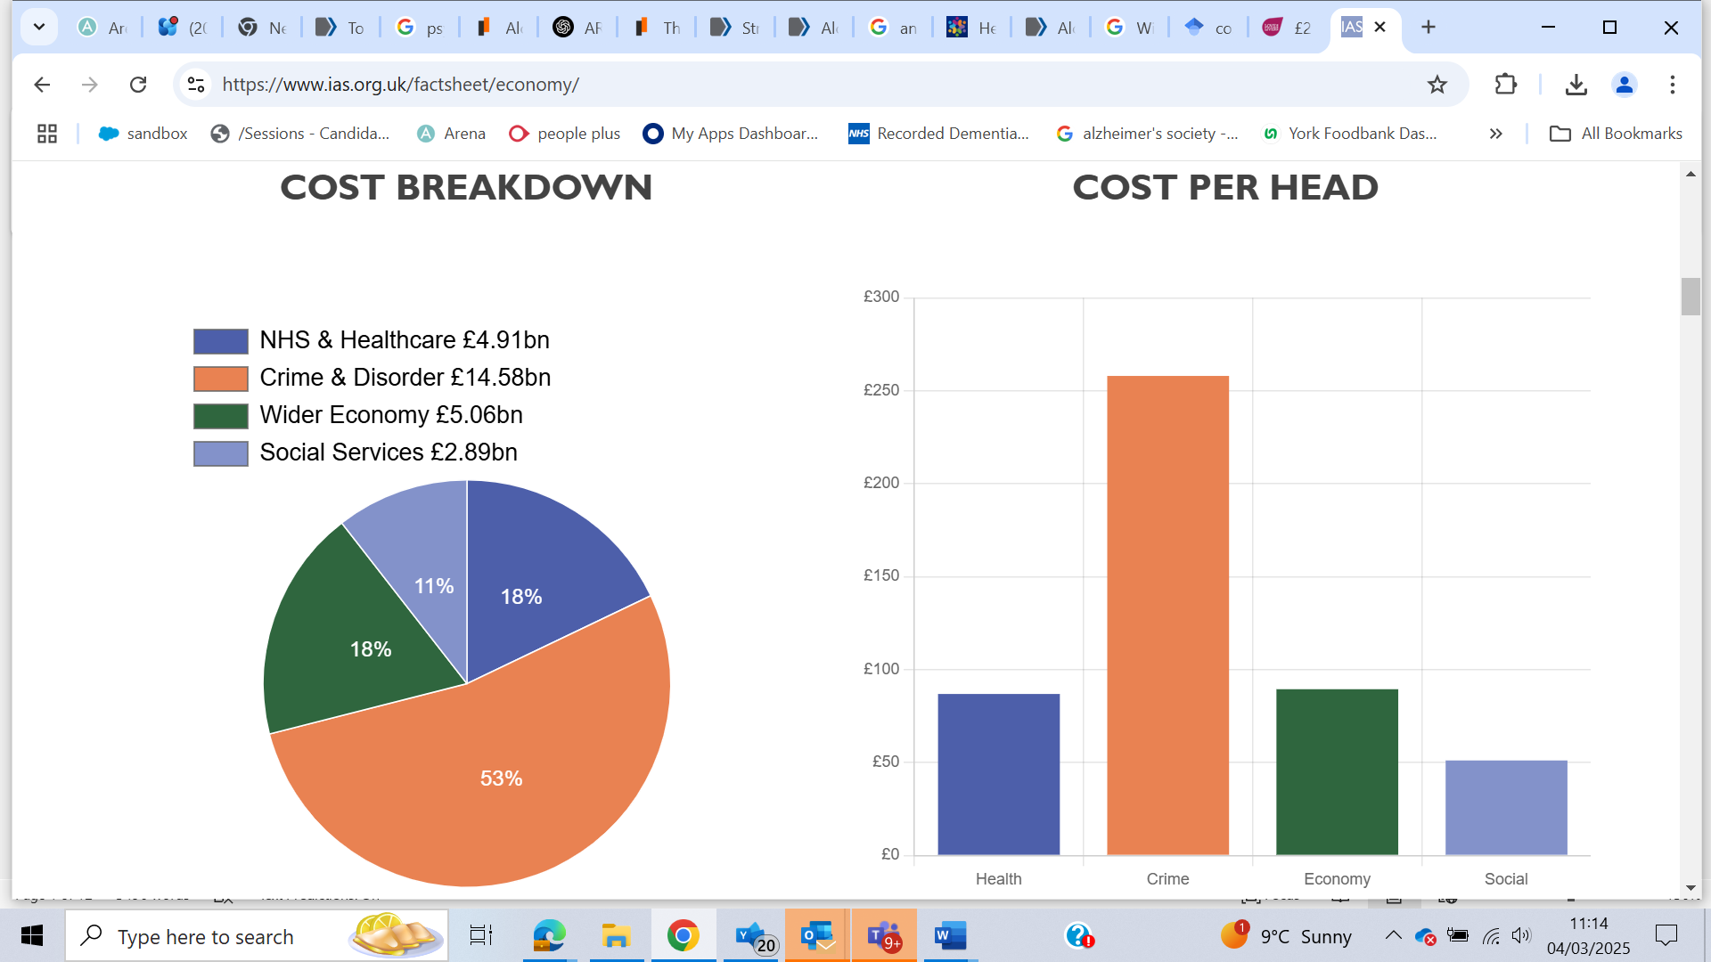
Graph source https://www.ias.org.uk/factsheet/economy/
Total Cost Breakdown of Alcohol Harm for Hull :-
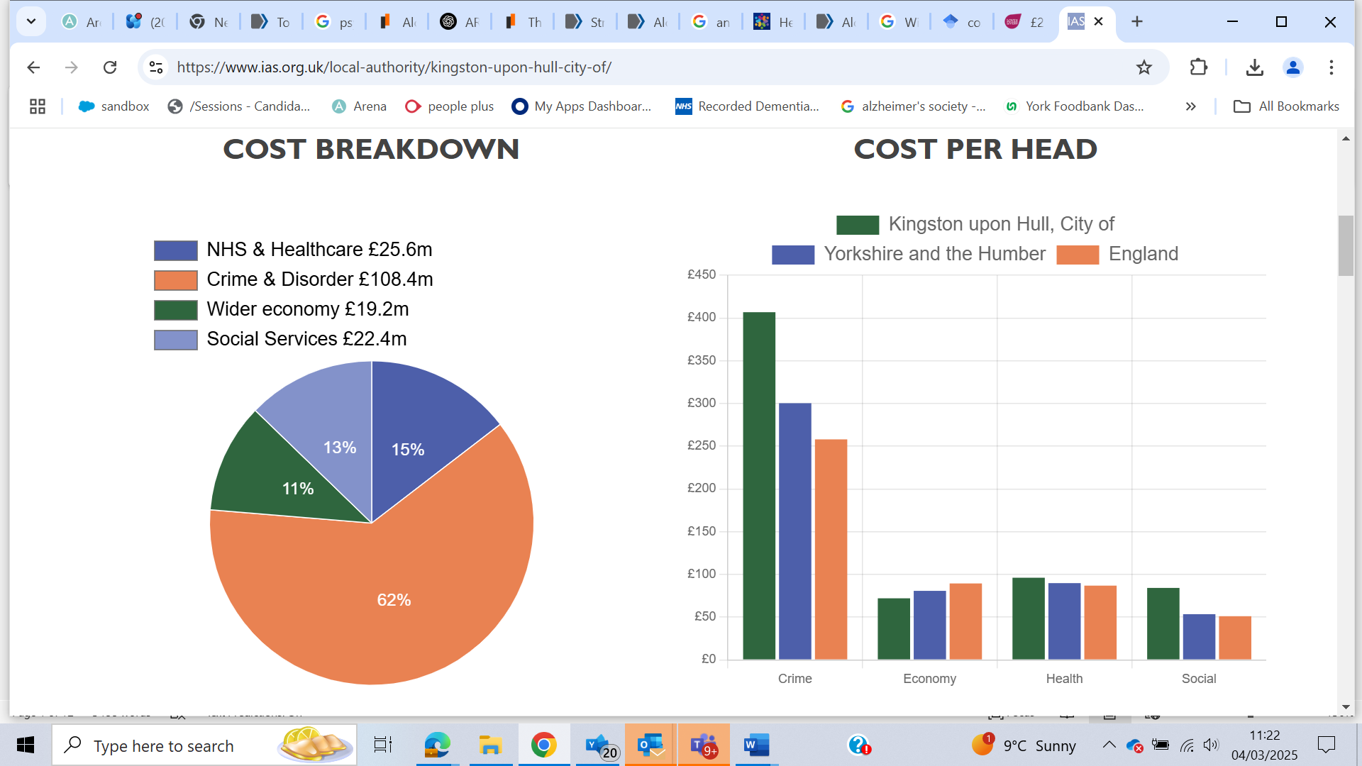
Graph source https://www.ias.org.uk/factsheet/economy/
Excessive use of alcohol can lead to Alcohol dependency, otherwise know clinically as Alcohol Use Disorder (AUD), a medical condition characterised by an impaired ability to stop or control alcohol consumption despite negative consequences on health, relationships, or daily functioning. It can range from mild to severe and often involves both physical and psychological aspects. AUD increases a person’s risk of developing Alcohol-Related Brain Injury (ARBI), structural and functional damage to the brain caused by long-term alcohol misuse. This condition can result from direct alcohol toxicity, nutritional deficiencies (especially thiamine), liver disease, and trauma.
AUD is a recognised a medical condition and is classified in both the Diagnostic and Statistical Manual of Mental Disorders (DSM-5) and the International Classification of Diseases (ICD-11). It is characterised by an inability to control alcohol consumption despite negative consequences.
Classifications for disorders are imperative to allow for efficient healthcare management, accurate record-keeping, and the smooth functioning of the healthcare system, allowing clinicians and healthcare providers to identify the best course of treatment based on the patient's specific condition.
Worldwide there are two classification systems to facilitate professionals to diagnose and support people with various physical and psychological conditions. ICD 10 (WHO) and DSM -5 which allow for consistent and reliable research about the diagnosis, prognosis, and treatment of disorders to improve patient care and clinical outcomes. DSM-5 is strictly intended for mental disorders. Whilst ICD-10 includes those same conditions, it contains conditions and diseases related to the entire human physiology but does not cover mental disorders in the same depth as the DSM-5 does. (Tyrer, 2014). ICD-11 has recently been released by the World Health Organisation (2024) and has been mandated to be the information standard for the NHS in England to replace ICD-10 in the next 5 years. ICD-11 has updated terminology, digital tools and reclassification in some instances. For example, ICD 10, RESIDUAL AND LATE-ONSET PSYCHOTIC DISORDER DUE TO ALCOHOL, becomes DEMENTIA DUE TO USE OF ALCOHOL in ICD 11. This classification change could be the fundamental change for how people will be supported in the future.
ICD and DSM have Limitations. The lack of a comprehensive classification system contributes to underdiagnosis or misdiagnosis. ARBI can sometimes be confused with other forms of dementia, leading to inappropriate treatment approaches. In ICD-10, this is simply classified under alcohol-induced dementia, for which the general criteria for dementia must be met. However, these earlier criteria reflect the characteristics of Alzheimer’s dementia, rather than the patterns typically seen in alcohol-induced cognitive impairment. (College Report, 2014).
It is important for the purpose of this project to understand these fundamental classification systems, to understand how the current systems are structured in a way that poses barriers to support people who have ARBI.
People with alcohol dependence often face significant discrimination in multiple areas of their lives, including healthcare, employment, social relationships, and even within the legal system (Kruithof, McGovern and Haighton, 2023). Alcohol dependency causes significant changes in the brain, affecting its structure, chemistry, and functioning. These changes can lead to tolerance, cravings, and difficulty controlling alcohol consumption leading to Alcohol-related brain damage (ARBD), or alcohol-related brain injury (ARBI) as it is otherwise known.
Core 20 plus, is NHS England’s initiative to tackle health inequalities at both national and system level to inform action to reduce healthcare inequalities at both national and system level (NHS England, 2022). Individuals within this cohort, are at a higher risk of Alcohol Use Disorder (AUD) and Alcohol-Related Brain Injury (ARBI), due to a combination of complex factors (Smith and Foster 2014), however, there is no dedicated service for people with ARBI to access (Kruithof, McGovern, and Haighton, 2023).
ARBI as an umbrella term for cognitive and neurological conditions or damage to the brain as a result of long-term heavy drinking. Over time, drinking too much alcohol can change the way the brain works and its physical shape and structure. This can bring some very serious consequences, including changes in personality, as well problems with thinking, mood, memory and learning (alcoholchange.org.uk, 2025).
Around 1 in 10 people with ARBI will develop some form of dementia, that’s over 98200 people (Alzheimer’s Society, 2025) living with the condition. This, however, alters significantly for those under the age of 65, with ARBI affecting about one in eight people (Alzheimer’s Society, 2025). ARBI affects men more often than women, but women tend to develop it at a younger age and after fewer years of alcohol misuse. This happens because women are more vulnerable to the harmful effects of alcohol (Alzheimer’s Society, 2025).
The cost of dementia to the UK economy is 31% higher than that of the economic cost of alcohol harm, with the current projection standing at £42 billion, with predictions that dementia costs will rise to over £90 billion a year by 2040 unless action is taken (Alzheimer’s Society, 2025).
Challenges in Diagnosis
Suspected ARBI is difficult to obtain a diagnosis. With Local Memory Assessment services insisting on abstinence for a period of time, GPs will also not assess until abstinence has been achieved.
The assumption that an individual with ARBI has the cognitive capacity and ability to engage in standardised programmes is setting people up to fail. Lack of self-awareness of ARBI and the cognitive impairment that ARBI causes, impedes the ability to implement behaviour change, this adding another barrier to an individual seeking support (Walvoort, van der Heijden, Wester, Kessels and Egger, 2016).
Systems currently only treat one or the other, with addiction services lacking additional support. ARBI impacts executive disfunction, increases confabulation, with a detrimental effect on memory, inability to control impulses, and unable to comprehend repercussions and so just go with impulse.
Because someone with ARBI may struggle to learn, store, and retrieve information, be unable to adapt to new situations (Griswold, Fullman, Hawley, Arian, Zimsen, Tymeson, Venkateswaran, Tapp, Forouzanfar, Salama, and Abate, 2018) the skills needed to recover from addiction are often severely impaired or absent.
Having ARBI, puts a person at a great disadvantage as the current pathways are not effective. Memory Assessment Services are structured to assess and offer simple medical solutions and not designed for complex social problems.
With the lack of insight and lack of self-awareness, people will not seek support from health services. There is no one trying to diagnose in the community, with people only having suboptimal opportunity to access support when they access the system, a system that is not structured to meet their needs.
ARBI does not always fit the stereotypical image of dementia, making it harder for people to recognise. When people think of dementia, they often imagine someone who struggles with their short-term memory or forgets names and faces. ARBI presents differently, as a person with ARBI may remember what they were doing 30 minutes ago or, if they don’t, they might confabulate. They might appear alert and engaged in conversation, leading others to believe they don’t have cognitive issues. Unlike stereotypical dementia, where memory loss is often the first noticeable sign, ARBI often affects decision-making, problem-solving, and impulse control first (Alzheimer’s Society, 2025).
An important and often underrecognised aspect of ARBI are the organic changes within the brain. Studies suggest the Neurochemical Changes in the brain, affect the dopamine (reward pathway), GABA activity and glutamate (excitatory neurotransmitter). (Kamal, Tan, Ibrahim, Shaikh, Mohamed, Mohamed, Hamid, Ugusman, and Kumar, 2020), leading to potential structural brain changes in various areas, such as brain shrinkage, white matter damage and risk of loss of neurons, which could lead to prefrontal cortex dysfunction with impairments to the amygdala and emotional processing, (Gorka, Fitzgerald, King and Phan, 2013) causing detrimental effects to memory and learning (Hippocampus Impact)and the stress response system (HPA Axis Dysregulation) (Stephens and Wand, 2012).
Alcohol-induced changes in the brain, lead to many challenges for many individuals with ARBI, brain alterations underlying addiction not only drive the addiction process itself but also make it difficult for many people with ARBI to change their drinking behaviour (Neuroscience: The Brain in Addiction and Recovery).
The brain has remarkable neuroplasticity, meaning it can heal and rewire itself to some extent. Abstaining from alcohol, engaging in therapy, maintaining a healthy lifestyle, and seeking social support can help reverse some of the brain changes associated with alcohol dependency. However, prolonged or severe use may lead to lasting damage (Rao and Topiwala, 2020).

Is abstinence essential – Are we setting people up to fail?
Humber NHS Memory Assessment Service policy aligns with clinical guidelines for assessing cognitive impairment in individuals with alcohol dependency. The requirement for at least six months of abstinence before referral ensures a clearer assessment of cognitive function without the confounding effects of alcohol-related toxicity or withdrawal symptoms. However, the abstinence requirement is not without rationale.
Why the 6-Month Abstinence Requirement?
1. Alcohol-Related Reversible Cognitive Impairment:
Cognitive deficits from alcohol use (such as memory problems and attention difficulties) can improve significantly within months of sobriety, as the brain begins to heal.
2. Brain Recovery (Neuroplasticity):
The brain exhibits substantial neuroplasticity, with some damage reversing over time. A six-month period allows for natural cognitive recovery and more accurate assessment of any lasting deficits.
3. Withdrawal and Post-Acute Withdrawal Syndrome (PAWS):
PAWS symptoms, including memory issues, mood instability, and brain fog, can persist for months after quitting alcohol. Waiting ensures that these temporary effects do not lead to misdiagnosis.
4. Delirium.
A person with ARBI may also develop delirium, especially if they experience alcohol withdrawal, infections, or metabolic imbalances. Withdrawal induced delirium has overlapping symptoms, as both conditions can cause confusion, memory issues, and disorientation, making it hard to distinguish between them, and more difficult to assess their true level of cognitive function until the delirium resolves. One could be assumed or diagnoses over the other, leading to ineffective treatment.
5. Accurate Diagnosis:
Alcohol-related brain injuries (like Wernicke-Korsakoff syndrome) or conditions such as Alzheimer’s Disease dementia need clear differentiation from temporary alcohol-related cognitive impairment, to effect appropriate treatment, prognosis, support, rehabilitation and potentially to identify any underlying causes.

Let’s be realistic – Is abstinence SMART (smart, measurable, achievable, realistic and timely).
Insisting on abstinence, may create a barrier for individuals seeking timely assessment, especially if they are motivated to address memory concerns. Without access to cognitive assessments, some may delay seeking help or be misjudged by other services.
Prognosis
Individuals with ARBI represent a population whose healthcare needs often go unmet (Quelch, Roderique-Davies, and John, 2023), as many clinicians and the public still lack awareness of ARBI. Many affected individuals are socially isolated, avoid healthcare, and remain undiagnosed for life (alcoholchange.org.uk, 2025). This is a critical and often overlooked group. The impact not only on the individual but also on their social and environmental networks who surround them.
The Blue Light approach recognises that cognitive impairment is very common in dependent drinkers, which may be due to an accumulation of brain injury and or trauma, intensifying the impairment and causing increasing brain damage. As a person with AUD continues to spiral downwardly, it becomes harder to engage in recovery, increasing the risk of further damage from issues such as cerebrovascular accident (CVA)or sleep deprivation (Alcoholchange.org.uk, 2025).
Potentially, chronic alcohol intake, increases the risk of development of neurodegenerative disease due to reduced dopamine and is a known contributory to other conditions such as Alzheimer’s Disease and Parkinson’s disease (Kamal, Tan, Ibrahim, Shaikh, Mohamed, Mohamed, Hamid, Ugusman, and Kumar, 2020).
There is an inconsistency in how a complete systems approach treat and support different health conditions. If a person with cancer who continues smoking is still given treatment, then a person with Alcohol Use Disorder (AUD) who are exhibiting symptoms of ARBI, should similarly receive cognitive assessments and support, even if they continue to drink.
This inconsistent and discriminatory approach is not only medically unsound but also stands in direct violation of the Hippocratic Oath, which compels healthcare providers to treat all patients to the best of their ability, without bias or prejudice. Denying individuals with AUD and potential ARBI, access to cognitive assessments and support neglects the fundamental principle of 'do no harm' and instead exacerbates their suffering.
Studies suggests that the prevalence of any alcohol use and heavy alcohol use during the COVID-19 pandemic (2020 vs. 2018) showed absolute increases of 2.7% (relative increase, 4.0%) and 1.0% (relative increase, 20.2%) and that the increases were sustained in 2022 (Ayyala-Somayajula, Dodge, Leventhal, Terrault and Lee, 2024.) In 2016, an estimated 589,101 adults in England were alcohol-dependent( Burton, Henn, Lavoie, O'Connor, Perkins, Sweeney, Greaves, Ferguson, Beynon, Belloni, and Musto, 2016), If the increase continues, then the impact and burden we are experiencing now, only has the potential to worsen, (Quelch, Roderique-Davies and John, 2023)
Clarifying ARBI vs Dementia
Unlike dementia, ARBI is not always progressive or irreversible. A significant proportion (up to 75%) of individuals show improvement with abstinence, nutritional support, and cognitive rehabilitation. (alcoholchange.org.uk, 2025).
Supporting the 25%: A Compassionate and Comprehensive Approach
Challenges Faced by Those with Severe or Non-Recoverable ARBI
However, 75% is not a complete recovery -
There is an assumption that individuals have the cognitive capability to engage in a change programme. However, 25% of individuals with ARBI, may not recover despite interventions and many face challenges in accessing appropriate long-term support. As previously reported, over 92000 people are living with ARBI (Alzheimer’s society, 2025).
ARBI may occur after several years of alcohol dependency, with presentations of differing degrees and varying nature of cognitive damage as a consequence of alcohol dependency and/or thiamine deficiency. As there are no specific tools validated for the diagnosis of ARBI, achieving diagnosis and pathway to support is very fraught and almost impossible, although MoCA may be an effective clinical tool for determining ARBI, but the the resulting impact of support for these diagnoses, may lead to a reduction in alcohol consumption and also reduced acute hospital admissions (Owens, Thompson, Patterson and Richardson, 2019). Montreal Cognitive Assessment (MoCA) is a quick cognitive screening tool used to determine an individual's cognitive abilities across a range of domains - cognitive domains: attention and concentration, executive functions, memory, language, visuoconstructional skills, conceptual thinking, calculations, and orientation (Hobson, J., 2015).
There is a growing network of professionals, advocating change (arbd network) with other’s going as far as proposing strategies and new models of working, one example of this is the work by Alcohol Change UK (2025) Blue Light approach.
ARBI can severely affect a person's ability to manage day-to-day tasks such as cooking a meal or managing money. They may forget to each, pay bills or take medication. Forgetting recent events, conversations, or appointments occur due to memory loss, with poor decision making due to impaired judgement to leading to financial or social difficulties. Personality and mood changes happen, people can become more irritable, apathetic or lose their inhibitions. The impact of ARBI on daily life can be severe, often leading to dependence on others for basic needs (Alzheimer’s Society, 2025). This level of dependency highlights the challenge that people face with ARBI to navigate every day-to-day situations, let alone with been able to engage in alcohol abstinence programmes.

Key Challenges for the 25% with Persistent ARBI
1. Healthcare System Barriers:
- Stigma in healthcare—substance use disorders are often treated as moral failings rather than medical conditions, whereas smoking-related illnesses are more readily accepted as deserving of care. Ethically and clinically, both conditions require a non-judgmental, patient-centred approach that prioritises treatment over blame.
- Exclusion from memory clinics that require abstinence as a precondition.
- Difficulty qualifying for dementia or neurological care services
- Exclusion from mental health and addiction services after abstinence is achieved.
- Insufficient understanding of neurological structures and chemicals within the brain.
- Do not turn up to appointments – repetitive “Did not attend” (DNA) coded on their records.
- Low treatment success – current system is targeted to manage and support people who are not dealing with additional organic and cognitive challenges.
- Capacity and consent are significant barriers when it comes to supporting individuals with ARBI.
2. Cognitive and Behavioural Impairments:
- Persistent memory loss, executive dysfunction, and behavioural challenges due to unmet needs.
- Psychological Barriers and mental health problems.
- Evasive, provocation, procrastinating.
- Mental health problems.
- Lack of insight or denial.
3. Social Isolation:
- Stigma, strained family relationships, and loss of social networks.
- Prejudice – normal or choice, moral fibre to withstand what life threw at them.
- Loss of employment, strained family relationships, and stigma associated with alcohol misuse.
- Persistent memory loss, executive dysfunction, and behavioural changes that impact daily living.

4. Financial and Housing Insecurity:
- Difficulty or limited access to benefits or appropriate housing when ARBI is not formally classified as a long-term neurological condition.

A novel approach is needed to support people who are experiencing cognitive impairment will need an adapted pathway for support, a pathway that will take a whole systems approach.
There is a crucial and often controversial aspect of dealing with Alcohol-Related Brain Injury (ARBI) to be considered—some individuals may be unwilling or unable to acknowledge their condition due to denial, lack of insight, or cognitive impairment itself. However, this does not mean they should be abandoned; they still deserve dignity, respect, and support.

Considerations for a new Diagnosis and Support Pathway

- Recognition of ARBI as a Long-Term Neurological Condition

- Advocacy for Policy Change:
Work with organisations like the Alzheimer's Society and Alcohol Change UK, and other partners across the Health, Social and VCSE system, to formally recognise ARBI as a condition requiring long-term support, whereby abstinence is not required.
- Advocacy for Diagnostic Criteria: Push for recognition of ARBI in clinical guidelines (ICD and DSM) to formalise its status and enable access to services.
- Healthcare Training: Equip primary care and neurological specialists with knowledge to diagnose and manage ARBI compassionately.
- Training for Professionals - Training for professionals to understand the biological challenges and the barriers these present to access current treatment pathways.
- No discharge policy – consider eliminating the need for referrals, to make support more accessible and reduce barriers for individuals seeking help. A “No Discharge Policy” could create a centralised, continuous care system where people can access services whenever they need them, without the hassle of re-entry or additional paperwork and the level of engagement and support adjusted to meet their needs.
- Abstinence not required - although the support pathway will look to work with the individual in reducing alcohol consumption.

2. Specialist Care Pathways
Establish ARBI Specialist Clinics:
Focus on neurorehabilitation and sustained care for those with chronic ARBI, integrating memory assessment services without a strict abstinence requirement.
- Memory Clinics with ARBI Expertise: Develop assessment pathways that accommodate alcohol-related cognitive impairment without requiring abstinence as a precondition.
- Neuropsychological Support: Provide tailored interventions to maintain cognitive functions and develop compensatory strategies.
- Nutritional and Metabolic Correction - High-Dose Thiamine (Vitamin B1) Therapy
- MoCA for psychometric testing.
- Neuroimaging (MRI & CT Scans) if can be tolerated, consider Neuro-imaging irrelevant is achieved abstinence or not

  - MRI (Preferred over CT)
  - Detects brain atrophy, particularly in the frontal lobes and corpus callosum (typical in ARBI).
  - Identifies white matter lesions and microbleeds in vascular dementia.
  - Shows hippocampal atrophy in Alzheimer’s disease.
  - CT Scan - Used when MRI is unavailable.
  - Can detect enlarged ventricles and brain shrinkage.

- Blood Tests and Biomarkers – consider medication where appropriate
- Thiamine (Vitamin B1) Levels: Low levels suggest Wernicke-Korsakoff syndrome (a severe ARBI subtype).
- Liver Function Tests (LFTs): Identifies alcohol-related liver damage that may impact brain function.
- Vitamin & Nutritional Deficiencies: Deficiencies in folate, B12, and magnesium can worsen cognitive impairment.
- Inflammatory & Metabolic Markers: Rule out conditions like hypothyroidism or infections that can mimic dementia.

3. Tailored Social and Care Support
- Case Management Services: Professionals to coordinate healthcare, housing, and benefits for those with ARBI.
- Specialist Allocated ARBI support worker/adviser - Alzheimer's Society provide some helpful information and supporting a person who has ARBI (Alzheimer’s Society, 2025). A support worker can provide tailored assistance and personalised Care, based on the individual’s unique needs and circumstances, improving the overall quality of care.
  - Consistency and Trust.
  - Navigation of Services.
  - Advocacy.
  - Monitoring and Early Intervention.
  - Emotional Support
- Specialist Residential Facilities: Long-term supported housing with trained staff who understand ARBI's complexities.
- Daily Living Assistance: Support with routines, medication management, and behavioural challenges.
- Training Programs for Care Providers:
Equip healthcare professionals and support staff with the knowledge to manage ARBI compassionately.

4. Holistic Well-Being Focus
- Mental Health Support: Therapeutic interventions to manage anxiety, depression, and social isolation.
- Peer Support Networks: Programs for individuals with ARBI to connect, share experiences, and reduce isolation.
- Recreational and Cognitive Stimulation Activities: Tailored programs to enhance cognitive function and emotional well-being.
5. Financial and Legal Assistance
- Benefit Navigation: Support accessing disability benefits when ARBI limits employment.
- Legal Advocacy: Assistance in securing appropriate care and housing.
6. Support for Families and Carers
Support for family to understand the changes and the impact. Alzheimers Society (Alzheimer’s Society, 2025) offer the Carers Information Support Programme, a training programme for carers of people with Mild Cognitive Impairment or dementia. This 4-week programme provides support and up-to-date, relevant information in a group environment, where carers can share experiences and find out about local and national services that can offer support. The programme enables carers to have increased knowledge of dementia, providing carers with practical information that they can use in coping with living with dementia day-to-day.
A similar initiative could be considered for this cohort of people.
7. Long Term Support - Alternate support pathway
Consider long term support pathway if abstinence is not achievable
Consider what other pathways exist within dementia diagnosis, like learning disability, where assessment is over a longer period of time.
8. Advanced Care Planning
Advanced care planning (ACP) for individuals with Alcohol-Related Brain Injury (ARBI) is a vital process that ensures their future care aligns with their preferences and needs. Lasting Power of Attorney may be a priority if the person whom is experiencing cognitive impairment still has capacity.

Recommendations for Support During Abstinence
Where a person is willing and able to engage in a programme to achieve abstinence, a comprehensive and holistic person-centred approach should be considered, that takes in to account the complexities of cognitive impairment and skills to engage in any type of behaviour.
- Addiction Support: Engage in either a community-based addiction recovery programs or a residential based programme, without any recourse should this not be sustainable.
- Mental Health Support: Counselling to manage anxiety, depression, or motivation issues.
- Nutritional Therapy: Vitamin supplementation, particularly thiamine, to support brain health.
- Health Care Monitoring: MDT team to provide routine physical and cognitive screenings during the programme and afterwards, especially if abstinence is sustained.
- Peer Support – consider the development of a peer support network.
- Allocated Support Worker - A support worker can provide tailored assistance and personalised Care, based on the individual’s unique needs and circumstances, improving the overall quality of care.
  - Consistency and Trust.
  - Navigation of Services.
  - Advocacy.
  - Monitoring and Early Intervention.
  - Emotional Support

Prevention as an Optimal Approach.
Of course, the optimal approach would be a preventative approach to mitigate why people have higher levels of alcohol consumption or dependency with a great risk to health. (House of Commons, 2023).

Recommendations
There is immense potential for investment in specialist pathways to not only improve outcomes for individuals with ARBI but also create efficiencies across the system. Prioritising physical and emotional well-being through a humane approach is key.
Professional networks are improving, although limited research exists. There is still a lot of ground to cover, in particular in recognising people’s human rights. For the health and social care commissioners, investing in specialist pathways and services could save money, reduce emergency admissions to Emergency Departments, reduce falls, reduce the risk of traumatic brain injuries, and reduce the impact and complexities of having such a neurological mess to unpick, but most important, to ultimately save lives.
Healthcare should be upheld as a fundamental human right by ensuring equitable access for all patients, regardless of their substance use status.
Substance use disorders, including AUD, are widely recognised as chronic medical conditions that require comprehensive, evidence-based treatment. The refusal to assess and support cognitive function in individuals with AUD not only contradicts best medical practices but also exacerbates health disparities. Cognitive impairments associated with AUD—such as memory deficits, executive dysfunction, impaired judgment. ARBI can significantly impact an individual’s ability to engage in treatment, maintain employment, and sustain relationships. Early and consistent intervention is critical to improving outcomes and fostering long-term recovery.
NHS England and integrated care boards (ICBs) have a legal duty to have regard to reducing inequalities associated with access to and outcomes from NHS services (NHS, England, 2023).
Future projects should establish early partnerships with service providers, possibly through formal agreements facilitated by Integrated Care Boards (ICBs). Any project groups/forums should consist of a multi-disciplinary professionals from the myriad of various Health, Social, VCSE and Academic organisations whose work can contribute to the development of a specialist pathway, with a champion to advocate and challenge on behalf of those with lied experience.
A person-centred approach that is flexible to meet the need of the individual and their cognitive capacity and capabilities.
The ICB has an opportunity to explore ways to provide research access for fellows and practitioners, ensuring equal opportunities for evidence-based practice.
Future research should include service user involvement through partnerships with community groups, charities, or advocacy organisations to ensure that lived experiences inform policy and practice.
Due to the increased risk of the acceleration of the onset of Alzheimer’s Disease Dementia or increased severity (Joshi, Giorgi and Sanna, 2024) earlier intervention for people with ARBI due to AUD, could mitigate or reduce the risk of escalation and crisis in the future.
Consider what models are offered in other international systems.

Limitations
It is important to acknowledge the limitations of the study, and the difficulty in engaging with a commissioned alcohol recovery service highlights a key challenge in research and service evaluation.
The inability to access certain research platforms (e.g., OpenAthens) limited the scope of peer reviewed literature reviews and evidence-based resources.
No Direct User Engagement - Due to access constraints, no direct engagement with individuals affected by ARBI took place. This resulted in a lack of first-hand experiences, which could have enriched the study’s findings.
Although a mentor was arranged by the Humber and North Yorkshire Health and Care Partnership, due to service delivery pressures, leave and other non-controllable factors, time was very limited. A dedicated supervisor, similar to that of a dissertation supervisor, to compliment mentors, would be able to provide educator, sponsor, coach, counsellor, and offer critical friend support.
Data collection gaps, reporting, barriers to assessment and diagnosis contribute to under-reporting of prevalence.
Compounding factors such as Social Economic Status, Environment, Educational Attainment, Comorbidity of other conditions (physical and psychological), cultural or genetic predispositions, were not considered for the purpose of this study. Consideration should be given to the effect they have on an individual and the pathway be flexible to adjust for these, including the potential of a multiplier effect, where two or more factors are present.
This project has focused solely on a individual only experiencing ARBI due to AUD. Future studies should consider a broader spectrum of complexities, such as dual diagnosis of Severe Mental Illness, or dual dependency of drug and alcohol.

Conclusion
Focusing solely on abstinence as a requirement, limits access to people who need help but may not be ready or able to commit to that approach. Abstinence should not be the only access pathway for people to receive assessment and support – an inclusive and equitable approach, eexploring harm reduction strategies and meeting individuals where they are, might open doors for more effective and compassionate support systems.

