Optional Template– Interim and Final report for Health Equity Fellowship
Project Details
Project Name | Taiye Timmy Fatoki
Mentor | Fatemi Mina
Start Date | 1 April 2024
Summary/Abstract – FINAL REPORT
The summary / abstract provides the reader with an overview of all covered in the project report. Even though a summary is placed at the beginning of a project report, you can only write it once your entire report is complete.
Introduction | Health inequity refers to unfair and avoidable differences in health status, access to healthcare, and quality of care across different population groups. These disparities are driven by social, racial, ethnic, economic, and environmental determinants that disproportionately affect marginalized communities. The persistence of health inequities around the world remains a significant barrier to achieving global health justice. This work explored health inequity causes, challenges, consequences, and strategies needed at reducing it, focusing mainly on the Black African community group living in the city of Hull.  According to Professor Bola Owolabi, NHS England’s Health Inequalities Programme Director, as reported in a public policy project publication, diversity in data should be priotised in order to better tackle health inequalities (and by extension health inequity). She believes that significant gaps in health data are distorting understanding of global health.  She was of the opinion that health inequalities have significant toll on nations, healthcare systems, communities and people, as glaringly evident during the Covid-19 pandemic, especially among Black men and women in England. She believes that, greater diversity within datasets would go a long way to reduce health inequalities, because the current imbalance is unsustainable for health systems and local communities, as imperative decisions about resource allocation (in health systems) are based on data that does not accurately represent the global majority.  A 2024 publication on health inequalities by The Health Foundation, says that deaths were 1.77 times higher for women and 1.76 times for men per 100,000 in the most deprived areas than the least deprived areas in 2019. It also reports that 50% of people in the most deprived areas report poor health by age 55-59, over two decades earlier than those in the least deprived areas. The report points to one major thing and that is deprivation.  According to a 2022 Public Health Intelligence publication by the Hull City Council. In 2020 there were 52,286 residents in the most deprived fifth of areas of Hull, of whom 15,339 (29%) were aged under 20, and 6,571 (13%) were aged 65+. The population of the most deprived fifth of areas of Hull is projected to decrease slightly by 2043 to 51,954, with the largest increase seen for those aged 65+, increasing by 22% to 7,994.  At 86.4%, the most deprived fifth of areas of Hull had a lower percentage of White British residents than the Hull average (89.7%), from the 2011 Census; a lower percentage of non-British White residents (mostly Eastern Europeans) (6.3%), than the Hull average (4.4%); and at 7.3%, a higher percentage of other Black and Minority Ethnic (BME) residents than the Hull average (5.9%).  More than half (54%) of Hull’s LSOAs are amongst the most deprived 20% nationally, and only four of Hull’s 166 LSOAs were in the least deprived fifth of LSOAs nationally. Hull has the fourth highest percentage of LSOAs within the most deprived 10% within England.  1.1 Historical Context of Health Inequity  Health inequity is deeply rooted in historical processes of exploitation, colonization, and systemic discrimination. Colonialism created lasting disparities in wealth, social status, and access to resources that continue to manifest in poorer health outcomes for many communities. For example, colonized nations were often left with inadequate healthcare infrastructures, contributing to severe disparities in access to basic healthcare services. In the United States, systemic racism has historically contributed to persistent health inequities. One notorious example is the Tuskegee Syphilis Study (1932–1972), in which African American men were denied treatment for syphilis as part of a government experiment; despite the availability of penicillin as an effective cure. Such events have sown deep mistrust in healthcare systems among minority populations.  People from Black and minority ethnic groups experience inequalities in health outcomes as well as inequalities in access to and experience of health services compared to White groups. This, according to the Kings Fund report, opines that most Black and minority ethnic groups are disproportionately affected by socio-economic deprivation (a key determinant of health status, driven by a wider social context in which structural racism can reinforce inequalities among Black and minority ethnic groups. Examples of such exists in housing, employment and the criminal justice system – which in turn can have a negative impact on people’s health.  The reports says that Black and minority ethnic group members experience inequalities in health outcomes as well as inequalities in access to, and experience of health services compared to White groups. In England, for example, people from Black and minority ethnic groups face a range of inequalities compared to White groups in their health, as well as in their access to, experience of and outcomes from using health services (Raleigh and Holmes 2021).  The report speaks about how COVID-19 pandemic has underlined the structural disadvantage experienced by people from Black and minority ethnic groups who have been at greater risk of contracting and dying from COVID-19 (Institute of Health Equity and Health Foundation 2020; Public Health England 2020).  In the United Kingdom, according to the report ‘Beyond the Data: Understanding the impact of Covid-19 on BAME Community’. There is clear evidence that COVID-19 does not affect all population groups equally. The report gives an understanding of the depth at which ethnicity impacts upon risk and outcomes.  The PHE review of disparities in the risk and outcomes of COVID-19 shows that there is an association between belonging to some ethnic groups and the likelihood of testing positive and dying with COVID-19. This review found that the highest age standardised diagnosis rates of COVID-19 per 100,000 population were in people of Black ethnic groups (486 in females and 649 in males) and the lowest were in people of White ethnic groups (220 in females and 224 in males).  For example, an analysis of survival among confirmed COVID-19 cases showed that, after accounting for the effect of sex, age, deprivation and region, people of Bangladeshi ethnicity had around twice the risk of death when compared to people of White British ethnicity. People of Chinese, Indian, Pakistani, Other Asian, Caribbean and Other Black ethnicity had between 10 and 50% higher risk of death when compared to White British.  Professor Sir Michael Marmot was reported in the January 2024 report on Health Inequalities, Lives Cut Short, by the Institute of Health, to have said that, “If you needed a case study example of what not to do to reduce health inequalities, the UK provides it”. Such is a testimony to the existence of inequalities in the nation’s healthcare services and provision. According to the report, in 2020, during the pandemic, inequality between the least and most disadvantaged 10% of areas contributed further 28,000 excess deaths, when compared to that over the previous five years.  The Marmot Review 10 Years on (published by the UCL IHE in 2020) report, confirms an increase in the North/South health gap in England. The largest decreases in health and life expectancy, according to the report, were seen in the most deprived 10% of areas in the Northeast of England, and the largest increases in the least deprived 10% of parts in London.  It further opines that the Covid-19 pandemic has shone a light on existing healthcare inequalities, especially regarding the disproportionate impact it has on Black and Minority groups. Some other studies, including a report by Public Health England and the Lancet paper on ethnic differences, also reported that people from ethnic minority groups, were more likely to test positive for Covid-19, become severely ill and die during wave two of the Covid-19 pandemic.  1.0 Social Determinants of Health  Health inequity is largely driven by the social determinants of health—non-medical factors that influence health outcomes. These include socioeconomic status, education, employment, neighbourhood environment, and access to nutritious food and clean water, and so on.  1.1 Socioeconomic Status  Low-income individuals and families tend to experience worse health outcomes compared to wealthier populations. Poorer communities often lack access to quality healthcare services, preventive care, and healthy living conditions. For instance, individuals from low-income households are more likely to suffer from chronic conditions like diabetes, heart disease, and mental health disorders, largely due to stress, unhealthy food diets, and inadequate medical care among others.  1.2 Race and Ethnicity  Health disparities between racial and ethnic groups are stark. In the U.S., African American, Hispanic, and Native American populations face higher rates of chronic illness, lower life expectancy, and reduced access to healthcare. Structural racism, which includes discriminatory policies in housing, education, and employment, perpetuates these inequities. Similar patterns exist worldwide, where ethnic minorities often experience inferior health outcomes due to discrimination and lack of access to resources.  1.3 Geographical Location  Where a person lives can significantly affect their health. People living in rural areas often face barriers such as limited healthcare facilities, a lack of specialized providers, and long travel distances to hospitals or clinics. In contrast, urban residents may have access to healthcare but face environmental hazards such as pollution, overcrowding, and inadequate housing, which contribute to poor health outcomes.  2.0 Health Inequity in Different Populations  The Black African population have been affected by health inequity among as a minor of the larger populations in the Hull community of England. This is because of cultural bias, language differences, colour, and religious beliefs among other factors. Some of the diseases are related to the African race.  2.1 Gender-Based Health Inequities:  Women around the world face unique health challenges, including maternal mortality, unequal access to reproductive healthcare, and gender-based violence. In many low-income countries, maternal health services are severely lacking, leading to preventable deaths during childbirth. Additionally, social norms often prevent women from accessing the healthcare they need. Globally, women are also more likely to suffer from certain diseases like depression and autoimmune disorders, which are often under-researched or inadequately addressed.  2.2 LGBTQ+ Health Inequities  LGBTQ+ individuals face significant health disparities due to stigma, discrimination, and a lack of culturally competent healthcare providers. These communities experience higher rates of mental health issues, including depression, anxiety, and suicide. LGBTQ+ individuals, particularly transgender people, also face barriers in accessing gender-affirming care, contributing to poorer health outcomes.  3.0 Consequences of Health Inequity  The consequences of health inequity extend beyond individual health outcomes, affecting entire communities and economies. Communities with high levels of health inequity experience higher rates of preventable diseases, lower life expectancy, and greater healthcare costs. The economic burden of untreated illness is substantial, as it can reduce productivity, increase healthcare expenditures, and exacerbate poverty. Furthermore, health inequity weakens social cohesion and stability, as marginalized groups become further alienated from society. This can lead to social unrest and political instability, particularly in regions where the government fails to address the needs of disadvantaged populations.
Central aim of your project | To explore and understand the health inequity experienced by Black African community members living in Hull
Methodology, results, conclusion | The project used questionnaires and interviews to collect data on the health inequity concern of the Black African community members living in Hull. The total number of questionnaires collected is 40 using Google Forms. While four people were interviewed. The data collected was analyzed using the Microsoft Excel tool, and data visualization was obtained using graphs to determine the response levels and general perceptions of participants about health inequities among the black African community in Hull.
Introduction: Purpose and Overview of the Project Brief – INTERIM REPORT
Provide background, context, and an outline for your chosen project
Problem the idea is seeking to solve or address (if any) and population group | Making a difference: Exploration and prevention of health inequity among the Black African community members living in Hull.  Health inequity has been a topic of interest among the people of colour, especially since the Covid-19 pandemic. This is because there seem to be little impacts resulting from the existing policy direction and interventions meant for the delivery of appropriate healthcare services to the affected population groups, in this case, the Black African community members living in Hull.  According to the World Health Organization (WHO), health inequities are unfair and avoidable differences in health status or access to health resources between different groups of people. It can be caused by social conditions, such as gender, socio-economic, income level, employment status, education, and so on.  Another publication on advancing health equity: Key questions for assessing policy, processes, and assumptions, defines health equity as when everyone has what they need, to be healthy, and that no one experiences unjust barriers that limit their health. It is an unfair difference in health status across populations. It opines that such differences in health are due to a wide range of social and economic conditions, especially when some groups benefit from the design of Systems that deliver things we all need—such as education or housing—while other groups do not. Inequities, according to the publication, can persist over time, as these systems tend to repeat and reinforce patterns of exclusion and marginalization.  According to the 2021 census, 1.6% of Hull’s population identified as Black African, which is approximately 4,292 people. A report on Hull Joint Strategic Needs Assessment, on race and ethnicity, also states that there is often lack of information in relation to the health and wellbeing needs of people from ethnic minority backgrounds, and some people from ethnic minority backgrounds, may experience language barriers and other barriers, in relation to accessing services.  The report also states that based on averages, people from different racial and ethnic groups can have different health needs, as they may have an increased risk of specific diseases due to different genetic factors or have different prevalence of lifestyle and behavioural risk factors. Resultantly, they may have some problems accessing services due to barriers such as language or cultural differences. It further acknowledges that there may also be an increased lack of knowledge around what services are available and how accessible they are. It suggests the importance of considering the potential factors so that everybody can have good health care and access to services.  The Macpherson Report of 1999 highlighted the fact that sometimes services are not also meeting the needs of an ethnically diverse group because of both unwitting and institutional racism, which was defined as “The collective failure of an organisation to provide an appropriate and professional service to people because of their colour, culture, or ethnic origin. It says that such can be seen or detected in processes, attitudes and behaviour which amount to discrimination through unwitting prejudice, ignorance, and racial stereotyping.” According to the report, this occurs because the majority of the population, usually white, set the rules and design the services without the input from the local diverse and usually minority communities, who have the understanding of their community’s culture, language, and barriers.  The report further states that the percentage of Hull’s resident population from ethnic minority background has increased over time. Between 2011 and 2021, the percentage of Black has increased by 80%, while that of Africans has increased by 63%. It concludes that the Black African population has been among the groups with the largest increase in Hull.  The Marmot review 10 years on report on Health equity in England suggests that the overall aims of health equity approaches should be to improve the distribution of determinants affecting health; to redress current patterns and reduce the magnitude of health inequities; and to reduce the risks and consequences of disease and premature mortality across different population groups.  The report suggests governance arrangements that are capable of building and ensuring joint action and accountability by all key actors that have a strong political and public commitment to improving health equity, and equity in social determinants. These include health and non-health sectors, public and private sectors, civil society, and communities and citizens.  The 2010 Marmot Review indicated that delivering on the six priority objectives it set out required action across central and local government, the NHS, the third sector, the private sector and community groups. The review proposed two policy mechanisms central to national action on reducing health inequalities, these are;  • Considering equality and health equity in all policies, across the whole of government, not just the health sector.  • Effective evidence-based interventions and delivery systems.  According to the same 2010 marmot review, in addition to the two policy mechanisms central to national action on reducing health inequalities, it suggests the following as list of principles of governance for health equity:  1. Health equity is an indicator of societal wellbeing.  2. The whole of government is responsible for prioritising health equity in all policies.  3. Development of strategies and interventions must involve a wide range of stakeholders  4. Accountability must be transparent with effective mechanisms.  5. Communities must be involved in decisions about programmes and policies for achieving health equity.  Based on various reports and reviews on health equity, which are of the opinion that a lot still needs to be done to reduce health inequity in order to ensure that everyone has fair and unrestrained access and information to quality health care and services. It is therefore important, to further find out the impacts of health inequity among Black Africans living in Hull. This is also of great importance in order to reduce pressure on the existing health care system. In Hull, a large number of Black Africans are now part of the community of people living there. It becomes imperative to know what they feel, experienced directly or indirectly regarding health inequity in the city.  To ensure that Black Africans living in Hull also have fair opportunities to healthcare services and support their needs, through access to knowledge, information, and education on available healthcare service opportunities, this project was established to address the followings:  1. Health literacy  2. Access to the right institution that can support them with education and knowledge on varied health concerns  3. Effective communication and socio-cultural barriers  4. Inadequate safe space where they can express themselves in an informal way  5. Knowledge and understanding on issues of health inequity, especially as migrants living in Hull, United Kingdom  6. Discrimination and stigma
Key assumptions and interdependencies | Some of the assumptions made, include the following; community cooperation, time constraint on the part of identified population group members, uncertain regarding how the survey questions were going to be answered, and the influence of members of the community on one another.
What is the overall purpose of this project? Aims? | To gather behavioural insight and health literacy.
Why it needs to be done? / Why it should be done now? | The health equity project is important in order to improve on the available information and data on health inequity among Black Africans, with the hope that data collected would contribute to the existing intervention on equity access to healthcare services and information by Black African community members.
Opportunities and Challenges? | The opportunities include:  1.Regular engagement and partnerships with the Black African community leaders and group  2.Community engagement and responsiveness  3. Community leaders’ influence on members  Challenges:  1 Small sample size reached through snowballing might not be a true representative of the Black African community
Desired results of the project? | Coproducing solutions to health inequity with members of the Black African community
Brief description of methodology used? | - Survey sample polls (Questionnaire) among Black Africans on issues of health inequity  - Analysis of the survey  - Interviews conduction with some members of the Black African community to triangulate survey data with narratives.  - Synthesize findings into a report, integrating quantitative and qualitative insights to inform evidence-based recommendations
Theory of Change – OPTIONAL: INTERIM REPORT
A Theory of Change is a way of mapping and visualising the future goals you want for your project, which is fundamental to its design. It helps to set out; A clear link between the activities you want to do to achieve your goals; What needs to be in place to ensure your activities link to your goals; how you will know whether you have achieved your goals. It helps to test how plausible, feasible are your goals, and provides a framework from which you gather data, learning and insight on your journey to prove how you are achieving your goals.
Outcomes (effects of the outputs on the desired result) | The outcomes of this project is focused on the data collected and the result of the analysis of the data in order to provide informed decisions on health equity.
Inputs | - Literature review  - Consultation and engagement with identified community leaders  - Mobilization of community members  - Survey sample questionnaire developed  - Interviews conducted
Activities undertaken | - Sharing of appropriate information via various social media channels of the Black African groups  - Sampled opinion polls among key target groups (Black Africans living in Hull)  - Analysis of the sampled polls  - Invitation and conduction of interview with four interested members of the community  - Data recording and analysis  - Report writing
Impact | - Ensuring strategic collaboration and networking with the Black African community group and effective engagement with charities that engages with them, for developmental purpose.  - Appropriate and adequate community-led support to healthcare service intervention, through a sustainable collaboration.  - Raising awareness among these community groups to engage with health surveys and general census towards ensuring that the voice of the communities are heard, and their concerns included in data.
Outputs | The analysed result and its meaning in terms of number and what they supported (What was accomplished).
Body of the report INTERIM REPORT and FINAL REPORT
This section provides the detail of your work analysis, data, and graphics
Provide the evidence and theory behind your project | Our method of data collection was by the use of questionnaire and interview. The total questionnaires administered was 45, While in-depth- interviews were conducted for 4 Black Africans (2 males and 2 females respectively), to probe further and have detailed information about their thoughts, experiences, and perspectives.  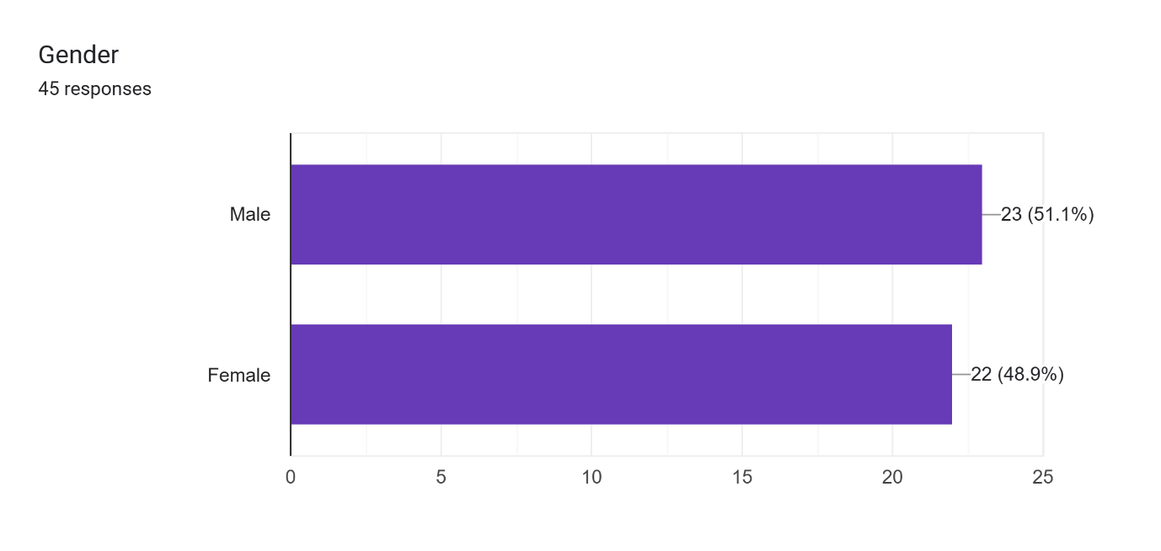  Figure 1: Gender representation analysis  There are 23 male responders and 22 female responders. The males constituted to 51.1% and females constituted to 48.9% .The age group of the responders was put into consideration. The analysis showed that age (21-40) constituted to 57.8%, age 41-60 are 40% while the rest falls between age (0-20) at 2.2%. The educational standard of the responders was also measured. It was observed that 86.6% falls within the postgraduate level while 11.1% are under graduates. The spread of health inequity has become so significant to a higher level such that 59.1% of the responders, all of whom are living in Hull, agreed to the fact that there is health inequity in the UK health sector. However, only about 35.6% were been directly affected.  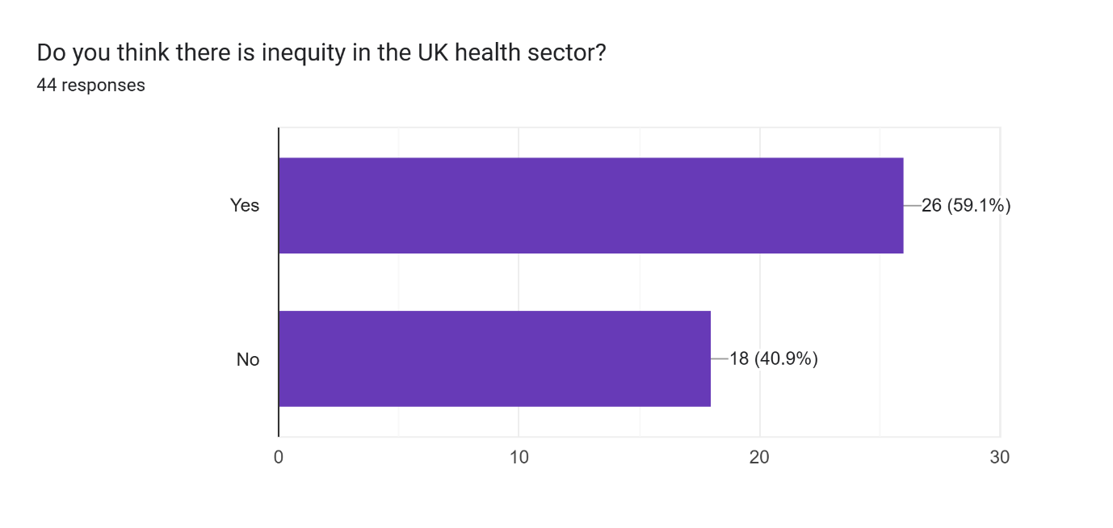  Figure 2: Showing the agreement to the presence of health inequity  However, 40.9% are either not aware or disagreed that it does not exist,59.1% of the responders are of the opinion that it does exist .However, 64.4% agreed that it has not affected directly in any way, with 35.6 % affirming that they have been directly affected.  The data obtained from the interview further reveals the existence and impact of health inequity in Hull. Respondent A, who participated in the in-depth interview on health inequity among Black Africans living in Hull, also stated that he was aware of the concept of health inequity and confirmed that it exists in Hull, particularly among Black Africans. When asked to describe a personal or family experience with health disparity. He cited examples of others around him who complained about being kept for too long after seeking medical attention. He however, said that he was aware that such a situation did not apply only to Black Africans, but to everyone seeking NHS assistance. However, he queried why access to healthcare services and resources have been unfair to the minority, including the Black Africans. He specifically mentioned how the attitudes and communication method of some medical personnel to people of colour has always been wrapped with bias and discrimination.  During the in-depth interview, Respondent A said, “I never knew one would have to wait for a long time to be attended to, and only to be told to go back home, take more fluid often, and use paracetamol. I cannot believe that would be the result of visiting the hospital after wasting transport money, time, and was hungry while waiting to be attended to.”  While another respondent B, reiterated said, “since my friend’s wife lost her pregnancy because of waiting time for an appointment, I have lost hope in the health services for people of my colour. I cannot imagine how another friend’s wife cope, while she was awaiting to be called for a surgery, which she was later called for after more than many months. What if her medical condition deteriorate, and made her uncomfortable to work or live quality life while awaiting to be called for her surgery?”  The third respondent (C) talked more about the heavy discrimination she suffered when she got an appointment with the NHS. She established that she was recruited from her country, and she did everything she ought to have done before and after her resumption. “I was made to feel that I do not know anything, and I was nothing” Some people lied against me, and planned big for my expulsion from work through a report written about me, until a committee was set up to look into it. That was when I was let free, because I was found not guilty. I cried for days, and was not sure of my future in the country if such is the condition under which I would be working. Really, I wonder how many people of my colour were not as lucky as I was, to have been found not guilty of false report about them, only because of their colour” She concluded.  The last respondent (D) specifically mentioned how it has been very difficult for her and some of her friends to know where to access different medical services. According to her, “There are services that I did not even know are free and accessible because there was never any time I had an engagement with the health providing institutions, except when I visit my GP. I once felt so bad in the first year of arriving in the UK, I could not speak confidently with anyone, I felt so sick of myself, and preferred to be all alone, probably because of the new environment, the pressure at work, and the huge responsibilities of keep up with all responsibilities in a new country. I never knew I could visit any mental health support institution free, nor was I aware of their services or location. I only got to know all these when we had a health awareness day, organised by the church I attend.”  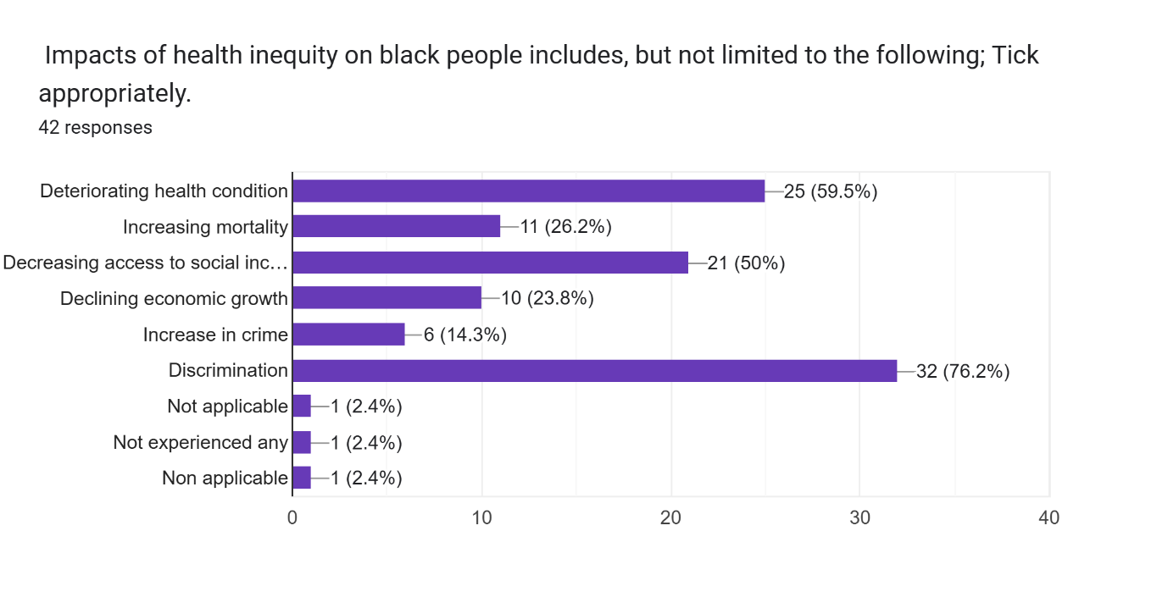  Figure3: The impact of health inequity  Figure 3 shows the various impact of health inequity as observed by the participants in the questionnaire survey exercise, showing the percentage of impact that depicts how high, medium, or low the impact are.  A respondent, B, says that information about health inequities among Black African communities in Hull is well known. According to her, it is something that she has been aware of, based on information from people around her in the same community. She said, she knows people who have been a 'victim' of inequity in their bid to access medical care, resources, and services, including her neighbor. According to her, she regrets that her neighbor, who is also a Black African, had a medical condition that required assistance since 2023, sought a NHS medical institution for Medicare, and she was scheduled for a surgery. Unfortunately, she was contacted to report for the surgery after eleven months. She said the incident left her neighbor with a horrible experience, especially because she was requested to report for surgery despite being on a waiting list for months, and on a day after moving out of her residence, to relocate to another city.
Explain your key findings, results, | This project has presented the reality, challenges, impact of health inequity, including possible actions that can be taken to reduce health inequity in Hull, especially regarding the Black African community members. It has revealed that the community still have a good number of people who have experienced health inequity. The causes as identified by respondent include the following: cultural differences, discrimination, inadequate targeted engagement with community, inadequate knowledge and understanding of available services and supports available, policy gaps, immigration status and so on. Inadequate attention to patients’ complaint during emergency and low priority of people of colour, are particular examples given by some participants during the survey conducted using questionnaire.  Consequently, most Black Africans are not accessing adequately, the available medical services and support in the city. Some do not have knowledge and understanding of available services and resources.
Describe achievements, changes and difference made, impact | The project reveals the occurrence of health inequity among Black Africans, it archives the significant of it and how it has directly affected the population. The changes rely on lowering the impact and establishing some mitigations techniques to lower it such as community inclusion, engagement, and collaboration, and inclusive policy and system and so on. The impact was measured using cultural differences, immigration status, language barrier, stigma, occupation, religious belief among others. See figure 3 above.
Provide any recommendations | The project recommends increased investment in targeted engagement with community groups, coproducing solutions to improve equitable access, and outcome and experience by Black African populations.
Conclusion – FINAL REPORT
This section brings the entire project report together, summarising your argument and why it is significant
Restate original ambition | Health inequity has become a menace among the Black African in the UK; This project explored the causes, effect and provided some recommendations to reduce the impact on their quality of life. The project cited some examples of people affected by health inequity, through interview and questionnaire, their insight on health inequity as it affects them, was revealed. It has revealed that health inequity actually exists and it is affecting the Black African community members living in the city of Hull.
Summarise the key themes | The project considered key themes that include race and ethnicity, inequalities in access, outcome and experience, community engagement, behavioural insight, and health literacy.
Summarise your thoughts | With the effects of health inequity among the Black Africans, it is recommended to provide a platform for the audience, enhance community engagement, provide adequate and appropriate access to healthcare information and services, Inclusive policies and influencing wider determinants of health such as socio-economic, structural, and other factors ,among Black Africans living in Hull.
Describe any future actions or work needed | It would be fascinating to have the project extend also to other ethnically diverse people and those who are non-native English speakers

Relevant terms
Equality We want everyone to have equally good health. However, the term ‘equality’ is sometimes used to describe equal treatment or access for everyone regardless of need or outcome.
Equity We want fair outcomes for everyone. What is important is addressing avoidable or remediable differences in health between groups of people.
Period life expectancy at birth is defined as the number of years that someone could be expected to live after they are born, if current age-specific mortality rates did not change for the rest of their life.
Healthy life expectancy measures the number of years someone is expected to live in good health, based on period life expectancy and a measure of self-rated health.
Deprivation describes a wide range of living conditions that impact on the lives of individuals and communities. People may be considered to be living in poverty if they lack the financial resources to meet their needs, whereas people can be regarded as deprived if they lack any kind of resources, not just income.
The Index of Multiple Deprivation (IMD) is the official measure of relative deprivation in England and is part of a suite of outputs that form the Indices of Deprivation (IoD). It follows an established methodological framework in broadly defining deprivation to encompass a wide range of an individual’s living conditions. People may be considered to be living in poverty if they lack the financial resources to meet their needs, whereas people can be regarded as deprived if they lack any kind of resources, not just income1.

References:
Ethnic-Health-Inequalities-Kings-Fund-Report.pdf
Health Inequalities, Lives Cut Short - IHE
https://assets.publishing.service.gov.uk/government/uploads/system/uploads/attachment_data/file/892376/COVID_stakeholder_engagement_synthesis_beyond_the_data.pdf
https://publicpolicyprojects.com/prioritise-diversity-in-data-to-tackle-health-inequalities-says-professor-owolabi/
https://www.health.org.uk/evidence-hub/health-inequalities
https://www.health.org.uk/evidence-hub/health-inequalities/life-expectancy-and-healthy-life-expectancy-at-birth-by
www.hulljsna.com
https://www.gov.uk/government/publications/health-disparities-and-health-inequalities-applying-all-our-health/health-disparities-and-health-inequalities-applying-all-our-health#fn:1
https://www.ons.gov.uk/peoplepopulationandcommunity/healthandsocialcare/healthandlifeexpectancies/bulletins/healthstatelifeexpectanciesuk/2017to2019
https://www.gov.uk/government/statistics/english-indices-of-deprivation-2019
https://www.gov.uk/government/publications/health-inequalities-reducing-ethnic-inequalities
https://www.health.org.uk/news-and-comment/news/new-data-shows-that-healthy-life-expectancy-in-england-and-wales-has-fallen-below-2017-19-levels
NHS England » Ethnicity health

Summary of interviews:
Respondent A, who was part of the in-depth interview conducted on health inequity among Black Africans living in Hull, also said he was aware of what Health inequity is, and affirmed that it exists in Hull, especially among the Black Africans living in Hull.
When asked to share an experience of himself, any of his family member or someone regarding health inequity. He gave an instance of people around him who complained of been kept for too long after they sought medical support. He acknowledged that he is aware that such situation was not peculiar to only Black Africans, but to everyone seeking NHS support. He said, Black Africans feel such unfair attitude more, because they put out their frustration with the attitude of medical personnel regularly on the community platform. He also opined that because of the experience of few people around, he hardly goes to the hospital for medical care, since he does not want to interact with health care service providers, whom many of his community members believed to be racists because of the way some Black Africans felt treated so far.
Regarding what to do to ensure changes and make the situation better for the Black African community group. Respondent A said that the right education and awareness creation on available health care services and resources for the people of colour, especially the Black African community, would go a long way to educate, inform and sensitize them effectively health literacy, access and other available Medicare opportunities for quality life. He suggested a diversified and inclusive system that ensure that the Black Africans living in Hull are in no way discriminated against, in their quest for quality medical service. He was of the opinion that he has experienced few medical personnel asking Black African patients some questions that they would not ask others who are of a different race and colour. He suggested that there is a need for the health institution (NHS) to ensure that the approach, interaction, and service provision for Black African community group members. He believes that such change of approach would t give the community and other minority ethnic group members, the opportunity of enjoying all available health care services. According to Respondent A, he believes that real data are the diversified voices existing in the community. He therefore suggested that regular active, strategic, and sustainable engagements with the Black African community would go a long way to reduce health inequity.
According to Respondent B, Health inequity among the Black African community groups living Hull is not uncommon. According to her, she has people around her who have been ‘victims’ of this, including her neighbor. She lamented that her neighbor who is also a Black African had a medical condition in need of support, and she approached a NHS medical facility for Medicare. She was scheduled for a surgery, but she ended up having the surgery about ten months after. According to her, it was a bad experience for her neighbor, because she was asked to report to the hospital for her surgery after being on a waiting list for months, a day after she just moved out of Hull. Consequently, she had to be sleeping in different places unplanned in order to have the surgery done. Consequently, she felt frustrated, discriminated, and uncared for. She felt frustrated too because of the financial, psychosocial and emotional effects of the long wait and wrong timing for the surgery. Personally, respondent B said she did not really have direct experience on unfair treatment regarding medical care and services. However, her daughter who was sick was told to go back home and be given water to drink, even after waiting with her for hours. She felt, she could was not asked to do any test, nor was any visible diagnosis done for her, but they were told to just go home and give her water. Respondent B felt this same treatment might not be given to another child who is not of Black African race. She felt discriminated against, and uncared for.
Respondent B believes that health inequity is in existence, and it happens to many Black Africans in Hull. She said she heard different stories where people complained about the way they were treated when they needed health care service. She believes there is still some kind of gap in the system, because she felt since diagnosis have been done, the next step should be to support a patient as soon as possible. However, such was not the case with her neighbor who was on a waiting list for about ten months. She agreed though that there is general delay for every citizen, but she believes the treatment given to her Black African neighbor was because of her colour. She mentioned that late diagnosis, long wait, inadequate attention, and attitude of some health care personnel are some of the barriers some Black Africans face when seeking quality health care and resources they need. She said, such treatments has been responsible for the ‘we shall be fine’ attitude of Black Africans, that results into self-medication and care, as a result of the unfair and non-caring attitude of the system and operators towards people of colour.
According to the third respondent, she was not happy about the way she was treated on arriving at her work place. She was recruited on a work visa, and had resumed with the intention of contributing her best for national development. She said, she started noticing signs of biases and discrimination even as a staff of NHS, when her non-black colleagues started complaining that she does not talk much with them, and she was being moved to another unit. She felt so sad, according to her when she was informed that she would face a disciplinary action, and she wondered what it could be, because she has not done anything unethical or against anyone or patient.
She talked more about the heavy discrimination she suffered when she got an appointment with the NHS. “I was made to feel that I do not know anything, and I was nothing.” Some people lied against me, and planned big for my expulsion from work, until a committee was set up to look into it. That was when I was let free and found not guilty. Really, I wonder how many people of my colour were not as lucky as I was. to have been found not guilty.”
For her, it was the mail sent by the people who made an allegation against her that worked against them. The committee set up saw a lot of errors and falsehood in the allegation, which the respondents could not give a satisfactory prove for. “I cried for days when all these were going on, and I asked myself if I did not make a mistake for coming to the United Kingdom.” She said. “If not for the support of a race group within the organisation, and the thorough work done by the committee, including the narrative of my innocence, I do not know what would have become of me and family, whether we would still be in the UK or back home to our country.” She concluded.
Respondent D specifically mentioned how it has been very difficult for her and some of her friends to know where to access what. According to her, “There are services that I did not even know are free and accessible because there was never any time she had an engagement with the health providing institutions, except when she visit her GP.” I once felt so bad in the first year of arriving in the UK; I could not speak confidently with anyone, I felt so sick of myself, and preferred to be all alone. I never knew I could visit any mental health support institution for free, nor was I aware of their location. I only got to know when we had a health awareness day, organised by the church I attend. A mental health crisis assistant, who was at the health day event, supported me. That really helped me until I became better, and now living my usual lifestyle without allowing pressure or stress to overweight me. She said.
When asked further about what she think about other members of her community, regarding access to information on health services, materials, and opportunities. She was of the opinion that a lot still has to be done by the relevant authorities to ensure that the black community are better reached out to on relevant health information and appropriate access they need to live quality life. She noted that many do not know that there are services that are free for the people, including children. She felt, it is a sign that institutions who are meant to inform and educate and support them, do not even care about them because of their colour. She pointed out that she cannot imagine the depth of difficulties that non-English speakers who are Black Africans might be facing if she and other Black English speakers are facing a lot. She hopes that improved engagement and effective communication with the Black African community groups would go a long way to reduce health inequity, and make lives better among Black Africans living in the city.

