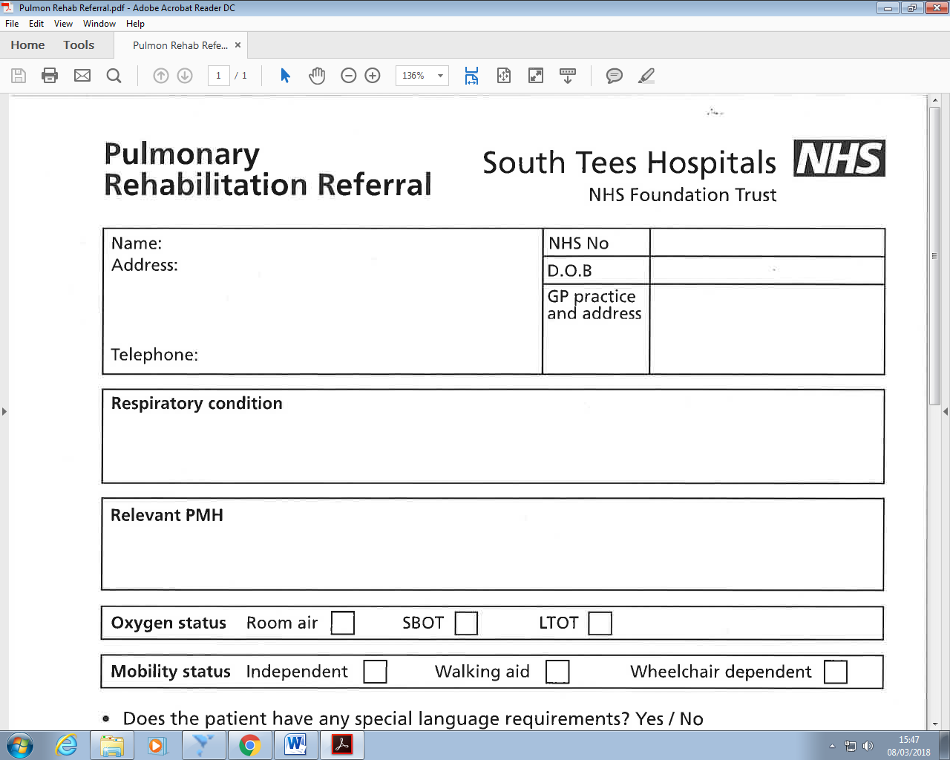**Pulmonary Rehabilitation Referral**

**Please send all completed referral forms to:**

E-mail: [stees.handrpulmonaryrehab@nhs.net](mailto:stees.handrpulmonaryrehab@nhs.net) contact number:01642 854218

**Pulmonary Rehabilitation Service, Rehabilitation Dept, James Cook University Hospital, Marton Road, Middlesbrough, TS3 4BW.**

**Patient Details:**

|  |  |  |
| --- | --- | --- |
|  | **NHS No** |  |
| **D.O.B** |  |
| **GP Practice & address** |  |

|  |
| --- |
| **Respiratory Condition:** |

|  |
| --- |
| **Relevant PMH:** |

|  |
| --- |
| **Oxygen Status Room Air □ AOT □ LTOT □** |

|  |
| --- |
| **Mobility Status Independent □ Walking aid □ Wheelchair dependent □** |

* **Does the patient have any special language requirements? Yes/No**

**If yes please specify………………………………………………………..**

* **Does the patient fit the inclusion exclusion criteria? Yes/No**

|  |  |
| --- | --- |
| **Inclusion** | **Exclusion** |
| * **Respiratory Condition** * **MRC > 3** * **Clinically Stable** | * **MI < 6WKS** * **Uncontrolled Asthma** * **Hemiplegia** * **Cardiac Instability** * **Poor Communication** * **Unable to manage in a group setting** * **AAA >5.5cm** |

**MRC Dyspnoea Score (please circle)**

**Grade Degree of Breathlessness**

1. **Not troubled by breathlessness except on strenuous exercise.**
2. **Short of breath when hurrying or walking up a slight hill.**
3. **Walks slower than contemporaries on level ground because of breathlessness or has to stop for breath when walking at own pace.**
4. **Stops for breath after walking about 100 metres or after a few minutes on level ground.**
5. **Too breathless to leave the house or breathless when dressing or undressing.**

**` Has the patient consented to this referral? Yes / No**

**Is the patient motivated to attend a 7 week programme? Yes/ No**

|  |  |  |  |
| --- | --- | --- | --- |
| **Name of Referrer:** |  | **Contact Number:** |  |
| **Designation:** |  | **Date:** |  |

**Incomplete Referrals will be declined – Please contact to discuss a referral if required**